**Introduction**

Sustainability communication has a dual focus: to make the target audience aware of how the products offered to them will meet their needs whilst addressing economic, social and environmental issues, and to allow a dialogue between stakeholders about the company as a whole (Belz and Peattie 2012). Companies adapt their sustainability communication and fine tune the persuasiveness of their messages according to their perceptions of how well the market will react. Consumer scepticism is caused by marketing communications that “*induce distrust*” through marketing strategies that seem manipulative or deceptive (Forehand and Grier 2003). Scepticism and perceived greenwashing means companies will be careful to not over position their sustainability practices (Belz and Peattie 2012, Bertilsson 2014). Greenwashing is a strategic disclosure of positive sustainability information about a company’s performance while omitting negative information with the purpose of self-creating a positive image (Lyon and Maxwell 2011).

Greenwashing however puts the company at risk of stakeholders’ backlash and encourages the opposite- greenhushing (Peattie and Crane 2005, Smith and Brower 2012). People dislike those who claim to be morally superior because the audience may feel inferior by comparison (Kreps and Monin 2011), and therefore companies will aim to not sound worthy in their marketing, but to appear customer focused. Traditional marketing has focused on giving customers what they want. Companies will aim to engage mainstream customers, not only those with sustainability values, by making their products more accessible (Hedlund 2011). The use of more emotional and less factual data has been found to be more attractive to both the more committed and the shallow green markets (Wehrli, Priskin et al. 2013).

Kreps & Monin (2011) suggest that companies will greenhush anticipating negative consequences of public moralisation. They provide evidence that customers see moralising companies as less competent, and have reduced likability through an image of being judgmental. Companies will also be careful to not over moralised as it creates a commitment to future moral performance avoid perceived hypocrisy, which businesses are likely to not want to commit to (Kreps and Monin 2011).

Consequently, the aim of this paper is to better understand the ability and willingness of volunteer tour operators to improve their responsible tourism communication messages. The paper is structured as follows. First, we review the feedback received from our 2012 study analysing responsibility communications, and update the methodology for this longitudinal study. Second, we compare the 2012-2014 results for the different key issues (responsibility per company, per issue and for three types of product). Third, we provide extensive industry intelligence to explain why these companies may have repositioned their management and communication practices, providing an unusual high level of industry detail for an academic study but that nevertheless is essential to monitor and evaluate practice. Finally, we summarise the results and contextualise them, having found that responsibility communication can improve with some external feedback and a concerted effort. Communication for more complex issues or more expensive products is worse, and communication has not relation with the legal status of the organisation.

**Method**

In our baseline study we created and applied an online content analysis tool based on the International Voluntourism Guidelines for Commercial Operators (TIES 2012) to understand the use of responsibility as a market signalling tool on volunteer tourism websites (Smith and Font 2014). Five influential web pages of eight organisations were scored across 19 responsibility criteria and compared against the organisation’s legal status, product type and price (the justifications for each of these can be found in our original study). We introduced the concept of Responsible Value, plotting the aggregated best practice criteria scores against a project product price per day, displayed visually on perceptual maps. We found that responsibility is not used for market signalling; preference is given to communicating what is easy, and not what is important. The status of the organisation was no guarantee of responsible practice, and price and responsibility communications displayed an inverse relationship. We concluded volunteer tourism operators are over-positioning and communicating responsibility inconsistently, which highlights greenwashing, requiring at least industry-wide codes of practice, and at best, regulation.

The 2012 research results were shared with the organisations involved before being published, to provide them with a learning opportunity. A further reflection considered how they reacted to this initially, and what course of action they intended to take as a result. The lowest performing business (8_Com, a commercial operator) responded with intent of litigation for defamation (and hence we anonymised all the companies in the publication), two companies ignored our results (5_Com and 6_NGO), two were happy to review and discuss (7_Com/Char, a Commercial firm with a Charitable arm, with their PR manager possibly to consider their response should they be named publicly and 3_Com/Char in view of potential web developments),

“I am impressed that from an external viewpoint this insightful paper has accurately identified and highlighted a number of issues we are addressing with the next iteration of our website”. (3_Com/Char)

Interestingly, the three organisations who responded most positively, embracing the research and data highlights and who chose to work further with us to learn more about the improvements they could make in the responsibility quality of their content, were the three social enterprises:

“we have used. . . unbiased and clear pointers for where we could do better to readdress and redesign our homepage to ensure that our message is more accessible, transparent and user friendly”. (1_SocEnt)

“has enabled us to identify possible areas of improvement to create a better online experience for our online users”. (2_SocEnt)

“we found the analysis and industry benchmarking to be very valuable and as a direct result of the work and a follow up consultation we have identified a number of changes to make”. (4_SocEnt)

While the comments came from the four top scorers, this gave us hope for the improved use of responsibility as a market signal that successfully differentiates high-performing volunteer tourism organisations. It also pointed out a potential way forward for researchers in sustainable tourism to work with businesses for the benefit of all.

Two years on from when the content analysis data was first created, we have reapplied the criteria framework, reviewed the organisations’ content and rescored the data points (see original paper for criteria definition and selection and scoring methodology). We acknowledge limitations additional to those included in the initial study. Given the two years since the last data capture exercise, the market changes in that time and the researcher’s own learning in online, marketing, volunteer and responsible tourism, the researcher may have lower or higher expectations of responsibility thus score more or less generously. We have reduced the likelihood of this by reviewing the initial scores during this process, and a couple of adjustments were made to previously noted costs and durations, which changed the relative Responsible Values. Finally, we note that the organisations may have developed their content on these pages as a result of the previous study, but not necessarily all pages, or indeed may have developed other pages which are not considered. Some previous page URLs have unsurprisingly become unavailable since the last study; where they are not automatically redirected to new page versions direct substitutes were made and any subsequent differences in content and strategy noted.

**Results**

The 2012 data is displayed alongside 2014 data demonstrating responsibility signals by criterion (Table1) and by page (Table 2) to summarise key data, and plotted against total price, per day price, organisation and project type (Figures 1, 2, 3 and 4) to allow us to visualise the Responsibility Value.

***Table 1: Responsibility per criterion and organisation, 2012 v 2014***



Table 1 presents the scores across all companies. With the supplemented data set we have reviewed the differences to consider what changes have been made to communications and what quality improvements achieved. We see that all organisations except NGO_6 have increased their total scores, that most criteria aggregated across organisations are more highly scored with the exception of “Clear goals and objectives” and “Donations” which remain static, and that responsibility in communications have increased 50% on an average page basis. The organisation which was previously considered best in communicating responsible volunteer tourism, 1_SocEnt, does so once again, scoring +52, an increase of 6 points on the previous score of +46. Likewise, the organisation previously considered the lowest in communicating responsibility again achieves this position, though has made up some ground, scoring an additional 17 points since last time.

Where previously we saw 1_SocEnt as the leaders in the sample by far, other organisations are now catching up. 2_SocEnt (+24, was +23) no longer comes in second best, taken over in points by 4_SocEnt now only 1 point behind the leaders (now +51, was +20 – the organisation which has made the largest improvement), 3_Com/Char (was +23, now +36) with whom they were previously level and 5_Com (was +20, now +31). 7_Com/Char have made up 9 points (was +10, now 19), overtaking 6_NGO (was +18, now +16), the only organisation to fall in total points in the study.

Top performing criteria previously (aggregated) included “Local Conservation” which has dropped (was +25, now +18), “Lasting Impact” (was +23, now +29) and “Show Values” (was +18, now +30). The latter two are now being the top performing criteria, followed by “Local Community First” (was +23, now +29).

As stated in Smith and Font (2014), Conservation was possibly easier to communicate due to more clear objectives and reporting with scientific data, thus was possibly over-represented within the mix of results. It has perhaps now fallen into a more realistic position, proportionate to the volume of conservation amidst more humanitarian initiatives, and due to improvements in communicating the positive purpose and ultimate impacts of volunteer tourism, although there is still a long way to go towards maximum scores (+2*5 pages*8 organisations = 80).

We now compare and consider the organisations’ positioning of responsibility on the different project web pages. Table 2 shows that all page scores have increased on an aggregate (thus average) basis, Latin America Conservation (was +44, now +67) and Africa Childcare (was +25, now +47) by the greatest amounts. In fact, Latin America Conservation now scores highest, above Responsible Tourism Policy pages, and Home pages remain the lowest (+28, was +13), often the result of limited inventory space to communicate a substantial number of criteria in any detail. Clear improvements have been made as this page shows the biggest percentage improvement (215%), the +15 score increase as a result of positive changes made by 4_SocEnt (page score was 0, now +8), 3_Com/Char (page score was +2, now +9) and 1_SocEnt (was +5, now +6) amidst drops by 6_NGO (+2, was +4) and 2_SocEnt (was +3, was +4). It is perhaps no surprise that Responsible Tourism Policy pages, previous the highest scoring in total, have developed less than other pages: the market has moved on from merely presenting the “big idea” with little follow-through on product pages. Half the organisations have bettered their score on the Policy pages, although 4_SocEnt (+10, was +4), 5_Com (+9, was +3) and 7_Com/Char deserve acknowledgement of their good improvements.

***Table 2: Responsibility per page and company, 2012 v 2014***



Latin America Conservation now scores highest, and showing how factual, detailed and evidenced content can supersede the “big idea” of policies when it comes to Responsibility communications. Figure 1 demonstrates total Responsibility scores (y axis) against total price (x axis) and average price per day (size of the bubble) for the compared organisations’ Latin America conservation projects. It is very clear (Table 2 & Figure 1) that communications for responsible volunteer tourism conservation initiatives in Latin America have improved largely across the board: all arrows show an upward direction for Responsibility and no organisations have dropped. Three organisations have remained static (=) and close in positioning in the mid-market, largely due to no changes in pricing or web content (3_Com/Char, 6_NGO and 7_Com/Char) and one has just increased in price (2_SocEnt). The other four organisations have improved and are moving away from the mid-market, one (4_SocEnt) whilst reducing total cost, the others whilst only slightly increasing total cost (1_SocEnt, 5_Com and 8_Com).

***Figure 1: Latin America Conservation Responsibility v Price, 2012 v 2014***

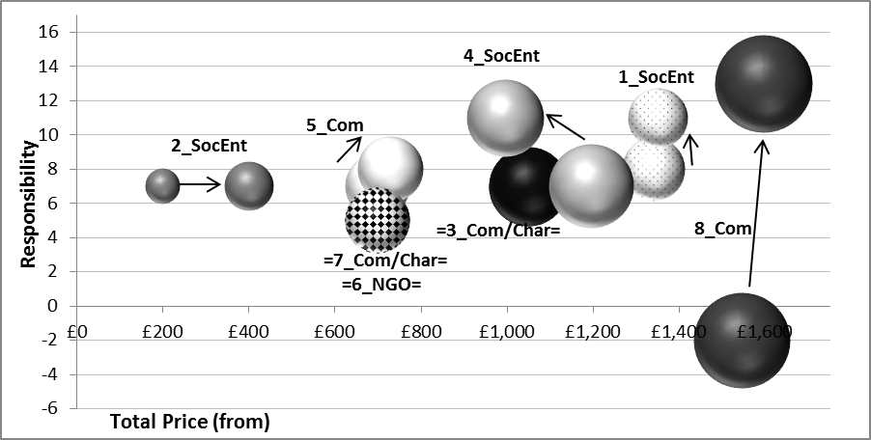

The biggest improvement goes to 8_Com, which has moved from a score of -2 to +13, the largest improvement in responsibility communications quality on a single page out of the whole sample. They have improved scores across many of the criteria, with bigger gains on “Local Community First (+1, was -4), “Lasting Impact” (+3, was -1), “Clear goals & objectives” (+3, was -1), “Impacts” (+2, was 0), “Show Values” (+5, was +3) and “Working with Locals” (+1, was -1). This has largely been achieved by less emotive, poverty marketing and more factual information, with additional web page tabs for “additional project info”, “monthly updates” and “data and reports”. The extensive animal, insect, bird and plant species recorded lists and information on the methods of collection, recording and impacts is factual and offers excellent detailed and contextual information. Having been awarded the reserve project with involvement by the Peruvian government, the organisation is required “to produce a technical report every year to justify our work…. to demonstrate that the area is recovering from previous disturbances and that our work is having a positive impact on the ecosystem in the reserve” and it is clear that this government-contracted reporting provides the impetus to not only create the reports, but use “data for these reports comes directly from our volunteers’ daily observations” to support responsible conversation volunteering on their website. It brings 8_Com to the upper echelons of best practice communicating responsible conservation volunteer tourism and reduces the gap and disparity with the other organisations in the sample, even setting a model for them to follow. This is an excellent development and which would offer 8_Com huge marketing benefits if rolled out across all their projects. However, we see from the further two project pages compared, that this level of information and reporting is not standard.

***Figure 2: Community Development Asia Responsibility v Price, 2012 v 2014***

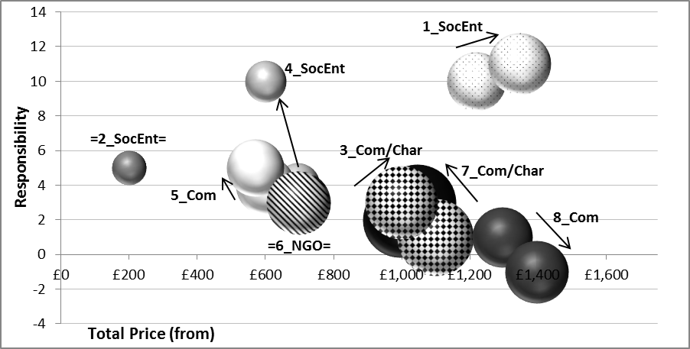

For the Community Development in Asia volunteer tourism projects, the sample organisations polarise (Table 2 & Figure 2). On the one hand, several are now closer in positioning in a less differentiated mid-market, either through improvement of Responsibility (from +2 to +_3 by 3_Com/Char), and with reduced price (from +1 to +3 by 7_Com/Char) or by staying static (6_NGO). Others have attempted to differentiate above the average with their Responsibility communications, increasing their Responsible Value: from + 10 to +11 for 1_SocEnt, at the same time as a slight price rise; from +4 to +5, at the same time as a slight price drop by 5_Com; and a huge jump again by 4_SocEnt, from +4 to +10 with a parallel £95 total price reduction. On the other hand, the market disparity seems to have widened rather than reduced because of improvements at the upper score end (from +10 to +11 by 1_SocEnt) and decline at the lower end (the only downwards arrow) at the same time as prices rising for 8_Com, representing worse Responsible Value.

***Figure 3: Childcare Africa Responsibility v Price, 2012 v 2014***

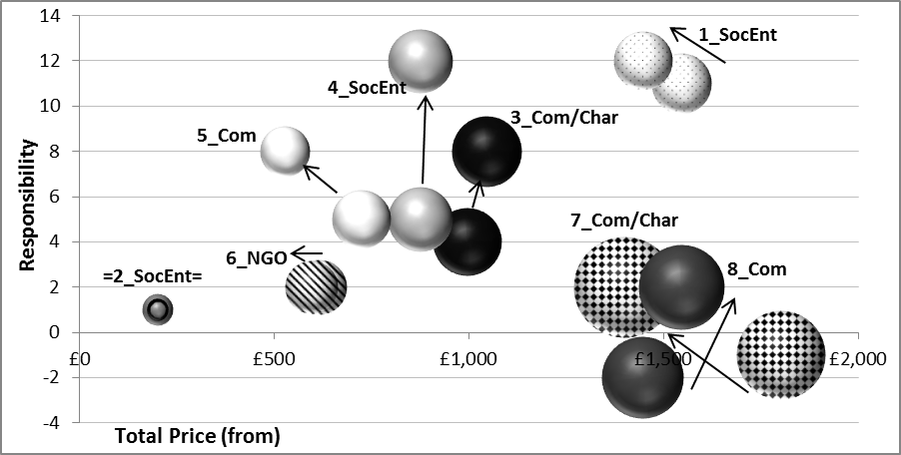

Unlike the Community Development in Asia content, the Africa Childcare projects demonstrate no decline (downwards arrows) in quality of Responsibility communications (Table 2 & Figure 3). All content is either equal in Responsibility with the same price (2_SocEnt, +1; 4_SocEnt, +12 was +5), with a lower price (5_Com, +8 was +5; 6_NGO, +2) or better Responsible Value with a higher score and slight increase in price (3_Com/Char, +8 was +4; 8_Com, +2 was -2) or even better lower price (1_SocEnt, +12, was +11; 7_Com/Char, +2 was -1). Once again, it is 4_SocEnt which has shown the best improvement in Responsibility communication quality.

With the scores for all organisations, pages and criteria aggregated, displayed against the average price per day of the projects and compared to the previous 2012 positions, we are able to demonstrate how the quality of Responsibility in web communications, and market place positioning for Responsible Voluntourism, has evolved (Figure 4).

***Figure 4: Responsible Value vs Average Price per Day, 2012 v 2014***

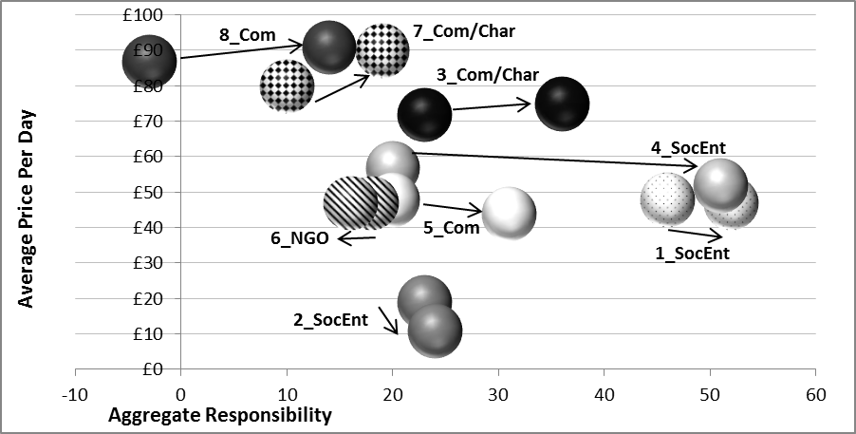

A shift to higher Responsibility is noted, with the exception of 6_NGO’s decline (arrow left). Average price per day has slightly increased for most of the more commercial businesses (3_Com/Char, 7_Com/Char, 8_Com ) and decreased for four organisations, including the three Social Enterprises (1_SocEnt; 2_SocEnt, 4_SocEnt, 5_Com) with the result of overall average per day price remaining static at £57. Higher Responsibility combined with static average price per day thus offers a better Responsible Value in the market on average this year.

**Analysis**

We now analyse how individual organisations have achieved change in their responsibility communication as part of the bigger context of changes in their product positioning and marketing tactics. The analysis shows how businesses improve their responsible volunteering practices as part of broader marketing redesigns, and how these are embedded into the product.

1_SocEnt (+52, was +46) was the most responsible in the previous study of website communication of responsible volunteer tourism. It holds this place, but only just, adding +6 to its score largely by improving linking to previously existing content as supporting evidence/policy. 4_SocEnt is just one point behind now. It does demonstrate some excellent best practice, for example explaining “This project offers a responsible alternative to the volunteer who would like to work in childcare but is rightly concerned about the ethics of short term volunteer work abroad in an orphanage” with supportive contextual links & recommended reading to e.g. the UN Residential Care in Cambodia research. It now needs to review its website thoroughly (possibly completely) in order to keep ahead of the market: Design and functionality can both be improved to enhance the user experience and information provided on responsibility. At the very least, some sections need to be updated e.g. UK criminal records screening is now done via the “Disclosure and Barring Service” and no longer the “Criminal Records Bureau” and ensuring content is included as web pages (not pdfs) would mean ease of navigation to/from further relevant evidence and supporting information. To increase responsibility communication quality, 1_SocEnt needs to now publish more specific needs assessments, goals and objectives, skills and on-going reports of exact work done (rather than examples), linked policy information on working with partners against sexual exploitation and how volunteers are dealt with if inappropriate behaviour is demonstrated, plus live social proof for “show values with social media / reviews integration.

2_SocEnt (+24, was +23) or rather, as a media, their project clients, have not changed their content in two years since the initial study. They have however gained a point for “Show values” on their homepage for additional functionality which offers greater social proof and transparency with Facebook and link to reviews on GoOverseas. There is no business development strategy clear from the data, they may be focusing on adding more projects/clients with the same model or pursuing other models or initiatives. However, as the site is a platform for projects to market themselves, there is no overall ownership, thus impetus for more responsibility. The projects are also fragmented and abroad and likely unaware of overall changing market pressures. 2_SocEnt could improve this through a more structured template for projects to complete including sections which specifically ask for information on more responsible levers, such as needs assessments, objectives and work achieved, acting as an overall brand and positioning guardian.

3_Com/Char (+36, was +23) have redesigned their site since the last study and made great improvements. Although pages are longer with more supportive content for Responsibility and there is more scrolling (which has been a web design trend in the last couple of years), they are more clear and usable. They bring forward stunning imagery and video footage, with additional social proof including “Community” section, more social media accounts (Pinterest and Instagram as well as the usual Facebook, Twitter, YouTube and Google+) and integrated Twitter feeds from destinations on project pages to “Show values”, as well as customer service functionality such as live chat and call back. The business strategy is clearly more marketing oriented in a more realistic way for voluntourism with improved quality of communications, but also more touristic with ‘free time’ and destination information, and more commercial, pursuing retention with the offer of alumni discounts (not just marketing to one-off experience potential volunteers), ancillary sales of Climate Change Offset and Travel Safe cloud storage for documents plus optional accommodation upgrades.

There is also definitely improved focus on sustainable projects, community first and positive impacts. On the homepage, different project categories highlight overall purpose with text written specifically for the page (where as previously content was fed dynamically so cut off to fit and subsequently did not communicate Responsibility well). 3_Com/Char’s best quality improvement for a project responsibility communications is its Childcare Africa page. With its read-to-children program, special needs children’s support, other needs such as construction considered, its charitable trust’s purchase of equipment and its strong child protection policy best practice in many ways (such as any photos having to be checked by staff, no children’s names or faces in social media, no background info on children given and strict expectations of volunteers interaction with children), 3_Com/Char shows considerably more Responsibility than previously for the project (+8, was +4), at a lower price and thus offers a much better Responsible Value.

However, recruitment operations could be more Responsible: There is no mention of any specific skills or any other requirements such as volunteer codes/checks required. Even the video, on the whole very positive, starts with saying 3_Com/Char “use unspecialised volunteers” to benefit their community and conservation related-purpose, which seems a little contradictory. It is also a shame that “the team” page added for staff at the project, including what they bring to project and what they think volunteers bring, is not from local project people (although, scholarships for volunteers do appear to have been moved into the charitable trust site specifically for host nationals). In addition, easy quality improvements to make for Responsibility including highlighting links to ‘Where money goes’ and the charitable trust for financial transparency above the fold. It is also less transparent that reviews are pushed back to the “testimonials” tab and only a select testimonial published along with linked blog about the project and Facebook page. Additionally, more focus on “How this Project makes a difference” actual community requirements and plans, data of past results, working with locals and impacts would improve the content, as would project-specific financial transparency.

4_SocEnt have demonstrated the best overall improvement (+51, was +20, an increase of 155%), which results from improvements to all pages (see Table 2 and Figure 4). This has been achieved by an extensive website redesign in the interim period, including mention of best practice criteria and extensive interlinking to/from more extensive supporting information, such as how project needs come first, how it is responsible, its child and vulnerable adults protection policy and social proof including quotes and links to reviews from not only recent volunteers for topicality which focus on how the organisation meets best practice and expectations, plus a Facebook account integration including evidence on project benefits, but also historical reviews spanning years demonstrating longer term commitment and project longevity. The clear-cut inclusions and exclusions, clearly categorised into ‘before’, ‘during’ and ‘after’ placement, is excellent for managing volunteer expectations, as is having a specific coordinator contact person who can also help build trust, and a good image gallery of the location, project work, community and down-time.

Financial transparency is good, with clear explanation of its non-profit status and pricing policy, how overall annual costs break down and how any profits are distributed to its charity. Like 3_Com/Char, there is also a more commercial orientation demonstrated in the promotion of third party partner ancillary products: Insurance, flights, local tours and TEFL courses not only offer business development but the information is responsible too, to ensure volunteers are prepared, whilst the sending organisation remains focused on its core skills. What could improve the Responsibility of the offering now includes needs assessments with ongoing work programs and clear goals and objectives published, as well as what has been previously achieved, financial transparency information linked from the Responsible Tourism policy, and information regarding the matching process of volunteers, skills and attributes required and codes of conduct relating to expectations of volunteer behaviour and local interaction (including DBS checks). A “How we work with communities” section could mention and link to all these. As reviews do inevitably tend towards the values of the volunteer, the review capture template could specifically address the question of what value they felt was delivered to the community.

5_Com (+31, was +20) has also redesigned its site, however this is largely a “flat” design (as is a current trend in websites) repaint of existing content rather than development of functionality, seemingly for commercial marketing reasons. Its larger font and buttons make its consumer usability on a PC slightly less appealing as they involve more scrolling, however display and usability on a mobile device works very well: A fair assumption would be their target market is more active on mobile. It has gained one point on its homepage, as an amendment towards its “Lasting Impact”, one on its Latin America Conservation page and one on its Asia Community Development page, its project pages using more targeted messaging and calls to action relevant to its audience, such as social media iconography and re-naming “Trip Notes” to “Volunteer Notes”. The projects also have more defined standard sections and clear steps targeted to potential volunteers, which seem to offer more transparency, such as “What is the project like?” regarding what was achieved last year for “Show Values” and “What you get” and “Next steps” links to generic information about placement fees, project sourcing and assessment, support, briefing and training.

Interestingly, some social sharing buttons have been removed ( G+ and Twitter ) suggesting these channels did not work so well (the Twitter account currently has over 2,500 followers) and the strategic focus is on building the Facebook audience (which currently has over 16,000 likes). Calls to action direct to ‘Join the Facebook Community’, as well as ‘Download a Brochure’ and ‘Watch Videos’ , on Thank You pages but once a consumer has already interacted online (eg. through Reservations, Call back, Ask a Question, newsletter sign up, fundraising guide download). This strategy to develop the Facebook audience (probably where reach is greater and demographics more apt) can diminish its use as a pre-sale service channel or by those who are less likely yet advocates: Like 3_Com/Char, there is a greater focus here not just on audience acquisition but also retention.

The biggest change of content for 5_Com has come in the re-written Responsible Travel Policy (+9, was +3). The focus now is very much on partnering with existing local community projects and needs, not creating their own to respond to Western demand, and the continuous flow of (even solo)volunteers to enable ‘Lasting Impact’, demonstrated through the linked Big Giving information. The Policy even includes reference to Responsible the Tourism definition from the Cape Town Declaration (the only organisation to do this), refers to its Volunteer Code of Conduct and links to financial transparency information. Whilst there is still a suggestion of condescending marketing (“Want to make that little bit of difference to a child`s smile?”), on the whole, the tone is more upfront plain speaking than marketing hyperbole and volunteer contributions and imagery have been toned down from the stereo typical Western “white saviour” with young developing-country children. 5_Com are definitely communicating more quality and Responsibility. Police checks are stated as required.

On the downside and where 5_Com can improve quality and Responsibility, many links were not working and there appears to be multiple pages with duplicate or similar content which could confuse the audience (though if the new redesign is recently live, these issues may still be being worked through). The Code of Conduct also appears to be missing any information on or link to child protection, or indeed be linked from projects (which would gain scores for “Inappropriate Behaviour”). This excellent line could be included on every project, “Please remember that you a role model and should therefore dress appropriately. You should not wear revealing clothes or t-shirts with slogans that may cause offence.” Whilst childcare projects state police checks are required, the Africa Childcare project is still ‘bookable’ with only a 3 day lead-time: perhaps it would be more responsible to have a minimum lead time to allow police checks to be done and potential volunteers’ expectations managed more accurately?

There is also apparent greater financial transparency, but on closer examination it is questionable: There is an overall breakdown of costs with more clarity on expenditure on local accommodation and transport, but no project contribution because they do not wish to discourage over-reliance on aid, rather support them to become self-sustaining (but offer donations to other projects they support). However, projects do incur costs other than accommodation and transport, so if these fall within the stated 5% “additional in-country costs” one cannot help but compare with the 8% stated organisational profit and consider the level of financial inequality with the projects. Likewise, the suggestion of equipment volunteers may like to bring can help direct focus appropriately, but on the other hand this could create expectation of gifts, and an equal over-reliance on gift-aid.

There also appears to be a contradiction in “Respect for Wildlife” with the promotion of an annual event which may be local but appears irresponsible to animal welfare standards advocated elsewhere in its conservation projects and not a “very elephant-friendly” event at all: "…its yearly elephant round-up which includes elephant talent contests, demonstrations of the various techniques used to capture and train elephants, a presentation of ancient elephant warfare techniques, and a tug-of-war between men and elephants”.

The final point in respect of this company there is a lack of explanation about how volunteers integrate and work together with locals and no information on long term goals and impacts or matching skills. Interestingly, 5_Com also seem to have removed “Volunteer test” to help guide towards apt projects: Maybe this did not help, or rather over-positioned the business as offering a matching service. In fact on the “about” page they say of projects, “most do not require a set of specific skills- all you need is passion, commitment and to not be afraid of hard work!” Volunteers are just still able to “reserve your place”. 5_Com have definitely improved the quality of their offering and responsibility in communications, but there is still some incongruence in positioning between policies and product offering. This may be hinting at greenwashing, or (given the temporal trend) an organisation in transition to taking more responsibility. Since the last data, they achieve a higher score at a lower price and represent better Responsible Value.

6_NGO (+16, was +18) are the only organisation to decrease in score, and coupled with a roughly equal price per day, this represents a drop in Responsible Value. The lower total score comes from a two point drop on their homepage, which has been slightly adjusted to a more ‘flat’ design and incorporating a few amendments. The ‘Review Centre’ logo/link has been removed, replaced with the organisation’s job vacancies button, promoting less transparency ( now all content appears in-house generated) and the Google+ logo/link has been removed from the header (although like 5_Com, the Facebook audience is considerable, growing from 10,000 two years ago to over 30,000 now). Interestingly, the project types and short cuts have been re-categorised, which is both a great example of the “nicheification” (Smith and Font 2014), for example ‘Conservation’ has now been split into ‘Wildlife’, ‘Marine’, ‘Environment’ and ‘Animal Care’; And of targeting, for example ‘School Projects’, ‘University Projects’. ‘Career Breaks’, ‘CSR projects’, ‘Study Abroad’ and ‘Dissertations’ have been removed , perhaps in recognition of a gap year, not student, core market, which also clarifies positioning vis-a-vis competitors.

All other pages have retained the same scores as the last study as there has been little change. Usability and customer service enhancements include a ‘Project type’ navigation, search by trip code or keyword, ‘Live chat’, “send to a friend” link and bi-weekly webinar “online info sessions”. Again, there is more of a focus on retention and building an audience community than just one-off acquisition. However on this point and where 6_NGO could definitely improve is in the curated reviews: Many are old, potentially out-of-date information and since the last study only one review has been added to one of the projects. As this organisation is one of the largest in terms of sending a volume of volunteers, it becomes questionable why they are not transparently including more recent and relevant information which could support potential volunteers’ choices.

7_Com/Char (+19, was +10) has also significantly re-designed their site, to a more modern, long scrolling design, which would likely resonate more with their target audience (probably Generation Y & Millennials). Not only can it enable more content on a page, including text, imagery and video, which can be better for engagement and storytelling, but it can also bring more SEO benefits as more traffic is funnelled through less pages, giving each page more popularity thus higher ranking potential than if split down. It is thus also a more commercial/marketing approach. As a tour-based travel organisation, the previous volunteer homepage now redirects to what is in effect a tour product search results page for “volunteer” activity, which appears to imply less focus for 7_Com/Char on volunteer tourism from the outset. Indeed there is no mention of volunteer tourism on the main homepage, and it is not included as one of their primary “travel styles”. The simple, single keyword search yields no results for “voluntourism”; for ‘volunteer’, returns the five trips, downscaled from their previous nine in 2012. And as a search result page includes no (positive or negative) textual content on the criteria, they score 0 for this page, matching their previous page score, although that was reached through both a +1 and -1 for content. Although the trips can also be found by selecting the “volunteer” activity filter, there is definitely more distancing from this product since the last research, or rather the organisation is returning its focus to its core tour product and even displaying the volunteer tourism trip information in the standard tour-oriented way: name of tour, itinerary map, cost, duration, type of group, service level and physical grading.

The sustainable tourism policy also redirects to a new page, now moved into the About Us section, which could be suggested as either being more integral to product overall, or taking a step back on focus. Matching the general site design, more story telling is apparent through imagery than text. The text that remains is perhaps more upfront than previously, communicating their business intent more clearly, e.g. “As a travel company, the planet is our product”, whilst cleverly angled to engage the audience with the impacts on communities, “When we say ‘We Love Changing People’s Lives’, we are not just talking about our travellers. We are talking about everybody.” However, there is a danger with greenwashing, using terms such as “Social Enterprise” not as a legal status but generic description of how they see themselves: 7_Com/Char “…is a social enterprise, which means the social value of what we do is just as important to us as the profit it earns.” In some countries such as the UK, a commercial business using this term in this way could perhaps prompt complaints to advertising standards for false representation, which is not responsible. Storytelling video content gives information on its projects and charitable foundation as reason and context for sustainable tourism intent, whilst cleverly detracting from the real sustainability of its commercial operation, and glossing over any real factual evidence or actual benefits.

For example, a video explains a weaving collective set up by the organisation which employs many local women, which may also “keep the past alive”, but the benefit is noted as “for the [7_Com/Char] travellers”. Another video on the negative impact of sex tourism on women in Siem Reap, Cambodia, the focus is away from poverty porn and on the positive opportunity an education centre and restaurant funded by 7_Com/Char offers for “feeding the hopes of a generation”. Whilst this offers sustainable solutions through tourism which support the local community, it is very emotive, “Make the world a little more perfect” and open to question about how much 7_Com/Char benefits by having also its tour clients fed there. Another video describes a biodegradable hygiene product business set up with micro-finance by 7_Com/Char’s charitable foundation, and used by its porters, chefs and other staff on the Inca Trail: Again, 7_Com/Char is the principal client and whilst this does support local business and economy, it also helps control and own the supply chain. “Community first” is questionable, but 7_Com/Char are certainly very good at giving that impression and intent, with evidence back up. As a result, its score has increased.

7_Com/Char’s project pages now redirect to tour-style pages, much more geared to inform and ready the traveller for a tour product. There is some duplication between the 3 pages of information now offered: The organisation ought to ensure unique content per page, both for search engine optimisation and indexing, and customer clarity. Also, whilst volunteer project location and activities are described, the volunteer information and preparation is relatively minimal, without explanatory context or evidence, and the volunteer involvement downplayed: Clients “participate in volunteer work”, “helping” or “assisting” with no specific benefits, impacts or value promised, to volunteer or community, other than “Your contribution will be productive, rewarding and beneficial to the local community”. It is much more of a commercial holiday tour sell. The childcare aspect of the Africa trip has now been removed and the trip is now a camping safari, visiting game parks and reserves and a Samburu village, with no information about any community benefits nor evidence.

An interesting enhancement is the company’s zero tolerance for the use of drugs or prostitutes by travellers; company trip guides have a right to expel from the tour any clients. They also clearly state they adhere to the strict no alcohol rule of the project. Thus the organisation gains points for ‘Inappropriate behaviour’ but loses points elsewhere. However on the whole, the majority of their extra points come from not being marked down negative points as they were in the last study for poverty marketing, either implied or clear publication of belittling content (-6), rather than positive, evidence backed content. In effect by distancing themselves further from a voluntourism program, they have lost less points thus gained, rather than better communicating a quality programme. Whilst their average price per day has increased, combined with the trip changes, the overall result may offer better Responsible Value than its previous data, for being less involved in voluntourism.

8_Com (+1, was -2) have also redesigned their website to a more modern, ‘flat’ and intuitive look and feel, and to a more marketing-oriented approach involving more commercial and social media links. ‘Apply Now’, Twitter and G+ have been added so always available in the header, ‘Top Destinations’ increased in number from 6 to 10 and footer links added to appear on all pages, replicating header links above and contact details, including YouTube, Pinterest and Instagram. However, while different images are used on the homepage, they are still all white Westerners surrounded by developing country children, with content focused on volunteers first and no mention of any of the best practice criteria, thus still score a -2 for their homepage.

Likewise on project pages social/sharing icon buttons and brochure download link have been added, along with “A parents’ view” link, clearly targeting their young audience and decision-makers. On some project pages, all other content remains and scores the same, however on their Latin America conservation page, there is a huge addition of enhanced information (as discussed with Figure 1), taking their page score from -2 to +13. Additional top tab navigation also brings “Volunteer Stories” to the fore (rather than missed link below), which equally clearly targets the different audiences for the project, categorising “pre-university”, “university students”, “recent graduates” and “career breakers and older volunteers”. There is also more focus on positioning as professional experts by re-naming “Our Colleagues” to “Our staff” - taking more ownership can be perceived as taking more responsibility, and can also demonstrate where staff are local.

However, even the extensive information regarding local and global conservation does not portray an organisation which promotes ‘Community First’. It is driven by the organisation rather than the local community, with local benefits and needs assessments not discussed. More factual support for this, along with how they are “Working with locals” would be more Responsible, as would making this level of reporting standard across all projects (rather than just where required by governmental partners).

8_Com’s Africa Childcare page also has more supportive content, including a Care Management plan and clearly stated role and objectives “including increasing literacy levels, improving emotional support and care to children and promoting early childhood development” – it is no longer about just “assisting local staff playing with children, basic teaching and general help” as previously written. However, the Care Management Plan’s first stated priority is still volunteers with the community secondary, “Our company mission is to make it the norm for young men and women from developed countries to live and work as volunteers in a developing country; they should work on projects which have a clearly favourable impact on host communities”. More concerning though, “Whatever your age, abilities or level of experience’, ‘all we ask is that you have enthusiasm for and a commitment to the work’ required as “Local staff are often highly overworked, and do not have the time to give the children much one-on-one attention” – and with no mention of background checks, and despite volunteers may have to ‘make sure the children are fed, washed and dressed’ – this is blatant publication of not taking more responsibility which earns negative marks. Interestingly, the video integrated is better focused on community, its needs & aims. Volunteers are not the priority in this, the community is. It could be that this incongruence of content and tone is because some comes from a local office and staff, and some from the UK head office, and represents their different values and attitudes.

There have been some amendments made to the Asia Community Development, possibly in light of negative perceptions, for example the removal of the teaching option on Koh Rong Samleon island and text, “A number of orphanages and charity schools support themselves by putting on traditional dance shows to generate vital funds”. However, stating, “You do not have to have any formal teaching qualifications or a TEFL certificate, nor do you require previous teaching experience “, “you will normally teach alone without a teaching assistant” is alarming and not responsibly putting ‘Community First’, especially when in parallel to citing Cambodia’s “turbulent past”, “devastation” and need and enthusiasm of students. This clear publication of easy to exploit context & opportunity gains negative marks. ‘Community First’ could also be questioned when 8_Com integrate a subject like Shark Conservation to the curriculum based on their global campaign: is this really the best subject for children in Phnom Penh to “reverse the negative connotations associated with these animals” (which maybe they do not have), rather than for example something more related to local Cambodian issues. Further improvement would include monitoring & evaluation feedback reports included on the site.

Overall, 8_Com’s improvement increases their score greatly from -3 to +14 with only a slight increase in average price per day, thus offering better Responsible Value. However averaging in this case, largely due to the wealth of conservation project information, could hide some of the most irresponsible and misaligned content related to other projects, and 8_Com’s position at the bottom of the sample reflects this positioning.

**Conclusions**

In the study of the 2012 data we noted there is overall low performance on the extended marketing mix that relates to responsibility. We still hold this as true, but we have seen a general market improvement by most of the organisations: Aggregate scores have increased +86 points, from 157 to 243; +54%; Average score per page increased +10 points, from +20 to +30; +50%; and average prices remaining fairly level, thus offering an improved Responsible Value. Transparency and evidence-backed content has increased, reducing the likelihood of greenwashing. But we also note that while website redesigns have been common among the sample, they largely relate to online usability, customer journey and commerciality factors, and as such are more akin to the commercial tourism market online developments than quality improvements in product or operations. It can be suggested that as such the volunteer tourism product is maturing and organisation orientation is switching focus to marketing developments. The inclusion of more factual data and less emotional communication is positive from a corporate disclosure perspective and engagement with stakeholders (Belz and Peattie 2012), and we assume these companies have also seen some benefits from responsible marketing signalling (Smith and Font 2014). Some organisations with quality product are better signalling Responsibility while others are pulling back from over-positioning and communicating with less emotive hyperbole and more realistically where product is less responsible volunteer related and more holiday-oriented, avoiding the moralisation trap (Kreps and Monin 2011). As such, we see the organisations moving to more differentiated positioning away from the mid mass market and finding market niches, signs of a professionalising sector. The improvement in sustainability communication is less likely to be a result of improved management, but instead better care of reporting what is already taking place.

Second, we found responsibility communication depends on the complexity of the issue, with organisations choosing to communicate not what is arguably most important, but what is easiest and most attractive. We still hold this is true, and possibly even more exaggerated, with Conservation scoring most highly, and extensive supportive factual information provided – but not standard across projects, and possibly not due to organisations taking responsibility of their own accord, rather being held accountable by higher powers. Where specific reports are not available, we see how social media can also “Show Values” through transparency, but we witness a trend toward less “open” integration, replaced with more curated controlled publication of reviews showing increased green marketing sophistication (Lyon and Maxwell 2011). However, Africa Childcare is no longer the lowest scoring project pages on average. We see this is due to careful communication and influence of negatively perceived market issues around blatant orphanage tourism, showing the operators’ ability to respond to stakeholder pressure with improved communication. This can also result from better posturing that avoids maligned keywords, using terminology which relates to child care rather than orphans, whilst describing the same projects. We also note a shift away from volunteer tourism, towards a more tour-focused product, where there is perhaps less complexity, criticism and more potential margin.

Third, we still find that “the status of the organisation is no guarantee of responsible practice”. Non-profit operations are not necessarily the most responsible, nor for-profit the least. 6_NGO and 7_Com/Char are amongst the lower levels of Responsibility demonstrated in the sample, much less than 5_Com. However, we do see two of the Social Enterprises, 1_SocEnt and 4_SocEnt, rising above. Additionally, where we previously noted we could not assume small or non-for-profit organisations have the in-house commercial marketing skills to effectively communicate a Responsibility bond, we see little difference in websites according to status of organisation. Six of the eight organisations have redesigned and developed their sites in line with commercial marketing current trends, with the exception of 2_SocEnt, which has fallen into 5th place in terms of Responsibility communicated, and 1_SocEnt which may need to consider a significant redesign to facilitate better content and functionality in order to retain its market leading position and not be overtaken.

Fourth, we found price and responsibility displayed an inverse relationship and price was not a Responsibility quality signal, as more Responsible products would have resulted in more premium prices. This still holds true when we consider the 2014 data with a trend line, although to a less exaggerated extent as prices have remained as wide ranging as previously , but overall Responsibility has increased. This could suggest that Responsibility is indeed moving to become a quality signal in the market, and that a market advantage can be achieved by better marketing Responsible volunteer tourism. This would be the result of positive framing specific responsible volunteering practices as quality assurance and trust behind a particular supplier- basically personal added value benefits for the consumer that help differentiate or justify a product price (Grimmer and Woolley 2012, Kim and Kim 2013).

Finally, we conclude that international volunteer tourism organisations may be prepared to learn from feedback on the quality of their responsibility communications, and that analysis and communication of these results may influence market improvement. Sustainability communication is not the result of poor perceived mastery through low self-efficacy (Bandura 1997), but a deliberate choice of underplaying current responsible practices, or perceived low demand for increasing their responsibility efforts.

**References**

Bandura, A. (1997). Self-efficacy: The exercise of control. New York, Freeman.

Belz, F. M. and K. Peattie (2012). Sustainability marketing: a global perspective. Chichester, John Wiley and Sons.

Bertilsson, J. (2014). "The slippery relationship between brand ethic and profit." ephemera: theory & politics in organization **14**(1): 125-136.

Forehand, M. R. and S. Grier (2003). "When is honesty the best policy? The effect of stated company intent on consumer skepticism." Journal of Consumer Psychology **13**(3): 349-356.

Grimmer, M. and M. Woolley (2012). "Green marketing messages and consumers' purchase intentions: Promoting personal versus environmental benefits." Journal of Marketing Communications(ahead-of-print): 1-20.

Hedlund, T. (2011). "The impact of values, environmental concern, and willingness to accept economic sacrifices to protect the environment on tourists’ intentions to buy ecologically sustainable tourism alternatives." Tourism and Hospitality Research **11**(4): 278-288.

Kim, S.-B. and D.-Y. Kim (2013). "The Effects of Message Framing and Source Credibility on Green Messages in Hotels." Cornell Hospitality Quarterly: 1938965513503400.

Kreps, T. A. and B. Monin (2011). "“Doing well by doing good”? Ambivalent moral framing in organizations." Research in Organizational Behavior **31**: 99-123.

Lyon, T. P. and J. W. Maxwell (2011). "Greenwash: corporate environmental disclosure under threat of audit." Journal of Economics & Management Strategy **20**(1): 3-41.

Peattie, K. and A. Crane (2005). "Green marketing: legend, myth, farce or prophesy?" Qualitative Market Research: An International Journal **8**(4): 357-370.

Smith, K. T. and T. R. Brower (2012). "Longitudinal study of green marketing strategies that influence Millennials." Journal of Strategic Marketing **20**(6): 535-551.

Smith, V. L. and X. Font (2014). "Volunteer tourism, greenwashing and understanding responsible marketing using market signalling theory." Journal of Sustainable Tourism **22**(6): 942-963.

TIES (2012). International Volunteer Tourism Guidelines for Commercial Tour Operators. Washington, D.C, The International Ecotourism Society.

Wehrli, R., et al. (2013). "Do sustainability experienced travellers prefer a more rational communication of the sustainability of a tourism product?" ITW Working Paper Series **Tourismus 002/2013**: Lucerne University of Applied Sciences and Arts.