An investigation into the effects of using 2 or 4 acupuncture needles with bi-directional rotation on experimentally-induced contact heat pain in healthy human participants

Carole A. Paley and Mark I. Johnson

Carole A. Paley PhD – Corresponding author
Head of Research & Innovation
Research Office
Airedale NHS Foundation Trust
Skipton Road, Steeton
Keighley BD20 6TD
Tel: 01535 292278
carolepaley2@btinternet.com

and

Faculty of Health and Social Sciences
Leeds Metropolitan University
Civic Quarter
Leeds LS1 3HE
and
Leeds Pallium Research Group, http://www.leeds.ac.uk/pallium, Leeds, U.K.

Prof. Mark I. Johnson, PhD
Faculty of Health and Social Sciences
Leeds Metropolitan University
City Campus
Leeds LS1 3HE
and
Leeds Pallium Research Group, http://www.leeds.ac.uk/pallium, Leeds, U.K.

Word Count: 3854
Keywords: Acupuncture, Pain, Hypoalgesia, Non-therapeutic Human Experimentation, Experimental thermal pain
ABSTRACT

Objectives
There is growing evidence from experimental studies that acupuncture dose or technique influences the speed of onset of hypoalgesia. The aim of this study was to investigate the effects of acupuncture using two or four needles on experimental contact thermal pain in healthy volunteers.

Methods
Forty two participants were randomised to 3 groups: 4 needle group (LI4, LI11, LI10, TE5), 2 needle group (verum at LI4, LI11 and mock at LI10, TE5) and mock-acupuncture group (LI4, LI11, LI10, TE5). Each participant rated pain intensity (VAS) to a series of noxious stimuli administered to the forearm, 2°C above heat pain threshold during needling and immediately after removal of the needles.

Results
Experimentally-induced heat pain intensity (VAS) during and after the intervention was lower than pre-intervention but there were no statistically significant differences in this change between groups. There were no statistically significant differences between groups in the time taken for pain intensity to decrease by 33% from pre-intervention. However, a 33% decrease in pain intensity within 3 minutes of needle insertion was observed for 13 (92.9%) participants in the 4 needle group compared with 66.7% participants in the 2 needle group and 57.1% in the mock acupuncture group. There was less variance in VAS in the 4 needle group suggesting more consistency in hypoalgesic response when using more needles.

Conclusions
There was tentative evidence that 4 needles may be superior to 2 needles at generating rapid onset hypoalgesia. The findings suggest that further investigation is warranted.

INTRODUCTION
Evidence suggests that acupuncture is effective for providing pain relief [1], and the insertion of at least four needles may be a necessary pre-requisite for an adequate dose [2-4]. A meta-analysis of 17,922 individuals with chronic pain who had participated in randomised controlled trials (RCTs) found little evidence that the number of acupuncture needles used during treatment affected pain, although better pain outcomes were associated with more needles when compared with non-acupuncture controls [5].

Few studies have investigated the effects of the number of acupuncture needles on clinical outcome. Ceccherelli et al. [6] failed to detect differences in pain relief achieved during acupuncture using 5 needles and 11 needles in patients with neck pain, although both groups achieved meaningful therapeutic pain relief. Taechaarpornkul et al. [7] found that electroacupuncture administered using 2 and 6 needles reduced pain and stiffness, and improved physical function in osteoarthritis of the knee. In laboratory studies, Li et al. [8] found no differences in the magnitude of hypoalgesia produced by deep needling of LI4 and LI11 individually (1 needle) and in combination (2 needles) suggesting that combined needling of points from the same meridian did not enhance outcome. Bäcker et al. [9] found that acupuncture administered using 5 needles bilaterally at LI4 and 4 non-acupuncture points, produced a greater change in electrodermal activity, reflecting sympathetic nerve activity, compared with 1 needle at LI4.

Studies using healthy human participants exposed to experimentally-induced pain have tended to focus the role of needle manipulation. Zaslawski et al. [11] found that needle location and needle manipulation influenced pressure pain threshold. Benham et al. [10, 22] have found that bi-directional needle rotation of ‘deep tissue’ increased hypoalgesia with a weak positive correlation between hypoalgesia and the intensity of needle sensations. Choi et al. [13] found that pressure pain threshold increased during deep needling with needle rotation compared with superficial needling (0.3 cm) without rotation and deep needling (2 cm) without rotation. They concluded that needle sensation and pressure pain threshold increased according to the depth and rotation of acupuncture. Langevin et al. [14] found that bi-directional rotation of the acupuncture needle generated mechanical stretching of tissues and mechanical transduction leading to nerve fibre activity that produced rapid-onset alterations in cellular activity such as cytoskeletal remodeling in connective tissue fibroblasts. Interestingly there are very few studies that have investigated the effects of the number of acupuncture needles on experimentally-induced pain. Amand et al. [12] found that acupuncture administered using 5 needles inserted to a depth of 12 mm with bi-directional rotation at verum points produced larger increases in electrical and heat pain thresholds when compared with control but not with sham needling.

Physiological studies have found that neuronal activity alters as soon as connective tissue fibres are manipulated suggesting that acupuncture has the potential to produce rapid onset hypoalgesia [14]. Rapid-onset analgesia is important in various painful conditions, including cancer breakthrough pain. The intensity of pain may become very severe within minutes and even fast-acting opioid preparations are inadequate. Evidence suggests that acupuncture may produce rapid onset analgesia in some patients experiencing postoperative pain [15] [17] and acute musculoskeletal injuries [16]. There has been limited research on the influence of needling technique on the speed of hypoalgesia.

The aim of this study was to investigate the effects of bi-directional rotation of different numbers of acupuncture needles on experimentally-induced contact heat pain in healthy human volunteers. Experimentally-induced contact heat pain delivered using the Peltier principle has been used with success to assess the hypoalgesic effects of acupuncture on pain sensitivity response in healthy human participants [18].

MATERIALS AND METHODS
The study employed a repeated-measure, parallel groups design using healthy human participants randomised to receive either acupuncture with four needles, acupuncture with two needles or mock acupuncture with no needle insertion. Approval was given by Leeds Metropolitan University’s Ethics Committee and the Research and Development Unit at Airedale NHS Foundation Trust. Participants were recruited from university and hospital staff, students and associates.

Potential participants were given an information sheet inviting them to attend the laboratory for one session which included screening, familiarisation with the equipment and procedure, and informed consent. Participants were excluded if they felt unwell on the day of the study, had any blood clotting disorder, were taking anticoagulants and had an unstable prothrombin time (blood clotting tendency), had experienced seizures or had needle phobia or allergy to stainless steel. Participants were not excluded if they had received acupuncture before. They were informed that they could withdraw from the study at any time. Written, informed consent was obtained.

During the study visit participants were familiarised with the techniques to be used. Age, sex, existing medical conditions, medication and whether the participant had received acupuncture before was documented on a case report form. Participants were then randomised to the 4 needle group, the 2 needle group or the mock acupuncture group using a computer-generated block randomisation and sealed envelope method. Participants were blinded to their group allocation but blinding of the investigator was not possible because they also administered the intervention.

<H1> Procedure
Each participant took part in one experimental session (Figure 1) that consisted of:
a) Determination of the test temperature to be used during the experiment which was 2°C above their heat pain threshold (i.e. test heat pain temperature);
b) Measurement of pain intensity at this test temperature pre, during and post intervention.

<H2>Determination of test heat pain temperature
Participants sat on a chair with the left forearm resting on a table, with the elbow bent to 90°. A screen was placed so that the forearm was not visible to the participant. Four acupuncture points were marked on all participants. A thermal sensory analyser (TSA) model TSA-II (Medoc, Israel) was used to deliver contact heat to the skin of the forearm. The thermode (30x30mm) of the TSA was attached to the radial aspect of the upper third of the forearm.

Baseline forearm temperature was set at 32°C and maintained for 5 minutes so that participants adapted to the temperature and did not sense warmth or cold. Then, the forearm temperature was increased at a rate of 1°C per second and participants were asked to indicate when they experienced the first sensation of pain. This temperature was recorded as heat pain threshold. The ‘test temperature’ was set at 2°C above this threshold.

<H2> Measurement of pain intensity at test temperature
Measurements of pain intensity were taken at time zero (pre-intervention), and then repeatedly throughout the 10 minute intervention period when needles were applied to the skin (during intervention) and repeatedly for 5 minutes after the needles had been removed from the skin (post-intervention) (Figure 1). Measurements of pain intensity were recorded using visual analogue scales (VAS) anchored at 0mm = “no pain” and 100mm = “worst pain imaginable” during a series of identical experimental cycles.

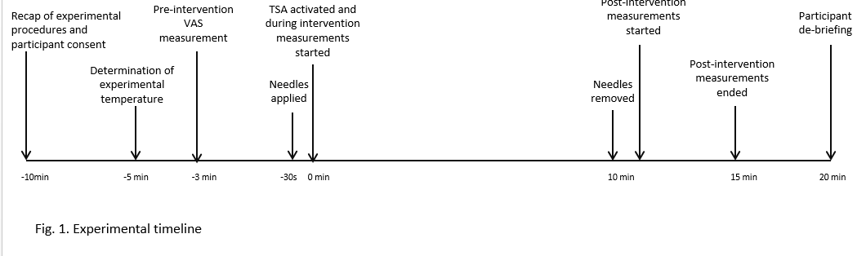

During each experimental cycle temperature increased from baseline 32°C at a rate of 1°C per sec to the ‘test temperature’ and was then maintained for 4 seconds whilst the participant rated pain intensity. The temperature then returned to baseline (rate 1°C per sec) for 4 seconds, to prevent participants becoming accommodated to the heat before the next experimental cycle (Figure 2). Experimental cycles continued for 10 minutes whilst the needles were in situ. Since test temperatures differed between participants, the duration of each experimental cycle varied slightly between participants.

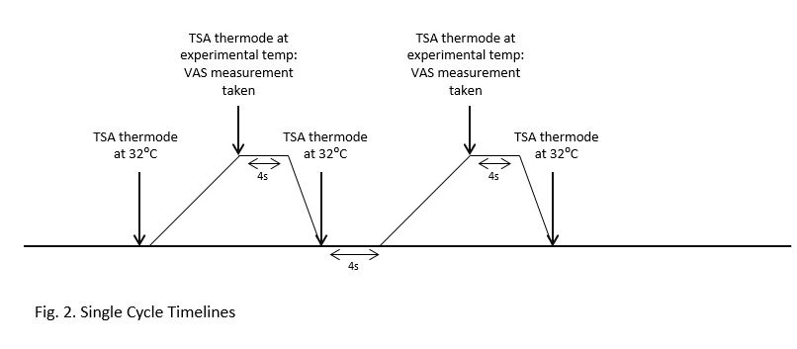
<H2> Interventions
Participants received one of the following interventions:
- Verum acupuncture with 4 needles at LI4, LI11, LI10, and TE5;
- Verum acupuncture with 2 needles inserted at LI4, LI11 and mock acupuncture without needle insertion at LI10 and TE5;
- Mock acupuncture at LI4, LI11, LI10, and TE5.

Verum acupuncture was performed by inserting one needle into each point. Mock acupuncture was performed by making a single skin tap over each point using a plastic guide tube, to aid blinding. Participants were told that they might receive ‘real’ acupuncture or ‘fake’ acupuncture but will feel a tap on the skin regardless of which group they were assigned to. They were also told that needle sensations varied from person to person and they may or may not feel a sensation.

The intervention was based on a medical model of acupuncture treatment by selecting points in the same dermatome as the thermode (i.e. ipsilateral C6/7). Needles at LI4, LI11, and LI10 were inserted into muscle tissue to maximise potential for mechanical stimulation of connective tissue. Bi-directional rotation (or mock bi-directional rotation) of needles began as soon as they were inserted using the same sequence for each participant: LI11, LI10 (if required), TE5 (if required), followed by LI4. Each needle was bi-directionally rotated continuously for 15 seconds at a rate of approximately 2Hz with no time gaps when moving on to the next acupuncture point. Mock rotation was achieved by rotating a guide tube just above the skin over the 4 acupuncture points in turn, so the participant was aware that some manipulation was taking place behind the screen.

A total of 40 periods of rotation were performed for each participant during the 10 minute needling phase: 10 periods of bi-directional rotation for each of the 4 verum needles in the 4 needle group; 20 periods of bi-directional rotation for each of the 2 verum needles in the 2 needle group; and 10 periods of bi-directional rotation for each site in the mock acupuncture group. VAS scores were recorded at the test temperature of each heat cycle throughout the intervention period. All needles were removed at the end of the 10 minute intervention period and the experimental cycles continued for a further 5 minutes. At the end of the experiment participants were asked to say which group they thought they had been assigned to, before being unblinded.

Table 1. Interventions in the three groups
Needles were Seirin J-type 25 x 30mm. All interventions were perpendicular, in the left arm, and sustained for 10 minutes. Bidirectional rotation at 2Hz was given for 15 seconds. See text for rationale of point selection.

Group | Acupuncture points [19] | Needling depth or control intervention | Stimulation
4 needle | LI4  LI11  LI10  TE5 | 1-1.5 cm  2 cm  1.5-2 cm  1cm | 10 sessions  10 sessions  10 sessions  10 sessions
2  needle | Verum LI4  Verum LI11  Mock LI10  Mock TE5 | 1-1.5 cm  2 cm  Plastic guide tube tapped on skin with no needle insertion  Plastic guide tube tapped on skin with no needle insertion | 20 sessions  20 sessions  none  none
Mock acupuncture (0 needle) | Skin tap over LI4, LI11, LI10 and TE5 | Plastic guide tube tapped on skin – no needle insertion | Mock rotation of guide tube above skin, 10 sessions at each location

<H1> Outcomes
The primary outcomes were mean changes in pain intensity from pre-intervention, intervention and post-intervention phases within and between groups. The first time point at which pain intensity (VAS) decreased by 33% of the pre-intervention, considered a clinically significant change [20], was calculated for each individual and the numbers in each group reaching <33% reduction in VAS at 90 and 180 seconds was used as a secondary outcome measure.

<H1>Data Analysis
The sample size for this study was based on recommendations for sample sizes of 20-40 participants for pilot studies where no prior information exists on which to power the study [21]. We decided to recruit 14 participants for each group.

Test temperatures were analysed using a one-way analysis of variance (ANOVA) to check for differences between groups. VAS scores for each cycle were plotted for each individual and visually inspected for any anomalies in the data. Mean + SD VAS scores were calculated for each group for each phase and compared using t-tests for mean pain intensity pre and during the experiment, and one-way ANOVA to analyse differences between groups. Data were checked for normality using a Kolmogorov-Smirnov goodness-of-fit test and boxplots for each group were used to identify outlying values. Data were normally distributed so parametric statistical tests were used.

The duration of each experimental cycle length was calculated for each participant as the sum of the time to reach the test temperature, 4 second ‘hold’ time to reduce back to baseline temperature and 4 second ‘rest’ period. From these data, the time at which the VAS score for each participant had decreased by 33% from baseline was calculated. A data point of >300 seconds was recorded and used in the calculation of the group mean for participants where VAS scores did not decrease by 33% of their pre-intervention value. The number of participants achieving a 33% reduction in VAS scores within 90 and 180 seconds was calculated. Statistical analyses were performed using Minitab version 16.

RESULTS
<H1> Characteristics of the participants
Forty five individuals expressed interest in taking part in the study. Three did not wish to enrol and forty two agreed to take part and provided written consent (27 female and 15 male, mean age = 36.2 SD 14.1 years). Twenty four of these 42 participants were acupuncture naive. One adverse event occurred where a participant began to feel faint during the needle retention phase. This participant was withdrawn from the experiment by the investigator and data up to the point of withdrawal was included.

<H1> Test temperature (i.e. 2°C above heat pain threshold)
There were no significant differences between groups in mean test temperature (4 needle group = 43.7 SD 2.8°C; 2 needle group = 44.1°C ± 3.1°C; mock acupuncture group = 42.9°C ± 3.5°C, F=0.492, p=0.615) or time taken to reach the test temperature (4 needle group = 15.7±2.8s, 2 needle group = 16.1±3.16s, mock acupuncture group = 15.0 ± 3.5s, F=0.486, p=0.619). There were no significant differences in mean duration of experimental cycles between groups (4 needle group = 39.39 ± 5.61s, 2 needle group = 40.27 ± 6.33s, mock-acupuncture group = 37.94 ± 6.93s, p=0.619).

<H1> Pain Intensity (VAS)
Visual inspection of the VAS data revealed a wide range of pre-intervention scores (minimum = 7mm, maximum = 87mm) and a clustering of VAS scores below 30mm during and post interventions for most participants. There were no clear trend lines or clustering of data points across the time course of the experiment.

Pain intensity during the intervention (needle retention) was lower than pre-intervention, irrespective of group (mean change (n=42) = -17.65+18.64, p <0.001, paired t-test). There were no statistically significant differences between groups in the change in pain intensity during the intervention compared with pre-intervention (4 needle group = -20.36+13.97; 2 needle group = -16.56+19.18; mock acupuncture group = -16.03+22.83, F=0.216, p=0.807). Pain intensity post intervention (needles out) was lower than pre-intervention, irrespective of group (mean change (n=41) = -16.13+20.46, p<0.001, paired t-test). There were no statistically significant differences between groups in the change in pain intensity post intervention compared with pre-intervention (4 needle group = -22.59+15.97; 2 needle group = -13.65+27.02; mock acupuncture group = -11.97+16.99; F=1.089, p=0.347).

<H1> Time to 33% reduction in VAS from pre-intervention
Pain intensity decreased by 33% of the pre-intervention baseline in 37/41 participants during the 10 minute intervention phase. There were no significant differences between groups in mean time to 33% reduction in VAS from pre-intervention (4 needle group = 78.2+48.0s; 2 needle group = 169.0+162.5s; mock acupuncture group = 146.8+124.6s; n=41, F=1.96, p=0.156, one-way ANOVA). Mean data for each group were normally distributed (Kolmogorov-Smirnov goodness of fit found none of the groups were significant at D = 0.05). Visual inspection of the box plot revealed larger upper and lower quartiles for the 2 needle group and mock acupuncture group and larger variability outside the upper and lower quartiles (whiskers) for the 2 needle group (Figure 3).

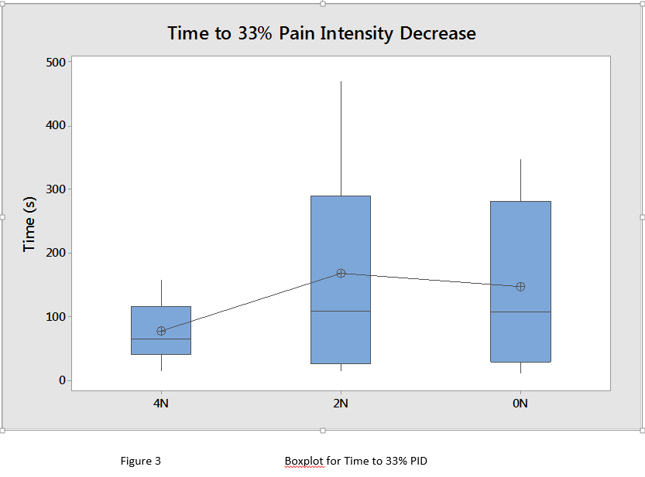

Pain intensity had decreased by 33% within 90 seconds in 11/14 (78.6%) participants in the 4 needle group, compared with 4/12 (33.3%) in the two needle group and 5/14 (35.7%) in the mock acupuncture group. Comparison of means revealed no significant difference between the 4 needle and mock acupuncture groups (Z = 1.147, p = 0.246), the 4 needle and 2 needle group (Z = 0.839, p = 0.390) or the 2 needle and mock acupuncture groups (Z = 0.251, p = 0.795).

Within 3 minutes of the start of the intervention 13/14 (92.9%) participants in the 4 needle group had reached a pain intensity decrease of 33%, compared with 8/12 (66.7%) participants in the 2 needle group and 8/14 (57.1%) in the mock acupuncture group. Comparison of means revealed a significant difference between the 4 needle and mock acupuncture groups (p<0.05, Z = 2.309, p = 0.029). There was no difference between the 4 needle and 2 needle group (Z = 1.647, p = 0.091) or the 2 needle and mock acupuncture groups (Z = 0.482, p = 0.617).

<H1> Blinding of participants
Thirty two of the 42 participants correctly identified their group allocation, of which eight were acupuncture naïve. Of the 10 participants who did not correctly identify their group allocation eight were acupuncture naïve. The remaining eight acupuncture naïve participants were unsure of their group allocation. Twelve of the participants described strong needle sensations from point LI4 or point LI11 and two participants described a strong experience of relaxation. Two participants from the 4 needle group experienced such a strong needle sensation they commented that it almost completely masked the thermal pain. One participant commented that they ‘got used to the pain’ as the experiment progressed. Interestingly, five participants from the mock-acupuncture group claimed to have experienced some mild sensation from the acupuncture sites.

DISCUSSION
This experimental study found no significant difference in reduction of contact thermal pain between groups experiencing 4 needles, 2 needles and 0 needles (mock acupuncture) with continuous bi-directional rotation. However, there were trends that support the possibility that 4 needles had a greater effect on pain intensity. A greater proportion of participants from the 4 needle group achieved a 33% reduction in pain intensity with 3 minutes following needle insertion when compared with 0 needles (mock acupuncture) but not when compared with 2 needles. Moreover, there was less variance in pain scores in the 4 needle group suggesting more consistency in hypoalgesic response. The aim of the study was to investigate the effect of fewer needle placements per se. Hence, the duration and technique of needling was identical between the 4 and 2 needle groups, but through fewer points. This may have contributed the failure to detect statistically significant differences between groups under the present conditions. Our findings add to the growing body of evidence suggesting that needle technique affects hypoalgesia [12, 13, 22], but provides only tentative evidence that more needles increase hypoalgesia and that at least 4 needles are required for an adequate dose of acupuncture for pain [2-4].

Our findings provide tantalising evidence that more needles increase the speed of onset of hypoalgesia. A greater proportion of participants from the 4 needle group achieved a 33% reduction in pain intensity with 3 minutes following needle insertion when compared with 0 needles (mock acupuncture) but not when compared with 2 needles. The rapidity of onset of hypoalgesia may have potential benefits for rapid-onset pain such as acute trauma and breakthrough pain. There is a lack of research on the clinical efficacy of acupuncture for cancer pain [23]. Data from a case series suggests that acupuncture may be useful for cancer-induced bone pain [24] and especially for breakthrough pain [25]. Fast-acting fentanyl preparations only become effective within 10-15 minutes, which may not be rapid enough to offset breakthrough pain which can reach peak intensity within 3 minutes or less. Evidence suggests that acupuncture needles may interact mechanically with connective tissue to produce an immediate onset hypoalgesia. Langevin and colleagues have shown that connective tissues wind around needles on the first rotation resulting in immediate mechanical effects that extend along connective tissue planes beyond the site of needle insertion [14]. Thus, it seems plausible that acupuncture using sufficient numbers of needles could be used alone or in combination with opioid preparations to produce rapid onset pain relief and lower doses of opioid medication and their associated adverse effects such as nausea, somnolence, constipation and headache [26].

Methodologically robust experimental studies are starting to provide evidence to support the widely held belief that greater hypoalgesia may be attained using techniques that increase the intensity of needle stimulation including deeper insertion of needles [13] more vigorous needle manipulation (rotation) [22] and more needles [9]. It is possible that these techniques increase the likelihood of conditioned pain modulation (i.e. diffuse noxious inhibitory controls) whereby a noxious stimulus reduces the sensation of pain in a different receptive field [27]. It has been suggested that intense stimulation of Aδ and C afferents and their sensory receptors from needle manipulation of deep structures may produce a ‘counter-irritation’ conditioned pain modulation effect. Sprenger et al. [28] found that the speed of onset of condition pain modulation was within a few seconds following noxious thermal stimuli and that these effects were partly reversed by naloxone suggesting a role for endogenous opioids. The depth of insertion and rotation of needles has been found to correlate with acupuncture needle sensations (de qi) [10] and this may be predictive of hypoalgesic response [29], although clinical evidence is not strong. Interestingly, three participants reported that the intensity of needle sensation may have masked heat pain raising the possibility that very strong needle sensation might have distracted some participants from the thermal pain. Acupuncture needle sensations were not recorded in the present study.

There were a number of potential shortcomings in this study. The small sample size raises the possibility of a type II error, although it was intended from the outset that the findings would be used to provide data upon which to calculate an adequate sample size for larger studies in the future. In the experimental debrief a small proportion of the participants reported that they believed they had become “accustomed” to the thermal pain as the experiment progressed. We suspect that this was a hypoalgesic response to acupuncture rather than habituation to the thermal stimulus because repeated exposure to noxious stimuli usually results in sensitisation (‘wind-up’). As always, one should be cautious about extrapolating the findings of experimental studies to the clinical environment.

In conclusion, this study failed to detect statistically significant differences in experimentally-induced heat pain during and immediately after acupuncture administered using 4 needles, 2 needles and 0 needles (mock acupuncture). There was tentative evidence that 4 needles may be superior to 2 needles at generating rapid onset hypoalgesia. It is hoped that these findings will catalyse further experimental and clinical studies to inform the potential use of acupuncture for rapid-onset pain such as breakthrough cancer pain.

SUMMARY POINTS
We compared the effect of acupuncture administered using 4 needles, 2 needles and 0 needles (mock acupuncture) on experimentally-induced heat pain.
There were no statistically significant differences between groups in pain intensity or time taken for pain intensity to decrease to 33% of pre-intervention baseline.
There was tentative evidence that 4 needles may be superior to 2 needles at generating rapid onset hypoalgesia.

DISCLOSURES
No funding sources were provided for this work.
The authors declare no conflicts of interest.

COMPETING INTERESTS
None declared

CONTRIBUTORSHIP STATEMENT
Carole Paley made a substantial contribution to the design and conduct of the experimental work and a significant contribution to data analysis and writing of the manuscript. Mark I. Johnson assisted in the design of the study and made a substantial contribution to data analysis and writing of the manuscript. Both authors made a substantial contribution to revision of the manuscript.

REFERENCES
1. Vickers A, Cronin A, Maschino A, et al. Acupuncture for chronic pain: individual patient data meta-analysis. Arch Intern Med. 2012;172(19):1444–53.
2. Bouffard NA, Cutroneo KR, Badger GJ, et al. Tissue stretch decreases soluble TGF-beta1 and type-1 procollagen in mouse subcutaneous connective tissue: evidence from ex vivo and in vivo models. J Cell Physiol. 2008;214(2):389-95.
3. White A, Cummings M, Barlas P, et al. Defining an adequate dose of acupuncture using a neurophysiological approach - a narrative review of the literature. Acupunct Med. 2008 June 2008;26(2):111-20.
4. White A, Foster NE, Cummings M, et al. Acupuncture treatment for chronic knee pain: a systematic review. Rheumatol. 2007;46(3):384-90.
5. MacPherson H, Maschino AC, Lewith G, et al. Characteristics of Acupuncture Treatment Associated with Outcome: An Individual Patient Meta-Analysis of 17,922 Patients with Chronic Pain in Randomised Controlled Trials. PLoS ONE. 2013;8(10):e77438.
6. Ceccherelli F, Gioioso L, Casale R, et al. Neck pain treatment with acupuncture: does the number of needles matter? Clin J Pain. 2010;26(9):807-12.
7. Taechaarpornkul W, Suvapan D, Theppanom C, et al. Comparison of the effectiveness of six and two acupuncture point regimens in osteoarthritis of the knee: a randomised trial. Acupuncture in Medicine. 2009;27(1):3-8.
8. Li W, Cobbin D, Zaslawski C. A comparison of effects on regional pressure pain threshold produced by deep needling of LI4 and LI11, individually and in combination. Complement Ther Med. 2008;16(5):278-87.
9. Bäcker M, Schaefer F, Siegler N, et al. Impact of stimulation dose and personality on autonomic and psychological effects induced by acupuncture. Auton Neurosci. 2012;170(1):48-55.
10. Benham A, Johnson MI. Characterization of Painful and Non-painful Acupuncture Needle Sensations During Bidirectional Rotation of a Single Needle Inserted 15–25 mm at Large Intestine 10. Med Acupunct. 2012 September 10, 2012;24(3):172-80.
11. Zaslawski C, Cobbin D, Lidums E, et al. The impact of site specificity and needle manipulation on changes to pain pressure threshold following manual acupuncture: a controlled study. Complement Ther Med 2003;11(1):11-21.
12. Amand M, Nguyen-Huu F, Balestra C. Acupuncture effect on thermal tolerance and electrical pain threshold: a randomised controlled trial. Acupunct Med. 2011 March 1, 2011;29(1):47-50.
13. Choi Y-J, Lee J-E, Moon W-K, et al. Does the effect of acupuncture depend on needling sensation and manipulation? Complement Ther Med. 2013;21(3):207-14.
14. Langevin HM, Bouffard NA, Churchill DL, et al. Connective tissue fibroblast response to acupuncture: dose-dependent effect of bidirectional needle rotation. J Altern Complement Med. 2007;13(3):355-60.
15. Han J-S. Acupuncture analgesia: areas of consensus and controversy. Pain, March. 2011;152(3 Suppl):S41-S8.
16. Arnold AA, Ross BE, Silka PA. Efficacy and feasibility of acupuncture for patients in the ED with acute, nonpenetrating musculoskeletal injury of the extremities. Am J Emerg Med. [doi: DOI: 10.1016/j.ajem.2008.02.018]. 2009;27(3):280-4.
17. Sun Y, Gan TJ, Dubose JW, et al. Acupuncture and related techniques for postoperative pain: a systematic review of randomized controlled trials. Br J Anaesth. 2008 August 1, 2008;101(2):151-60.
18. Shukla SS, Torossian AA, Duann J-RJR, et al. The analgesic effect of electroacupuncture on acute thermal pain perception--a central neural correlate study with fMRI. Mol Pain. 2011;7:45-.
19. Norris CM. Acupuncture Pocketbook: point location: Norris Health; 2005.
20. Bennett MI, Johnson MI, Brown SR, et al. Feasibility Study of Transcutaneous Electrical Nerve Stimulation (TENS) for Cancer Bone Pain. J Pain. [doi: DOI: 10.1016/j.jpain.2009.08.002]. 2010;11(4):351-9.
21. Herzog M. Considerations in determining sample size for pilot studies. Res Nurs Health. 2008;31:180-91.
22. Benham A, Johnson MI. Effect of bidirectional rotation of an acupuncture needle at LI10 on acupuncture needle sensation and experimentally-induced contact heat pain in healthy human volunteers. Acupunct Med. 2014 February 7, 2014.
23. Paley C, Johnson M, Tashani O, et al. Acupuncture for cancer pain in adults. Cochrane Database Syst Rev. 2011 20 January 2011 (1).
24. Paley CA, Johnson MI. Acupuncture for cancer-induced bone pain: a pilot study. Acupunct Med. 2011 March 1, 2011;29(1):71-3.
25. Paley CA, Johnson MI, Bennett MI. Acupuncture: a treatment for breakthrough pain in cancer? BMJ Support Palliat Care. 2011 December 1, 2011;1(3):335-8.
26. Rauck R, North J, Gever LN, et al. Fentanyl buccal soluble film (FBSF) for breakthrough pain in patients with cancer: a randomized, double-blind, placebo-controlled study. Annals of Oncology. 2010 June 1, 2010;21(6):1308-14.
27. Le Bars D. The whole body receptive field of dorsal horn multireceptive neurones. Brain Res Brain Res reviews. 2002;40(1-3):29-44.
28. Sprenger C, Bingel U, Büchel C. Treating pain with pain: Supraspinal mechanisms of endogenous analgesia elicited by heterotopic noxious conditioning stimulation. Pain. 2011;152(2):428-39.
29. Benham A, Phillips G, Johnson MI. An experimental study on the self-report of acupuncture needle sensation during deep needling with bi-directional rotation. Acupunct Med. 2010;28(1):16-20.

LICENSE STATEMENT

The Corresponding Author has the right to grant on behalf of all authors and does grant on behalf of all authors, an exclusive licence (or non-exclusive for government employees) on a worldwide basis to the BMJ Group and co-owners or contracting owning societies (where published by the BMJ Group on their behalf), and its Licensees to permit this article (if accepted) to be published in Acupuncture in Medicine and any other BMJ Group products and to exploit all subsidiary rights, as set out in our licence.

