Competitor Presence Reduces Internal Attentional Focus and Improves 16.1 km Cycling Time Trial Performance

Emily L. Williams, Hollie S. Jones, S. Andy Sparks, David C. Marchant, Adrian W. Midgley and Lars R. Mc Naughton
Sports Performance Group
Edge Hill University

Send all correspondence to:
Professor Lars Mc Naughton

Edge Hill University,
St Helens Road,
Ormskirk,
Lancashire,
L39 4QP
lars.mcnaughton@edgehill.ac.uk
+44 1695 657296

Word Count: 2955
Abstract Word Count: 247
Tables: 1
Figures: 2
Abstract
Objectives: Whilst the presence of a competitor has been found to improve performance, the mechanisms influencing the change in selected work rates during direct competition have been suggested but not specifically assessed. The aim was to investigate the physiological and psychological influences of a visual avatar competitor during a 16.1-km cycling time trial performance, using trained, competitive cyclists. Design: Randomised cross-over design. Method: Fifteen male cyclists completed four 16.1km cycling time trials on a cycle ergometer, performing two with a visual display of themselves as a simulated avatar (FAM and SELF), one with no visual display (DO), and one with themselves and an opponent as simulated avatars (COMP). Participants were informed the competitive avatar was a similar ability cyclist but it was actually a representation of their fastest previous performance. Results: Increased performance times were evident during COMP (27.8 ± 2.0 min) compared to SELF (28.7 ± 1.9 min) and DO (28.4 ± 2.3 min). Greater power output, speed and heart rate were apparent during COMP trial than SELF (p < 0.05) and DO (p ≤ 0.06). There were no differences between SELF and DO. RPE was unchanged across all conditions. Internal attentional focus was significantly reduced during COMP trial (p < 0.05), suggesting reduced focused on internal sensations during an increase in performance. Conclusions: Competitive cyclists performed significantly faster during a 16.1-km competitive trial than when performing maximally, without a competitor. The improvement in performance was elicited due to a greater external distraction, deterring perceived exertion.
Key Words: Pacing Strategy, Power Output, Perceived Exertion, Visual Feedback, Motivation

Introduction
Direct competition influences athletes’ selected work rates, but the specific mechanisms are both complex and relatively unknown¹. Previous studies have demonstrated the presence of a competitor improves performance^{2,3}, often on the basis of psychological and emotional responses⁴⁻⁶, such as increasing motivation³, positively influencing the balance of willingness to exert the required effort versus negative factors of fatigue and risk^{4,7}. Work examining the motivational influence of competitors has used untrained participants naïve to competitive cycling situations³. However, trained performers demonstrate different motivational goals³, which may alter pacing through other psychological mechanisms, during head-to-head competition.
Performance improvement during head-to-head competition, potentially result from increased focus on an opponent’s performance, directing attention away from internal sensations of fatigue^{3.} Athletes’ limited attention capacity during competitive exercise is likely to process conflicting thoughts relating to self, and competitors’ performance^{8,9}. Research indirectly supporting this proposal has investigated the effects of visual occlusion¹⁰, visual or auditory cues¹⁰⁻¹², and disassociation coping strategies¹³⁻¹⁵, upon attentional focus and performance. How the visual presence of a competitor influences attentional focus, has yet to be investigated.
Performing alone initially requires regulatory decisions to be made pre-event to optimally plan for goal achievement. However, direct competition additionally encourages tactical decision-making throughout an event in response to competitors’ strategies, in an attempt to achieve additional goals, such as to finish ahead of their rivals^{1,5}. Performance time improvements evidenced during competitive time trials (TT) have been due to altered pacing strategies^{3,16}. The consistency of pacing strategies, when performing alone, in TT is robust^{17,18}, and is inclusive of an increased speed at the end of the trial, ‘endspurt’, to complete the trial in the shortest time¹⁹. However, athletes have been found to increase their finishing speed further to beat a competitor^{3,16}. Alterations in power distribution, different to previous performance during an alone time trial, regardless of its time of occurrence, reflect a reactive decision to employ a strategy, different from originally thought optimal²⁰.
Whilst benefits upon performance have been found during simulations of competitive TTs using visual avatars as pacers^{16,17}, the influence of direct competition on behavioural responses has not been elucidated. Previous methods restricted the isolation of specific competitor influences, as they provided additional performance feedback, offered rewards encouraging external motivation, and provided pacing cues in using a previous performance as the opponent¹⁷. Similarly, a faster performance time found when employing a deceptive performance manipulation to competitor representing a previous performance16, without examining the psychological influences, leaves the true effects of competitor presence unclear.
The aim of the present study was to investigate the influence of direct competition on performance in trained, competitive cyclists. This was investigated in 16.1 km TT, a commonly competed road cycling distance. Additionally, motivational influence, attentional focus, and the impact upon perceived exertion during performance against a competitor was compared to a TT with no competitor, and to one with limited visual feedback.
Methodology
Fifteen competitive male cyclists with a median (IQR) age, 34 (13) years; body mass, 73.8 (12.3) kg; height, 177.8 (7.6) cm; and V̇O₂peak, 56.8 (8.8) ml·kg·min⁻¹ participated in this study. Participants had median (IQR): 9 (6) years competitive cycling experience and current training volumes were 5 (8) hours per week. The institutional ethics committee approved the study, and all participants gave informed consent before completing health screening.
Participants completed an incremental maximal exercise test during their initial visit. They performed a 5-min warm-up at 100 W followed by 20 W.3min⁻¹ increments, to volitional exhaustion on an Excalibur Sport ergometer (Lode, Groningen, Netherlands) to determine V̇O₂peak²¹. Continuous respiratory gas analysis (Oxycon Pro, Jaeger, GmbH Hoechburg, Germany) and heart rate (Polar Electro OY, Kempele, Finland) were measured throughout.
The following four visits each included a 16.1 km cycling (TT) performed on their own bike, mounted on a cycle ergometer (Computrainer Pro, Racermate, Seattle, USA). This was interfaced with 3D visual software projected onto a 70-in screen and calibrated according to manufacturer’s instructions. Participants were informed that the study was examining the influence of different feedback during cycling TT and to prevent any pre-meditated influence on preparation or pre-exercise state, the specific feedback presented on each trial was only revealed immediately before each trial. Trials were completed at the same time of day (± 2 hours) to minimise circadian variation, and 3-7 days apart to limit training adaptations. Participants were asked to maintain normal activity and sleep pattern throughout the testing period, and kept a diet log for the 24-h prior to the first testing session, used as a template for each session’s preceding 24-h. Participants refrained from any strenuous exercise, excessive caffeine, or alcohol consumption in the preceding 24-h, and consumed 500 ml of water and refrained from food consumption in the two hours before each visit.
Prior to each TT participants completed a 5-min warm-up at 70% HR_{max}, determined from the maximal test, followed by two minutes rest. The initial visit familiarised participants with equipment and procedures, during which participants performed with the feedback of a synchronized graphical avatar representing their performance in a second person perspective, and distance covered feedback presented throughout, as if performing on a flat, road-based 16.1 km TT course. All pre, during and post-trial measures were recorded during this session. No verbal encouragement was given to the participants during any trial²² and participants were instructed to complete each TT, in the fastest time possible, regardless of condition and with no coercion to compete against the competitor.
The second visit replicated the familiarisation trial (SELF). Paired t-tests were performed to analyse the presence of any systematic bias between the familiarisation and SELF trial. Further visits included TT with different visual feedback which were randomised and counterbalanced in order. One was performed with only distance covered displayed on the screen (DO), while the other was performed with a visual avatar representing current performance, together with an avatar representing a competitor (COMP). Distance covered and distance of the lead avatar was also displayed. Whilst the participants were informed the competitive avatar was a replication of a previous performance completed by a cyclist of a similar ability, the avatar was actually a visual representation of their fastest previous performance from the first two trials (Familiarisation or SELF).
Power output, speed and elapsed time were blinded during all trials and stored at a rate of 34 Hz. Each trial was completed in a controlled laboratory environment using a flat-graded windless course and therefore any change in power output would reflect a change in pacing strategy. During each TT, breath-by-breath respiratory gases were measured for the duration of a kilometre at every 4-km, subsequently averaged, and expressed in 5-s intervals. Heart rate was recorded continuously, pre- and post- finger-tip capillary blood lactate concentrations were determined using an Analox analyser (Micro-stat, P-GM7, USA), and blood pH was determined using a blood gas analyser (Radiometer ABL800, Copenhagen, Denmark).
Prior to each trial, willingness to invest physical and mental effort was assessed separately, each on a visual analogue scale ranging from 0 (not-willing) to 10 (willing). Pre-task state motivation, adapted from previous research²³, was measured once participants had been informed of the nature of the trial and immediately post-trial as a retrospective measure. Participants were asked to rate their perceived exertion (RPE)²⁴ every kilometer. Attentional focus was measured every 4-km using a 10-point Likert scale²⁵, and participants were asked to indicate where their attention had been focused over the last kilometre in relation to external and internal thoughts. Lower values represented attention towards external thoughts, for example environment, or distance covered. Higher values represented internal attention towards how the body feels and breathing technique. Attentional focus was also measured retrospectively, as a maintenance check, once the trial was completed. This was recorded as a percentage of attention that was focused on internal thoughts during different distances (whole trial, 0-4 km, 4-8 km, 8-12 km and 12-16.1 km).
The effect of condition (SELF, DO and COMP) and time (0-4 km, 4-8 km, 8-12 km and 12-16.1 km) on completion time, power output, speed, heart rate, RPE, motivation and attentional focus was analysed using mixed procedure for repeated measures²⁶. Various plausible covariance structures were assumed and the one that minimised the Hurvich and Tsai’s criterion (AICC) value was chosen as the main selection criterion for the final fitted model. Post hoc pairwise comparisons with Sidak-adjusted p values were conducted where a significant F ratio was observed. Statistical significance was accepted as p < 0.05 (IBM Statistics 22.0; SPSS Inc., Chicago, IL).
Results
Whole trial performance averages (mean ± SD) and the differences between the conditions (SELF, DO and COMP) for completion time, power output, speed, heart rate and perceived exertion are illustrated in Table 1.
Pacing strategies and performance variation across the trials were assessed by comparisons of time trial quartiles. Significant main effects of condition (p < 0.001) and time (p < 0.001) were evident for PO. No significant interaction effect for condition x time was found (p = 0.59) and, therefore, post hoc comparisons of condition were averaged across time. There was significantly greater power output in the COMP trial than SELF trial (mean difference (MD = 13 W; 95% CI = 6, 20; p < 0.001) and DO trial (MD = 11 W; 95% CI = 4, 18; p = 0.001), however no significant difference between SELF and DO trials (MD = -3 W; 95% CI = -10, 4; p = 0.72). Differences in pacing strategy were seen with the fourth quarter having a significantly greater power output than each of the other three quartiles (p ≤ 0.001), all other quartiles had no significant difference between them (p ≥ 0.32) (Figure 1). Significant main effects for condition (p < 0.001) and time (p = 0.001) were found for speed, but no interaction effect (p = 0.73). Speed was significantly greater in COMP than during SELF (MD = 0.8 km/h; 95% CI = 0.3, 1.2; p < 0.001), and during DO (MD = 0.6 km/h; 95% CI = 0.05, 1.17; p = 0.029). There was no significant difference in speed between SELF and DO (MD = -0.1 km/h; 95% CI = -0.7, 0.4; p = 0.88). Significant differences were apparent between the fourth quartile and all other quartiles (p ≤ 0.01), no significant differences were apparent between all other quartiles (p ≥ 0.83).
Heart rate was also assessed in quartiles and had significant main effects across condition (p < 0.001) and for time (p < 0.001), however there was no interaction effect (p = 0.27). Participants had significantly greater heart rate values during the COMP trial than SELF (MD = 4 bpm; 95% CI = 1, 8; p = 0.010) and DO (MD = 5 bpm; 95% CI = 2, 7; p < 0.001). SELF and DO heart rate values were not significantly different (MD = 0 bpm; 95% CI = -2, 3; p = 0.98). Heart rate was significantly different between all quartiles (p ≤ 0.001), except the second and third quarter (p = 0.20) (Figure 2). There was a significant main effect for time for blood lactate and pH (p < 0.001 and p < 0.001, respectively), however, no significant main effects for condition (p = 0.27 and p = 0.94, respectively) and no interaction effect (p = 0.062 and p = 0.56). Significant condition effects were evident for V̇O₂ (p = 0.030) and V̇CO₂ (p = 0.012). Both V̇O₂ and V̇CO₂ values were significantly greater in COMP than in SELF (MD in V̇O₂ = 246 ml·min⁻¹; 95% CI = 23.9, 467.4; p = 0.027 and MD in V̇CO₂ = 294 ml·min⁻¹; 95% CI = 2.2, 525.1; p = 0.010).
Perceived exertion had significant main effects for condition (p = 0.039) and time (p < 0.001) across the quartiles but no significant interaction effect (p = 0.16). Post hoc analysis however found no significant differences between any conditions (p ≥ 0.07), though all quartiles time points were significantly different from each other (p ≤ 0.003) (Figure 2). Motivation had no main effect for condition for pre- and post-trial (p = 0.25). However there was a main effect for time on motivational scores (p = 0.047), where participants gave greater motivational values after the trial than prior to (MD = 0.2; 95% CI = 0.003, 3.3; p = 0.047). Attentional focus was not significantly different between the trials for whole-trial during-task scores (p = 0.32); however, whole-trial post-task attentional focus scores were significantly different between trials (p = 0.003). Significantly greater focus towards internal sources was apparent during the DO trial than in COMP (MD = 18 %; 95% CI = 6, 31; p = 0.004) and during SELF trial than COMP (MD = 15 %; 95% CI = 0.1, 30; p = 0.049). There was no significant difference found between SELF and DO for post-trial attentional focus (MD = -3 %; 95% CI = -12, 5; p = 0.69).
Discussion
The findings of this study add further understanding to the physiological and psychological influences of competitor presence. The present study used trained, competitive cyclists over an ecologically-valid distance. Utilisation of a deceptive manipulation as to who the opponent was, reduced the provision of influential pacing cues, and the impact of different goal and motivational effects. In addition the psychological influences of direct competition were able to be explored through simultaneous psychological measurements. This was in contrast to previous research utilising competitors³ or previous performances as opponents, and the inclusion of deception manipulations of competitor’s performance intensity¹⁶, which omitted psychological measurements such as RPE, motivation and attentional focus. Previous investigations of this nature inhibit the understanding of how direct competition can elicit performance changes and established improvements. Furthermore the current study examines the effects of competitor presence compared with self-performance visual feedback and limited visual feedback, to gain insight into the influence of visual feedback on both performance, and the unexplored psychological mechanisms during time-trial cycling.
Competitive cyclists performed significantly faster during a 16.1 km competitive TT than when performing alone. The findings are consistent with previous research and recent performance models^{3,16,17}. The magnitudes of improvement from fastest baseline to competitor trial, of 2.8% in power output and 1.4% in performance times are also comparable with previous research using the presence of competitors, of 1.0-1.7% during 2-km and 4-km TTs in trained cyclists^{3,16}. For the participants in the present study, this represents a competitive advantage of 24 seconds, a considerable performance improvement that exceeds the estimated worthwhile meaningful change of ~0.6% (representative of 10 seconds in the present study), previously reported for elite cyclists²⁷.
Whilst there were improvements in physical performance (power output and speed) and concurrent increases in heart rate, V̇O₂ and V̇CO_{2,} during the competitor trial, RPE was unchanged. Though contradictory to previous significant findings between alone and competitor TTs¹⁶, during the present study whole-trial RPE was averaged from multiple measurements throughout the trial, rather than a single post-trial measure. Furthermore, this study offers possible mechanisms likely for the increase in performance without increases in perceptions of exertion. Participants reported a reduced internal attentional focus whilst performing against a competitor, supporting that with an increased focus on external environmental cues, fewer attentional resources were directed to afferent sensory feedback⁸⁻¹⁰. Although it has previously been reported associative, internal attentional focus strategies were advantageous for endurance performances²⁸, it is suggested, and further supported by the present study’s results, that psychological state can dissociate afferent feedback’s influence on RPE¹⁹. In accordance with previous visual feedback investigations which have found visual representations of environmental motion influence individuals’ perceptions of exertion, acting as a buffering effect for the way in which physiological sensations are perceived²⁹.
Additionally, the present findings also correspond with models of behaviour linked to competitive endurance events, in which athletes are likely to set their work rate based on the behaviour of a competitor, limiting their attention to afferent information relating to their own physiological status¹. The constant alteration of work rate in response to the changing external environment, creates a mismatch between the original pacing strategy, pre-anticipated based on previous experience, and the current strategy necessary for optimal performance^{7,30} Cognitive processes such as affect, found to have a greater association with performance than RPE¹, have been suggested to regulate the effort chosen to exert and the physiological capacity that is available during an exercise challenge^{1,16}. Since perceptions of risks and benefits motivate the choice to change behaviour¹, the affective responses associated with such changes during complex decision-making, such as competitive exercise, warrant further investigation.
The temperament to invest both physical effort, displayed by an increase in performance (PO and Speed) and physiological variables (HR, V̇O2, V̇CO2), and mental effort, indicated in higher motivational scores, although not statistically significant, in order to beat the competitor, could be a plausible explanation for the influences of direct competition within the present study. The extra effort invested could have out-balanced negative sensations of fatigue and pain; supportive of the motivational intensity theory’s cost: benefit judgement⁴. Anecdotally, all participants expressed a wish to beat the competition and thirteen participants were able to improve performance successfully beating the opponent. The two participants that were unable to perform better than their competitor (previous fastest performance), only reduced performance by 4.2 s and 6.8 s.
In agreement with previous investigations^{3,16} faster performance times during COMP were achieved by an altered pacing strategy. An overall greater power output was performed throughout the COMP trial, alongside an increase in power during the second quarter which was not displayed in the SELF or DO trial (Figure 1). Despite this alteration in pacing, the increased motivation and external attentional focus in the COMP trial, enabled access to a similar reserve capacity to those exerted in the alone conditions (SELF and DO). Future research is necessary to specifically investigate decisions athletes make with respect to opponents and where regulation of pace is most susceptible to changes in behaviour.
It would have been anticipated that due to a greater amount of visual information available during the SELF compared to DO trial, an increase in external attentional focus and reduced perceptions of exertion would be evident. However, there was no difference in focus across the two conditions, both trials were performed with a greater internal focus than the COMP trial. One explanation could be that the visual information provided in the SELF trial represented feedback of current performance (e.g., avatar responded to cyclist’s movements). This concurrent feedback may have inadvertently directed attention towards the movements and sensations associated with the task, encouraging similar internal attentional focus as performing with no external feedback. Another possibility is that despite the addition of visual stimuli in the SELF trial, the feedback did not allow knowledge of results in relation to their performance goal (performing the TT in the fastest time possible). Unlike the provision of feedback regarding results towards a performance goal of beating the competitor, the visual feedback during SELF was perhaps not sufficient to draw attentional focus externally. This finding suggests that merely providing external visual stimulus may not always be sufficient to direct attention externally. Intrinsic value in the information being presented to the observer may be desirable; such as knowledge of results or the provision of an opponent to beat. A potential limitation of the present study’s measurement technique of attentional focus should be noted, as whilst illustrative of attention direction, it was unable to highlight the specific visual information athletes engaged with or processed when performing. Further research is necessary to directly assess cognitive processing and attentional allocation in sporting performance.
Conclusion
In summary, the presence of competition increased cyclist’s motivation to perform a TT and produced differences in their adopted pacing strategies. Where exercise tolerance is limited by perception of effort, despite high motivation⁶, a competitor increases external attentional focus, reducing attention to perceived effort. This reduction in internal attentional focus was associated with increased fatigue tolerance, resulting in an unchanged RPE and an increased performance.
Practical Implications
- Direct competition significantly improves performance times and power output during 16.1-km TTs and induces alterations in power output across the quartiles of the trial.
- Athletes using competitive stimulation in training could advantageous, by providing external distraction or knowledge of a previous opponent’s performance, thus supplying comparable simultaneous feedback.
- External visual stimulus may need to present information that has intrinsic value for the athlete, where the addition of a simulation of themselves on screen and distance covered feedback were not sufficient to generate performance changes or improvements.

Acknowledgments
No financial support was given for this project.
References
- Renfree A, Martin L, Micklewright D et al. Application of decision-making theory to the regulation of muscular work rate during self-paced competitive endurance activity. Sport Med 2013; doi:10.1007/s40279-013-0107-0.
- Triplett N. The dynamogenic factors in pacemaking and competition. Am J Psych 1898; 9(4): 507-533.
- Corbett J, Barwood MJ, Ouzounoglou A et al. Influence of competition on performance and pacing during cycling exercise. Med Sci Sports Ex 2012; 44(3): 509–515.
- Brehm JW, Self EA. The intensity of motivation. Ann Rev Psychol 1989; 40: 109–131.
- Lazarus RS. How emotions influence performance in competitive sports. Sport Psychol 2000;14: 229-252.
- Beedie CJ, Lane AM, Wilson MG. A possible role for emotion and emotion regulation in physiological responses to false performance feedback in 10 mile laboratory cycling. App Psychophysiol Biofeedback 2012; 37(4): 269–277.
- Noakes, T. D., & Gibson, A. S. C. (2004). Logical limitations to the ‘‘catastrophe’’ models of fatigue during exercise in humans, Br J Sports Med 38. 648–649.
- Rejeski WJ. Perceived Exertion : An active or passive process? J Sci Ex Pyschol 1985; 7(4): 371–378.
- Hutchinson JC, Tenenbaum G. Attention focus during physical effort: The mediating role of task intensity. Psychol Sp Ex, 2007; 8(2): 233–245.
- Razon S, Basevitch I, Land W et al. Perception of exertion and attention allocation as a function of visual and auditory conditions. Psychol Sp Ex, 2009; 10(6): 636–643.
- Kriel Y, Hampson DB, Lambert EV et al. Visual stimulus deprivation and manipulation of auditory timing signals on pacing strategy. Percept Motor Skills 2007; 105(3): 1227–1241.
- Eriksson M, Halvorsen KA, Gullstrand L. Immediate effect of visual and auditory feedback to control the running mechanics of well-trained athletes. J Sports Sci 2011; 29(3): 253–262.
- Weinberg B, Sciences S. Attentional strategies in rowing : performance, perceived exertion, and gender considerations. J App Sport Psychol 2003; 15: 195-212.
- Stanley CT, Pargman D, Tenenbaum G. The effect of attentional coping strategies on perceived exertion in a cycling task. J App Sport Psychol 2007; 19(3): 352–363.
- Lohse KR, Sherwood DE. Defining the focus of attention: effects of attention on perceived exertion and fatigue. Front in Psychol 2011; 2:332: 1-10.
- Stone MR, Thomas K, Wilkinson M et al. Effects of deception on exercise performance: implications for determinants of fatigue in humans. Med Sci Sports Ex 2012; 44(3): 534–541.
- Noreen EE, Yamamoto K, Clair K. The reliability of a simulated uphill time trial using the Velotron electronic bicycle ergometer. Eur J Appl Physiol 2010; 110(3): 499–506.
- Stone MR, Thomas K, Wilkinson M et al. Consistency of perceptual and metabolic responses to a laboratory-based simulated 4,000-m cycling time trial. Eur J App Physiol 2011; 111(8): 1807–1813.
- Renfree A, West J, Corbett M, et al. Complex interplay between determinants of pacing and performance during 20-km cycling time trials. Int J Sport Physiol Perf. 2012; 7(2): 121-129
- St Clair Gibson A., Lambert EV, Rauch LHG et al. The role of information processing between the brain and peripheral physiological systems in pacing and perception of effort. Sport Med 2006; 36(8): 705–722.
- Bishop D, Jenkins DG, Mackinnon LT. The effect of stage duration on the calculation of peak V̇O₂ during cycle ergometry. J Sci Med Sport 1998; 1(3): 171-178
- Andreacci JL, Lemura LM, Cohen SL. The effects of frequency of encouragement on performance during maximal exercise testing. J Sport Sci 2002; 20(4): 345-352.
- Matthews G, Campbell SE, Falconer S. Assessment of motivational states in performance environments. Proc Hum Fact Ergon Soc Annu Meet. 2001; 45(13): 906–910.
- Borg G. Perceived exertion as an indicator of somatic stress. Scand J Rehabil Med 1970; 2(2): 92-98.
- Tenenbaum G, Connolly CT. Attention allocation under varied workload and effort perception in rowers. Psychol Sp Ex 2008; 9(5): 704–717.
- Peugh JL, Enders CK. Using the SPSS mixed procedure to fit cross-sectional and longitudinal multilevel models. Educ Psychol Meas 2005; 65: 717-741.
- Paton CD, Hopkins WG. Variation in performance of elite cyclists from race to race. Eur J Sport Sci 2006; 6(1): 25–31.
- Morgan WP, Pollock ML. Psychologic characterization of the elite distance runner. Annals of the New York Academy of Sciences 1977; 301(1): 382-403.
- Parry D, Chinnasamy D, Mickelwright D. Optic flow influences perceived exertion during cycling. J Sport Ex Psychol 2012; 34(4): 444-456
- Tucker R, Noakes TD. The physiological regulation of pacing strategy during exercise: a critical review. Br J Sport Med 2009; 43(6): 265-271.

 |  | SELF vs DO |  |  | SELF vs COMP |  |  | DO vs COMP
 | Mean ± SD | MD | 95% CI | p | MD | 95% CI | p | MD | 95% CI | p
Completion Time (min)  SELF  DO  COMP | 28.7 ± 1.9  28.4 ± 2.3  27.8 ± 2.0ª | 0.02 | -0.5, 0.4 | 0.999 | 0.6 | 0.2, 0.9 | 0.001 | 0.6 | -0.04, 1.4 |  | 0.067
Power Output (W)  SELF  DO  COMP | 219 ± 37  220 ± 43  231 ± 38ª | -1 | -11, 8 | 0.97 | -12 | -20, -5 | 0.001 | -11 | -24, 2 |  | 0.096
Speed (km/h)  SELF  DO  COMP | 34.2 ± 2.2  34.2 ± 2.6  34.9 ± 2.3ª | -0.04 | -0.6, 0.5 | 0.996 | -0.7 | -1.2, -0.3 | 0.002 | -0.69 | -1.5, 0.8 |  | 0.083
Heart Rate (bpm)  SELF  DO  COMP | 158 ± 12  159 ± 10  163 ± 10ª | -1 | -4.5, 3.3 | 0.97 | -4 | -8, 0.5 | 0.025 | 4 | -8, 0.2 |  | 0.064
RPE (AU)
SELF  DO  COMP | 15.6 ± 1.8  15.6 ± 1.9  16.1 ± 1.8 | 0.03 | -0.5, 0.6 | 0.998 | -0.4 | -1, 0.08 | 0.11 | -0.47 | -1, 0.05 |  | 0.081
Table 1. Mean ± SD completion time and trial-averaged power output, speed, heart rate and ratings of perceived exertion (RPE) for the three experimental conditions, and post hoc analysis of omnibus F test for whole trial averages across conditions. Results of main effects for condition are in the footnote.

Main effect for condition: competition time (F = 11.4, p = 0.001); power output (F = 11.5, p = 0.001); speed (F = 11.1, p = 0.002); heart rate (F = 11.4, p = 0.001); RPE (F = 3.4, p = 0.05). Competitor trial (COMP); Distance only trial (DO); visual of self as avatar trial (SELF); standard deviation (SD); Mean Difference (MD); 95% confidence intervals (95% CI); significance value (p); Ratings of Perceived Exertion (RPE);ª significantly different to SELF (p < 0.05)

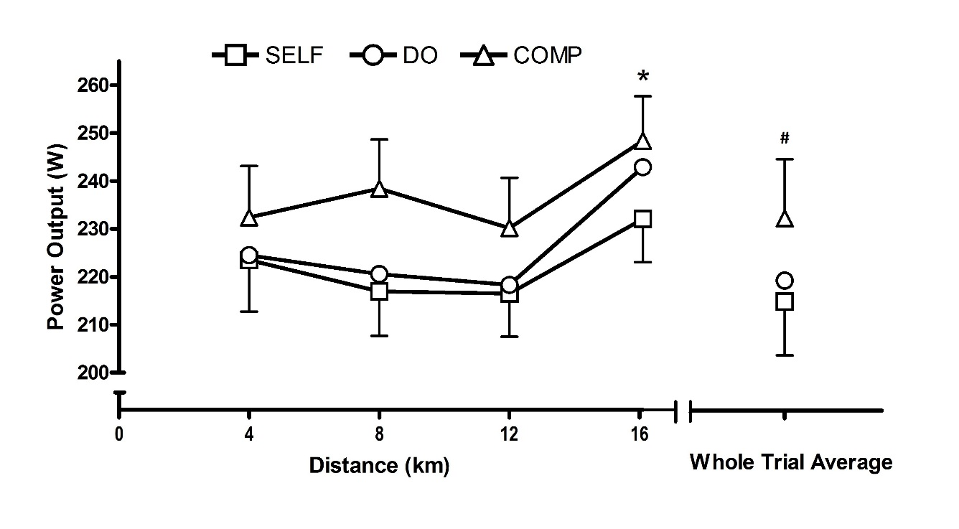
Figure 1. Power output expressed as quartile and whole trial averages for each experimental condition. Error bars illustrate SEM. * denotes fourth quartile significantly different to all quartiles (p < 0.05). # denotes COMP significantly different to DO and SELF (p < 0.05).
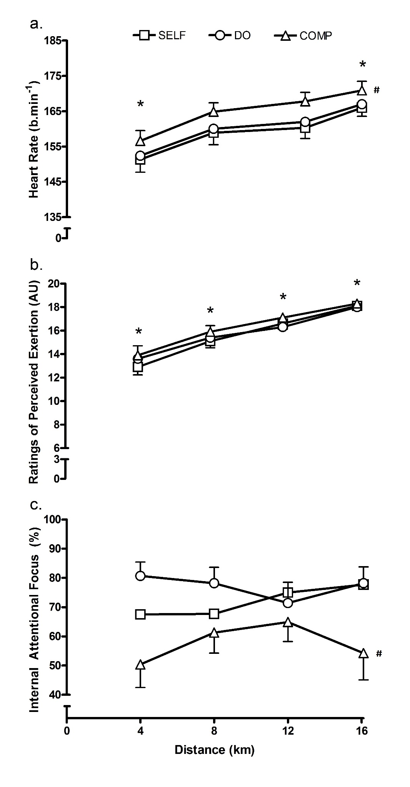
Figure 2a. Heart rate (bpm) expressed as quartile averages across SELF, DO and COMP conditions with error bars illustrating SEM; * quartile significantly different to all other quartiles (p < 0.05), # COMP significantly different to DO and SELF (p < 0.001); 2b. Ratings of perceived exertion (RPE) * quartile significantly different to all other quartiles (p < 0.05); 2c. Internal attentional focus (%) # COMP significantly different to DO and SELF (p < 0.05).

