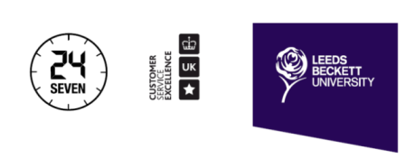
Module resource lists: Using a puzzle to solve a puzzle

Laurence Morris and Dr. Ellie Windle

[With these images on screen, decipher the Rebus]

Leeds Beckett University is currently ranked as the 15th largest university in the UK, with approximately 28,000 students and 2,900 staff arranged over 2 campuses.

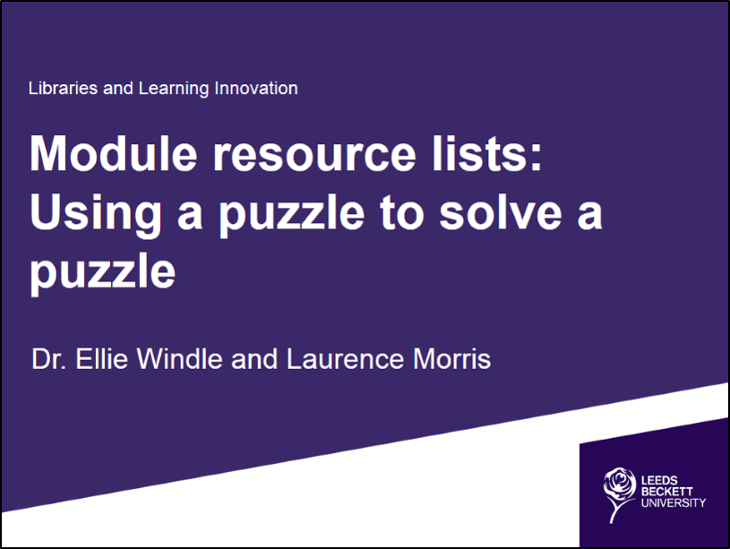

This presentation outlines our implementation of PTFS’s Rebus:list Resource List Management System, with an emphasis on exploring our organisation’s experiences.

In particular, in relation to this conference’s themes, it explores access to resources by patrons and general research and learning support issues.

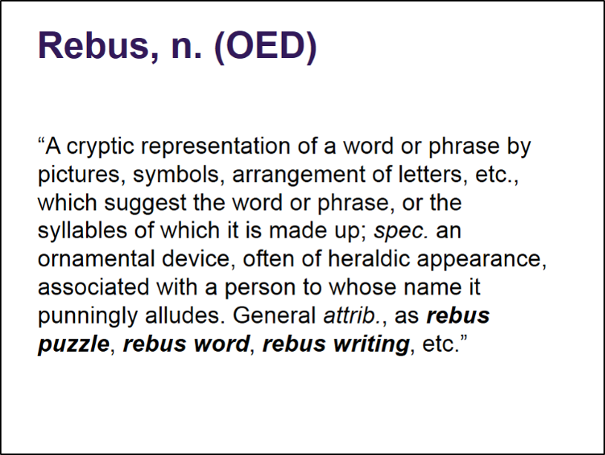

It seems appropriate that the name for PTFS’s resource list system is Rebus: playing as it does on ideas of puzzles, literacy (and its obverse illiteracy) and the dissemination of information through alternative schemas. Rebus as a pictographic system makes sense in an increasingly pictographic age.

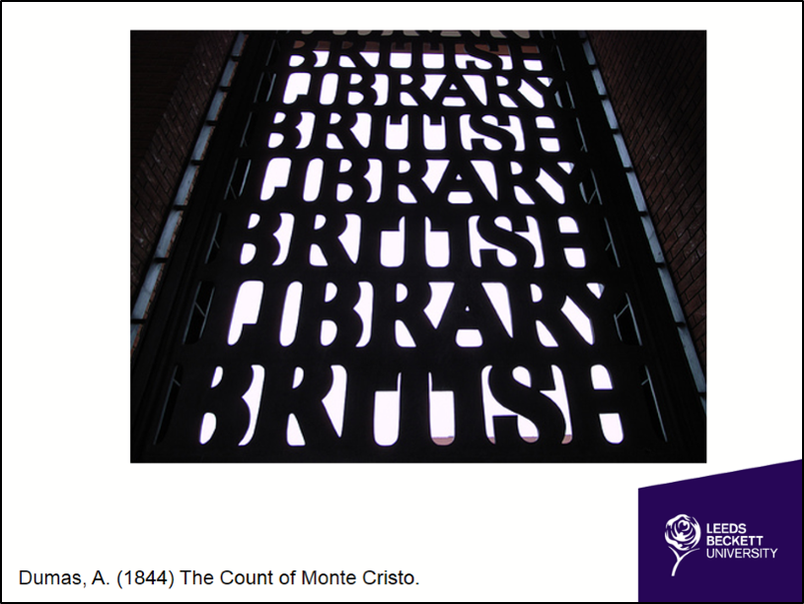

Going back to first principles, the information professional should above all guide users to relevant information resources. When The British Library uses this arrangement of letters it suggests both prison and gateway - where knowledge can be used to break free of a confinement of the intellect. At Leeds Beckett, our University motto is “opening minds, opening doors” where librarians could be seen as the gatekeepers of knowledge.

In 2012 the University instigated an Undergraduate Curriculum Review. Library staff checked module content against library resources, investing large sums in expanding the university’s portfolio of curriculum focused resources. However, we did not invest in a Resource List System at that time.

This meant that, as time passed since the review and module content evolved, library staff again found themselves dealing with student resource lists where items were referenced which we didn’t have in stock.

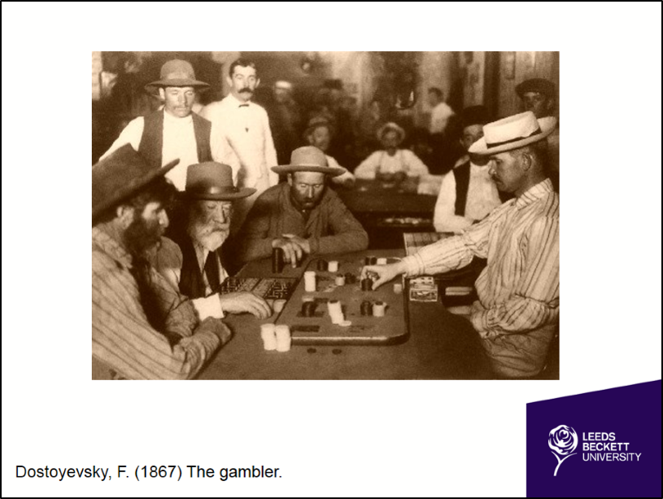

It was effectively impossible for library staff to improve the situation when we did not have a reliable mechanism for obtaining and capturing resource lists.

The end result seemed unduly weighted against the student and the student experience was compromised due to what was at best ambiguity, at worst error. Considered thus, both research and access to resources were risky games: puzzles without visible rules.

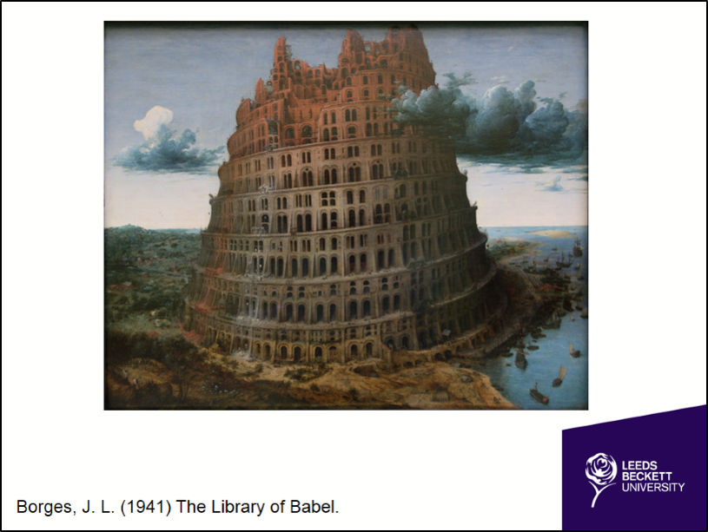

Prior to resource list implementation our Library service carried out surveys into how students actually used our library. So just how did our students see the library?

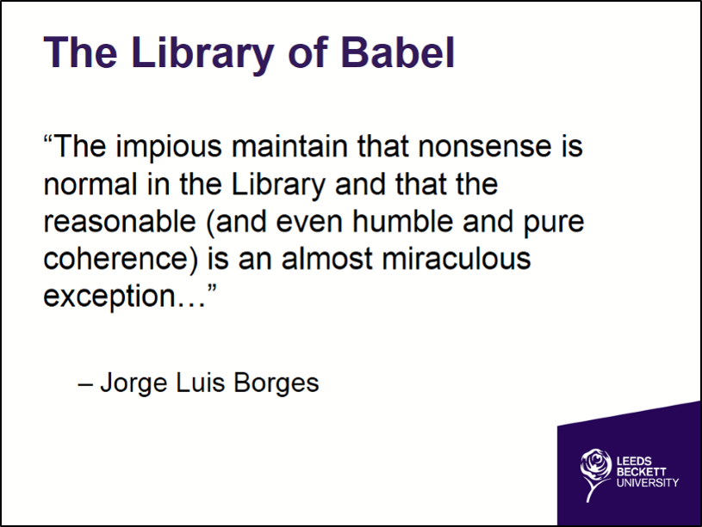

Even if a student were to actually have a perfect resource list in their hand, we then set them a challenge: how to locate the resources. Here is the Library website:

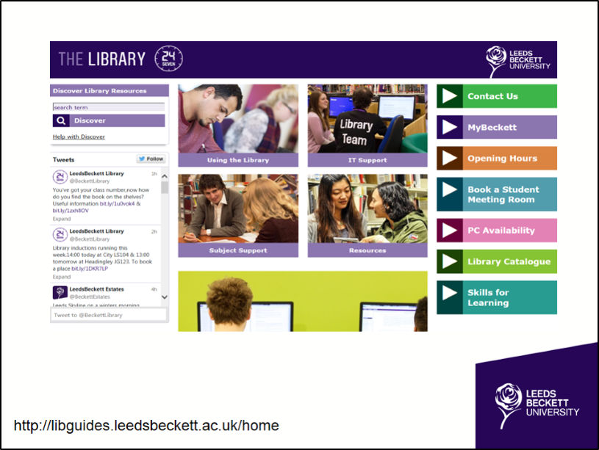

Which is accessed from a number of different pathways: from Google, to the Students Union website, but, by and large, from our VLE:

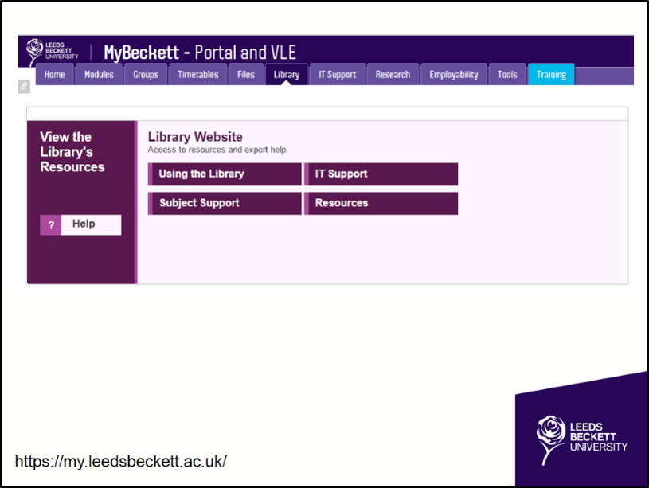

The VLE is itself accessed via the main university website:

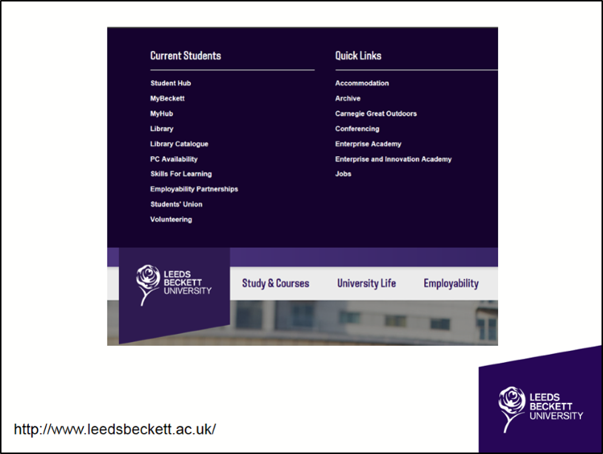

Once on the website, do we even highlight the library Catalogue? Given that, as Ken Chad for one has noted, “the value of the library catalogue as a destination site has diminished.”

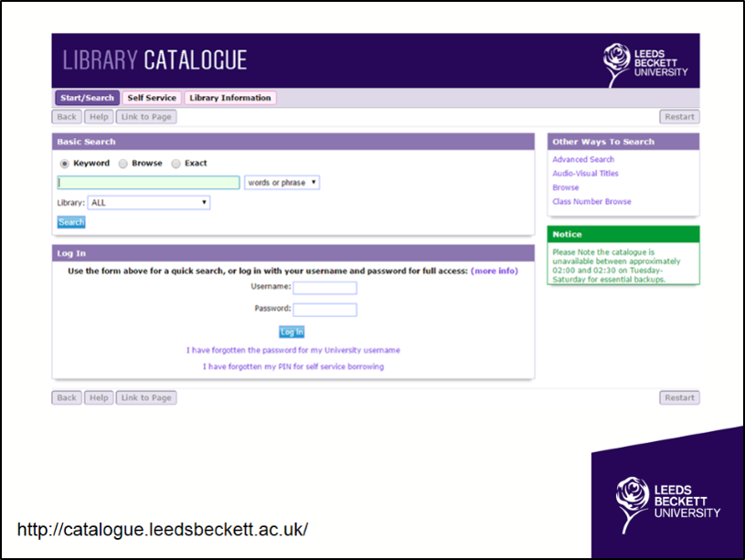

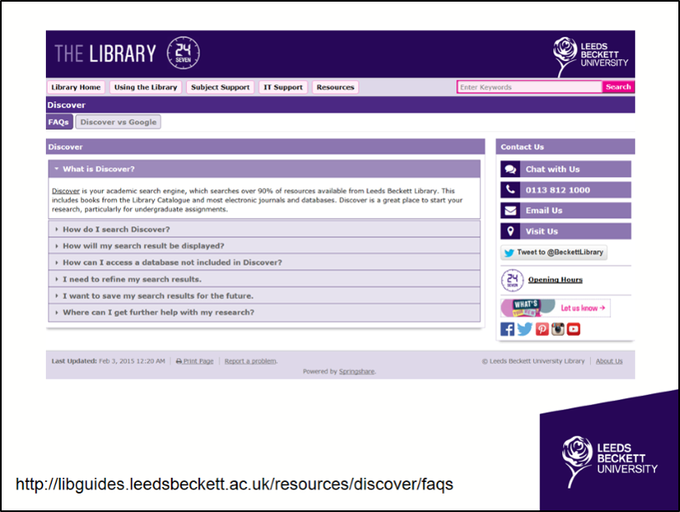

Indeed, in our library website’s latest incarnation, we did not initially provide a direct link to the catalogue, preferring instead to highlight Discover, the Library’s own search engine, as a research tool.

But Discover is not a totally inclusive search engine. We have to provide a disclaimer about resources that lie outside it: “Discover is your academic search engine, searching over 90% of resources available from Leeds Beckett Library”.

So, for example, a Law student might also want to search the online journals:

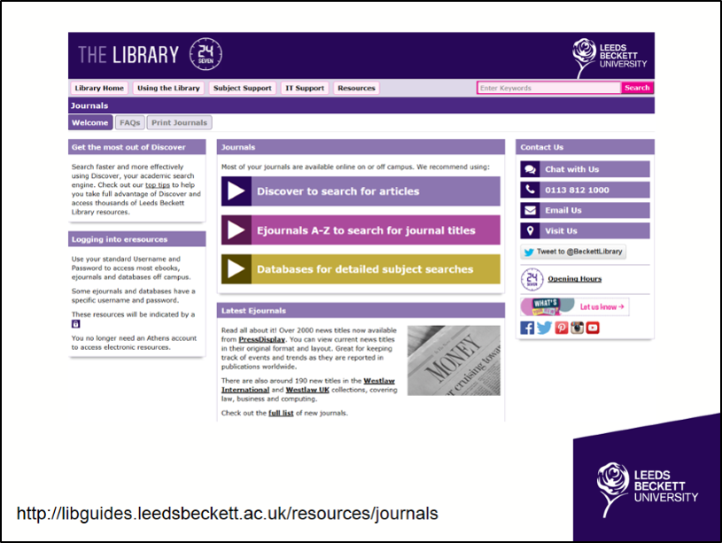

Or search our databases:

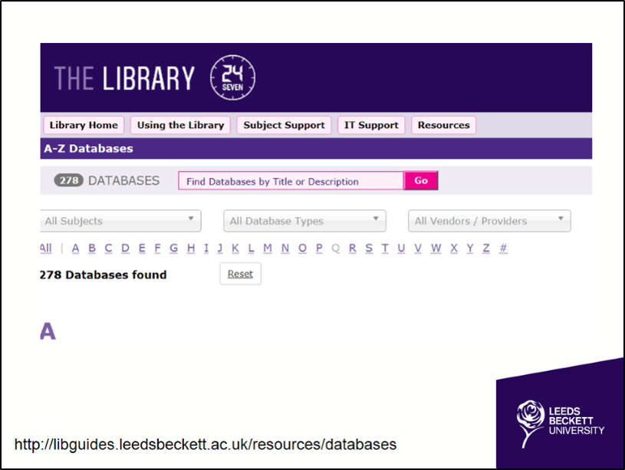

Or search the University repository:

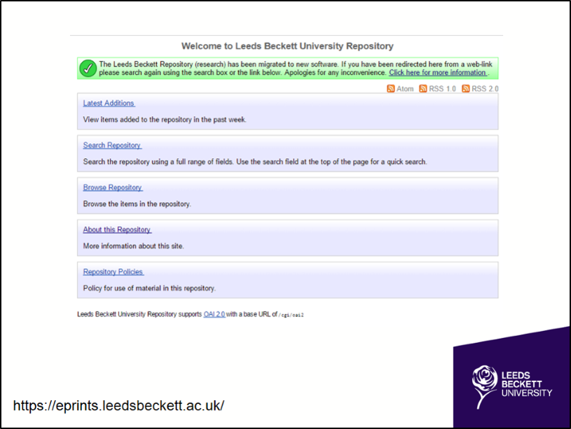

And should our students get to where the information resides, can they actually interpret what they see?

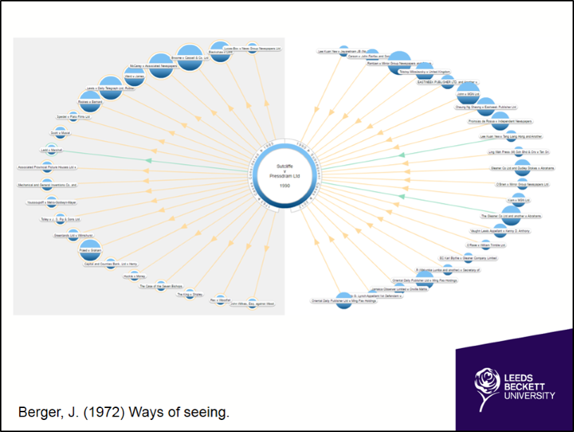

Instead of our straight road, what we have created, to the untutored eye, might seem chaotic:

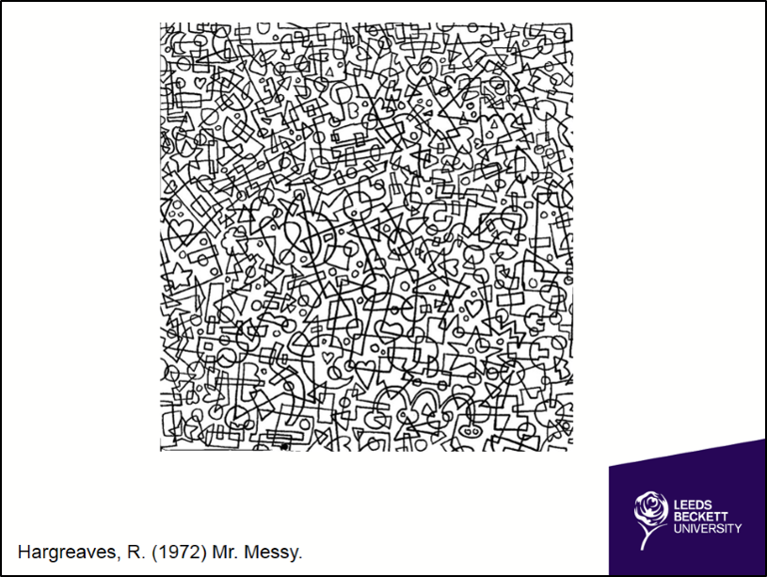

Patterns and organisation are clearly present, but in such a way that it is small wonder that we find our students on Google instead:

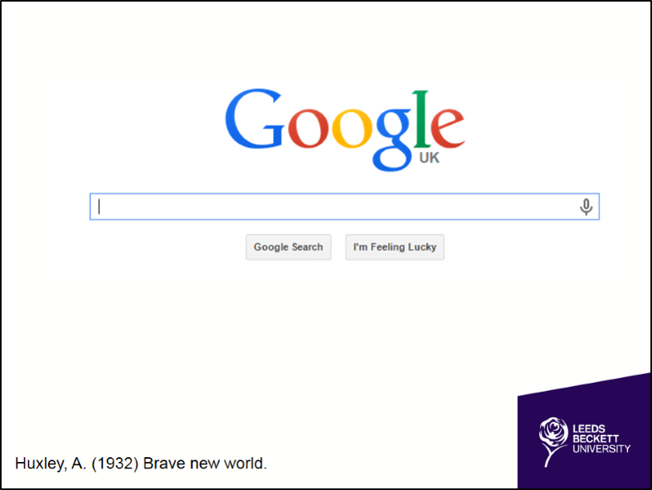

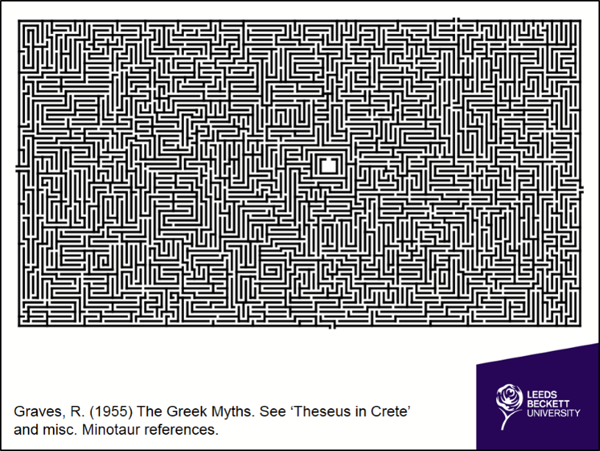

Rebus:list is built around an organising principle which maintains the idea of research as a puzzle or challenge while providing clearly established rules. Rebus presents users with a simple uncluttered interface, where clicking on the relevant symbol leads them directly to their course specific resources.

Consequently, we decided to identify, replicate and re-frame research through resource list software to provide a way through the maze.

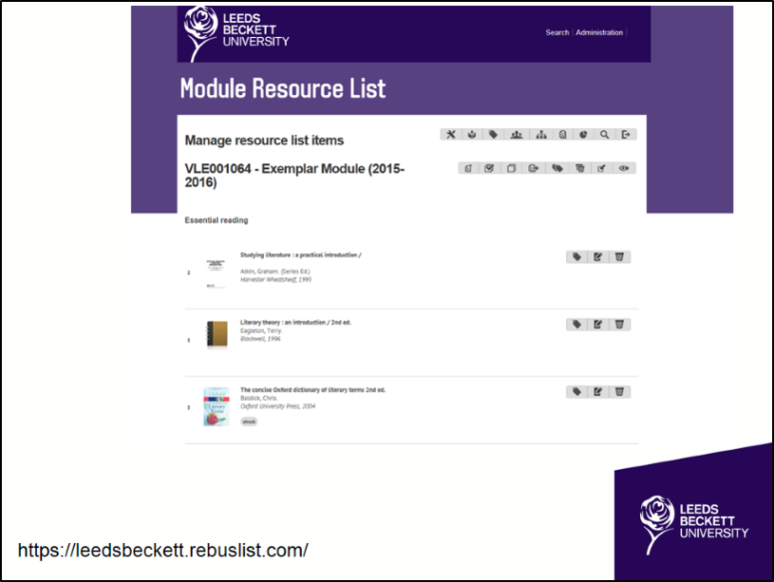

From the start we took some major decisions about the visibility and accessibility of our resource lists. Key to choosing Rebus:list was its “targeted simplicity” and capability to integrate with our existing systems, leading to a system which allows students to engage intuitively with library resources without the need for extensive training.

Embedding the service within the VLE, we linked VLE modules to the corresponding reading lists. This was developed in-house using the Rebus:list API and the Blackboard Building Blocks API. This integration also managed the creation of user accounts and allocation of list permissions. While a separate XML data feed was developed to manage the creation of lists and feed through the related student numbers.

In practice, this means that on accessing the VLE, students find a direct link to take them to their module-specific reading list, rather than going onto the library website and facing the new puzzle of searching for one list among many.

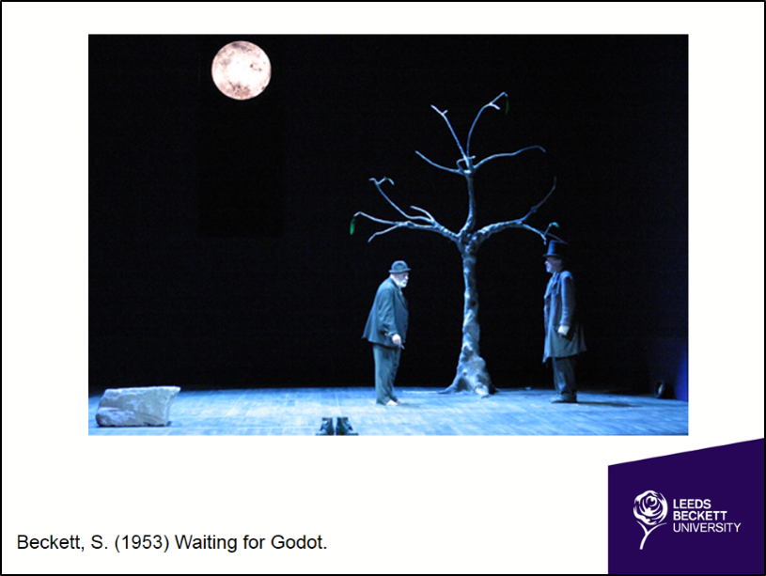

However, behind this solution is the real professional puzzle: a set of new conundrums that we have spent the last year trying to solve. We have had to mimic the student experience and problem-solve every step of the way. Starting with certain big questions, like:

“Where are these lists?”

“Who owns them?”

“How many are there?”

“How do we get them?”

And when we ask these questions, we are asking them for each and every student at the University.

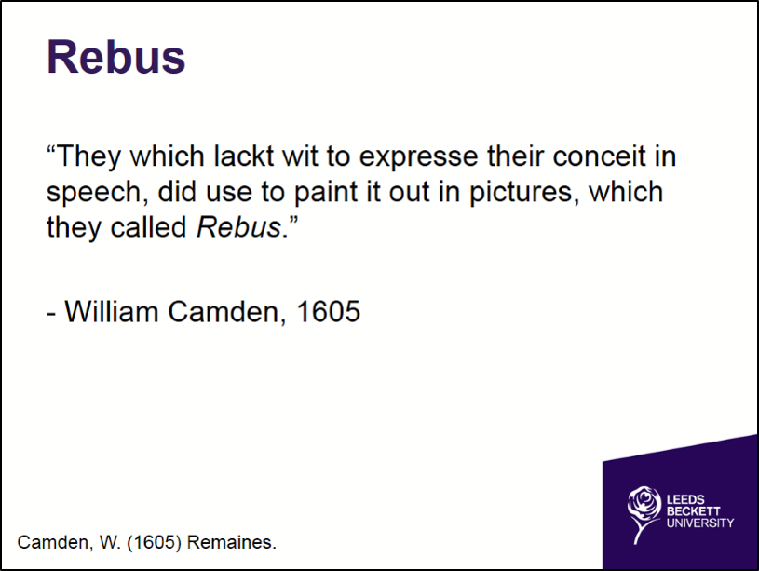

Harvesting lists has been one of our biggest difficulties, with an ‘early adopter’ model, and direct liaison by Academic Librarians only managing to harvest some 200 lists from a possible total of 2000.

Why has it been so difficult? Without doubt, some academics believe that they have intellectual ownership of the lists, and are unwilling to relinquish a degree of control to the library.

There has also been a concern about the possible erosion of information literacy skills through an apparent “dumbing down” of the research experience.

Whereas we would argue that Rebus:

- suits a highly visually literate student body,
- satisfies student demands for easier access to Resources
- offers a consistency of approach in teaching and learning.
- And encourages independent research through promoting the development of familiarity with key portals.

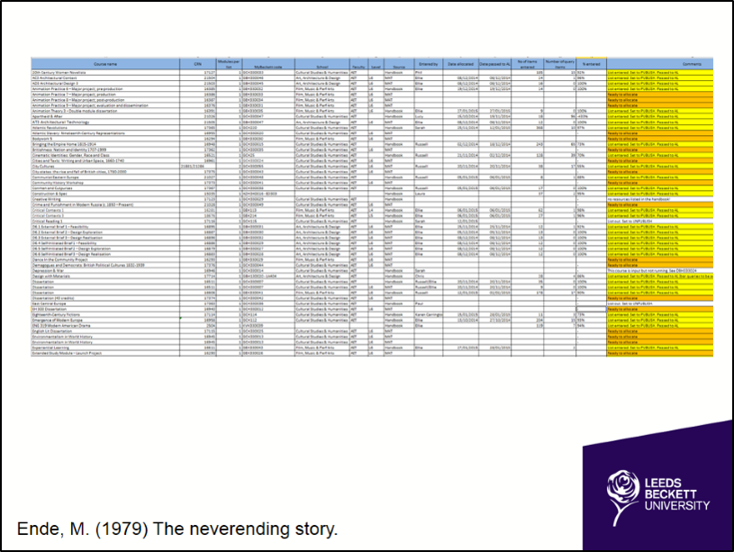

Our outgoing Vice Chancellor very visibly supported the Resource List Management System’s implementation, which gave us useful leverage. Library Management involved Quality Assurance Teams in the mass harvesting of lists on a departmental basis.

We now have over 1000 live lists linked to over 1400 modules and approximately 70 lists awaiting input. This represents approximately 75% of the total lists institutionally available.
Harvesting lists, linking them to modules on the VLE, attaching them to relevant Academic Librarians, allocating them to staff for input and understanding how they fit into the bigger picture has been, and continues to be, a mammoth administrative task, and one which was not necessarily fully appreciated at the outset.

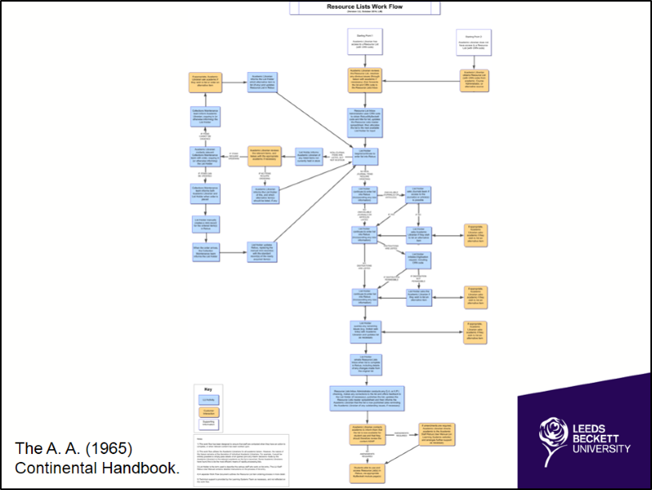

Interpreting lists has probably been our biggest challenge. After all, this is not simply a data input exercise – we are still trying to resolve all those issues that students previously faced, such as:

- out of print resources
- imprecise referencing

When someone inputting a list encounters these problems, they engage with staff from across the university to resolve them. To map this complex process we came up with 2 workflows, representing the journeys that we are taking on behalf of the student: a sort of route map with all the diversions and dead ends that we encounter on the way.

One day, we hope it will be more of a straight track, especially now that staff and students have accurate guidebooks for their journey. After all, the library does not want to own or author the lists. Once we have populated all the lists, academics will take over their upkeep. There are already some early signs that this is the case, with Academic Librarians now running regular system training for interested course leaders. And we are working on embedding regular list maintenance into standard university administrative and quality assurance processes.

However, we do want to establish certain rules about what a list should be in terms of its structure and hierarchy. While an ideal length might not be appropriate to enforce, given variety between subjects, we do seek to establish an organising principle and a standard vocabulary across the University.

The lists are for the students. But as they become more visible to Quality Assurance and Governance teams within Faculties, to academics, LLI staff and students, it is obvious that these lists are for everyone at Leeds Beckett University.

Another question might be: should the lists be restricted to members of the University or should anyone be able to access them? Can we use them as a marketing tool [Brewerton: Ariadne 2013] for prospective students? Or to encourage fresher engagement, before they actually begin their formal studies?

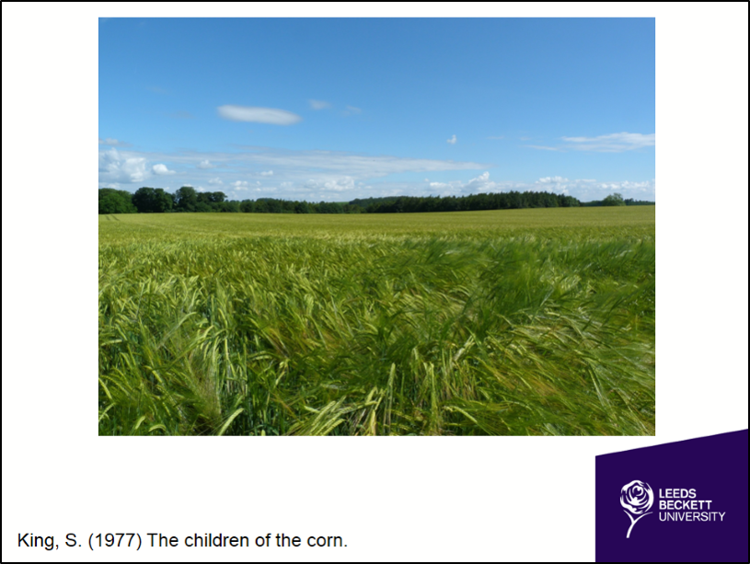

The main benefits of implementation have been:

- Connecting learners directly and efficiently to relevant resources
- Refocussing library acquisitions processes
- harvesting statistics related to both system usage and list content which can be used to engage Faculties.

With the importance of NSS results established and the role Rebus can play clearly visible – not least given overt student requests for online reading lists – a by-product of this exercise has been the production of useful data around faculty list lengths and faculty engagement.

What lies ahead?

We need to improve the reporting capability of Rebus:List and are collaborating with PTFS and the University of Sunderland to implement Piwik for Rebus:list. This open source web analytics platform will deliver item-level tracking. We already know that resource lists were the fifth most popular item in our VLE this year – strikingly high, given that for much of the year many courses did not have an active resource list – but with item-level data, we will be able to further advise library management and academics how to make the best use of Rebus:list.

When we can see exactly which resources from a list students are choosing to use, we will be better placed than ever before to consider the implications of learner behaviour for collection development and general pedagogic practice.

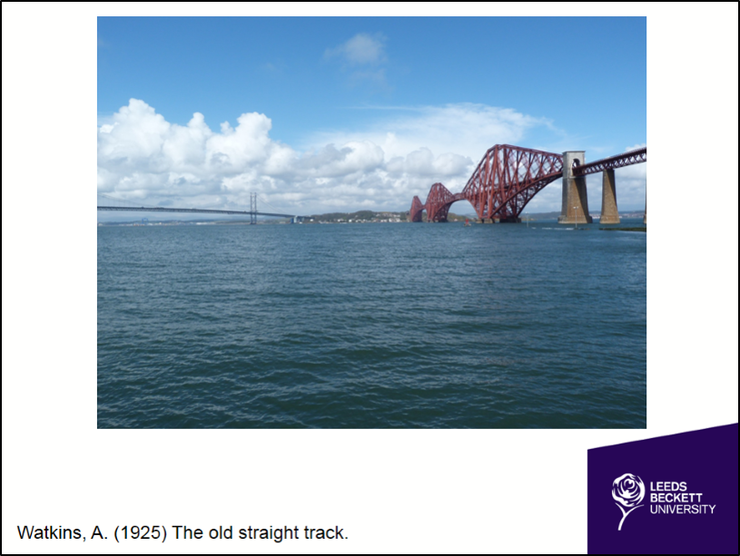

Forthcoming rebuses include how best to develop an institutionally coherent approach to the process of updating lists annually: ensuring that this process is embedded in university-wide administrative and quality assurance procedures where our academic colleagues take ownership of what, after all, remain their lists.

We also need to reconsider library acquisition processes: specifically how to tie resource acquisition in with list management.

And finally, with the second generation of Rebus:list imminent, we need to embrace user feedback on potential system development and use this to push forward system enhancements with our developers.

Ultimately then, though new challenges will doubtless emerge, our engagement with a Resource List system has enabled us to address some of the primary challenges confronting our staff, students and researchers. Effectively, through the use of Rebus:list, we are able to fulfil our primary professional role: guiding students directly towards relevant resources and removing potential barriers which might lie in their path.

Opening doors, Opening minds is the motto of our organisation, and that, in essence, is what this project has achieved.

