asthma in elite athletes – who cares?
Oliver J. Price¹ MRes, James H. Hull^{1,2} PhD

¹Faculty of Health and Life Sciences, Northumbria University, Newcastle, United Kingdom (UK).
²Department of Respiratory Medicine, Royal Brompton Hospital, London, UK.

Corresponding author:
Dr. James H. Hull MRCP PhD
Department of Respiratory Medicine, Royal Brompton Hospital, Fulham Road,
London, SW3 6HP
Tel: 0207 351 8043
Fax: 0207 351 8937
E-mail: j.hull@rbht.nhs.uk

Word count: 3106 Abstract: 172
Running title: Asthma care in athletes

ABSTRACT
Asthma or exercise-induced bronchoconstriction (EIB) is highly prevalent in athletes and if untreated has the potential to impact on their health and performance. The condition can be diagnosed and managed effectively yet there is concern that the care afforded to elite athletes with this condition is often sub-optimal.
In this respect, it is apparent that more could be done to protect athletes from developing airway dysfunction (e.g. by reducing exposure to irritant environments); that the diagnosis of asthma in athletes is often made without secure objective evidence and that athletes may be advised to reduce activity levels in order to improve symptoms. Moreover there appears to be poor surveillance of airway health in athletes when a diagnosis of asthma has been made.
Overall this raises the question of who cares about athletes with asthma? The article that follows presents the case of why this is an important clinical area for physicians. The review provides an overview of asthma in athletes with the overall aim of ensuring that respiratory health in this unique population is optimised.

Key words: Asthma, athletes, exercise, exercise-induced bronchoconstriction, inflammation.
INTRODUCTION
Asthma or exercise-induced bronchoconstriction (EIB) is highly prevalent in athletes (1, 2). Indeed it is estimated that up to half of athletes partaking in certain sports (e.g. swimming) have evidence of ‘asthma’ and as such it is the most frequently encountered chronic medical condition in Olympic athletes (3).
On the face of it the condition would appear to be relatively simple to assess and manage. However, as this article will outline, this is often not the case and as a consequence there is legitimate concern that the care afforded to elite athletes with asthma is often suboptimal (4-8).
Debate and controversy in the field of ‘asthma in athletes’ usually begins with a definition of the condition (9). In this respect, it is clear that many athletes with ‘asthma’ have respiratory symptoms confined to the exercise period alone and as such do not describe features characteristic of ‘classical’ asthma, e.g. nocturnal symptoms. In this population the condition may thus be better described by the physiologically descriptive term - exercise-induced bronchoconstriction (EIB); a transient airway narrowing occurring in association with exercise (10).
Further difficulties arise when the criteria for a diagnosis of asthma / EIB are considered. It is now established that a ‘symptom-based’ approach to diagnosis is imprecise and that objective tests are required to ensure a diagnosis is secure (5, 11). Despite this it is apparent that even at the elite level of the sport, the diagnosis of asthma in an athlete is often based entirely on a clinical appraisal or with support from tests with poor diagnostic precision (e.g. peak flow monitoring) (4, 11).
Moreover, when an athlete is diagnosed accurately there is often poor surveillance of their airway function following commencement of treatment, with the responsibility of clinical follow-up often falling to a sports team doctor without respiratory medicine expertise; e.g. an orthopaedic specialist (12). This is remarkable given the impact of marginal physiological gains for performance in athletes competing at the elite or professional level.
It is also now increasingly apparent that exercise hyperpnoea, particularly in certain environments (e.g. indoor swimming), may be detrimental to the respiratory health of athletes. In this respect, it has been argued that exercise itself may actually cause airway ‘injury’ in athletes (13); prompting the development of airway dysfunction and respiratory symptoms. Regardless of the underlying mechanisms, it is apparent that more could be done to protect athletes from developing airways disease (i.e. by reducing exposure to irritant environments) (14).
Overall these issues beg the question - who cares about elite athletes with asthma? It is the aim of this the article to present the case of why this is an important area of respiratory medicine. The review describes the characteristics of asthma / EIB in athletes and highlights the current state of knowledge in terms of the best way to detect and manage asthma in elite athletes.

Why care about asthma in elite athletes?
It is generally accepted that for a condition to be considered clinically ‘relevant’ and of interest, the condition should: (i) be prevalent; (ii) have an impact on an affected individual; (iii) be accurately diagnosed and finally (iv) have effective treatment. There is a now a good body of published evidence to provide relevant support for each of these considerations with regards to asthma in the athletic population. The following section will address these criteria in turn.
(i) Prevalence
A considerable quantity of published data now exists detailing the prevalence of asthma and EIB in athletes (Table 1). The prevalence estimates vary significantly dependent on differences between studies in definition, diagnostic methods and techniques, population, subject gender and age, country, season, environment and sporting discipline (8, 15-17). An additional factor relates to the inclusion of studies that use symptoms alone for diagnosis or a combination of symptom-questionnaire and provocation testing. It has generally been found that in studies using symptom-based criteria, prevalence tended to be below 20%, whereas in those employing objective tests, the prevalence tended to be greater than 20% (8).
Regardless, it is now accepted that the prevalence of asthma and EIB in elite athletes as a group is considerably greater than the general population and may be as much as five times greater in Olympians (3), (equating to approximately 8% of athletes). Moreover, this increased prevalence is stable when assessed longitudinally; the prevalence of airways disease was 21.2% and 20.7% in the British Olympic Team at the 2000 and 2004 Olympic Games respectively (15).
A particularly high prevalence of asthma is reported in athletes competing in irritant laden or noxious environments; for example indoor swimming or cross-country skiing. This may relate to the impact of a high ventilatory demand interacting with an environmental insult (Table 2). For instance, the prevalence of asthma in cross-country skiers is approximately 15-20% (3) however in contrast, the prevalence in athletes partaking in ski-jump competition (comparable conditions without the high ventilatory demand) is only 4% (14). Similar findings have been observed in pool-based sports in which it has been reported that 20% - 40% of Olympic swimmers have evidence of airway disease (3, 15), whilst data from indoor divers indicates a prevalence of merely ~4% (IOC Independent Asthma Panel, 2002-2011). The prevalence of EIB in athletes performing sports that require neither a high-ventilatory demand, nor are performed in noxious environments (e.g. table tennis and shooting) is likely to be similar to that expected in the general population (3, 15).
Accordingly, there is an evolving literature examining the role of noxious environments in causing an insult or ‘injury’ to the airways (13, 14, 18). Indeed when airway samples are studied from certain athletic groups (e.g. cross-country skiiers) there is evidence of pathobiological damage that has a pattern akin to a biological injury (19, 20) (Figure 1).
(ii) Impact of the condition
In the athletic population, the impact or consequence of a diagnosis of asthma can be considered two-fold; firstly and perhaps most importantly in terms of impact on health and secondly on athletic performance.
The health impact of asthma is typically considered by evaluating the consequences of the condition on quality of life but also morbidity (e.g. exacerbations) and mortality. There currently is a paucity of data specifically evaluating these outcomes in athletes with asthma. Moreover, data from a longitudinal study evaluating the lifetime occurrence and impact of asthma indicates that a prior diagnosis of asthma in former athletes had no long-term consequence (21). In support of this, more recent work reveals that airways hyper-reactivity witnessed in certain groups of athletes (e.g. swimmers) is a transient phenomenon that improves within a short period of training cessation (22).
This acknowledged, one study reported that a high proportion of asthma-related deaths occur in elite or competitive athletes (57%) in close association with a sporting event (23). A further study revealed that asthma was a significant risk for unexplained death in young athletically fit adults (24).
It is recognised that athletes are generally more likely to report coryzal symptoms i.e. those typically associated with upper respiratory tract infections (URTI) (25, 26). It has been proposed that the relative risk of developing URTI symptoms may be heightened during periods of prolonged, high-intensity physical activity (i.e. elite endurance athletes).
In a study evaluating underlying cause(s) for recurrent infection in athletes, a new diagnosis and/or the presence of poorly controlled asthma was found to be a common explanation (13% of athletes investigated) (27). Differentiating an infective from non-infective aetiology of respiratory tract symptoms in athletes however is difficult given the overlap between symptoms; i.e. symptoms are non-specific and may relate to drying of the airway mucosal surfaces (28). Thus a definitive association between asthma and a heightened prevalence of respiratory tract infection has yet to be established.
In the elite athletic population a crucial consideration is the impact of asthma or EIB on athletic performance. Several studies have now specifically examined this issue although it remains an area of active research.
Stensrud et al. (29) reported that for athletes with EIB, exercising in a humid environment (19.9ºC and 95% relative humidity) improved exercise capacity in compared to training in normal ambient conditions (20.2ºC and 40% relative humidity). Moreover, they also showed that exercise performance in a cold environment was diminished in this population (30).
Several studies have evaluated the influence of asthma treatment on performance. In healthy individuals without evidence of airways disease, it is now established that inhaled asthma medication, when administered at standard therapeutic doses, has no impact on the athletic performance (31). However in athletes with EIB, Brukner and colleagues found that regular inhaled asthma preventative medication (32) increased peak oxygen uptake in a small number (n=12) of football players.
Despite this, we (33) and other investigators (34) have failed to find any impact of treating EIB on performance in a sport-specific exercise test. Moreover, Sonna et al. (35) screened a cohort of US Army recruits and found that EIB did not hinder physical performance during basic training; peak oxygen uptake levels and Army Physical Fitness Test scores were not significantly different between individuals with and without EIB.
Overall, key differences in study methodologies employed continue to make it difficult to draw robust conclusions regarding EIB and performance in athletes and further work is needed in this area.

(iii) Diagnosis
Extensive investigation over the past 30 years has highlighted an important yet often overlooked fact in the field of EIB in athletes. That is, that symptoms correlate poorly with objective evidence of exercise associated airway narrowing (7, 11, 36). This poor association has been repeatedly demonstrated in athletes from a broad range of sporting disciplines and acts to limit the accuracy of a symptom-based method for diagnosis. Indeed Rundell et al. (36) concluded that basing a diagnosis of asthma or EIB on clinical symptoms alone in an athlete was likely to be as (im) precise as a coin toss.
The reason for this discrepancy remains to be determined but may relate to a high prevalence of conditions that mimic asthma (12). In this respect a recent study (7) indicated that a high proportion of young athletes with exercise associated dyspnoea develop a transient narrowing that occurs at the level of the larynx causing the development wheeze and dyspnoea; termed exercise-induced laryngeal obstruction (EILO). In this study, athletes referred with dyspnoea completed a comprehensive assessment of their lung function, bronchial hyper-reactivity and airway inflammation. They also completed a nasendoscopic evaluation of their laryngeal movement - recorded continuously during exercise. Of the 88 athletes completing assessment, approximately one third had evidence of EILO as an explanation for their exercise-related symptoms. It is important to note that the majority of these athletes were taking, or had previously been prescribed, inhaled asthma therapy and that it was not possible to differentiate those with or without EILO on the basis of clinical features alone.
This finding has important diagnostic and treatment implications and highlights a problem for physicians encountering athletes who have unexplained symptoms and/or symptoms that are ‘refractory’ to treatment. Athletes are often misdiagnosed as having ‘asthma’ following a diagnostic assessment based on clinical features alone (i.e. without objective test confirmation) (6, 11). This is true even at the elite level of sport, where athletes are often labelled from an early stage in their career and on the basis of tests with a poor predictive value (e.g. peak flow monitoring) (4, 11).
The role of clinical assessment in this context should simply be to focus evaluation on features supporting a diagnosis of asthma, but with consideration for alternative diagnoses (e.g. cardiac pathology) (37). A secure diagnosis then depends on confirmatory investigation (proposed assessment algorithm is presented in Figure 2).
It has been argued that a sports-specific exercise field-test, simulating the exercise environment and demonstrating a reduction in airflow, represents the true ‘‘gold-standard’’ method for making a diagnosis of EIB. However exercise challenge tests are not recommended as a first line investigation given their poor sensitivity for diagnosis and difficulty to perform reliably (38).
A bronchial provocation challenge is therefore often necessary to establish evidence of variable airflow obstruction, i.e. to demonstrate airway narrowing in response to a provocation that mimics exercise (e.g. dry, cold gas). More specifically, an athlete performs serial spirometry tests before and following a challenge; typically looking for a 10% fall in forced expiratory volume (FEV₁) from baseline values (39). The International Olympic Committee currently favor eucapnic voluntary hyperpnoea (EVH) testing as the gold-standard test to accurately diagnose airway dysfunction in athletes. However, alternative accepted diagnostic challenges include bronchodilator reversibility and laboratory/field exercise testing, methacholine, saline or dry powder mannitol challenges (40).
(iv) Treatment
The treatment of asthma in athletes is well established and is in the most part straightforward and effective (41). Both pharmacological and non-pharmacological therapies play an important role in management.
In terms of non-pharmacological management, it is recommended that athletes should perform a dedicated warm-up (i.e. bursts of high-intensity exercise interspersed with periods of low-intensity exercise) (42) to take potential advantage of the ‘refractory period’; defined as a period following warm-up during which further vigorous exercise results in significantly less severe or an absence of airway narrowing. Strategies to humidify the inspired air (e.g. face muffle) may also prove beneficial (43). Other studies have highlighted the importance of dietary manipulation as an adjunctive intervention (41) .
Pharmacological therapies evaluated and shown to protect against EIB include inhaled beta-2 agonists, inhaled corticosteroids, cromolyn compounds and leukotriene modifiers. An inhaled short acting beta-2 agonist administered prior to exercise is usually effective in negating EIB and forms the mainstay of pharmacological treatment (41). Beyond this however, there is a lack of consensus with regards the optimum choice, timing of initiation or dose of regular preventative medication. It has been recommended that an athlete who has asthma symptoms outside the setting of exercise or who is using beta-2 agonist medication (i.e. greater than three times per week) should be treated with anti-inflammatory agent; e.g. regular inhaled corticosteroid or an oral leukotriene antagonist. However for an elite athlete it is commonplace to train twice daily and as such this advice is effectively obsolete. The current best evidence with regards treatment of EIB is presented in the recent American Thoracic Society Guidelines (41).
Clinicians should also be aware that some medications used for the treatment of asthma are prohibited for use by the World Anti-Doping Agency. The list of prohibited asthma medications has diminished considerably over the past five years however there remain notable exceptions and it is therefore advisable to view www.globaldro.org or consult with the relevant national anti-doping agency to ensure an athlete remains compliant with regulations from their sporting body.
Who currently cares for elite athletes with asthma?
In the UK, it is common for primary care physicians to regularly encounter patients with exercise-related respiratory symptoms (4). Moreover, in a one-year period (2008-2009), approximately 70% of applications for asthma medication ‘therapeutic use exemption’ forms (i.e. the paperwork to permit an elite ‘national standard’ or professional athlete to use asthma medication) was submitted by primary care physicians (personal communication N.Wojek – UK Anti-Doping).
It is therefore of concern, that evidence suggests that the diagnosis and treatment of asthma / EIB in athletes is often not in keeping with guideline recommendations. Indeed in a questionnaire survey of primary care UK physicians, one third indicated that they would initiate treatment based on clinical information alone (4). Moreover, although over two-thirds of primary care physicians chose investigation as the initial course of action, the tests selected (e.g. PEFR on exercise (44%) and resting spirometry pre-and post- bronchodilator (35%)) are recognised to have poor diagnostic precision. Similar findings were apparent in a study evaluating primary care physicians approach to EIB in the US (6). Overall, these findings have important implications regarding the quality of management of an athlete’s respiratory health.
It could be argued that all elite athletes, and certainly members of an Olympic squad, should be ‘screened’ for airway dysfunction. We have previously discussed the implications of implementing a widespread EIB screening policy in athletes highlighting the benefit versus harm of such a policy (1). One important consequence to be considered in view of a heightened focus on diagnostic accuracy is the risk of over-diagnosis (1, 8). In this respect it is becoming increasingly apparent that there exists a population of athletes whom are asymptomatic, yet have been labelled as having ‘asthma’ on the basis of airways hyper-reactivity; i.e. detected from a positive bronchoprovocation test (44). The impact of a diagnosis of ‘asthma’ in this population, both for the health and performance of an athlete remains to be established. On balance therefore general screening for asthma in athletes is not recommended however, this may be appropriate in high risk sporting groups (e.g. swimmers) (41).
Overall, it could be argued that given the complexities regarding diagnosis and surveillance it is ideal that athletes presenting with respiratory symptoms are referred to a sports physician or respiratory physician with expertise in this area.
Who cares about researching asthma in athletes?
There has been a steady increase in the number of manuscripts published in the field of asthma and EIB in athletes over the past 20 years (Figure 3). Recent work has focussed on accuracy of clinical diagnosis, differential diagnosis, the impact of detraining on airways hyper-reactivity, presence of airway pathology and airway injury.
It remains however the experience of many researchers studying EIB in athletes in Europe (variety of personal communications) that research in this field remains under-funded by the major medical grant awarding bodies. This may relate to a perception from the funding bodies, that when compared with other respiratory diseases the impact of airway dysfunction in a relatively fit, young population is of low priority.
It remains however that exercise is the one of the most commonly reported symptom triggers in individuals with asthma and dyspnoea on exertion is a prominent and disabling clinical characteristic of the disease (45). Undoubtedly, research in the field of EIB in young fit individuals has been of translational benefit for the general asthmatic population. Furthermore recent work evaluating airway injury and potential mechanisms to protect the airway of asthmatic athletes will be of likely benefit to the general asthmatic population.
Conclusion – time to care more about asthma in athletes
The purpose of this article was to present the case for why it is important to care about asthma in elite athletes. The evidence presented highlights a wealth of data that indicates that asthma / EIB in athletes is highly prevalent, has an important potential impact on their health and performance and can be diagnosed and treated effectively. Despite this, the review also details important deficiencies that remain in the current state of knowledge in this field (Table 3), supporting the fact that focus should remain on this condition with the aim of optimising respiratory care in athletes.

TABLE FOOTNOTES
Table 1. Studies evaluating the prevalence of Asthma in Elite Athletes
Definition of abbreviations: EVH, Eucapnic voluntary hyperpnoea; MT, methacholine test; LT, laboratory exercise test; FT, field test; SS, sport specific exercise challenge; FEV_{1,} forced expiratory volume in one second; PD_{20,} provocative dose (causing a fall in 20% in FEV₁); PC_{20,} provocative concentration (causing a fall in 20% in FEV₁).

Table 2. Environmental exposure during sport and impact on athlete airway health
Definition of abbreviations: AHR, Airway hyper-responsiveness.

Table 3. Asthma in Elite Athletes – Summary of key criteria and research needs

FIGURE LEGENDS
Figure 1. Impact of exercise hyperpnoea on airway health in susceptible athletes. Adapted from Anderson and Kippelen (46) .

Figure 2. Approach to diagnostic assessment and management of asthma in elite athletes. Reproduced with permission from Hull et al. (12)

Figure 3. Research publications in exercise-induced bronchoconstriction published on PubMed (National Institutes of Health) between 1992-2012 – using search terms: exercise-induced asthma; exercise-induced bronchoconstriction; asthma; in combination with athletes.

First Author | Year | Population | Number (n) | Protocol | Diagnostic criteria | Prevalence (%)
Weiler (47) | 1986 | Student football (F) and basketball (B) based athletes | 172 | MT | PC₂₀ <25mg.ml⁻¹ | 50% (F)  25% (B)
Wilber (48) | 1986 | Olympic winter sport athletes | 170 | FT | >10% fall in FEV₁ | 23%
Larsson (49) | 1993 | Cross-Country Skiers | 42 | MT | PC₂₀ > 10th Centile | 55%
Sue-Chu (50) | 1996 | Cross-Country Skiers | 171 | MT | PD₂₀ <1800μg | 14 – 43%
Mannix (51) | 1996 | Figure skaters | 124 | SS | >10% fall in FEV₁ | 35%
Helenius (52) | 1996 | National standard runners | 32 | FT | >10% fall in FEV₁ | 25%
Helenius (53) | 1998 | National standard swimmers | 29 | HT | >10% fall in FEV₁ | 48%
Helenius (54) | 1998 | National standard runners | 58 | FT | >10% fall in FEV₁ | 9% (26% if 2 SD from control group)
Leuppi (55) | 1998 | National standard ice hockey (IH) and floorball (FB) | 50 | MT, FT | PC₂₀ <2mg.ml⁻¹ | MT = 35 (IH), 21 (FB)  FT = 11(IH), 4 (FB) 60%
Mannix (56) | 1999 | Figure skaters | 29 | SS, EVH | >10% fall in FEV₁ | 55%
Ross (57) | 2000 | Professional football players | 34 | Reversibility | >12% rise in FEV₁ | 56%
Langdeau (58) | 2000 | Athletes from a variety of sporting backgrounds | 100 | MT | PC₂₀ <16mg.ml⁻¹ | 49%
Rundell (36) | 2001 | Elite winter sport athletes | 158 | SS | >10% fall in FEV₁ | 26%
Rundell (59) | 2004 | National standard female Ice Hockey Players | 43 | SS | >10% fall in FEV₁ | 21%
Dickinson (15) | 2005 | Olympic standard athletes Summer Sports | 77 | EVH | >10% fall in FEV₁ | 21-44%
Durand (60) | 2005 | Ski-Mountaineers - Skiing | 31 | SS | >10% fall in FEV₁ | 50%
Verges (61) | 2005 | National standard athletes  Skiing, Triathlon (Tri) | 39 | LT, MT | >10% fall in FEV₁, | 41% (Ski), 40 % (Tri)
Bougault (62) | 2009 | High-level (provincial to international) competitive swimmers and cold air athletes | 64 | MT | PC₂₀ <16mg.ml⁻¹ | 69% (Swimmers)  28% (Cold air athletes)
Table 2.
 | Sporting Environment | Environmental  Irritant | Impact on airway health
Pool-based sport  (e.g. swimming, water polo) |  | Chlorine derivatives (e.g. sodium hypochlorite and chlorinated isocyanuric acids) | Repeated exposure to chlorine compounds in swimming pools during training and competition implicated in the increased prevalence of bronchial hyper-responsiveness, airway inflammation and structural remodelling processes
Indoor Winter sport  (e.g. speed skating, ice hockey) |  | Pollution related particulate matter | Daily high ventilation rates with cold dry air and ice re-surfacing pollutants implicated in airway injury.
Outdoor Winter Sport  (e.g. Cross-country skiing) |  | Cold / dry air - inhaled at high volumes | Environmental stress to the proximal and distal airways  Results in the development of respiratory symptoms, airway inflammation, AHR, epithelial injury and structural remodelling.
Indoor Summer sport  (e.g. track cycling) |  | Humid / dry air  Aeroallergens  Stadia dusts / particulate matter | Aeroallergens (dog, cat and mite) identified within indoor arenas exceeding the threshold for allergic symptoms and/or sensitisation.
Outdoor Summer sport  (e.g. cycling, rowing, running) |  | Environmental pollutants (e.g. sulphur dioxide), ozone, aeroallergens) | Exposure to high levels of environmental pollutants / irritants / allergens when combined with prolonged exercise hyperpnoea may provoke respiratory tract infection, lung function deterioration and promote airway inflammation.

Table 3.
 | Criteria | Summary / key considerations | Further research
Prevalence |  | Highly prevalent in athletes partaking in endurance sports in certain environments (e.g. swimmers). | Explore longitudinal changes in occurrence of asthma / EIB from youth to professional / elite level sport.
Impact
Health |  | Evidence of increase mortality associated with asthma in some studies. Increased prevalence of cough. Some evidence of heightened propensity to upper respiratory tract infection. | Evaluate risk of infection / loss of training days in athletes with EIB.
Performance |  | Some evidence of improved aerobic capacity when EIB treated. | Work needed to explore impact on sport-specific exercise performance in asymptomatic athletes with EIB.
Diagnosis |  | Symptoms correlate poorly with objective evidence of airway narrowing.  Bronchoprovocation testing therefore recommended to ensure diagnosis is secure. | Establish place of exhaled biomarkers in diagnosis and monitoring.  Evaluation of approach to diagnosis that permits simultaneous evaluation of most important differential diagnosis- i.e. laryngeal obstruction versus EIB
Treatment |  | Pharmacological and non-pharmacological management important.  Include - strategies to humidify the inspired air (e.g. face muffle).  Dietary modification (i.e. omega-3 fish oils).  Pharmacological prophylaxis to prevent EIB includes: beta-2 agonists, inhaled corticosteroids, cromolyn compounds and leukotriene modifiers. | Impact of treatment on repeated bronchoprovocation in a ‘real-life’ treatment trial. i.e. in Olympic squad members.  Work needed to explore impact of primary prevention on long-term airway health (e.g. face muffles in cross-country skiers).

Figure 1.
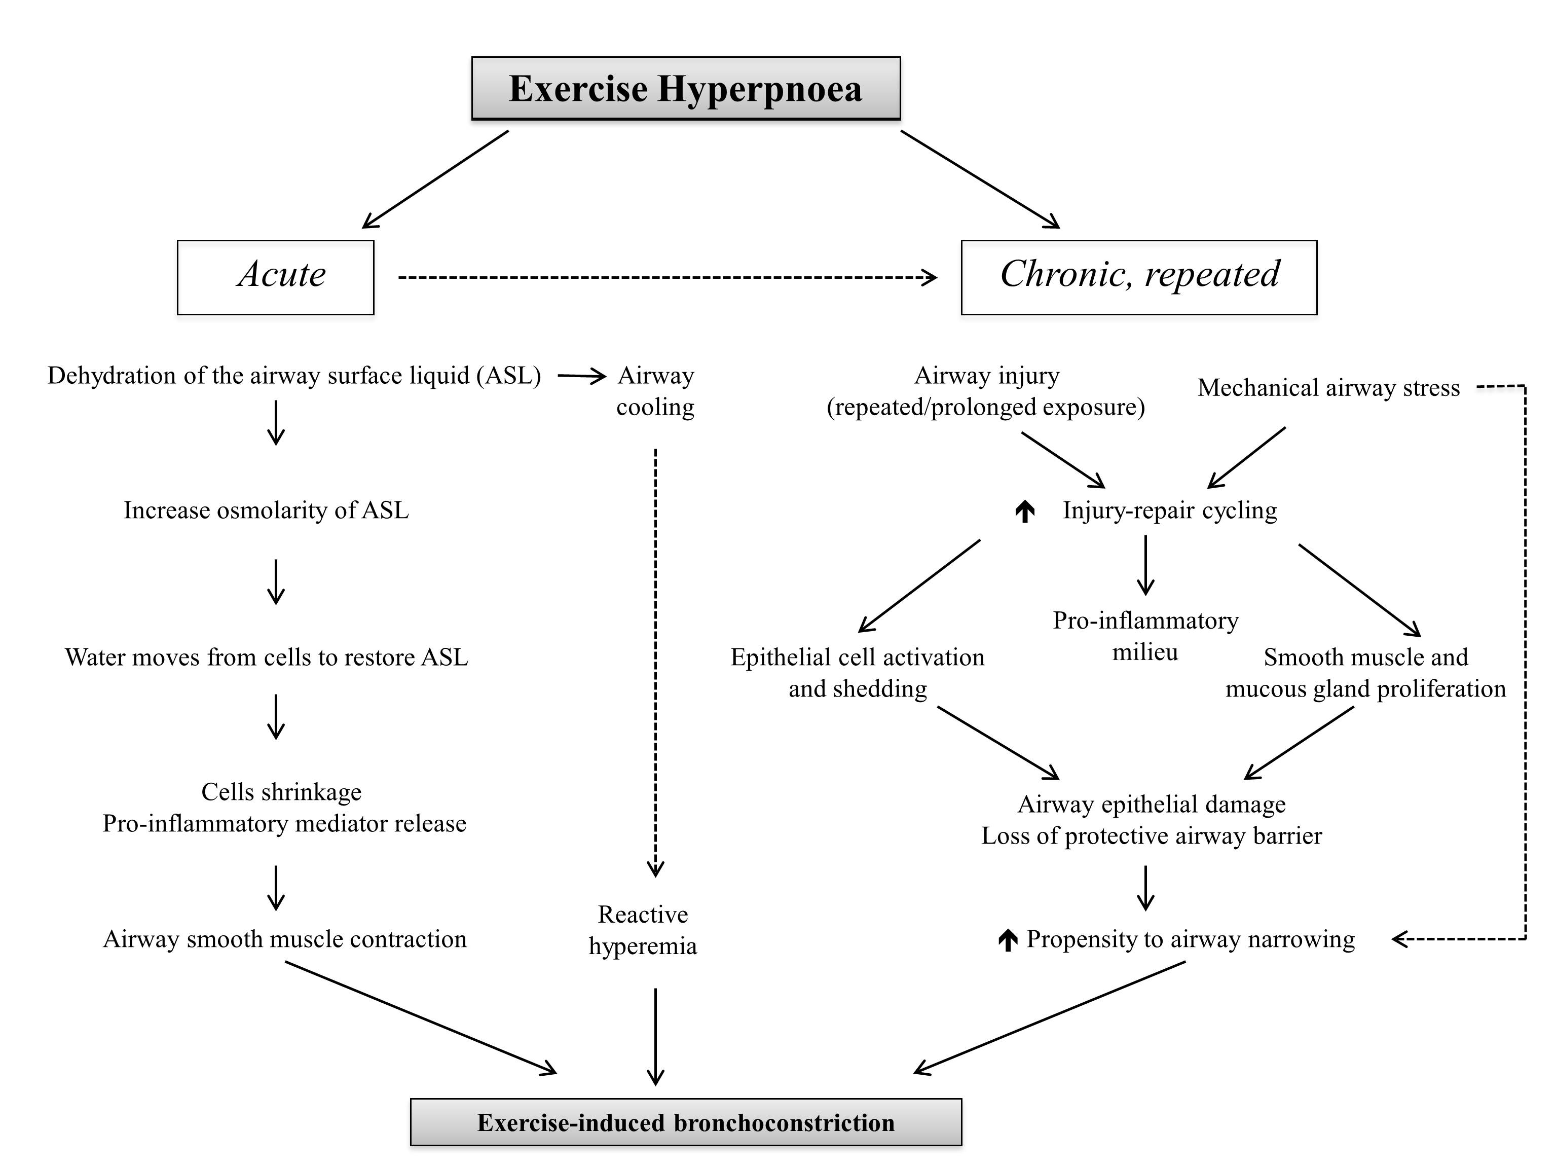

Figure 2.
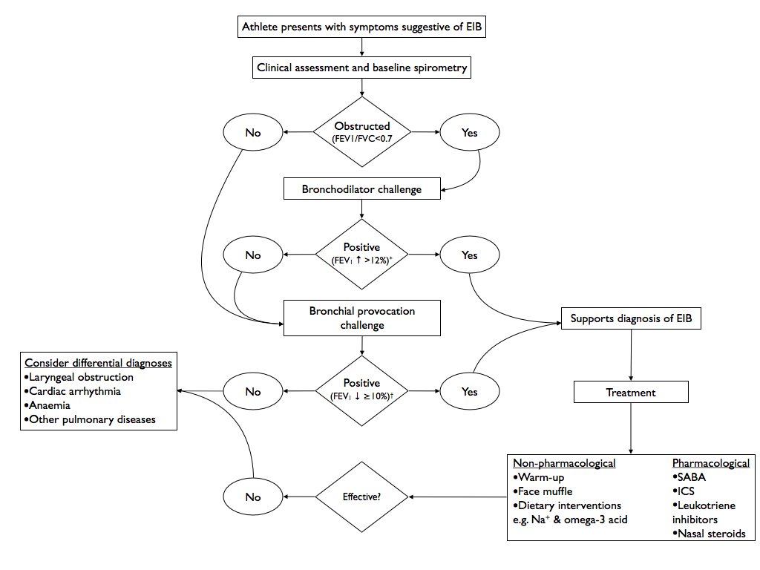

Figure 3.
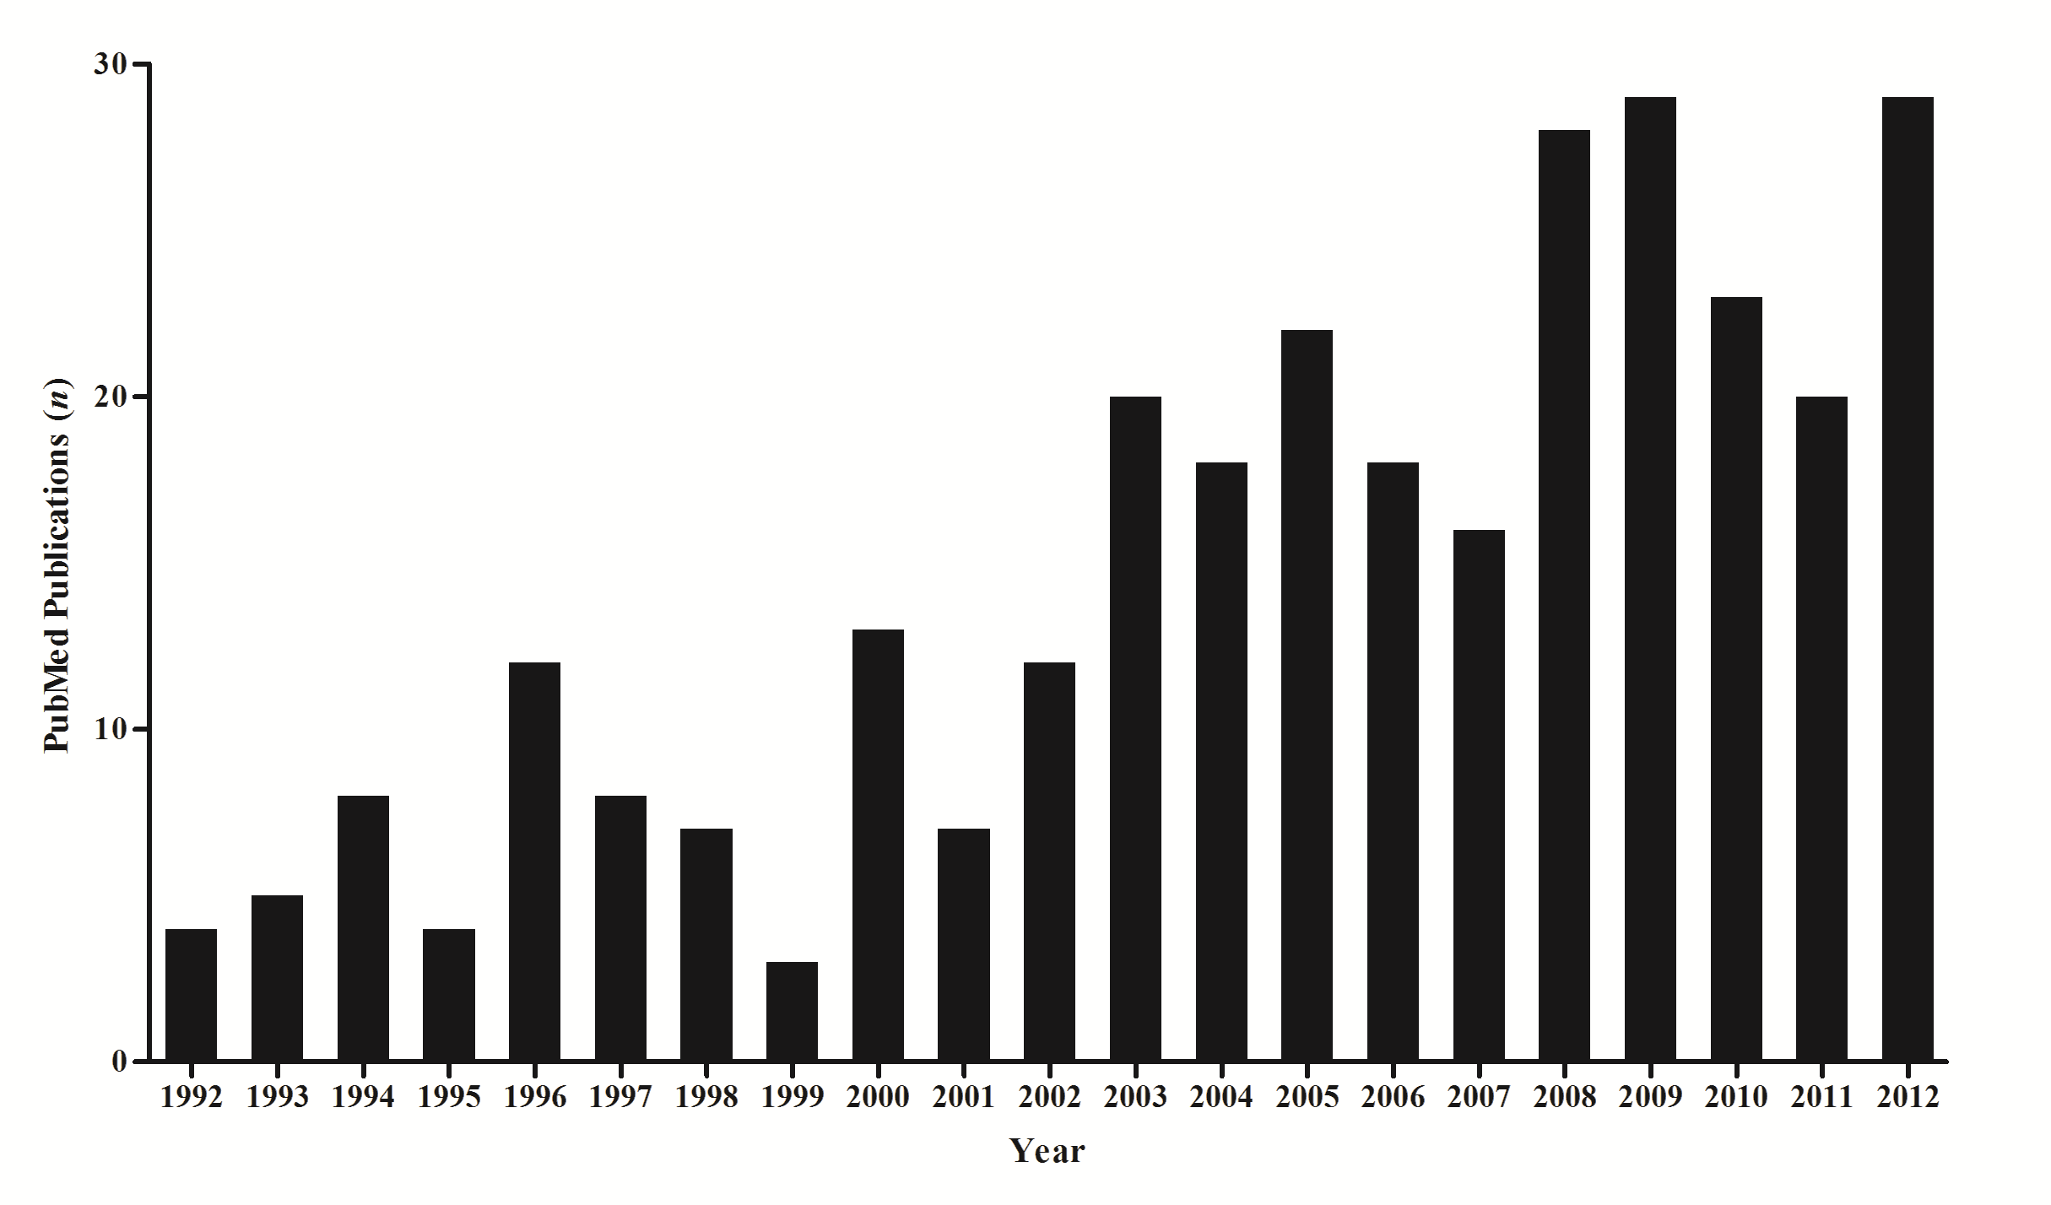

ACKNOWLEDGEMENTS
Nil
FUnding STATEMENT
Nil relevant
COMPETING INTERESTS
The authors have no real or perceived conflict of interest in respect of this manuscript.
CONTRIBUTION STATEMENT
All authors contributed to the preparation of this manuscript.

REFERENCES
1. Hull J, Ansley L, Garrod R, et al. Exercise-induced bronchoconstriction in athletes-should we screen? Medicine and science in sports and exercise.2007;39:2117 - 2124.

2. Parsons JP, Mastronarde JG. Exercise-Induced Bronchoconstriction in Athletes*. Chest.2005;128:3966.

3. Fitch KD. An overview of asthma and airway hyper-responsiveness in Olympic athletes. British journal of sports medicine.2012;46:413-416.

4. Hull J, Hull P, Parsons J, et al. Approach to the diagnosis and management of suspected exercise-induced bronchoconstriction by primary care physicians. BMC Pulmonary Medicine.2009;9:29.

5. Holzer K, Anderson SD, Douglass J. Exercise in elite summer athletes: challenges for diagnosis. Journal of allergy and clinical immunology.2002;110:374-380.

6. Parsons JP, O'Brien JM, Lucarelli MR, et al. Differences in the evaluation and management of exercise-induced bronchospasm between family physicians and pulmonologists. Journal of Asthma.2006;43:379-384.

7. Walsted NE, Hull JH, Backer V. High Prevalence of Exercise-Induced Laryngeal Obstruction in Athletes. Medicine and science in sports and exercise.2013.

8. Langdeau J-B, Boulet L-P. Is asthma over-or under-diagnosed in athletes? Respiratory medicine.2003;97:109-114.

9. Weiler JM, Bonini S, Coifman R, et al. Work Group Report* American Academy of Allergy, Asthma & Immunology Work Group Report: Exercise-induced asthma. The Journal of allergy and clinical immunology.2007;119:1349-1358.

10. Rundell KW, Jenkinson DM. Exercise-induced bronchospasm in the elite athlete. Sports Medicine.2002;32:583-600.

11. Ansley L, Kippelen P, Dickinson J, et al. Misdiagnosis of exercise‐induced bronchoconstriction in professional soccer players. Allergy.2012;67:390-395.

12. Hull JH, Ansley L, Robson-Ansley P, et al. Managing respiratory problems in athletes. Clinical Medicine, Journal of the Royal College of Physicians.2012;12:351-356.

13. Kippelen P, Anderson SD. Airway injury during high-level exercise. British journal of sports medicine.2012;46:385-390.

14. Kippelen P, Fitch KD, Anderson SD, et al. Respiratory health of elite athletes–preventing airway injury: a critical review. British journal of sports medicine.2012;46:471-476.

15. Dickinson J, Whyte G, McConnell A, et al. Impact of changes in the IOC-MC asthma criteria: a British perspective. Thorax.2005;60:629-632.

16. Stickland MK, Spooner CH, Dryden DM, et al. The need for standardization in exercise challenge testing for exercise-induced asthma/bronchoconstriction. Journal of allergy and clinical immunology.2010;126:878-880. e876.

17. Anderson SD, Pearlman DS, Rundell KW, et al. Reproducibility of the airway response to an exercise protocol standardized for intensity, duration, and inspired air conditions, in subjects with symptoms suggestive of asthma. Respir Res.2010;11:120.

18. Anderson SD, Kippelen P. Airway injury as a mechanism for exercise-induced bronchoconstriction in elite athletes. Journal of allergy and clinical immunology.2008;122:225-235.

19. Sue-Chu M, Larsson L, Moen T, et al. Bronchoscopy and bronchoalveolar lavage findings in cross-country skiers with and without" ski asthma". European respiratory journal.1999;13:626.

20. Karjalainen E, Laitinen A, Sue-Chu M, et al. Evidence of airway inflammation and remodeling in ski athletes with and without bronchial hyperresponsiveness to methacholine. American journal of respiratory and critical care medicine.2000;161:2086.

21. Kujala UM, Sarna S, Kaprio J, et al. Asthma and other pulmonary diseases in former elite athletes. Thorax.1996;51:288-292.

22. Bougault V, Turmel J, Boulet LP. Airway hyperresponsiveness in elite swimmers: Is it a transient phenomenon? Journal of allergy and clinical immunology.2011;127:892-898.

23. Becker JM, Rogers J, Rossini G, et al. Asthma deaths during sports: report of a 7-year experience. Journal of allergy and clinical immunology.2004;113:264-267.

24. Amital H, Glikson M, Burstein M, et al. Clinical Characteristics of Unexpected Death Among Young Enlisted Military PersonnelResults of a Three-Decade Retrospective Surveillance. Chest 2004;126:528-533.

25. Robson-Ansley P, Howatson G, Tallent J, et al. Prevalence of Allergy and Upper Respiratory Tract Symptoms in Runners of the London Marathon. Medicine & Science in Sports and Exercise.2012;44:999-1004.

26. Nieman DC. Risk of upper respiratory tract infection in athletes: an epidemiologic and immunologic perspective. Journal of athletic training.1997;32:344.

27. Reid V, Gleeson M, Williams N, et al. Clinical investigation of athletes with persistent fatigue and/or recurrent infections. British journal of sports medicine.2004;38:42-45.

28. Bermon S. Airway inflammation and upper respiratory tract infection in athletes: is there a link. Exerc Immunol Rev.2007;13:6-14.

29. Stensrud T, Berntsen S, Carlsen KH. Humidity influences exercise capacity in subjects with exercise-induced bronchoconstriction (EIB). Respiratory medicine.2006;100:1633-1641.

30. Stensrud T, Berntsen S, Carlsen K-H. Exercise capacity and exercise-induced bronchoconstriction (EIB) in a cold environment. Respiratory medicine.2007;101:1529-1536.

31. McKenzie DC, Fitch KD. The asthmatic athlete: inhaled Beta-2 agonists, sport performance, and doping. Clinical Journal of Sport Medicine.2011;21:46.

32. Brukner P, Holzer K, Davies L, et al. The Impact of Exercise-induced Bronchoconstriction on Exercise Performance: 639: May 31 9:45 AM 10:00 AM. Med Sci Sports Exerc.2007;39:S30-S30.

33. Hull J, Conlon J, Gateley B, et al. Does Salbutamol Improve Athletic Performance In Elite Soccer Players With EIB? Am J Respir Crit Care Med.2012;185.

34. Dickinson J, Hu J, Chester N, et al. The physiological effect of 800 mcg and 1600 mcg inhaled salbutamol during a football specific treadmill run at high ambient temperatures. British journal of sports medicine.2011;45:A19-A20.

35. Sonna LA, Angel KC, Sharp MA, et al. The Prevalence of Exercise-Induced Bronchospasm Among US Army Recruits and Its Effects on Physical Performance*. Chest.2001;119:1676-1684.

36. Rundell KW, IM J, Mayers LB, et al. Self-reported symptoms and exercise-induced asthma in the elite athlete. Medicine & Science in Sports & Exercise.2001;33:208.

37. Ansley L, Rae G, Hull JH. Practical approach to exercise-induced bronchoconstriction in athletes. Primary Care Respiratory Journal: Journal of the General Practice Airways Group.2013;22:122-125.

38. Dryden DM, Spooner CH, Stickland MK, et al. Exercise-induced bronchoconstriction and asthma. 2010.

39. Anderson SD, Kippelen P. Assessment and prevention of exercise-induced bronchoconstriction. British journal of sports medicine.2012;46:391-396.

40. Porsbjerg C, Brannan JD. Alternatives to exercise challenge for the objective assessment of exercise-induced bronchospasm: Eucapnic voluntary hyperpnoea and the osmotic challenge tests. Breathe.2010;7:52-63.

41. Parsons JP, Hallstrand TS, Mastronarde JG, et al. An Official American Thoracic Society Clinical Practice Guideline: Exercise-induced Bronchoconstriction. American journal of respiratory and critical care medicine.2013;187:1016-1027.

42. Stickland MK, Rowe BH, Spooner CH, et al. Effect of warm-up exercise on exercise-induced bronchoconstriction. Med Sci Sports Exerc.2012;44:383-391.

43. Beuther DA, Martin RJ. Efficacy of a heat exchanger mask in cold exercise-induced asthma. Chest.2006;129:1188-1193.

44. Dickinson J, Whyte G, McConnell A, et al. Screening elite winter athletes for exercise induced asthma: a comparison of three challenge methods. British journal of sports medicine.2006;40:179-182.

45. Parsons JP, Craig TJ, Stoloff SW, et al. Impact of exercise-related respiratory symptoms in adults with asthma: Exercise-Induced Bronchospasm Landmark National Survey. In: Allergy and Asthma Proceedings; 2011: OceanSide Publications, Inc; 2011. p. 431-437.

46. Anderson S, Kippelen P. Exercise-induced bronchoconstriction: Pathogenesis. Current Allergy and Asthma Reports.2005;5:116-122.

47. Weiler JM, Metzger WJ, Donnelly A, et al. Prevalence of bronchial hyperresponsiveness in highly trained athletes. CHEST Journal.1986;90:23-28.

48. Wilber RL, Rundell KW, Szmedra L, et al. Incidence of exercise-induced bronchospasm in Olympic winter sport athletes. Med Sci Sports Exerc.2000;32:732-737.

49. Larsson K, Ohlsen P, Larsson L, et al. High prevalence of asthma in cross country skiers. British Medical Journal.1993;307:1326.

50. Sue-Chu M, Larsson L, Bjermer L. Prevalence of asthma in young cross-country skiers in central Scandinavia: differences between Norway and Sweden. Respiratory medicine.1996;90:99-105.

51. Mannix ET, Farber MO, Palange P, et al. Exercise-induced asthma in figure skaters. CHEST Journal.1996;109:312-315.

52. Helenius I, Tikkanen H, Haahtela T. Exercise-induced bronchospasm at low temperature in elite runners. Thorax.1996;51:628-629.

53. Helenius I, Rytilä P, Metso T, et al. Respiratory symptoms, bronchial responsiveness, and cellular characteristics of induced sputum in elite swimmers. Allergy.1998;53:346-352.

54. Helenius IJ, Tikkanen HO, Haahtela T. Occurrence of exercise induced bronchospasm in elite runners: dependence on atopy and exposure to cold air and pollen. British journal of sports medicine.1998;32:125.

55. Leuppi J, Kuhn M, Comminot C, et al. High prevalence of bronchial hyperresponsiveness and asthma in ice hockey players. European respiratory journal.1998;12:13-16.

56. Mannix ET, Manfredi F, Farber MO. A comparison of two challenge tests for identifying exercise-induced bronchospasm in figure skaters. CHEST Journal.1999;115:649-653.

57. Ross R. The prevalence of reversible airway obstruction in professional football players. Medicine and science in sports and exercise.2000;32:1985-1989.

58. Langdeau J-B, Turcotte H, Bowie DM, et al. Airway hyperresponsiveness in elite athletes. American journal of respiratory and critical care medicine.2000;161:1479-1484.

59. Rundell KW, Spiering BA, Evans TM, et al. Baseline lung function, exercise-induced bronchoconstriction, and asthma-like symptoms in elite women ice hockey players. Medicine & Science in Sports & Exercise.2004;36:405.

60. Durand F, Kippelen P, Ceugniet F, et al. Undiagnosed exercise-induced bronchoconstriction in ski-mountaineers. International journal of sports medicine.2005;26:233-237.

61. Verges S, Devouassoux G, Flore P, et al. Bronchial hyperresponsiveness, airway inflammation, and airflow limitation in endurance athletes. Chest.2005;127:1935-1941.

62. Bougault V, Turmel J, St-Laurent J, et al. Asthma, airway inflammation and epithelial damage in swimmers and cold-air athletes. European respiratory journal.2009;33:740.

