Multivariate Time Series Approaches To Analysing The Northern Irish Conflict: Lessons For Future Sub-State Conflict Control
Steve Wright & Dave Webb

The Praxis Centre, Leeds Metropolitan University, Leeds UK
Abstract
This paper is essentially an introduction to the use of multivariate time series analyses of the Northern Irish conflict from 1969-1981.It draws on the conceptual work of Paul Smoker to describe systemic conflict relationships between all the parties to this conflict. Using some of the most comprehensive statistical documentation ever compiled on an internal conflict, the authors present an innovative methodology to show the highly structured nature of this conflict over a long period of time. The paper and its ancillary web sites present not only the data archive, but also the univariate, bivariate and multivariate time series programmes used to make the analyses. The outputs are presented in the form of descriptions of associated influence or ‘systemograms’ which can describe the dynamic and changing conflict ecology where apparently disparate conflict behaviour such as house searches, plastic bullet firings and the killing of military personnel, are highly correlated.
Measures of autocorrelation are used to suggest a loss of freedom in the actions of particular conflict participants. Particular attention is given to the use of “less-lethal weapons” and their impact on overall conflict dynamics. What emerges is that sectarian killings form a distinct conflict susbset, whereas the counter-insurgency behaviour of the state security forces act as a conflict driver, ratchet ting up the conflict as each more severe phase of the counter-insurgency programme is introduced. The paper attempts to introduce a whole systems conflict approach which is both dynamic and puzzling, since in many respects it indicates co-operation between the various participants to carry on the conflict at a systemic level. The provisional lessons of this study are that sub-state conflict control measures can prove dysfunctional. The work is very much a case of research in progress and the findings remain tentative. We are re-introducing it at this time since it does open the prospect of repeating the research methodology in other sub-state conflicts such as Israel and Iraq, if reliable data were ever to become available.

1. Introduction

The roots of this paper lie in work undertaken at the Richardson Institute, at the University of Lancaster, nearly thirty years ago. Research reported in the Journal of Peace Research (JPR) in 1978 outlined a series of hypotheses on how sub-lethal acts by State Security Forces, might dysfunctionally alter a conflict’s dynamics in ways which led to a loss of control (Wright, 1978).
The challenge was to first find sufficient and accurate data on a conflict to test the nine hypotheses outlined in the JPR report and then to design a methodology capable of describing inferred causal influences.
Fortunately, the Director of the Richardson Institute during that time, Dr Paul Smoker, had pioneered the use of new methodologies to examine the ways in which conflict processes could lock in, in regard to the Sino-Indian conflict during the Sixties (Smoker, 1969). Smoker was a founding pioneer of quantitative and simulation approaches in peace and conflict research and he was willing to adapt his Sino-Indian work to the much more complex task of examining the interaction and associated influences of scores of variables over different time levels. Part of that work was written up as a PhD thesis (Wright, 1987), some of it found its way into one of the first volumes on quantitative perspectives on terrorism, (Wright, 1981) but apart from a passing reference to the work in a report for the European Parliament’s Scientific and Technological Options Assessment Unit on approaches to testing and assessing the hidden social and political impacts of technologies of political control in 1997 (Wright 1997), the work lay moribund and too complicated and problematic to excite peace researchers not enthused by mathematics.
But for 9/11 the work may have continued to gather dust. However, the new strategies of ignoring international law, the emergence of new polices seeking to target civilians and combatants together with new weapons technology and the dysfunctional effects of the current military containment strategies in the Middle-East including Iraq and Israel, provoked the authors to re-understand the challenge of attempting to quantify or even accurately describe inferred causal inferences in complex conflict dynamics. We offer the following presentation, data, programmes and analyses not as finished piece of work but as a demonstration or illustration of an approach to those who we hope can reassess its implications and limitations from a deeper undertstanding of statistics than either of the authors possess. In many senses this is a tribute and a plea to continue the creative work of Paul Smoker, whose imagination created the methodologies we are attempting to illustrate and apply in this study.

2. Testing Hypotheses on Destabilizing Conflict Processes in Northern Ireland

The hypotheses outlined in (Wright, 1978) were originally designed to examine the hidden and longer term impacts of so called ‘less-lethal weapons’ such as plastic bullets – an area of armaments which has subsequently become much more significant as the US and other states develop new technologies for fighting asymmetric warfare after 9/11.
In short, the theory went that “In certain circumstances, the use of less-lethal weapons may be considered as an over corrective response. Through a cybernetic process of destabilizing feedback, over corrective responses can bring about an opposite effect to the one intended. Instead of containment, an over corrective response would lead towards an induction of uncontrollable conflict and further polarization. Thus attempts to control a situation with over corrective responses are thwarted because in effect the resulting system works against itself. This early study argued that the impact effectiveness of such technological\fixes would decline over time so that increasing amounts would be required to obtain the same powers of control. If powers of control \were lost in this way, then a resurgence of the phenomena under control might develop as the fix lost potency. If the underlying dynamics were not realized, reliance on ever more powerful fixes would prove counterproductive as such cycles of destabilization would repeat themselves.
The paper argued that even if these hypotheses were true, it was likely that in the short term such weapons would appear to be an effective means of crowd control. ‘The possibility that they constitute a destabilizing factor in a conflict might only be revealed by a study which correlated their effects on a range of indicators for longer periods of time.’ One methodological challenge was thatb an input of aggression into a conflict by one party during one point in time which results in an output of retaliatory aggression at another period of time, the form in which this output manifests itself might be quite different from the form of input.
The British Army in Northern Ireland had adopted startegies from their Land War Operations Volume 111 which were essentially ‘counter-revolutionary operations.’ A key concern here therefore was that if a successively more oppressive set of phased counter-insurgency strategies comprised the software which programmed the behaviour of the dominant system of socio political control, then a self generating conflict could ensue. Thus the introduction of the second most severe phase of the counter-insurgency techniques may be legitimated through the waves of violent retaliation amplified by the use of less-lethal weapons during the first phase. Subsequently, phase two is likely to generate further dissent, which if handled by even more severe riot weapon deployment, may destabilize the situation sufficiently to legitimate the introduction of phase three and so on. The parallels with the current conflict in Iraq and Israel reveal similar dynamics but with rather more lethal than less lethal force being deployed. The concern too was similar in that if the authorities failed to realize the nature of this process, the entire gamut of the counter-insurgency spectrum of operations would be deployed in a manner tantamount to self-fulfilment. For Northern Ireland, even a crudse time point analysis of political killings graphed against changes in socio-political control tactics, appeared to support this thesis (See Fig 1)

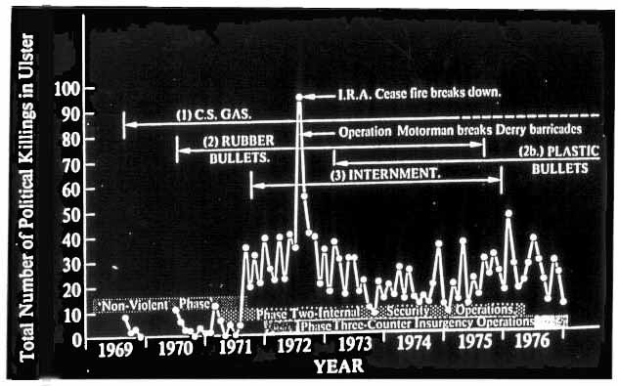
Fig 1. Military Counter Insurgency Phases & Political Killings In Northern Ireland

3. Data Considerations
The problem with such a crude model was that its decription was based on the changes in only one empirical conflict indicator, overall death count. It was fruitful in suggesting that their were unforeseen relationships between state and non-state conflict activities which could be measured. It also provide a rudimentary framework to consider such changes. It also implied that the influence of a conflict action may persist within a conflict system, long after the event. The challenge in attempting to develop even a basic holistic approach to just describing the Northern Irish conflict raised fundamental questions about how to select representative conflict indicators, how to find such data and how could substantial amounts of information on this conflict be presented in a meaningful way? The challenge was not just academic sionce any commentator on this conflict and others of its ilk is likely to draw fire because of inferred political bias. Paul Smoker saw a clear need for the process of interpretation to be clearly separated from the actual conflict description so that subjective bias could be eliminated as far as possible. We decided to pick variables that characterised incidents which most people would regard as being symptomatic of internal war. These included activities of state security personnel (such as house and vehicle searches, gas and plastic bullets fired, internment; paramilitary activists (shooting attacks, bomb explosions, catholics assassinated, protestants assassinated, state security personnel (Army, RUC & UDR) killed or wounded, kneecappings etc) and civilian victims of the conflict processes, (e.g civilians killed and wounded).

Taken together, these variables provide a significant measure of the Northern Ireland conflict’s level and intensity. The data was collected from official sources such as the Northern iIreland Office, and the British Army and RUC Press Offices in the form of a monthly breakdown from 1969-1981. The full dataset and source references is provided to this conference as an url for the first time (NIrishdata-check). Of course all such conflict data are problematic since each ‘event’ is a summation of a much richer set of conflict processes and it is more usual for conflict participants to disagree on conflict statistics than agree.(See NIRC,2003 in regard to baton round figures for example) However, it is arguable that this conflict is better documented than almost any other of its type and provides researchers with a unique framework to understand more about the conflict dynamics at work in what is now known as military operations operations other than war.
4. Some Methodological Considerations

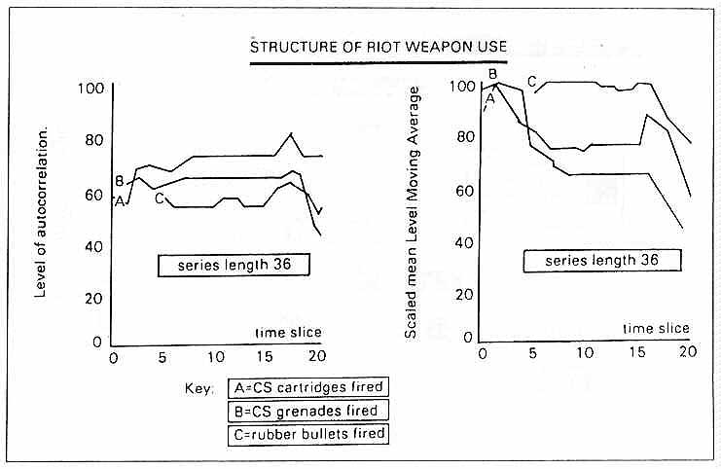
Fig 2. High Levels Of Autocorrelation & Associated ‘Loss of Freedom’ in Riot Weapon Use

Briefly the univariate tsa enables a description of the level of influence which any variable’s past behaviour exerts on that variables subsequent activity. This autocorrelation measure as it is termed provides an important indicator of emergent processes especially a loss of freedom. Highly autocorrelated behaviour is especially important since it is often associated with episodes where conflict participants lock in to their own conflict behaviour and become less responsive to actions of other conflict actors. In Fig 2 for example, a univariate time series analysis of riot munitions (CS gas cartridges, grenades and rubber bullets) shows not just highly predictable behaviour but also consistent mean level moving averages over considerable periods of time, as if the supply itself was the greates determinant of the number of sub-lethal munitions fired.
The bivariate tsa enables a description to be made of the influence one variable’s behaviour has on another, or more precisely, it provides a measure of the extent to which proceses associated with the formation of variable A are implicated in the processes associated with the formation of variable B.
The multivariate tsa is a more complex technique created to display the extent to which one variable’s behaviour is implicated in the influences responsible for generating all the others, as it and they change over time. More precisely, it quantifies the overall connectivity of the influencesgenerating all the variables; a measure of the strength of particular linkages together with an indication of the direction of any flows of associated influence wghich are revealed.
Smoker designed the technique as a multivariate cluster time series analysis, that is an amalgam of two different techniques, i.e. a clustering procedure and a time series analysis procedure.The clustering procedure is essentially a form of typal analysis derived from the work of McQuitty(1957). As a component of this methodology it is used to define each variable’s time series as a member of a type, if its behaviour is more like the behaviour of other members of that type than it is like anything else. The time series components are derived from the works of Smoker (1969), Quenouille (1959) & Wold (1949).
The time series element serves to ascertain the direction and strength of any associated influences flowing within and between variables. The technical conventions, concepts and measures used to perform these measures together with the technical methodologies for interpreting the results are provided in our Praxis website for those who wish to undertake a more detailed scrutiny. (http://www.imresearch.org/PraxisCentre/NIrelandStudy). The website also provides detailed instruction on constructing a map of all these influences from the output of the multivariate tsa. This is an important element of the approach, since the descriptive systems map of flows of associated influences or ‘systemograms’ can then be compared with other conflict data to make comparisons and evaluations of the impact of policies or any particular episode or activity on the overall conflict dynamics. The actual process of drawing out the ‘systemograms’ is laboriously time consuming. However, in 1985, a research student at UMIST, Tim Walker managed to semi-automate the process and this work is also available for anyone interested in taking the work further.(Walker, 1985)

5. Mapping Key Participants Contributions To A Conflict’s Dynamics
Mapping out the associated influence of key indicative variables of all the representative participants in a conflict provides a systemic picture of the conflict and enables us to at least describe the level and extent to which participants are actually co-opertaing to structure and maintain their conflict behaviour. It also enables us to identify highl;y auto-correlated activities of any group which has in effect become autistic, being most influenced by their own behaviour rather than any of the other conflict participants. For the purpose of this study a complete output of systemograms for time series 24 , has been created on the associated url (http://www.imresearch.org/PraxisCentre/NIrealndStudy). Here we will discuss only some of the structures and sub-sytems emerging from a typical sequence and how this methodology could be applied to\other conflicts experiencing similar forms of conflict behaviour.
In many ways, the multivariate systemogram approach enables a broad trawl of the data sets to actually identify highly structured behaviour. In practice, sub-sytems emerge either between or within variable clusters as a consequence of undertaking this tracking exercise on the ‘systemograms’. Variables within each sub-system develop certain patterns which sustain as typical features within each systemogram. These can be characterised as follows:

Active Variables which have only strands of influence emanating out from them. They act on other variables rather than being significantly acted upon themselves; Reactive Variables have only strands of influence feeding into them; Mixed Variables both give and receive influence from other variables; Interactive Variables neither receive or give influence but correspond their influence with other variables to which they are linked; Highly Autocorrelated Variables which feed a large part of their influence back into themselves indicating a pattern of self generation. Such variables are easy to spot in the systemograms since they are represented by conspicuous concentric circles or semi-circles. Eyeballing an illustrative systemogram sequence is perhaps the best way to understand this methodology.

6. An Illustrative Systemogram Sequence

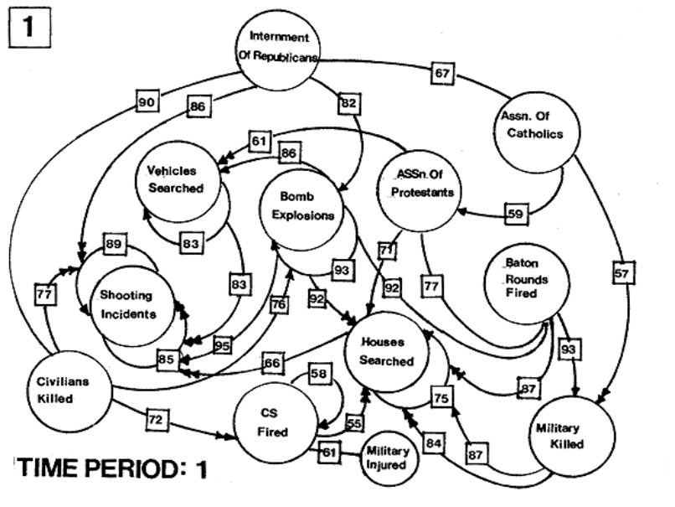
Fig 3 Systemogram 1
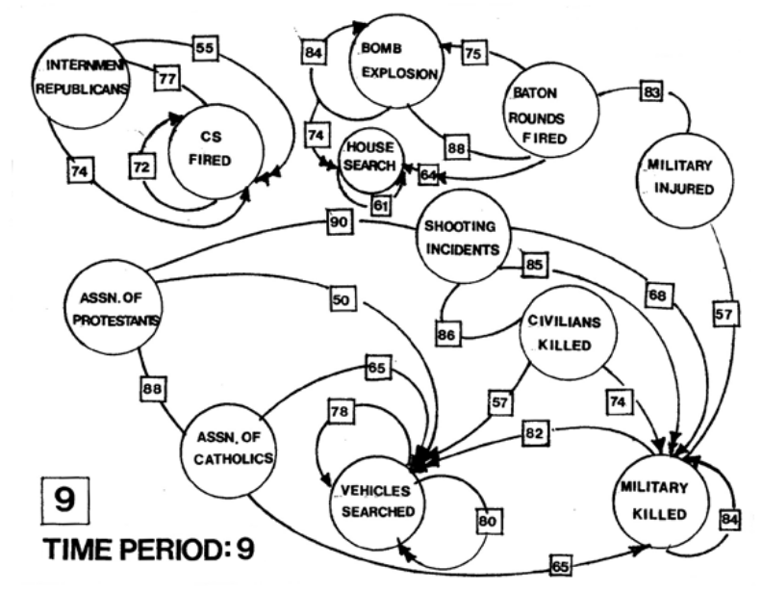
Fig 4 Systemogram 2

If the conflict time sequence contained in
(http://www.imresearch.org/PraxisCentre/NIrealndStudy), is examined systemogram by s.ytemogram, it is possible to discover whether the changing influence processes between different variables or within variable clusters are growing stronger or weaker. The change in the strength of the systemic process is revealed by the change in the level of correlation over selected time periods. Strengthening processes are associated with an increase in the level of correlation, whilst processes which are weakening, exhibit a decline in the level of correlation.
The systemograms used here are for illustration but a full analysis can determine whether any political, military or NGO decision, policy or tactic is significant by empirically establishing when the particular ‘event’ entered the sequence. If we define the influence horizon of an event as being the time period limit of the systemogram when its influence is first felt, the relevant systemogram TP = t – n + L

Where t = the chronological number of the appropriate month
n=the series length
L=the maximum time lag used

For example if we are interested in discovering whether or not the decision to introduce internment produced a measurable influence on the dynamics of the conflict, then we can find the first relevant systemogram if we know the following:-

t=August 1971 (=12+12+8) = 32
n=24 (in this illustrative sequence)
L=2 (in this particular study
TP = 32-24 +2 = Systemogram 10

In systemogram 1, the most significant patterns of influence to emerge concern reactive variables, all of which are strongly autocorrelated.. These include the process of vehicle searches (81); house searches (75) bomb explosions (93) and shooting incidents (89). By systemogram 5, these processes have structured with strong links between them. Bomb explosions and House Searchews are mutually influencing each other and Bomb Explosions are actively influencing Vehicles Searched (83) Some of these links confirm common sense – eg its natural to up searches of vehicles if bomb attacks are taking place but in systemopgram 1 baton round firings are strongly acting on Military killed (93) This is an interesting finding since traditionally any killing of military personnel is usually associated with punitive house searcjhes eg not just in Northern Ireland but in Iraq and Israel where the military action is so sever, that civilian houses are destroyed. In this first sytemogram military killed is empiurically described as actively influencing houses searched (87 + 84)
By systemogram 9, CS `fired forms a separate cluster, reacting to the influence from Republican Internment (74 & 55); Baton Rounds are driving influence towards bomb explosions (75), which continues to drive influence into House Searches. The assassination of Protestants and Catholics has become interactively linked (88) as Military Personnel Killed continues to drive influence towards Vehicles Searched (82) as both variables yield high levels of autocorrelation (84 and 80 respectively) suggesting that these aspects of the conflict processes have become self organising structures. A full preliminary breakdown is provided by Wright (1987).
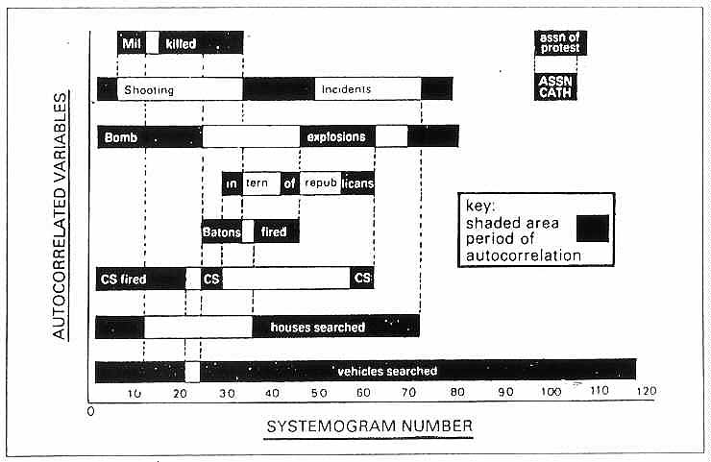
Fig 5. ‘Lock In’ Profiles Of Northern Ireland Conflict Participants 1969-1981

If we tabulate the autocorrelated variables across the entire time sequence (Fig 5), we should expect a conflict ‘lock in’ when several of the different conflict participant groups manifest some degree of autistic behaviour as measured by highly autocorrelated variables. In fact a series of ‘lock ins’ emerges. At the beginning of the conflict, government searching and firing of CS was locked in with paramilitary bombings; shooting and killing of Army personnel, until time period 25. A short phase of lock in emerges from the period 25-33 and then another from time period 33-44 and so on. According to Stafford Beer “this is a system in homeostatic equilibrium. Each part is structuring the other. So the structuring goes mutually on. If one part stops in this creative, evolutionary process, then the whole system breaks down. In Northern Ireland terms that is, the war is over” (Beer, 1980).
Exactly why so many of the British Army reactions developed such highly deterministic traits is a question which must be answered by future studies. Obviously military behaviour, by definition is variety reducing, whilst urban guerrilla activists depend onn their unpredictability and the variety increasing aspects of their behaviour to remain effective, alive and at large. The possibility which must be faced is that certain military doctrines are actually dysfunctional.
The presence of so much self-legitimating behaviour in the activities of military personnel should be of concern. Traditional counter-terrorist theory suggest such wars must be fought by taking out the hard men. Yet when freedom of decision is lost in the military group of participants on the level described above, the efficacy of such an approach to conflict resolution must be deeply questioned. The range of associated `activities in this process appear to have just as much efficacy in evolving more hard men to get.
Having said that, it must be acknowledged that such quantitative approaches to whole systems conflict analysis are fraught with difficulties and their findings can seem opaque to non statisticians- including most policy makers Anecdotal analyses is much easier to churn out and is far more accessible to sound-bite formation. Indeed this conference is very unusual in bringing the approaches of mathematical and conflict analyses together. Richardson’s conflict models are much les well known that his weather forecasting equations – perhaps because with the advent of computers, his erstwhile laborious log calculations can be converted into understandable weather pictures that most of us can grasp.
So few work in these field. A 1996 analysis of terrorism research in terms of the evolution of a body of knowledge, identified just 32 major members of the community. (Reid, 1996). And the majority of these contributors make qualitative rather than quantitative contributions. Of course after 9/11, the media appetite for terrorist and conflict experts has been voracious but few new quantitative approaches are emerging except at the most basic death count level or the production of chronologies – many of which are open to challenge about objectivity and reliability. And even that is revealing since in the ongoing Iraq conflict, the coalition partners would appear not to be as seriously documenting non coalition casualties, or at least not outside the prisons where different agendas for documenting conflict activities prevail.
A key question is relative utility. What can such studies tell us or reveal that is not more accessible from more anecdotal or story based analyses? The short answer is, they can yield tremendous insight into the hidden structuring of conflict processes. This is going to become increasingly important as the tactics and technologies being offered for asymmetrical warfare are destined not only to alter the casualty count but the membership of who becomes a designated casualty. Nevertheless, such statistical studies need to be capable of showing a facility for generating testable hypotheses. One of the concerns of this study has been to put reliable conflict data in the public domain for use by other researchers.
White and Falkenberg-White in a ground breaking study applied regression analysis to some of this data and discovered that deaths caused by Loyalist paramilitaries increased the number of persons killed by British Soldiers. They concluded that one explanation for this curious finding given that most of those killed by the Army were Catholics, might be evidence of “some kind of co-ordinated activity between Loyalist paramilitaries and members of the security services”. (White and Falkenberg-White, 1995). Whilst there is evidence now since 2002 to support such claims – especially in the light of the Steakknife double agent fiasco, at other moments alternative agendas have emerged including protecting keep members of Sein Fein to ensure the peace process was not derailed (see Moloney, 2002)
In conclusion, we have entered` a time when public presentation and information management are as much a part of conflict management as implementing military theories of peace keeping and conflict reconciliation. During periods of military intervention, the costs of following a misinformed policy are huge, yet the level of effort and resources devoted to independent conflict assessment and monitoring activity is minuscule. During future periods of conflict we need to find a way of more independently collecting the raw data of war if we are ever to effectively evaluate existing policies especially the new ‘wars against terror.’ Without such objectivity we are all prey to propaganda. The important lesson from Northern Ireland is that if we are to truly understand future armed conflict dynamics, accurate data is paramount and there needs to be much more pressure on governments to provide it and to set up structures which in principle enable enough accountability for modern states to be legally challenged about the veracity.of the statistical conflict data which they gather. The challenge to researchers is to create simulations of war which have sufficient truth content to challenge.

REFERENCES

ALKER, H.R. 1967 Causal Inference and Political Analysis. In Joseph Bernd (ed.) Mathematical Applications in Political Science, University Press of Virginia, Charlottesville.
BEER, S. Letter to S. Wright from Stafford Beer, dated 22 August 1980..
BLALOCK, H.M. 1964. Causal Inferences in Non-Experimental Research, University of North Carolina Press, Chapel Hill.
BOUDON, R. 1965 Methodes d’analyse causale, Revue Francais de Sociologie, 6, 24-43
CAMPBELL, C.T. 1963 From description to Experimentation: Interpreting Trends in Quasi Experiments. In Harris C.W. (ed) Problems in Measuring Change, University of Wisconsin Press, Madison.
MCCLELLAND C.A. et al 1965 The Communist Chinese Performance in Crisis qand Non crisis: Quantitive Studies of the Taiwan Straits Confrontation, 1950-64, Behavioural Sciences Group, Naval Ordnance Test Station, China Lake, California.
MCQUITTY, L. 1957 Elementary Linkage Analysis For Isolating both Othogonal Types & Typal Relevancies, Educational & Psychological Measurements, 17,207-229.
MOLONEY, E. 2002. Panorama Missed the real story of collusion in Ulster, Daily Telegraph 25 June.
OMEGA FOUNDATION, 2003. Baton Rounds: A Review of the Human Rights Implications of the Introduction and Use of the L2A1 Baton Rouind in Northern Ireland and Proposed Alternatives to the Baton Round, Northern Ireland Human Rights Commission, Belfast, April.
PETERSEN, I.D. 1977. Laws of development of Cybernetic Systems – the Case of the Sino-Indian Border Conflict, Part 1, Paper Presented To the British Academy and the Wolfson Foundation, December.1-90.
QUENOUILLE, M. H. 1952 Associated Measurements, Academic Press, New York.
REID, E. O. F. 1997. Evolution Of a Body Of Knowledge: An Analysis of Terrorism Research. Information Processing and Management. 33, No.1, 91-106.
SIMON, H.A. 1957. Models of Man, New York, Wiley.
SMOKER P. 1969. A Time Series Analysis of Sino-Indian Relations, J. of Conflict Research 13, No.2, 172-191.
SMOKER, P. 1970. Social Time and its Relevance For Causal and Time Series Data, A Paper presented to a meeting of the Peace Research Society (International) Conference, London, 26-27 August.
TANTER, R. 1966 A Systems Analysis Guide For testing Theories Of International Political Development, Northwestern University.
WALKER, T.J.V. 1985. Automated Plotting of Complex Multivariate Time Series Analysis Systemograms, A thesis submitted in part fulfilment of a BSc in Computation, UMIST, Manchester.
WHITE,. R.W. & FALKENBERG WHITE, T. 1995, Repression and the Liberal State: The Case of Northern Ireland, 1969-1972 , J. of Conflict Resolution 39, No.2, 330-352.
WOLD, H. 1949 On Least Squares Regression with Autocorrelated Variables & Residuals, A APer Presented to a meeting of the International Statistics Institute, Berne, Switzerland.
WRIGHT, S. 1981. A Multivariate Time Series Analysis of the Northern Irish Conflict, 1969-1976. in ALEXANDER, J. & GLEASON,. J.M. 1981 Behavioural and Quantitative Perspectives On Terorrism, Permagon Press, New York, 283-328.
WRIGHT, S. 1978. New Police Technologies: An Exploration of the Social Implications & Unforseen Impacts Of Some Recent Developments, J of Peace Research 15, No. 4, pp.305-322.
WRIGHT, S. 1987 New Police Technologies & Sub-State Conflict Control, PhD Thesis, The Richardson Institute, Department of Politics, University of Lancaster.

