The Sustainability Challenge: Measurement to reduce Global Emissions
Christopher Gorse, Leeds Sustainability Institute, Leeds Beckett University, Leeds, United Kingdom
e-mail: C.Gorse@leedsbeckett.ac.uk

Abstract Purpose – Modern Man’s impact on the Ecosystem, sustainability and the built environment’s contribution to global emissions are highlighted. The review provides a specific focus on the thermal performance of buildings and work undertaken to recognise and reduce wasted heat energy. Drawing on current research, data on buildings achieving enhanced levels of energy efficiency are presented and underperformance is discussed. While it is clear that domestic properties can perform, the pressure from legislation has been limited and significant gaps in thermal building performance continue. The paper proposes a model for building performance, based on control of fabric and services and the influence of occupant behaviour. The work also demonstrates where significant change has been achieved through processes of testing, measurement and monitoring.

Design/methodology/approach – Drawing on a number of current research projects, this paper identifies the emergent methods for testing buildings and assessing fabric energy efficiency.
Findings – The research identifies methods suitable for understanding and assessing building fabric performance. Using established methods, the performance metrics identify a significant difference between those achieving the energy efficiency standards and those failing to meet their designed performance.
Originality/value – Highlighting the issue of sustainability is common place, but few have identified practical process measures that differentiate innovation that can lead to significant improvements in the building stock and identify those failing to achieve target performance.
Keywords Integration - Building Performance, Energy Monitoring, Sustainability, Thermal Performance Testing
Paper type - Viewpoint

Sustainability: The Eco System in Context –where we live
The grass is not always greener on the other side, and as a matter of the best astronomical science, our neighbouring planets have little to offer even if we wanted to relocate (Boss, 2009). Exploration for signs of life focus on exoplanets beyond our solar system, well outside Man’s ability to travel (Boss, 2009; Mazza, 2015). The Earth’s atmosphere, biodiversity and ecosystem are unique, requiring protection before the window of opportunity to stop irreversible climate change closes (Ceballos, et al., 2015). Sustainability, in a significant way, can begin at home and to be specific, benefits can be achieved if improvements are made to the way we live, design, build and operate homes. The value of such change is already recognised; the housing stock can make a meaningful contribution and is legislated to become more energy efficient and less carbon intensive (Vadera et al., 2008; CLG, 2009; EPBD, 2010). Unfortunately, while the legal machinery is in place the pressure to change has not resulted in the desired action. If the legislation has failed to bring about change, why should the built environment be more sustainable and why not wait until the regulations develop real teeth?

A unique Ecosystem
The Ecosystem that secures our wellbeing is, as far as we know, unique. Created over 4.5 billion years (4.55 ± 0.01; Manhesa et al., 1980), by big bang or some other phenomena the Earth was born. The planet’s Ecosystem fostered life and allowed Homo-Sapiens to start their 2.5 million year period of evolution. However, after the relatively short period of Modern Man, 340,000 years (Barras, 2013), the species started to ‘devolve’, engaging in detrimental activity that is changing the Ecosystem that Man relies on. From the industrial revolution, in less than 250 years, ‘Industrious Man’ harnessed the power to impose irreversible change and create ripples in the atmospheric composition the size of which have never occurred in the history Modern Man (see Met Office, 2009 carbon records). What is often termed ‘development’ has started threaten Human wellbeing and existence; with the limitation of natural resource being overlooked. Unfortunately, if Humans destroy the planet’s Ecosystem, then there is no obvious place for future generations to escape to. Although we identify galaxies over 13 billion light years away (NASA, 2011), many fail to realise just how precious the Ecosystem is. Earth like planets do exist, some being just 11 light years away (Petigura, et al., 2013), and although explorations look for signs of life (Mazza, 2015) they have yet to find another inhabitable Ecosystem or life-form.

Current Human development imposes threats to the planet’s Ecosystem and for some species the situation is acute (World Economic Forum, 2013). Conservative calculations, with evidenced based on fossil remains, suggest species extinction is over 100 times the biological norm (Jowit 2010; Ceballos, et al., 2015). Due to the interconnected relationship of the Ecosystem, industrious anthropogenic influence has inadvertently changed the atmosphere and habitats relied on by one or more species, thus affecting biodiversity that Mankind relies on (Ceballos et al., 2015). Some bodies, such as Global Warming Policy Foundation, use the regional variations of biodiversity and climate changes as evidence that the impact is not as great as suggested (Mueller, 2011). While there are some short term regional positives, leading researchers have not changed their position with regard to global warming; the evidence, based on CroSat data, show global change taking place now (Parliament, 2013). How and when the changes will impact on each region is difficult to predict but change is upon us (Met Office, 2009; Hawkins and Sutton, 2009). Disappointingly the solutions are not obvious and the preferred option is to delay change and reduce the impact on people living now, allowing time for mitigation (Joshi et al., 2011).

Since the Industrial Revolution the concentrations of greenhouse gases, have more than doubled, coursing a trajectory that shows no sign of stopping. Over 800,000 years of carbon deposits in the ice caps tell us that Man’s actions have vastly exceeded CO₂ production caused by any natural phenomena (Met Office, 2009). The increase in CO₂ is so striking that it is difficult to comprehend. Blame for emissions is often shifted to those nations with the largest populations, although distribution per capita would suggest that the UK provides more than its fair share contributing 7.8 tonnes per head, compared with China’s 5.4 and India’s 1.4 tonnes (Oliver et al., 2013). Countries contributing the most total emissions are China 29%, USA 16% and European Union 11% (Oliver et al., 2013). Not surprisingly, European development and the built environment sit at the heart of the emissions challenge.

Constructing responsibility
As part of the construction industry, the burden is greater than most; the built environment consumes more natural resources than any other industry and contributes the largest share of emissions (Prism Environment, 2012: Report for the European Commission; Palmer & Cooper, 2013). Reduction in emissions related to the built environment should be a relatively straight forward proposition (Oreszczyn and Lowe, 2010). It is possible to build and retrofit more energy efficient homes (Stafford et al., 2012a, 2012b) and there are particular benefits in focusing attention on homes. Domestic properties use a third of all energy consumed in the UK, with 65% being used for heating and cooling (DECC, 2014; Palmer and Cooper, 2013) thus, changes to the building stock can create a significant impact.

Building envelopes and performance
For domestic buildings, in Northern European Climates, the main concern is the high energy heating loads required during the winter months. During this and other seasons, reliance is placed on the building envelope to act as a thermal barrier that resists heat losses through the fabric and undesirable air exchanges. However, research has shown that the effectiveness of the barrier can vary and gaps in performance are considerable (Stafford et al. 2012a; 2012b). In most cases the thermal barriers are not effective and internal conditions are at the mercy of the external environment, changing rapidly as external temperature and wind changes.

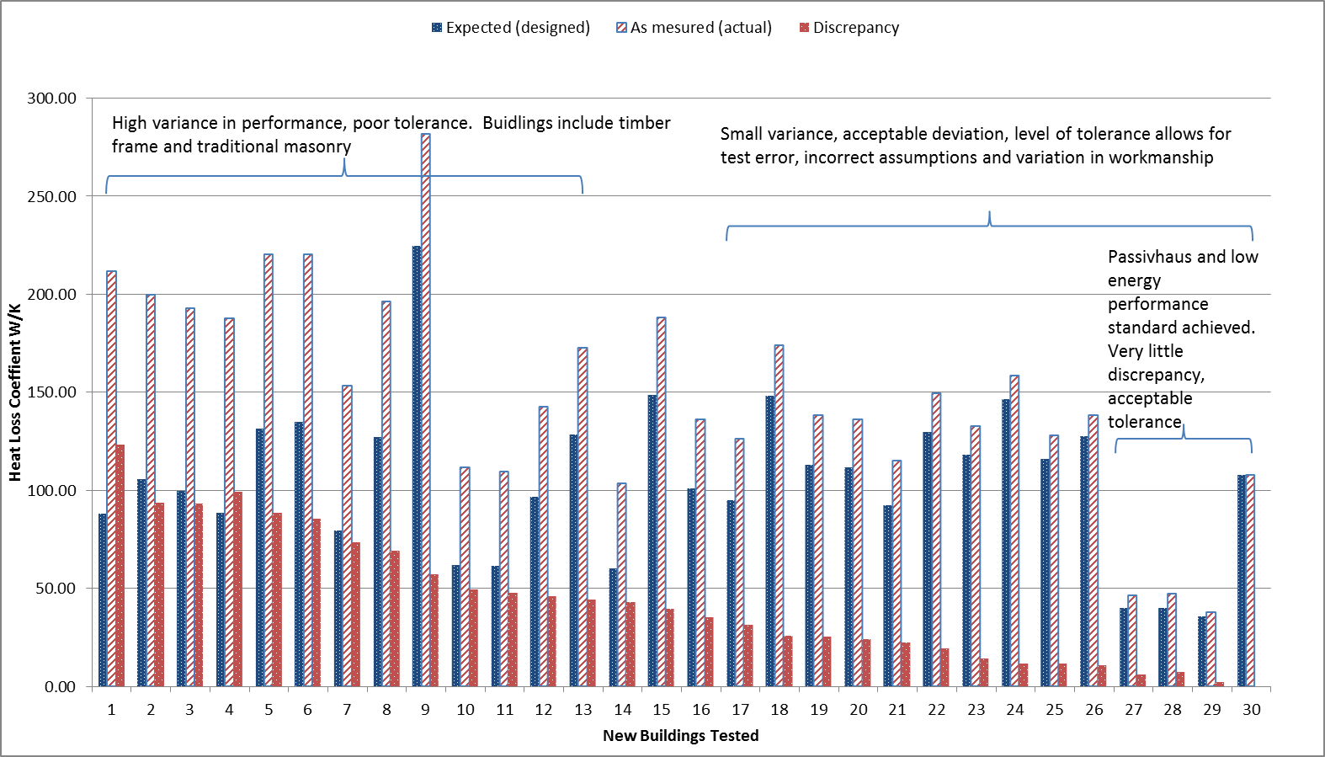

Figure 1: Heat loss studies conducted in the UK – new build (adapted from Johnston et al., 2014)

In light of wasted energy, of real concern is the degree that a building’s fabric performance differs from that specified, especially as current regulation is aimed at design (CLG, 2009). Figure 1 shows the results of heat loss studies, providing an accurate assessment of the building fabrics thermal performance, using a co-heating methodology (Johnston et al., 2013). In most cases, the buildings on the left of Figure 1 show the measured (actual) thermal performance being very different to the predicted resistance (as designed). The evidence from whole building heat loss tests shows, that it is not uncommon for dwellings to experience 60% greater heat loss than designed (Gorse et al. 2013; 2014). Where such differences occur buildings do not offer the thermal resistance required and cannot be controlled effectively. The first step towards a change to a more effective building stock is to understand building behaviour, recognise the actual performance, and then to apply appropriate remedies to improve performance. The measurement and monitoring of building performance is important so the building’s energy behaviour can be understood. The results of recent studies, that also include passive fabrics, which align closely with nearly zero energy targets, show that it is possible to achieve performance within acceptable levels of performance tolerance, such as those shown to the right of Figure 1. However, other simple airtightness tests show how variable performance of existing and retrofitted fabrics can be.

How effective are our building envelopes: why control air penetration?
Simple airtightness tests have been particularly revealing when assessing the effectiveness of the external envelope. In a small airtightness study on a varied sample of existing buildings in the UK, Gorse et al. (2015) found some buildings were so ‘leaky’ that it was not possible to perform heat loss tests using standard electrical heating equipment. The power required to elevate the whole house to a sufficient temperature above its surroundings would have overloaded the property’s domestic electric supply. The implications being that such buildings are so poorly constructed or maintained and so ‘leaky’, that they do not provide an effective envelope. In relatively small buildings, air changes rates of 16 – 29 h⁻¹ @ 50 Pa were found in properties that had been previously occupied. In the leakiest buildings the conditions observed suggested that it would not be possible to adequately heat the whole building during winter conditions.
Air testing in buildings that have been retrofitted can be revealing. In similar building typologies with similar retrofit measures, but installed by different contractors, air permeability results were different. Where thermal insulation was installed, but floor and edge seals were overlooked improvements were limited, changing from 24 to 20 m³/ (h.m²) @50Pa. In properties, where due attention was given to detail and workmanship, ensuring seals were effective, changes from around 19 to 4.73 m³/ (h.m²)@50Pa and 16.77 to 6.43 m³/ (h.m²)@50Pa were achieved. Thus, in some properties, significant improvements were made while in others, for a similar cost, the improvement was minimal. Determining the level of airtightness is a relatively straightforward commercial test and could be used to assist retrofit programmes. Furthermore, the introduction of a thermal survey during the heating season under depressurisation provides valuable information on the building’s behaviour and where air leakages occurs. Recognising air infiltration and exfiltration through simple observations and providing appropriate remedies can improve air tightness.
The consequences of underperforming fabrics are not limited to the detrimental impact on energy use and the environment; occupants are directly affected, incurring higher bills and accommodating substandard living conditions, health problems and increasing risk of fuel poverty (Santamouris et al. 2014). With some buildings, poor air tightness can mean that adverse weather could strip a building of all of its heated internal air within minutes. Thus, in the midst of winter, exposed to wind pressure, occupants would be unable to achieve an adequate heated environment. Fabric performance is essential for energy control and satisfactory living.

Emerging tests: Measuring whole building thermal performance
To understand how the building fabrics perform researchers have focused on different assessment methods and how to develop the methods so that they become commonly accepted diagnostic tools (Stafford et al. 2014; Erkoreka et al. 2015). As the assessment methods improve it may be possible to obtain characteristic energy behaviour through in-use energy monitoring enabling the energy efficiency of the building fabric and services to be gathered instantaneously. However, such real time evaluation and energy efficiency control is not widely available. The current focus remains on field test although new tests, as outlined below, are emerging.
During the six stages of a retrofit project within a controlled laboratory, the Saint-Gobain team used a relatively new method to measure heat loss. The Quick U-value of Buildings method (QUB) was used and cross checked with the Leeds team’s co-heating test (Farmer et al., 2015). The Energy House facility, a whole house contained within a climate chamber, meant it was possible to perform test separately and sequentially, under the same controlled external conditions, something which is not possible to achieve in the field. The Quick U-value of Buildings (QUB) is a diagnostic method that enables the heat loss coefficient (heat transfer through unit area) to be calculated over one or two nights. It measures the temperature response during a heating and free cooling period. A level of uncertainty is estimated to be ± 15% when performed on a single night which becomes less as the test period is extended (Pandraud et al., 2014). The cross checking of the methods showed a close fit (Farmer et al., 2015).

Other methods, based on in-use monitoring data have also been cross checked with the co-heating tests and show comparable results. Methods that use the buildings own heat system with smart meters to check energy required to elevate the building temperature are currently being developed and provide a less resource intensive methods of testing the building’s thermal resistance and the heat system’s efficiency (Farmer, 2015). As more is understood about the characteristic energy signatures that could be obtained from such methods, both during occupied and unoccupied periods, the potential to assess the performance of buildings and impact of occupant behaviour can be understood. Understanding building performance is only useful if the performance is fed back to a system model. The fabric provides just one aspect of building performance, but it is essential that this aspect is understood and controlled first.

A proposition for better understanding, feedback and control
As over half of a building’s energy is attributable to the conditioning of a building’s internal environment, fundamental to energy reduction is to ensure that this space is thermally enclosed and can be controlled. Without being able to control the internal environment users are limited in attempts to change to more energy efficient behaviour. Conversely, if the building’s envelope provides an effective enclosure and the thermal resistance, capacity and storage is understood then users can, if they desire, adopt appropriate behaviour. It is possible to reduce overheating and eliminate space conditioning during unoccupied periods. However, without effective control and understanding of the building, influencing user behaviour change will be problematic.

Figure 2 provides a schematic showing where energy efficient control and influence can be achieved. If the building space is of a known quantity and the energy demand to condition the building can be accurately predicted and the services properly specified. If services are installed, commissioned and regulated correctly, the building system can provide a functioning facility and, subject to occupant behaviour, the potential energy efficient gains can be realised. With effective feedback, the occupants can accommodate their conditioning demands, so that energy is only used when needed. If the building has good thermal storage capacity and there is potential for pre-heating on a lower energy tariff, reducing peak grid demand, then more effective energy use can be achieved.
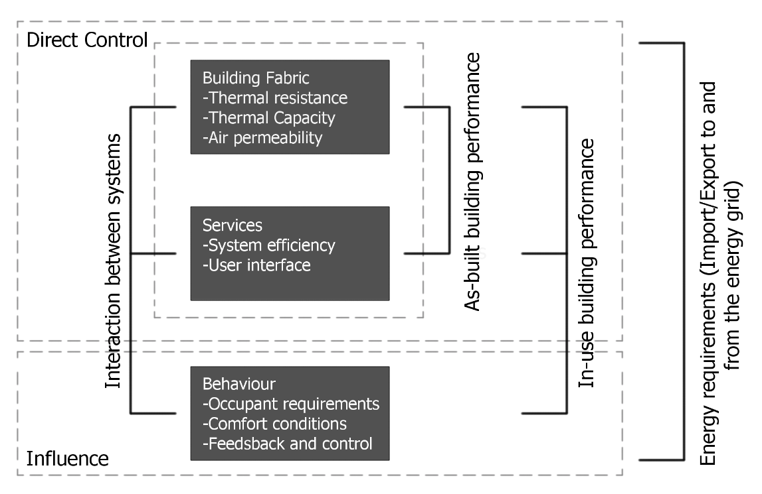
Figure 2. Essential Energy Efficiency Link: Building effective integration

Conclusion
Heat energy is unintentionally lost and wasted through poorly insulated, designed or constructed buildings, resulting in a performance gap. Associated emissions can be reduced by ensuring the envelope is effective, provides the necessary thermal performance and air tightness. Understating the building fabric and enclosure performance is a fundamental requirement if control of the internal space is to be achieved. By understanding building behaviour and gaining control of the building further efficiency gains can be achieved through efficient operation of the services.

The methods used to accurately measure building performance exist, but their use is contained largely to scientific studies, however new less resource intensive test are emerging that show greater potential for in-use diagnostics. As more studies are undertaken and buildings are tested and monitored, knowledge about their actual behaviour will enable change to the way buildings are understood, operated and serviced.

One of the main findings of the forensic analysis undertaken on building fabric is that the most common faults occur where the integrity of the air and thermal barriers are breached. Thus, the connection and continuity of the thermal envelope and the air barrier should be maintained in design and when built. The performance gap work reported shows there is considerable potential to change and reduce associated energy emissions. The work demonstrates that some buildings are achieving considerable reductions in energy use through changes to their thermal properties. The work also highlights buildings that have achieved high standards in design and construction, the findings of such studies providing an important step in achieving low energy and nearly zero energy buildings. Evidence suggests that reductions in energy use and related emissions can be achieved with new and retrofit buildings in the UK.

References
Barras, C (2013) The father of all men is 340,00 years old, New Scientist, Life, 13, March 2013. http://www.newscientist.com/article/dn23240-the-father-of-all-men-is-340000-years-old.html#.VUceeO9OWpo>

Boss, A (2009) The Crowded Universe: The search for living planets. New York, Basic Books

Ceballos, G., Ehrilich, P. R., Barnosky, A. D., Garcia, A., Pringle. R. M. and Palmer, T. (2015) Accelerated modern human-induced species losses: Entering the sixth mass extinction. Science Advances, 19/6/15. 1(5)

CLG (2009) Planning, building and the environment, Proposed Changes to Part L and Part F of the Building Regulations: A consultation Paper. Communities and Local Government, 18 June 2009, <http://webarchive.nationalarchives.gov.uk/20120919132719/http://www.communities.gov.uk/publications/planningandbuilding/partlf2010consultation>

DECC (2014) Energy consumption in the UK, Department of Energy and Climate Change. 31st July 2014. <https://www.gov.uk/government/uploads/system/uploads/attachment_data/file/337452/ecuk_chapter_1_overall_factsheet.pdf>

EPBD (2010) Energy Performance Building Directive, 2010/31/EU, Directive 2010/3/EU of the European Parliament and of the Council, 19 May 2010, Official Journal of the European Union. < http://eur-lex.europa.eu>

Erkoreka, A. Gorse, C. A. and Fletcher (2015) Decision tree for testing and analysis, International Energy Agency Annex 58. Guide and Decision Tree: DYNASTEE ,< http://dynastee.info/decision-tree-for-testing-and-analysis/>

Farmer, D, Brooke-Peat, M, Miles-Shenton, D, Cuttle, C. and Gorse, C (2014 a) Sain-Gobain Energy House Thermal Upgrade Testing, Technical Report, Leeds Sustainability Institute, Leeds Beckett University, Unpublished

Farmer, D (2015) Characterisation of whole house thermal performance using its heating system. Leeds Beckett University. PhD work in progress.

Gorse, C. A, Glew, D, Miles-Shenton, D, Farmer, D and Fletcher M. (2013) Building Performance: Fabric, impact and implications, Sustainable Building 2013 Hong Kong Regional Conference, Urban Density & Sustainability, 12 -13 September 2013 < http://sbconferences.org/sb13hongkong>

Gorse, C. A, Glew, D, Stafford, A, Fylan, F, Miles-Shenton, D, Farmer, D, Fletcher M. Smith, M, Throup, G, and Brooke-Peat, M, Parker, J and Johnston, D (2015) DECC Core Cities Monitoring and Evaluation Project - Green Deal Trial, Reports 1 - 4, DECC, Leeds Sustainability Institute, Leeds Beckett University, Unpulished.

Hawkins, E and Sutton R (2009). Bulletin Of The American Meteorological Society Vol 90 (8) 1095-1107

Johnston, D, Miles-Shenton, D, Farmer, D and Wingfield, J. (2013) Whole House Heat Loss Test Method (Coheating), Centre for the Built Environment, Leeds Metropolitan University (renamed Leeds Beckett University), June 2013, <www.leedsmet.ac.uk/as/cebe/projects>

Johnston, D and Farmer, D and Brooke-Peat, M and Miles-Shenton, D (2014) Bridging the domestic building fabric performance gap. Building Research and Information. ISSN 0961-3218

Joshi, M., Hawkins, E., Sutton, R., Lowe, J and Frame, D. (2011) Projections of when temperature change will exceed 2ºC above pre-industrial levels. Nature Climate Change 1, 407-412

Jowit, J. (2010) Humans driving extinction faster than species can evolve, say experts. The Guardian, 7 March 2010 < http://www.theguardian.com/environment/2010/mar/07/extinction-species-evolve>

Manhesa, G, Allègre, C. J., Dupréa, B. and Hamelin, B. (1980) Lead isotope study of basic-ultrabasic layered complexes: Speculations about the age of the earth and primitive mantle characteristics. Earth and Planetary Science Letters 47 (3): 370–382.

Mazza, E. (2015) NASA’s Bold New NExSS initiative will search for signs of life on other planets, The Huffington Post 04/23/15. < http://www.huffingtonpost.com/2015/04/23/nasa-nexss-search-for-life_n_7123788.html>

Met Office (2009) Science driving our response to climate change, Ban Ki Moon, World Climate Conference, 3 September 2009 <http://www.metoffice.gov.uk/media/pdf/f/d/COP15_Informing_Mitigation.pdf>

Mueller, P (2011) The Sahel is Greening, The Global Warming Policy Foundation, Briefing Paper No 2, Global Warming Policy Foundation, (http://www.thegwpf.org/images/stories/gwpf-reports/mueller-sahel.pdf)

NASA (2011) NASA’s Hubble Finds Most Distant Galaxy Candidate Ever Seen in Universe. NASA <1.26.11.http://www.nasa.gov/mission_pages/hubble/science/farthest-galaxy.html >

Oliver, J. G. J., Jenssens-Maenhout, G., Muntean, M and Peters, J.A.H.W. (2013) Trends in global CO2 emissions: 2013 report, Netherlands Environmental Assessment Agency, The Hague < http://edgar.jrc.ec.europa.eu/news_docs/pbl-2013-trends-in-global-co2-emissions-2013-report-1148.pdf>

Oreszczyn, T and Lowe, R (2010) Challenges for energy and buildings research: objectives, methods and funding mechanisms. Building Research & Information, 38 (1) 107 - 122.

Palmer, J. and Cooper, I. (2013) United Kingdom Housing Energy Fact File 2013. Cambridge Architectural Research, Eclipse Research Consultants and Cambridge Energy, Report prepared under contract to Department of Energy & Climate Change, London, UK.

Pandraud, G, Gossard, D, and Alzetto, F. (2014) Experimental optimization of the QUB method, IEA EBC Annex 58, 6th Expert meeting, Ghent, Belgium 14-16 April 2014

Parliament UK (2013) Energy and Climate Change Committee – Minutes of Evidence HC 60, Oral Evidence Taken before the Environmental Audit Committee, 12th June 2013 http://www.publications.parliament.uk/pa/cm201314/cmselect/cmenvaud/60/130612.htm

Petigura, E. A., Howard, A. W., Marcy, G. W. (2013) Prevalence of Earth-size planets orbiting Sun-lie stars. Proceedings of the National Academy of Sciences of the United States of America 110 (48) 19175-19176

Prism Environmental (2012) Construction Sector Overview in the UK, report for the European Commission <http://www.prismenvironment.eu/reports_prism/UK_PRISM_Environment_Report_EN.pdf>

Santamouris, M. Alevixos, S.M. Aslanoglou, L. Mantzios, D, Sarelli, I, Karatasou, S. Cartalis, K. and Paravantis, J. A. (2014) Freezing the poor – Indoor environmental quality in low and very low income households during the winter period in Athens, Energy and Buildings, 70: 61-70

Stafford, A., Johnston, D., Miles-Shenton, D., Farmer, D., Brooke-Peat, M. and Gorse. C. (2014) Adding value and meaning to coheating tests, Structural Survey, Vol 32, (4), pp 331-342

Stafford, A, Gorse, C. and Shao, L (2012a) The Retrofit Challenge: Delivering Low Carbon Buildings, Report no. 4. Energy Saving Trust & Low Carbon Futures,<[www.lowcarbonfutures.org>, March 2012

Stafford, A, Bell, M. and Gorse, C., (2012b) Building Confidence: A Working Paper, Report no. 8. Energy Saving Trust & Low Carbon Futures, <www.lowcarbonfutures.org>, March 2012

Vadera, S., Wools, P., Flint, C., Pearson, I., Hodge, M., Jordon, W. and Davies, M. (2008) Strategy for Sustainable Construction, HM Government, June 2008, <http://webarchive.nationalarchives.gov.uk/+/http:/www.bis.gov.uk/files/file46535.pdf>

World Economic Forum (2013) Has climate change tipped out of control? World Economic Forum, 9th Jan 2013. <https://agenda.weforum.org/2013/01/has-climate-change-tipped-out-of-control>

ISO (1994) ISO 9869: Thermal insulation – Building elements - In situ measurement of thermal resistance and thermal transmittance. Geneva, Switzerland, International Organization for Standardisation.

