ISB 2015
Lower Limb
ISB 2015-131
THE ROLE OF GENDER ON THE VARIABILITY OF JOINT KINEMATICS AND KINETICS IN UNINJURED ATHLETES DURING A MATCH SPECIFIC LAND-CUT TASK
S Clarke^{* 1}, I C Kenny², A J Harrison²
¹Leeds Beckett University, Leeds, United Kingdom, ²University of Limerick, Limerick,

Preferred Presentation: Oral Presentation
If your abstract is not accepted as an oral do you wish to be considered for a poster?: Yes
Clinical Biomechanics Award: No
David Winter Young Investigator Awards: Yes
David Winter Award - presentation Preference: Oral
Emerging Scientific Award sponsored by Professor J De Luca: No
Promising Scientist Award sponsored by Motion Analysis: No
Introduction and Objectives: Higher levels of movement or coordination variability have been reported to provide flexibility and allow adaptations to complex dynamic sport environments [1]. Decreased movement and coordination variability has been previously been reported in females [2] and proposed as a risk factor for injury. The aim of this study was to compare the variability of hip and knee joint kinematics (movement) variability and lower extremity joint and segment coupling (coordination) variability in healthy males and females during a dynamic landing task. There is a scarcity of information on gender differences in coordination and movement variability during dynamic landing and cutting tasks. This information may provide valuable insight to further explain the gender bias of ACL injury, where lower levels of movement and/or coordination variability may increase injury risk.
Methods: Ten healthy males and ten healthy females were recruited for this investigation. Participants performed a dynamic task (see Figure 1) which involved dropping from a 0.30 m bench, and performing an immediate jump to touch a target and on landing perform a side cut in a randomly cued direction. Five intralimb couplings were calculated using a modified vector coding technique [3]; thigh abduction-adduction leg abduction-adduction, thigh rotation leg rotation, hip abduction-adduction knee rotation, hip rotation knee abduction-adduction, knee rotation knee abduction-adduction. Variability of the normalised coupling and joint angle timeseries was calculated point by point and averaged during the initial 40% of landing and the push off phase of cutting (70-100%). Differences in average variability were assessed using independent t-tests or Mann-Whitney U tests. Cohen's d was utilised as a measure of effect size with a 0.2=small, 0.5=moderate, >0.8=large, scale.
Results: During the initial deceleration period of landing, females demonstrated significantly less movement variability at the knee in the transverse plane on both legs (Table 1) and coordination variability in two of the five couplings examined on the dominant leg (Table 1) when compared to males. During the final push off phase of the cutting movement, females also demonstrated significantly less movement variability at the non-dominant knee and hip in the frontal plane and the dominant and non-dominant hip in the transverse plane (Table 1). No gender differences in coordination variability were noted for either leg during the final push off phase of the cutting movement for any of the examined couplings.
Figure:
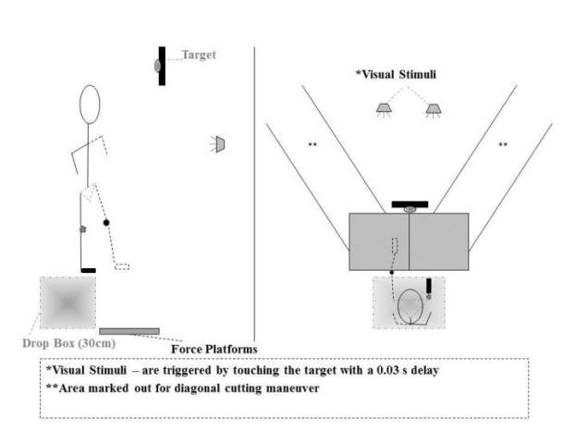
Conclusion: These findings may help explain the gender bias in ACL injury incidence. Reduced female coordination variability could also result in less flexible coordination patterns during match situations, with a decreased ability to adapt to perturbations experienced in game play. Poor adaptation to these perturbations may result in an unsafe movement response in females which are associated with the occurrence of an ACL injury. DISCLOSURE: The Irish Research Council for Science Engineering and Technology is acknowledged for its funding of the lead author for the completion of this work. All authors declare no conflict of interest.
Table:
 |  | Dominant | Leg | Non-Dominant | Leg
MOVEMENT | VARIABILITY | MALE | FEMALE | MALE | FEMALE
Landing | Knee Internal-Ext Rot | 3.26 | 1.53 | 3.10 | 1.52
Cutting | Knee Internal-Ext Rot |  |  | 4.37 | 3.53
" | Hip Int-Ext Rotation | 3.72 | 2.29 | 4.22 | 2.68
COORDINATION | VARIABILITY | MALE | FEMALE | MALE | FEMALE
Landing | Thigh-Rot Leg-Rot | 26.60 | 23.15
" | Hip-Rot_ Knee-Ab-Ad | 20.57 | 19.24
“ | Hip-Ab-Ad_ Knee-Rot |  |  | 21.08 | 23.50
“ | Knee-Rot_ Knee-Ab-Ad | 23.99 | 22.12

Caption: TABLE1 CAPTION: Significant gender differences in the average variability of 3D Joint Angles and joint couplings during landing & cutting..
References: Reference 1
Mullineaux, D. R., & Uhl, T. L. (2010) Coordination-variability and kinematics of misses versus swishes of basketball free throws. Journal of sports sciences, 28(9): 1017-1024.
Reference 2
Pollard C, Heiderscheit B, van Emmerik R, Hamill J. (2005) Gender differences in lower extremity coupling variability during an unanticipated cutting maneuver. Journal of Applied Biomechanics. 21(2):143.
Reference 3
Sparrow W, Donovan E, Van Emmerik R, Barry E. (1987) Using relative motion plots to measure changes in intra-limb and inter-limb coordination. Journal of Motor Behaviour. 19(1):115-129.

Disclosure of Interest: S. Clarke Conflict with: The Irish Research Council for Science Engineering and Technology., I. C. Kenny: None Declared, A. J. Harrison: None Declared

