Gorse, C.A. Thomas, F, Miles-Shenton, D. Farmer, D, Glew, D and Johnston, D. (2015) Understanding Building Performance: Implications of heat loss and air permeability on building control, Journal of Zero Carbon Building, Vol 4, pp 36-49 <http://zcb.hkcic.org/Eng/InformationCentre/Publications.aspx>

Professor Christopher Gorse BSc (Hons), MSc. PhD, MCIOB, MAPM, ILTM, Cert. Ed, Dip (Ed.), Dip (H&S).
Chris is the Professor and Director of the Leeds Sustainability Institute, Leeds Beckett University. He has over 20 years of industry and academic experience in research, commerce and innovation. He has written extensively on buildings, construction law, education, management, energy efficiency and sustainability. Through current projects that Chris directs, research is being undertaken in building simulation, data integration, modelling, building physics, building performance, manufactured build processes, occupant energy behaviour, renewable energy and sustainability.

Felix Thomas

Felix Thomas is a Research Assistant at the Leeds Sustainability Institute, with expertise in design, architectural technology, building performance and sustainability. Felix is currently involved in a range of the CebE group’s activities, primarily the DECC retrofit field trial and the coordination of learning programmes based on sustainability.

Dominic Miles-Shenton

Dominic Miles-Shenton is a Senior Research Fellow at the Centre for the Built Environment (CeBE). Since joining the group in 2004 he has been measuring the actual performance of building fabrics, particularly the relationship between as-designed and as-built building performance. Areas of expertise include building performance and evaluation, building physics, airtightness, sustainable design, co-heating testing, thermal imaging, in-situ building component testing and building process evaluation
David Farmer
David Farmer is a Research Fellow at the Leeds Sustainability Institute, Leeds Becket University. He is primarily involved with assessing the energy performance of buildings, combining in-situ fabric and services test methodologies with data analysis techniques. His work has included building performance evaluation on new and existing dwellings, as well as in-use monitoring projects. He is currently developing a methodology to characterise whole house heat loss.
Dr David Glew
Dr David Glew is a Senior Research Fellow at Leeds Sustainability Institute. David's research interests are around the performance gap between as-built and designed energy efficiency in buildings. This incorporates on site testing of building fabric, dynamic modelling of buildings and the in-use monitoring of energy consumption in occupied buildings. He is also interested in the ramifications of the performance gaps in terms of Greenhouse Gas emissions and performing Life Cycle Assessments on products and processes
Professor David Johnston
David is a Professor at the Leeds Beckett University, his work has focused on predicted and the measured performance of buildings and the performance gap. His work in this area has involved developing methodological approaches to assessing the fabric performance of buildings, exploring the techniques that can be used to quantify the size of the performance gap, identifying the reasons why this ‘gap’ is important and examining the various factors that contribute to the performance gap.

Understanding Building Performance: Implications of heat loss and air permiability on building control
Christopher Gorse, Felix Thomas, Dominic Miles-Shenton, David Farmer, David Glew and David Johnston

Leeds Sustainability Institute, Leeds Beckett University, Leeds, United Kingdom
e-mail: C.Gorse@leedsbeckett.ac.uk

With the built environment being one of the largest contributors to anthropogenic emissions, it is essential that building energy demand is controlled, cleaner energy sourced and emissions reduced. However, aligning demand with supply is challenging, as building performance is variable and largely unknown. Central to understanding energy demand is the ability to quantify the energy required to comfortably condition a building and the role that the building envelope plays in effectively enclosing the space. Unfortunately, relatively little is known about building fabric features and how different aspects affect performance under real conditions. Of serious concern and a factor that impacts greatly on control, is the degree that a building’s fabric performance differs from that which is expected. Many buildings do not offer the thermal resistance required to meet their design intent. Where variations in fabric thermal performance are significant this will prove a barrier to the effective use of energy and affect the control of buildings. For effective control, the building demand under different environmental conditions should be relatively stable.

The building behaviour and response must be a known quantity. This paper explores air tightness studies in existing and retrofit properties, demonstrating how some buildings have the capacity to be stripped of all conditioned air, while others prove more airtight. Furthermore, results of whole building heat loss tests on new buildings are presented showing the variance in heat loss coefficient, an established indicator of difference in designed v’s as-built performance. The work also demonstrates that energy efficient, thermally resistant, building enclosures can be built within acceptable tolerance; such fabric solutions being key to the nearly zero energy buildings required. The results provide an important step in understanding what is required to achieve the control necessary to move towards energy flexible and efficient buildings.

Keywords: building energy demand, energy flexible buildings, energy monitoring, performance gap, themal building performance

Introduction: Buildings and the environment
The Intergovernmental Panel on Climate Change (IPCC) have confirmed that the world’s climate is changing due to anthropogenic carbon dioxide (CO₂) emissions (IPCC, 2014). Approximately 34% of man-made CO₂ emissions come from the built environment (United Nations Environment Program, 2007), representing 45% of the UK’s total carbon footprint (The Carbon Trust, 2009), with space heating loads accounting for the greatest proportion of emissions (Pérez-Lombard, 2008; Palmer & Cooper, 2013). Heating loads make up 62% of the total energy used in homes (Palmer and Cooper, 2013; DECC, 2013; DECC, 2014). Thus, the construction industry carries a significant burden, being responsible for the largest share of emissions by some way (EC report by Prism Environment, 2012).

Regulations and European Directives are driving change for new build, and the retrofit of the existing stock will follow (CLG, 2009; EPBD, 2010). As it is estimated that 87% of existing buildings will remain operational by the year 2050 (Kelly, 2009), the thermal upgrading of buildings will have a significant role in reducing overall CO₂ emissions. The value of such change is already recognised and the housing stock is legislated to become more energy efficient (Vadera et al., 2008; EPBD, 2010). Despite this, the understanding of the measures that are required to be undertaken is relatively limited and still developmental.

Reducing the energy use associated with buildings has been identified as a key, relatively easy and cost-effective strategy within existing policy. Conversely, if buildings do not deliver the required energy savings, then CO₂ reductions will become very difficult to achieve (Oreszczyn and Lowe, 2010). In order to meet the aspirational targets of nearly zero energy buildings in the UK by 2016, for domestic buildings, ahead of the Energy Performance of Buildings Directive 2020 target (EPBD, 2010); a better understanding of real building performance is required. The thermal characteristics of buildings needs to be measured and tested in the field to understand their response to changes in their internal and external environments, and the energy demanded to achieve a stable and comfortable internal environment.

When building fabrics provide sufficient thermal resistance, the capability to control building spaces and move towards more efficient energy exchanges becomes possible and the balancing supply and demand more achievable. While nearly or net zero carbon is the target (EPBD, 2010); high performing fabrics that result in buildings with controllable low energy demand are required as a neutral energy balance is almost impossible to achieve without energy efficiency (Hermelink et al., 2013).

Control of energy demand
There is a need to control building energy demand so that the energy required for space heating can be better aligned with a decarbonised supply. It has been recognised that the concepts of low energy buildings, with passive fabric measures, such as Passivhaus type buildings, with renewable energy offer one of the more common approaches to achieving net zero energy buildings (Hermelink et al., 2013). Cleaner energy needs to be sourced to reduce emissions and meet the 80% reduction by 2050, based on 1990 levels (Climate Change Act 2008). However, to use decarbonized energy sources better control of demand will be required.

The methods of capturing and transferring energy, often referred to as ‘energy generation’, are changing. Energy providers are reducing their reliance on fossil fuels moving to more variable renewable energy or nuclear sources that cannot easily be switched on and off. Methods of controlling demand are important for energy efficiency and carbon reduction; there needs to be effective and efficient use of energy available. Ensuring that supply meets demand has become a challenging proposition. However, attempts to balance this situation will become significantly easier, if building energy demand can be controlled. The notion of energy flexible buildings is desirable, furthermore, where building energy demand is controllable it has the potential to relieve stress on the energy generation infrastructure (Cioffi et al., 2012; Bley, 2014; Østergaard Jensen, 2015). The first step is to ensure that the fabric is effective at maintaining a controllable and condonable environment with low or zero energy demand.

Methodology
A key step to net zero energy buildings is to establish the energy required to comfortably condition a building and to ensure the building is performing as expected. For economical and energy efficient use, factors such as thermal resistance, heat capacity and the ability of the building to draw energy when available play an important role in the economics of net zero and energy flexible buildings. The reliable measurement and assessment of buildings is fundamental so that demand can be predicted. The energy required to condition the building must be known and the role that the building envelope plays in effectively enclosing the space and thermally separating the internal and external environment must be understood. Unfortunately, relatively little is known about fabric performance under real conditions. The degree that heat energy flows through the fabric’s plane elements, junctions and thermal bridges, as well as accounting for the volume of air that bypasses insulation, must be understood if demand is to be accurately predicted.

Importantly, the building fabric should be of a sufficient quality and level of performance; providing a thermally resistant, sufficiently airtight and sealed enclosure so that users can control their environment and accommodate optimal energy behaviour. Users need the ability to stabilise and control their internal environment, if they are to make the most effective use of the energy available to them.

In this paper a review of research programmes undertaken by Leeds Beckett University is provided. In particular the review draws on the research of a party wall study to demonstrate the variability in element performance that takes place when voids connect and the insulation properties are bypassed. Further to this, air permeability studies of whole buildings are discussed to explore the differences enclosures and retrofits achieve in reducing undesirable leakage. Finally, the presentation of heat loss coefficients for 30 new buildings are presented. The work is used to demonstrate the differences in predicted and measured performance. The predictions are produced from a combination of specified and design performance values (notional design requirements) compared with the actual performance measured in the field when built. The review of heat loss coefficient provide an overview of the differences found.

RESEARCH METHODS
The research reported here spans a period of over 10 years. During this period a number of research methods were used for performance measurements. Those most pertinent to the work reported are highlighted below. Further information on the methods is available at the Leeds Sustainability Institute (http://www.leedsbeckett.ac.uk/as/cebe/).

Steady-state thermal performance measurements
The measurement of in situ U-value and whole house heat loss requires a steady-state test environment where a level of internal temperatures can be controlled and variations in external conditions monitored. The whole building heat loss tests (Johnston et al., 2013) provide ideal conditions for monitoring heat flux through the fabric and elements of the building envelope. The thermal transmittance of a building element (U-value) is defined in ISO 7345 as the “Heat flow rate in the steady-state divided by area and by the temperature difference between the surroundings on each side of a system” (ISO, 1987, p.3). U-values are expressed in W/m²K. In situ U-value measurements were undertaken in accordance with ISO 9869 (ISO, 1994). In situ measurements of heat flux density, using heat flux plates (HFPs) from which in situ U-values were derived, were taken at different locations, depending on the nature of the thermal elements under investigation. It would be usual to use an array of five or more heat flux sensors to ensure an average heat transfer for an element could be established. Generally, measurements of heat flux density were taken from locations considered not to be significantly influenced by the thermal bridging at junctions (typically readings are taken at distances greater than 1000 mm from the junctions and thermal bridges).

The predicted U-values were calculated in accordance with BS EN ISO 6946 (BSI, 2007), SAP or the RdSAP assumed U-value assumed (BRE, 2012).

Steady-state whole house heat loss measurements (Heat Loss Coefficient)
The heat loss coefficient (HLC) is the rate of heat loss (fabric and ventilation) in watts (W) from the entire thermal envelope of a building per kelvin (K) of the temperature differential between the internal and external environments. The HLC is expressed in W/K. A modified version of Leeds Beckett University’s Whole House Heat Loss Test Method (Johnston et al., 2013) is used obtain HLC measurements during steady-state measurement period, normally this is 7-14 days, where the internal temperatures were maintained at a constant temperature (the constant being fixed at a temperature between 22 and 25 ºC depending on the nature of the building and external conditions). The HLC represents the aggregate of the plane element, thermal bridging and ventilation heat losses.

Relative humidity
Where possible relative humidity (RH) is monitored within the test buildings. RH is monitored to establish whether the air moisture content changes during test periods. Changes in moisture content can have a significant impact upon the thermal conductivity of the building fabric.

Airtightness testing and Building pressurisation tests
Building pressurisation tests using a blower door in accordance with ATTMA L1 (ATTMA, 2010) are performed to establish the airtightness. An estimation of the background ventilation rate is derived from the air leakage rate at 50 Pascals. The airtightness value is used to isolate the ventilation heat loss components of the HLC using the n/20 rule (Sherman, 1987). The conditions present during the pressurisation tests provide the opportunity for leakage and air infiltration identification. During pressurisation leakage detection can be performed using a smoke puffer stick. Occasionally, where building owners allow a whole building smoke leakage detection test has been undertaken, using a high volume smoke generating machine. During depressurisation stage of testing, under elevated temperatures conditions within the dwelling infrared thermography can be used to observe areas of air infiltration and thermal bypass.

Thermography
Thermographic surveys are undertaken as part of the building forensics. The surveys are undertaken in accordance with the guidance set out in BSRIA Guide 39/2011 (Pearson, 2011). Thermography is used to observe surface temperature distribution and thermal anomalies within the building fabric. Using thermograph under depressurisation, air infiltration points and paths can be identified.

Thermal bridging calculations
Thermal bridging calculations are often performed at the junctions to ascertain the linear thermal transmittance (Ψ-value) and minimum temperature factor (ƒ_{min}). Thermal modelling is used to calculate thermal bridging. Modelling is undertaken using the Physibel TRISCO version 12.0w (Physibel, 2010). Conventions BR 497 (Ward & Sanders, 2007) are followed where appropriate. The thermal conductivity (λ) of materials for the models are sourced from manufacturers’ literature where possible based on the project specification. In instances where these could not be obtained, suitable values are sourced from BS EN 12524 (BSI, 2000) or from BR 443 (Anderson, 2006). The geometry of junctions is based on the original design drawings and specification or from site observations during the research and testing period.

BUILDING FABRIC CONTROL
As half of a building’s energy is attributable to the conditioning of building space, it is of crucial importance that the dwelling’s behaviour during heating periods is understood. In Northern European Climates, one of the main concerns is with the peak energy required during the heating periods in the winter months. One factor that can have a significant influence on the energy use and CO₂ emissions attributable to the space heating system is the thermal performance of the building fabric. If the building’s thermal performance is poor both the peak and net energy demand are likely to be higher. There is a growing body of research indicating that the thermal performance of the building fabric in-situ is poorer than that predicted, when tested under steady-state conditions (see Doran and Carr, 2008; Hens, 2012). Although the building envelope acts as a thermal barrier, research has shown that the effectiveness of the barrier can vary considerably (Panel, 2015). Enclosures that are not air tight or thermally resistant, fail to offer effective barriers; thus, the internal conditioned space is at the mercy of the external environment, changing as external temperature and wind changes.

Air exchanges and bypasses occur at whole building and elemental levels and both should be considered to ensure the fabric offers the required resistance enabling the conditioned building space to be controlled. A recent study of heat losses through party walls provides an example of uncontrolled heat exchanges which has impacted on design and regulation.
Figure 1 shows the heat flow into a cavity party wall between two buildings. The graph shows apparent U-values, not accounting for the dynamic effects, such as thermal lags, but clearly shows the behaviour of the wall during the observation. To establish the effective U-values calculations were taken over a two day period. Heat flux measurements were taken as part of a research project to show the effectiveness of filling the cavity wall with mineral wool, in order to prevent air movement within the cavity and reduce heat exchanges with the external environment. The heat flows were recorded, with subsequent analysis providing effective U-values. Measurements were taken from an open unsealed cavity and after the cavity fill was introduced.
Prior to the recognition that the party wall contributed to heat flow through the building, the party wall was not treated as a heat loss mechanism in the building regulations (MIMA, 2009; Wingfield et al., 2010). As both sides of the party walls were assumed to be equally heated, the regulatory documents (used to guide design) assumed zero heat exchange and thus zero U-value. The new regulations now assume an unfilled open cavity is to be assigned a U-value of 0.5W/m²K, an unfilled cavity that has been effectively sealed against air infiltration will be assigned a U-value of 0.2 W/m²K and a fully filled and sealed cavity will assume a zero heat exchange of 0 W/m²K (CLG, 2009; DCLG 2013). Thus, the regulations now recognise that pervious assumptions with regard to net zero heat loss through the party wall were incorrect and the understanding of the energy demand of a building has changed. The changes, in part are a result of studies undertaken by Leeds Beckett University. As a result, the regulatory assumptions are closer to the type of behaviour shown in Figure 1. The observations in Figure 1, have been found to be typical of a number of studies conducted by Leeds Beckett University. The work shows considerable variance in open cavities with effective U-values generally operating and varying above 0.5W/m²K when voids connect and dropping to less than 0.2 W/m²K when the cavity is effectively filled and sealed. Since the discovery of this thermal bypass, research undertaken has been revealing, indicating how different building fabrics respond. The work also demonstrates that a considerable quantity of heat can be lost through, what may have previously been considered a minor, often overlooked, feature (see related publications CeBE, 2015).

What is revealing about this research is the degree of variability of heat flow within uninsulated cavities. A recent study of an unfilled masonry cavity was found to have a low U-value of ~0.30 W/m²K, further work is being undertaken to determine why there can be such high variance, with some walls performing and others not. Through forensic investigations, it has been shown that cavities often link to both the internal and external environments via connecting gaps and cracks in the fabric. The passages allow air to flow freely in response to internal and external pressure differences. In Figure 1, prior to the insulation being added, the fabric was not providing an effective separating barrier.

Prior to the insulation being installed the performance of the wall is variable with heat flow increasing and decreasing as the external conditions change. Once the insulation is installed the heat flow is reduced, the wall offers an effective thermal resistance and heat flow is stable and controlled. Currently, it is expected that most unfilled and partial filled cavity walls in the UK would exhibit the type of behaviour shown. The lack of consistent thermal resistance, in such walls, prevents the building fabric offering an effective barrier and reduces control over the conditioned space within the building. As the fabric behaviour was not expected to behave in the manner shown the services installed would not have been designed to accommodate the dynamic changes. Unless heating systems are oversized, it is unlikely that the services and building system will provide comfortable living spaces when such bypasses occur.

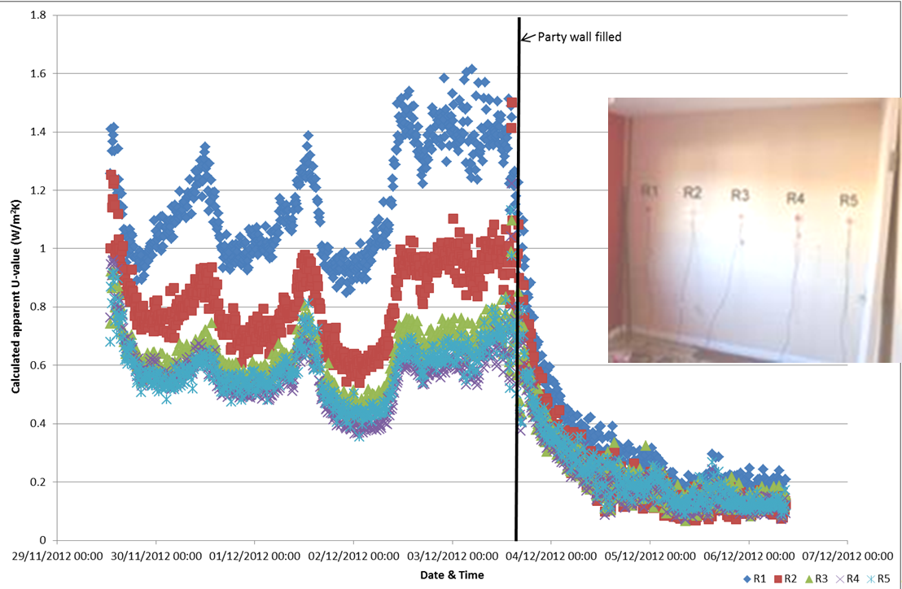
Figure 1: An unfilled cavity party wall exhibiting characteristic signs of thermal bypass and air movement, the full-fill intervention creates a fabric that controls air movement and significantly reduces heat loss. (Courtesy Leeds Beckett University and Knauf Insulation Research programme)

Air permeability: air leakage and air tightness and the impact on performance
The ability of the fabric to provide an effective envelope is not just affected by cavity walls. Building enclosures with solid and cavity wall construction can be prone to considerable variation in their air permeability. Tests, on a small and varied sample of existing buildings in the UK (Gorse et al., 2015), found some buildings to be so leaky that it would not be possible to adequately heat them using standard electrical heating equipment. The power required to elevate the whole house to a sufficient temperature above its surroundings would overload the property’s electric supply. Even if it were possible to heat the space, either using gas or electricity heat sources, the associated heating cost could be inherently prohibitive for some occupants, especially those experiencing fuel poverty. Some of the buildings studied were so poorly constructed, maintained and, or so, inherently leaky that they did not provide an effective envelope. In relatively small buildings, air changes rates of 16 – 29 h⁻¹ @50 Pa were found in properties that had been previously occupied (Figure 2). In the most air permeable buildings it was not possible to conduct a blower door test with any degree of accuracy (Figure 2, Building E, prior to the thermal upgrade). With such a property it would not be possible to adequately heat the whole building during winter conditions. In buildings with high air permeability, the heat loss will be significantly higher as internal/external pressure differentials increase. Factors affecting the heat exchange could include wind speed, wind direction, exposure, height of building and temperature difference. Leaky buildings are more likely to suffer greater heat loss when exposed to such conditions.
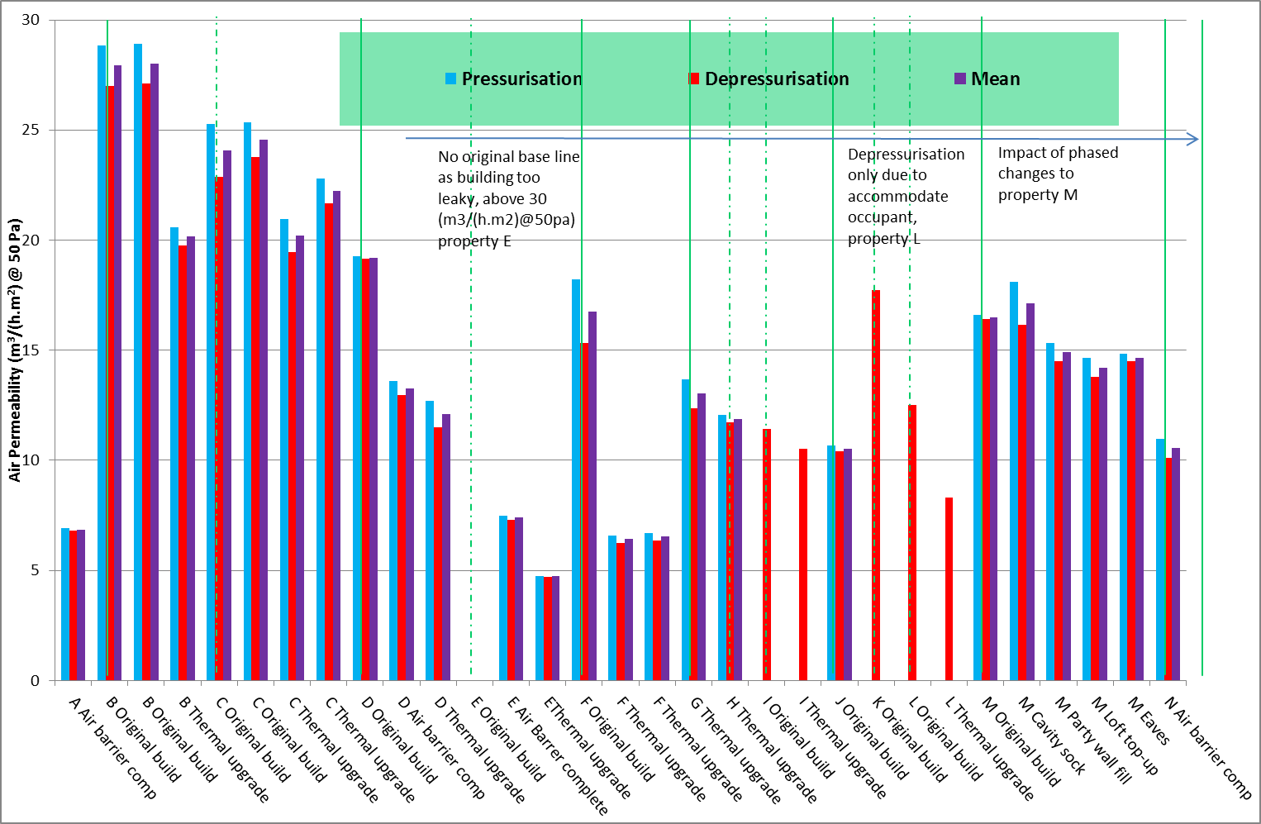Figure 2 Air permeability test on existing buildings, before and after thermal upgrades

The air tests in retrofit properties are of significant importance, especially when evaluating the impact of an upgrade. In similar properties with similar retrofit measures the air permeability results were surprisingly different. Where little consideration was given to airtightness and the seals between the insulation and the existing fabric, air permeability was high. In the properties with cellars and suspended floors the seals between wall and floor insulations were found to be one of the more dominant areas of air exchange. In the properties where seals were overlooked or ineffective the improvement in air tightness were limited (24 – 20 m³/(h.m²)@50Pa). In properties where due attention was given to detail and the workmanship ensured effective seals, there were step changes from around ≈ 19 to 5 m³/(h.m²) @50Pa achieved (Figure 2). In the property that initially could not be tested, because the enclosure offered such an ineffective air barrier, after thermal upgrade and sealing, the air permeability was below 5 m³/(h.m²)@50Pa. The potential impact of effective air barriers on such a property is significant.

In a more intensive study performed in an environmental chamber, on a property with similar characteristics to some of those reported in Figure 2, off-the-shelf retrofit measures were exposed to an intense and phased regime of testing. The Saint-Gobain Energy House project, applied off-the-shelf retrofit measures to a solid wall Victorian style semidetached property (Farmer et al., 2015), the most effective measure to reduce air permeability was installation of the floor membrane and insulation. In this building a 42% reduction was achieved where retrofit insulation and air membranes were applied to walls and ceilings, but with the floor membrane alone a further 28% reduction was achieved. With final remedial sealing, using leakage detection, to identify paths, a further 16% reduction was achieved.

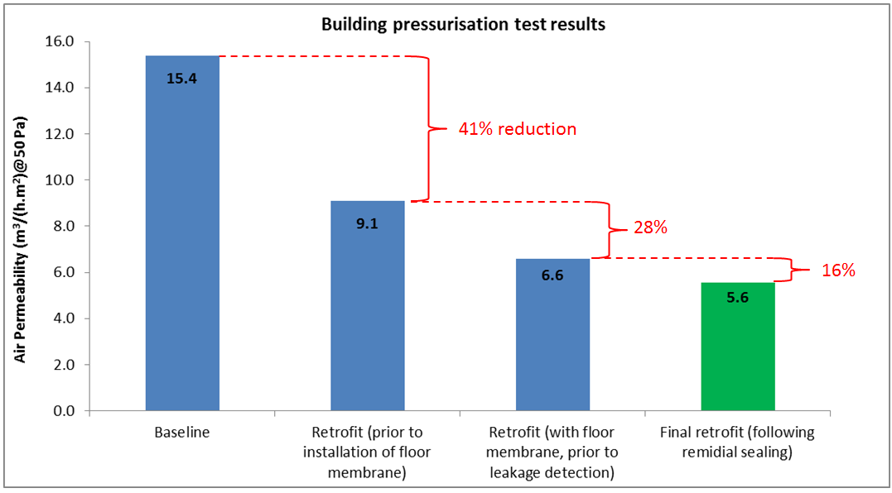

Figure 3, Air permeability using off the shelf retrofit measures (Farmer et al., 2015 courtesy of Saint-Gobain and Leeds Beckett University)

Tests and forensic observation for domestic retrofit
Sample air tightness tests are used to measure air permeability as part of new housing built in the UK, to demonstrate compliance with Approved Document part L of the building regulations. The quantitative measurement of air permeability would also be of benefit in large scale retrofit programmes. The use of the blower door test together with thermal surveys, where there is a difference in the temperature between the internal and external environment are also useful for qualitative assessment to identify where air exchanges are occurring. Using thermal surveys during the heating season when the building is depressurised, information on the air infiltration paths into the building can be obtained. The tools required to undertake such tests and surveys, including thermal cameras and blower doors, are becoming commonplace. Use of such tools coupled with an appropriate level of professional competency, will be valuable in establishing leakage paths, air exchange mechanisms and understanding the effectiveness of installations. Thermal surveys also indicate irregularities in surface temperatures, provide indications of thermal bridges as well as identifying the difference in surface temperature between building elements. Figure 4 provides a schematic of the irregularities in junctions, plane elements and thermal bridges that can be detected using thermal images when buildings are depressurised. The thermal image also shown provides an example of cold air movement and thermal bridges at the eaves, ceiling perimeter and around the window openings.

The air permeability tests could be used to expose underperforming buildings, indicating buildings that are difficult to heat. Where buildings are more difficult to heat they could affect the health and wellbeing of some building occupants. Those occupants within the fuel poverty bracket may be unable to afford adequate heating of such buildings, especially during periods of high internal/external pressure differentials. The air tightness work suggests that some buildings are prone to loss of heat energy through air permeability. It is expected that such properties would experience considerable heat loss during periods of high winds. Further work, into the impact of air tightness is being undertaken.

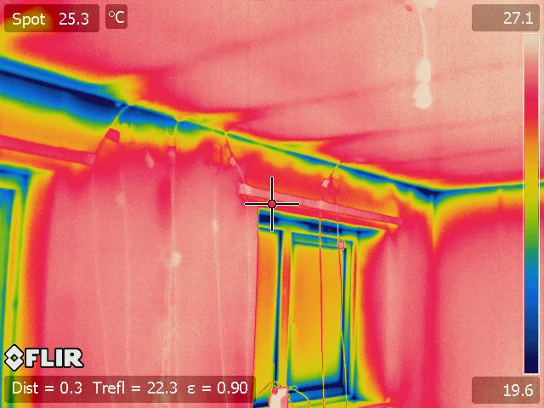
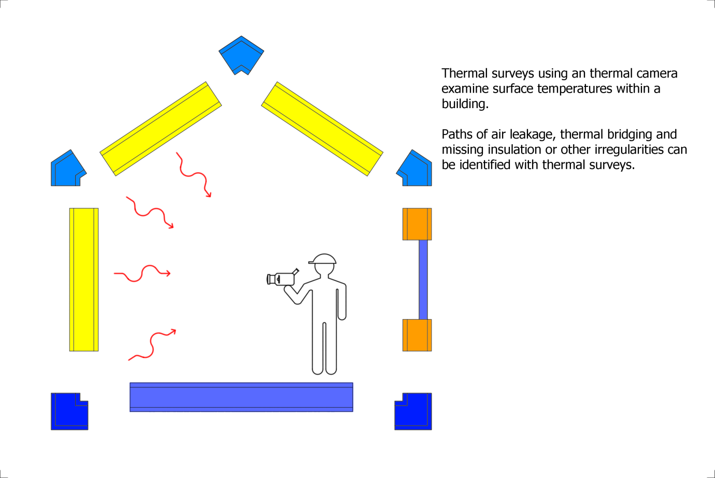

16%
28%
41% reduction

Figure 4 Schematic of thermal survey and when the building is depressurized: difference in surface temperatures and air paths become apparent.

The examination of the building fabric through heat flux measurement, air permeability and thermal surveys proves useful when exploring building elements, fabric and leakage through the structure. Commensurate with such investigations is the understanding of the thermal resistance of the whole building and how buildings resist the passage of heat when heated.
Whole building testing
The whole building heat loss test (Johnston et al. 2013), or co-heating test as it is commonly known, has been influential in recognising that many dwellings were not achieving their predicted level of building fabric thermal performance. Figure 5 shows new buildings tested over an 11 year period using the co-heating test methodology. The co-heating test is a method of measuring the aggregate heat loss (both fabric and background ventilation) from a building. Central to the analysis of the co-heating test data is the assumption that the energy balance holds true, in that the total power input into the dwelling (including solar radiation) is equivalent to the total fabric and background ventilation heat loss. The experimental set up for the co-heating test involves elevating the building temperature above that of the external temperature, using electric resistance point heaters, holding the mean internal temperature stable, using a thermostat (in a quasi steady-state condition). The total energy input required to hold the temperature stable against the changing external temperature is measured and recorded (in Watts). The heat loss coefficient for the building can then be determined by plotting the total daily heat input against the daily temperature difference between the inside and outside of the dwelling (ΔT). The heat loss coefficient is provided by the resulting gradient, which can be corrected to account for solar heat gains.
Achieving and failing to achieve performance
The results of the co-heating test were first used to identify a performance gap, between the predicted performance and that achieved when the buildings were measured ‘as-built’ in the field (Wingfield et al., 2011; Gorse et al., 2014). The work is also being used to discuss acceptable tolerance, with a view to regaining confidence in building performance (Stafford et al., 2012a; 2012b) and addressing the possibility of closing the gap (Bell. 2010; Johnston et al., 2014). The results reported here clearly show that for some buildings, regardless of their design intent and regulatory control, show a considerable discrepancy in the predicted and actual performance (Figure 5). The dwellings with the lowest Heat Loss Coefficient (HLC), shown to the right of the graph, were built to Passivhaus standards; two of the buildings were built using pre-fabricated timber-frame cassettes and one using masonry cavity construction. It is also noted that the building with no effective discrepancy reported is a masonry cavity construction (dwelling 30) aspiring to low energy standards (shown to the far right of Figure 6). With dwelling 30 it was considered that the predicted heat loss, as specified, was not as accurate as used in other studies; a y-value of 0.03 W/m²K was used in the prediction. However, small discrepancies are expected as currently there is no specification for over design of thermal performance. As there is no safety margin, acceptable tolerance, allowing for ambiguity in design information, test set up and data error, has been considered to be 10-15% for the purpose of this research. In the few buildings with low deviation, particular attention was given to the design and workmanship.

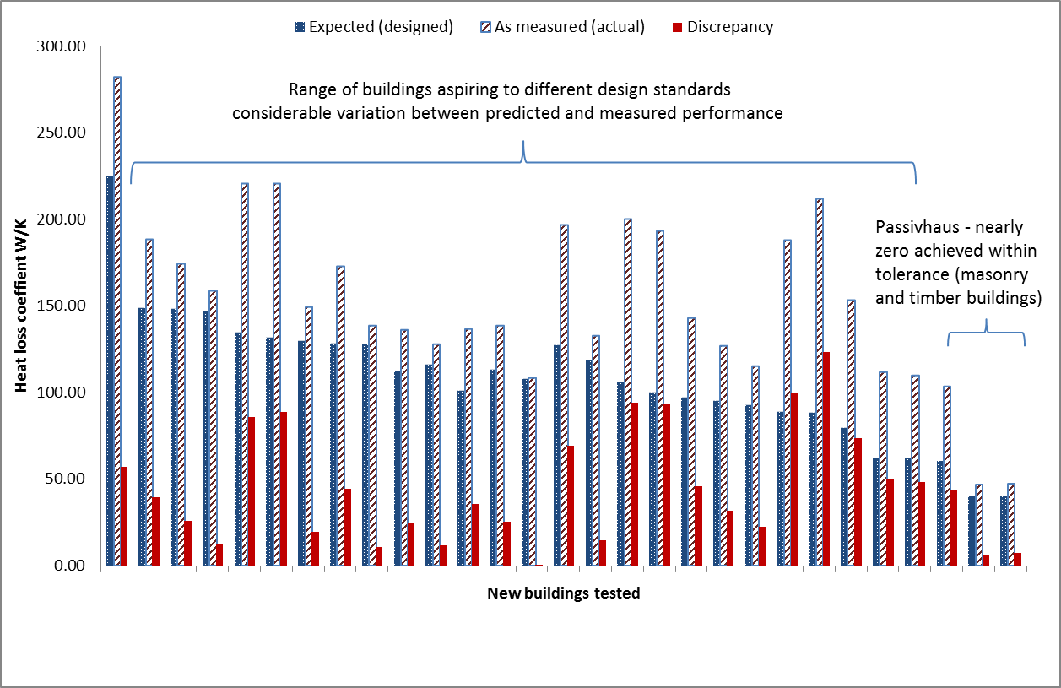
Figure 5 Whole building heat loss tests: Predicted versus measured HLC.

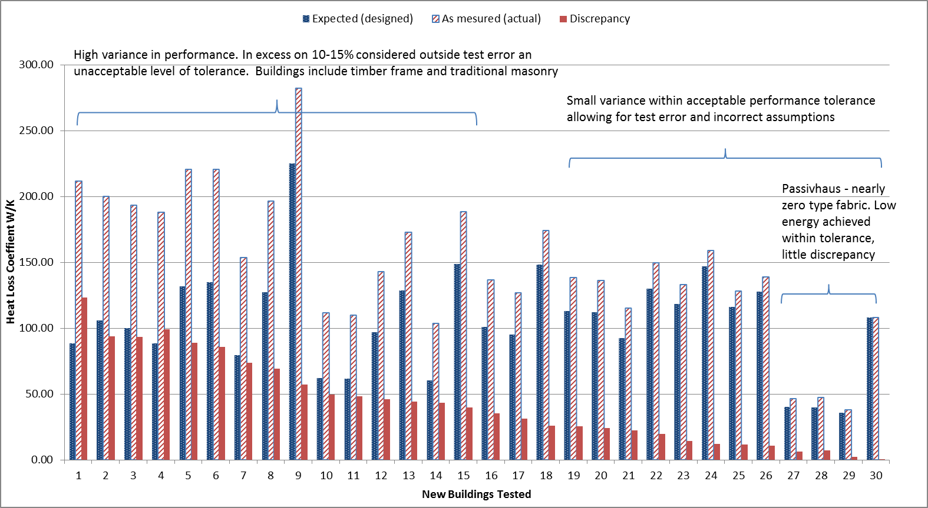
Figure 6 Whole building heat loss tests: In order of discrepancy in performance
Table 1, Construction method: Key to X axis Figure 6
Dwelling number | Construction method (brief)
1,2, 5, 9, 18 | partial fill masonry
3,4, 7, 10,11,13,14,15 | full-fill masonry (blown)
6 | other - sustainable organic material
8, 23, 27, 29 | timber-frame SIPS panel
12, 22 | thin joint masonry
16 | thin joint masonry (SIPS roof and second floor walls)
17, 20, 21, 25 | full-fill masonry (built-in)
19 | thin joint masonry (SIPS roof and third floor walls)
24, 26 | timber-frame
28 | full-fill masonry
30 | thin joint masonry (SIPS roof and third floor walls)
Figure 6 shows the histogram and buildings presented in order of discrepancy between anticipated and actual performance. Table 1 provides brief information on the construction method and performance achieved. It is noted that, in this small non-random sample of dwellings, the partial fill buildings did not perform as anticipated. As reported earlier, where voids are allowed to connect, it is expected that air infiltration and exfiltration will take place and a variance in performance may occur. Based on the initial descriptive analysis, the evidence is insufficient to comment with authority on the construction method and its applicability to the housing sector. However, in the sample reported the SIPs panels have performed more consistently than other methods, timber frame showed less variance than masonry, although the masonry construction was one of the buildings with least variance. A characteristic of SIPs panels is that there are fewer interfaces and junctions formed on site. If the interfaces of the panels function and fit together they can be effectively sealed. Masonry structures are more reliant on the skill of personnel to fill and form all of the interfaces between bricks, blocks, stone and other products with mortar, insulation and sealants. The results show that it is possible to produce high performing masonry and timber dwellings. Based on observations made during the tests, it is noted that where attention was given to the design, construction, and where seals were sound, performance was more consistent with that expected. It is also noted that the tests conducted on the buildings have taken place over a considerable period of time. Those buildings most recently tested do perform better and with a closer tolerance than those tested at the start of the research, however, this is not without exceptions. Based on observations, photographic evidence and assessment of design information; it is the designers, contractors and clients that ensure design information is available, the design is buildable, components are assembled correctly and good workmanship is applied that achieves the designed standard within acceptable tolerance. Both the small builder and those building for large developments have produced buildings within acceptable tolerance.
It is important to record that the professionals involved in delivery of the building that were tested, in this sample, were aware that the buildings were to be tested and monitored. Based on this fact, it is counterintuitive that such large variations between design and real performance were observed. The evidence of variation found and the problems identified are likely to occur in the building stock.
Where the buildings perform as expected, such as those shown on the right hand side of Figure 6, there is greater potential for the thermal comfort and energy levels to be more consistent and predictable throughout a full session of heating. It is also expected that greater variation in energy demand will be experienced with buildings that have high air permeability and low thermal resistance. Co-heating tests are only valid if conducted under a certain set of environmental conditions, in more extreme conditions the tests becomes unreliable. The tests are generally conducted when wind speeds are low and relatively stable to reduce uncertainty in the results. In more extreme conditions the test may become unreliable, especially with buildings of high air permeability. Thus, the results reported are those collected during stable winter (heating) conditions. It is likely that the results for the high air permeable buildings would be more variable during extreme conditions, though this requires further research.
Reliability of the whole building tests
Tests have been conducted to explore the repeatability of the co-heating test. In January 2010 a research team from Leeds Metropolitan University (now Leeds Beckett University) undertook a co-heating test on a 2 ½ storey detached dwelling using the Whole House Heat Loss Test Method (Miles-Shenton et al., 2010). The test was undertaken as part of a project designed to test the thermal performance of prototype dwellings in-situ for an energy efficient housing development. The Heat Loss Coefficient (HLC) resulting from the 2010 co-heating test, conducted in January, was 132.9 (± 1.5) W/K. In December 2012, a different research team from the same University undertook a co-heating test on the same dwelling in accordance with the 2012 iteration of the Co-heating Test Method (Johnston et al., 2012; Farmer et al., 2013; 2014b). The HLC resulting from the December 2012 co-heating test was 133.8 (± 1.9) W/K. The two co-heating test results obtained 35 months apart and with differing research teams differed by < 1%. An independent sample T-test of the 24 hour solar corrected HLCs obtained showed no statistically significant difference (P = 0.432) between the HLCs obtained in each test. This suggests a reasonable level of precision (repeatability) in the co-heating test in this instance.

Cross checking heat loss tests: Reliability and validity
In addition to checking the repeatability of the co-heating method on the same dwelling in the field, an opportunity also presented itself to cross check alternative testing methods through the Saint-Gobain Energy House project (Farmer et al., 2014; Weaver & Gibson, 2014). At each of the six stages of the retrofit project, blind tests were undertaken independently by the Leeds Beckett University team (at Leeds Sustainability Institute) and Saint-Gobain Recherché. The Saint-Gobain team used the QUB (Quick U-value of Buildings) method (Pandraud, et al., 2014) and the Leeds team used the co-heating test.

The unique facility offered by the environmental chamber meant it was possible to perform each test separately and sequentially, under the same controlled external conditions, something which is not possible to achieve in the field. QUB is a diagnostic method that enables the heat loss coefficient to be calculated over one or two nights. The Quick U-value method measures the temperature response during a heating and free cooling period. The level of uncertainty is estimated to be ± 15% when performed on a single night which becomes less as the test period is extended (Pandraud, et al., 2014). However, the cross checking of the methods at the energy house showed a much closer fit than was expected (Farmer et al. 2014). The tests and the work reported have proved reliable.

Standards and build quality

As well as having to design buildings to a high standard in order to meet a nearly zero energy predicted performance target, the buildings themselves must be constructed to a high standard in order for that performance is to realised. High thermal performance targets can be met where construction is carried out carefully and sufficient quality control is exercised in order to ensure that design targets are reached, the work reported here confirms this and supports earlier assumptions made on smaller sample (see initial work by Stafford et al. 2012a. 2012b). One of the main findings of the forensic analysis undertaken is that the most common faults occur where the integrity of the air and thermal barriers are breached or discontinued (Gorse et al. 2013). Thus, the connection and continuity of the thermal envelope and the air barrier must be maintained in design and when built. The work of Johnston et al. (2014) highlights buildings that have achieved high standards of energy performance in design and construction. The work reported here used thermal surveys and whole building heat loss tests to understand the fabric performance. Those buildings that met their design standard showed limited evidence of unintended bypass, air leakage and thermal bridging. However, test results still show a considerable discrepancy between design intentions and ‘as built’ performance, which are seldom accounted for by margin of error alone. It is evident that buildings that offer effective thermal barriers will provide more consistent and reliable behaviour. Through further research, it will become evident how much heat energy is required to achieve thermal comfort, then understanding the thermal inertial and capacity will help address the potential for energy storage.

As energy harnessing and supply moves towards mixed energy modes, made up of renewable, carbon and nuclear sources there is an increasing need to understand and control demand. As argued and the initial research suggests, this will only be achieved with control and knowledge of the building stocks behaviour. The need to have energy flexible buildings and better integration, as part of the energy network, is recognised (Østergaard Jensen, 2015). Furthermore, the evidence suggests that those with better thermal resistance and those which attain a higher level of airtightness will be less demanding in terms of control and will experience a lesser degree of variance in energy consumption.

As buildings become easier to control the possibilities of influencing the user to be more energy efficient, make use of lower energy tariffs and be less carbon intensive can be realised. Figure 7 provides a schematic to show the relationship between fabric and service control, user influence and link to more energy efficient supply.

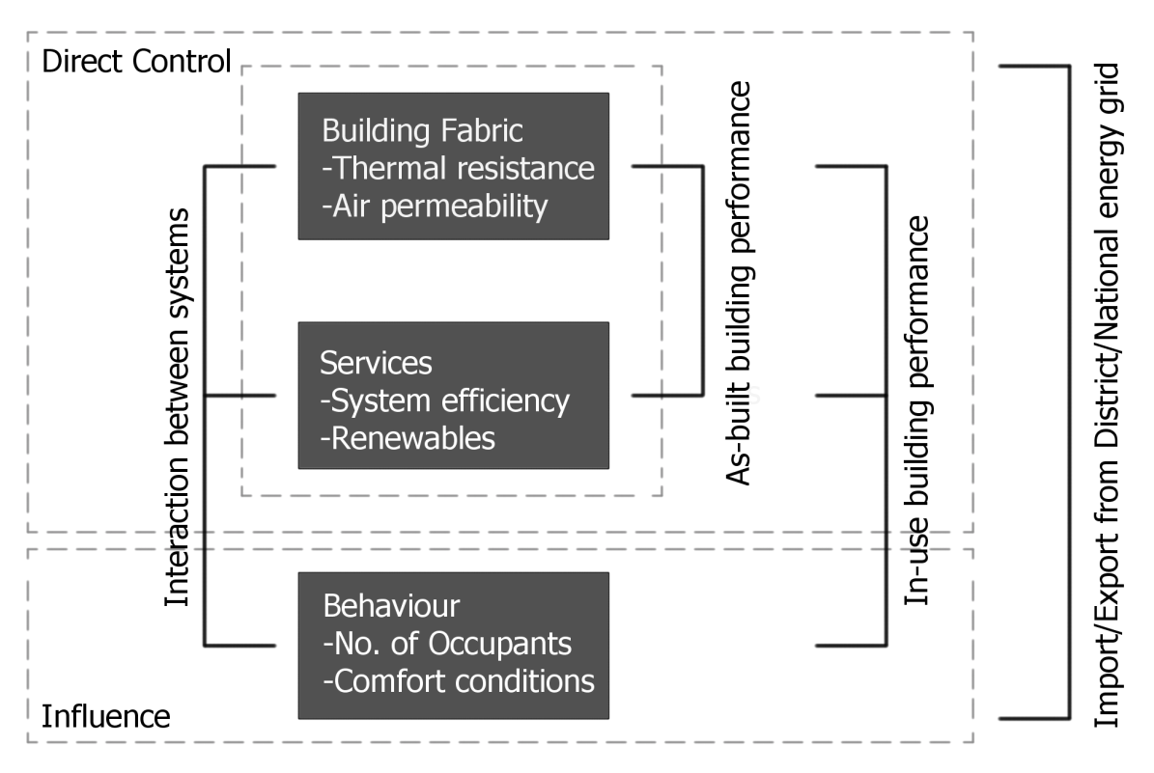
Figure 7. Link between elements of the building fabric and services that that can be controlled and energy behaviour that can be influenced, if the building system is controllable.

Conclusion
Attempting to close the gap between designed and actual energy consumption in buildings is not an easy challenge. In our research we have shown that when the performance gap has a high profile in both new builds and in retrofits, dwellings and elements within dwellings can be designed and constructed to perform consistently and may have performance gaps which are within an acceptable range of tolerance. On the whole, the performance gap is not conventionally recorded and has not previously been a fundamental part of the house building process and so it is reasonable to predict that a great deal of variation exists in the UK housing stock. The implication of this is that a large amount of energy may be being unnecessarily and unaccountably consumed by the UK housing stock. It is important to gather more data on a greater range of dwellings, working with house builders, to confirm if this is the case or not and to begin to be able to quantify what the larger scale impact of the performance gap might be for the environment, the industry and of course householders themselves.

References

Anderson, B. (2006) Conventions for U-value Calculations. BR 443. Watford: Building Research Establishment.
ATTMA (2010) ATTMA Technical Standard L1. Measuring the Air Permeability of Building envelopes (Dwellings). October 2010 Issue. Northampton, UK, Air Tightness Testing and Measurement Association.
Bell, M. (2010) Closing the Gap between Designed and Built Performance, A Report for
the Zero Carbon Hub, August, 2010, London, UK, 15,
http://www.zerocarbonhub.org/resourcefiles/TOPIC4_PINK_5August.pdf [Date
accessed 11 July, 2011].

Bley, B. (2014) Energy Flexible Buildings, Proposal for new EBC Annex, Belgium Building Research Institute 10th June 2014, <http://economie.fgov.be/nl/binaries/PPT_Bleys_tcm325-249266.pdf> [accessed 2015].

BRE (2011) U-value Calculator. version 2.03 [Software]. Watford, Building Research Establishment.

BRE (2012) Appendix S: Reduced Data SAP for existing dwellings. Watford, Building Research Establishment.

BSI (2000) BS EN 12524: Building Materials and Products. Hygrothermal Properties. Tabulated Design Values. Milton Keynes, British Standards Institution.

BSI (2007) BS EN ISO 6946: Building Components and Building Elements – Thermal Resistance and Thermal Transmittance – Calculation Methods. Milton Keynes, British Standards Institution.

BSI (2007) BS EN ISO 13370: Thermal performance of buildings – Heat transfer via the ground – Calculation methods. Milton Keynes, British Standards Institution.
Carbon Trust (2009) Building the future, today: Transforming the economic and carbon performance of the buildings we work in. London: HMSO. Available from: <http://www.carbontrust.co.uk/Publications> [accessed 2014].

CeBE (2015) Technical Reports: Centre for the Built Environment, Leeds Sustainability Institute, Leeds Metropolitan University (renamed Leeds Beckett University) <www.leedsmet.ac.uk/as/cebe>[accessed 2015]

Cioffi, M., di Genaro, F. and Zinwrri, S. (2012) Cross-ETP Research and Innovation Roadmap for the Energy Efficiency in Buildings, 7th Framework Programme, Stuttgart, Steinbeis-Edition

CLG (2009) Planning, building and the environment, Proposed Changes to Part L and Part F of the Building Regulations: A consultation Paper. Communities and Local Government, 18 June 2009, <http://webarchive.nationalarchives.gov.uk/20120919132719/http://www.communities.gov.uk/publications/planningandbuilding/partlf2010consultation> [accessed 2014].

Climate Change Act 2008 (c.27) London: The Stationery Office.

DECC (Department of Energy & Climate Change) (2013) 2012 UK Greenhouse Gas Emissions, Provisional Figures and 2011 UK Greenhouse Gas Emissions, Final Figures by Fuel Type and End-User. < https://www.gov.uk/government/publications/
provisional-uk-emissions-estimates> [accessed 2014].

DECC (2014) Digest of United Kingdom Energy Statistics (DUKES) 2014. See <https://www.gov.uk/government/uploads/system/uploads/attachment_data/file/338750/DUKES_2014_printed.pdf>[accessed 2014].

Doran, S. and Carr, B. (2008) Thermal Transmittance of Walls of Dwellings Before and After Application of Cavity Wall Insulation. A report to the Energy Saving Trust by the BRE, Glasgow. <http://www.decc.gov.uk/assets/decc/11/about-us/economics-social-research/3146-thermal-transmittance.pdf> [accessed 2014].

EPBD (2010) Energy Performance Building Directive, 2010/31/EU, Directive 2010/3/EU of the European Parliament and of the Council, 19 May 2010, Official Journal of the European Union. < http://eur-lex.europa.eu> [accessed 2014].

Farmer, D. Johnston, D. Miles-Shenton D. and Peat, M. (2013) Post Construction and Early Occupation Study, Derwenthorpe – Heat Flux Measurement Report. A report to the Technology Strategy Board as part of the Technology Strategy Board’s Building Performance Evaluation Programme. July 2013. Leeds, UK, Centre for the Built Environment (CeBE), Leeds Metropolitan University.

Farmer, D., Brooke-Peat, M., Miles-Shenton., D, Cuttle, C. and Gorse, C. (2014) Saint-Gobain Energy House Thermal Upgrade Testing, Technical Report, Leeds Sustainability Institute, Leeds Beckett University, Unpublished

Farmer, D., Brooke-Peat, M., Miles-Shenton., D. and Gorse, C. (2015) Saint-Gobain Energy House Thermal Upgrade Testing, Technical Report, Leeds Sustainability Institute, Leeds Beckett University, Unpublished

Gorse, C. A., Glew, D., Miles-Shenton, D., Farmer, D. and Fletcher M. (2013) Building Performance: Fabric, impact and implications, Sustainable Building 2013 Hong Kong Regional Conference, Urban Density & Sustainability, 12 -13 September 2013 < http://sbconferences.org/sb13hongkong> [accessed 2014].

Gorse, C. A., Miles Shenton, D., Farmer, D., Fletcher, M., Glew, D., Stafford, A. and Parker, J. (2014b) The gap between calculated and real performances: Experiences from laboratory and field and the measures to address the difference. Real Building Energy Performance Assessment, Universiteit Gent & BBRI Belgium DYNASTEE Seminar www.dynastee.info. 16 April 2014

Gorse, C. A., Glew, D., Stafford, A., Fylan., F, Miles-Shenton, D., Farmer, D., Fletcher M. Smith., M, Throup, G. Brooke-Peat, M., Parker, J and Johnston, D. (2015) DECC Core Cities Monitoring and Evaluation Project - Green Deal Trial, Reports 1 - 4, DECC, Leeds Sustainability Institute, Leeds Metropolitan University, Unpulished.

Hens, H (2012) Applied Building Physics: Boundary Conditions, Building Performance and Material Properties, Ernst & Sohn, Berlin.

Hermelink, A., Schimschar, S., Boermans, T., Pagliano, L., Zangheri, P., Armani, R., Voss, K. and Musall, E. (2013) Towards nearly zero-energy buildinds: Definition of common principles under EPBD: Final Report, BESDE10788, prepared for the European Commission, 14th Feb 2013, Ecofys <https://ec.europa.eu/energy/sites/ener/files/documents/nzeb_full_report.pdf> [accessed 2015].

IPCC (2014) Climate change 2013: The physical science basis. Available from: <http://www.ipcc.ch/> [accessed 2014].

Johnston, D., Miles-Shenton, D., Farmer, D. and Wingfield, J. (2012) Whole House Heat Loss Test Method (Coheating), Centre for the Built Environment, Leeds Metropolitan University (renamed Leeds Beckett University), March 2012, <www.leedsmet.ac.uk/as/cebe/projects>[accessed 2014]

Johnston, D, Miles-Shenton, D, Farmer, D and Wingfield, J. (2013) Whole House Heat Loss Test Method (Coheating), Centre for the Built Environment, Leeds Metropolitan University (renamed Leeds Beckett University), June 2013, <www.leedsmet.ac.uk/as/cebe/projects>[accessed 2014].

Johnston, D and Farmer, D and Brooke-Peat, M and Miles-Shenton, D (2014) Bridging the domestic building fabric performance gap. Building Research and Information. ISSN 0961-3218 (In Press)

Kelly, J.M. (2009) Retrofitting the existing UK building stock. Building Research and Information. 2009; 37, p. 196-200.

Miles-Shenton, D ., Wingfield, J., Sutton, R. & Bell, M. (2010) Temple Avenue Project Part 1 – Evaluation of Design and Construction Process and Measurement of Fabric Performance of New Build Dwellings, Report to Joseph Rowntree Foundation, Leeds Metropolitan University, Leeds < http://www.leedsbeckett.ac.uk/as/cebe/projects/tap/tap_part1.pdf> [accessed 2015]

MIMA (2010) Preventing Themal Bypasses in Party Separating Walls, Design Guide, 2010 Building Regulations Issue, Mineral Wool Manufacturers Association, L7315, November 2010. < http://www.mima.info/pdf/MIMA-Party-Walll-Bypass-Guide.pdf> [accessed 2014].

Oreszczyn, T and Lowe, R (2010) Challenges for energy and buildings research: objectives, methods and funding mechanisms. Building Research & Information, 38 (1) 107 - 122.

Østergaard Jensen, S (2015) Energy in Buildings Community Programme, International Energy Agency, EBC Annex 67 Energy Flexible Buildings. Accessed 2015 http://www.iea-ebc.org/projects/ongoing-projects/ebc-annex-67/ [accessed 2015]

Palmer, J. and Cooper, I. (2013) United Kingdom Housing Energy Fact File 2013. Cambridge Architectural Research, Eclipse Research Consultants and Cambridge Energy, Cambridge, UK, Report prepared under contract to Department of Energy & Climate Change, London, UK.

Pandraud, G., Gossard, D., and Alzetto, F. (2014) Experimental optimization of the QUB method, IEA EBC Annex 58, 6th Expert meeting, Ghent, Belgium 14-16 April 2014

Pannell, R. (2015) The Delivery of Zero Carbon Housing in the UK, Zero Carbon Building Journal, January, 3,33-39

Pearson, C. (2011) Thermal Imaging of Building Fabric. BG 39/2011. Bracknell, BSRIA.

Pérez-Lombard, L., Ortiz, J. and Pout, C. (2008) A review on buildings energy consumption information. Energy and Buildings, 2008; 40(3), p. 394-398.

Physibel. (2010) TRISCO. version 12.0w [Software]. Maldegem, Physibel.

Prism Environmental (2012) Construction Sector Overview in the UK, report for the European Commission <http://www.prismenvironment.eu/reports_prism/UK_PRISM_Environment_Report_EN.pdf> [accessed 2015]

Santamouris, M. Alevixos, S.M. Aslanoglou, L. Mantzios, D, Sarelli, I, Karatasou, S. Cartalis, K. and Paravantis, J. A. (2014) Freezing the poor – Indoor environmental quality in low and very low income households during the winter period in Athens, Energy and Buildings, 70: 61-70

Sherman, M. (1987) Estimation of Infiltration for Leakage and Climate Indicators. Energy and Buildings 10 (81).

Stafford, A., Johnston, D., Miles-Shenton, D., Farmer., D., Brooke-Peat, M. and Gorse. C. (2014) Adding value and meaning to co-heating tests., Structural Survey, Vol 32, (4), pp 331-342

Stafford, A, Gorse, C. and Shao, L (2012a) The Retrofit Challenge: Delivering Low Carbon Buildings, Report no. 4. Energy Saving Trust & Low Carbon Futures <[www.lowcarbonfutures.org>, March 2012 [accessed 2014]

Stafford, A, Bell, M. and Gorse, C.(2012b) Building Confidence: A Working Paper, Report no. 8. Energy Saving Trust & Low Carbon Futures, <www.lowcarbonfutures.org>, March 2012, [accessed 2014]

United Nations Environment Program (2007) Buildings and climate change: Status, challenges and opportunities.< http://www.unep.org.> [accessed 2015]

Vadera, S., Wools, P., Flint, C., Pearson, I., Hodge, M., Jordon, W. and Davies, M. (2008) Strategy for Sustainable Construction , HM Government, June 2008, <http://webarchive.nationalarchives.gov.uk/+/http:/www.bis.gov.uk/files/file46535.pdf> [accessed 2015]
Ward, T. (2006) Assessing the Effects of Thermal Bridging at Junctions and Around Openings. IP 1/06. Watford, Building Research Establishment.
Ward, T. and Sanders, C. (2007) Conventions for Calculating Linear Thermal Transmittance and Temperature Factors. BR 497. Watford, Building Research Establishment.
Weaver, M and Gibson, S (2014) Energy House - Saint-Gobain, <http://media.saint-gobain.co.uk/App_Media/Saint-Gobain/pdfs/V9477_Saint-Gobain_Energy_House_Leaflet_HIGH_RES_V8.pdf>[accessed 2014]

Wingfield, J, Johnston, D, Miles-Shenton,D and Bell, M. (2010) Whole House Heat Loss Test Method (Coheating), Centre for the Built Environment, Leeds Metropolitan University (renamed Leeds Beckett University), May 2010, <www.leedsmet.ac.uk/as/cebe/projects> [accessed 2014]

Wingfield, J., Miles-Shenton, D. and Bell, M., (2010) Investigations of the Party Wall Thermal Bypass in Timber Frame Dwellings, Report to EURISOL, Leeds Metropolitan University, Leeds <http://www.leedsmet.ac.uk/as/cebe/projects/eurisol/eurisol_timber_frame_report.pdf>
[accessed 2015]

Wingfield, J., Bell, M., Miles-Shenton, D., South, T. and Lowe, B. (2011) Evaluating the impact of an enhanced energy performance standard on load-bearing masonry domestic construction, Understanding the gap between designed and real performance: Lessons from Stamford Brook. London: Department for Communities and Local Government

n/19.2 was used for background ventilation, this includes corrections for storey height and sheltering factor.

