Title: “Mouth-Rinsing with Carbohydrate Solutions at the Postprandial State Fail to Improve Performance During Simulated Cycling Time Trials”

ABSTRACT
Mouth-rinsing with carbohydrate solutions during cycling time trials results in performance enhancements, however the majority of studies have utilised ~6% carbohydrate solutions. Therefore, the purpose of this study was to compare the effectiveness of mouth-rinsing with 4%, 6%, and 8% carbohydrate (CHO) solutions on 1-h simulated cycling time trial performance. On four occasions, seven trained male cyclists completed at the postprandial period, a set amount of work as fast as possible in a randomised, counterbalanced order. The subjects mouth rinsed for 5-s, upon completion of each 12.5% of the trial, with 25 mL of a non-CHO placebo, 4%, 6%, and 8% CHO solutions. No additional fluids were consumed during the time trial. Heart rate (HR), ratings of perceived exertion (RPE), thirst (TH) and subjective feelings (SF) were recorded after each rinse. Further, blood samples were drawn every 25% of the trial to measure blood glucose (BG) and blood lactate (BG) concentrations, whilst whole body carbohydrate oxidation was monitored continuously. Time to completion was not significant between conditions with the placebo, 4%, 6%, and 8% conditions completing the trials in 62.0 ± 3.0, 62.8 ± 4.0, 63.4 ± 3.4, and 63 ±4.0 minutes respectively. There were no significant differences between conditions in any of the variables mentioned above however significant time effects were observed for HR, RPE, TH, and SF. Post-hoc analysis showed that TH and SF of subjects in the CHO conditions but not in the placebo were significantly increased by completion of the time trial. In conclusion, mouth-rinsing with CHO solutions did not impact 1-h cycling performance in the postprandial period and in the absence of fluid intake. Our findings suggest that there is scope for further research to explore the activation regions of the brain and whether they are receptive to CHO dose, before specific recommendations for athletic populations are established. Consequently mouth-rinsing as a practical strategy for coaches and athletes is questionable under specific conditions and should be carefully considered before its inclusion. The emphasis should be focused on appropriate dietary and fluid strategies during training and competition.

Keywords: metabolism, ergogenic, cycling, carbohydrate, electrolytes

INTRODUCTION
It is generally accepted that carbohydrate (CHO) ingestion can enhance endurance performance (22, 36). However, the literature is equivocal on whether CHO ingestion improves performance during shorter duration (≤ 1 hours) endurance exercise, with some studies showing improvements (2), and others not (21). Potential improvements cannot be only explained by sparing of glycogen stores (21, 34) and exogenous CHO availability during the first hour of exercise (23). Thus, any performance benefits may be due to a central effect. Carter and colleagues tested this hypothesis in the first study of its kind (10) which showed a performance improvement of 2.9% during a cycling trial when subjects rinsed their mouths with a 6.4% maltodextrin solution. Since then, other studies have reported similar ergogenic effects during cycling (11, 17, 28, 30), running (31, 33), and force production tests (12, 18). Conversely, other studies have found no significant effect of mouth-rinsing on cycling (3) or running (38).
Interestingly, fewer brain regions are stimulated in response to artificial sweeteners, more regions are activated with foods that have a higher energy density (11, 19, 26), whilst foods that contain sugar and salt are perceived as more pleasurable (26). Hence, it is reasonable to expect that, by manipulation of the CHO content, a hypertonic solution may be more beneficial than hypotonic or isotonic solutions. Indeed, it has been shown that mouth-rinsing with a 10% CHO solution is beneficial during a simulated cycling trial however the 10% CHO solution was not compared against other CHO solutions (28). Despite the fact that a longer mouth rinse duration (10-s) with a high CHO content solution (10%) has shown to improve performance, no studies have investigated the impact of mouth-rinsing for a shorter duration (5-s) with CHO solutions containing more than 6.4% CHO. The majority of studies have also shown that performance benefits are more likely to occur when mouth-rinsing with CHO in a fasted state rather than fed state (14, 17, 28). Thus, the optimal concentration of CHO solutions for mouth-rinsing to impact on performance is yet to be determined. In particular, there is a need to explore further the effectiveness of mouth-rinsing with beverages of varied CHO concentrations in the postprandial period which would be a more ecological approach for habitual exercise performers. We hypothesised that rinsing the mouth with a high CHO content (8%) solution would result in greater performance gains during a 1-h simulated cycling time trial compared to 6% and 4% CHO solutions, or a placebo.

METHODS
Experimental Approach to the Problem
Subjects reported to the laboratory on 5 occasions separated by 7 days between 5-7 p.m. Visit 1 consisted of an exhaustive test to determine maximal workload (W_{max}) and familiarisation. Visits 2-5 involved performance of a set amount of work in a simulated 1-h cycling time trial (room temperature and humidity 20.2 ± 0.4 °C and 48 ± 5%). During the trials, subjects rinsed their mouths with a 4%, 6% or 8% carbohydrate-electrolyte solution, or a placebo (0% CHO). A double blind, counterbalanced experimental design was implemented.

Subjects
Nine trained male cyclists voluntarily participated in this study contingent on meeting the set criteria of 3 years cycling experience and training at least 3 times per week for 60-min (24). Seven cyclists managed to complete all tests [mean age of 30 ± 6.7 years, body mass 82.8 ± 3.5 kg, and BMI 24.0 ± 0.8 kg.m⁻² (n=7)], one was unable to complete all trials due to pre-screening identifying him as being at risk when taking part in maximal exercise, and another one ceased participation due to lack of availability within the testing period. Subjects had a mean W_{max} of 347 ± 35 W and a VO₂ peak of 58.7 ± 4.3 mL·kg⁻¹·min⁻¹. Procedures and potential risks were explained to each subject before a written consent was obtained. The study was approved by the Institution’s Ethics Committee.

Preliminary Testing
To determine maximal workload capacity and VO_{2peak}, subjects performed an incremental exercise test to volitional exhaustion as previously described (27) on a Lode cycle ergometer (Lode Excalibur, Groningen, Netherlands). Expired air was measured continuously using breath by breath online gas analysis (Cortex, Metasoft 3, Germany) whilst subjects wore a face mask (Hans Rudolf, Series 8940, Germany). Heart rate (HR) was recorded at 1-min intervals throughout the test using a radio telemetry monitor (Polar vantage NV, Kemple, Finland); W_{max}, VO₂ _{peak} and maximal HR were also recorded. W_{max} was used to determine the experimental trial workloads. After the W_{max} test, subjects cycled for 30-min, so they could be fully familiarised with the experimental time trial procedures that included blood sampling, mouth-rinsing, and expired air collection; subjective scales were also administered at the same time points as in the experimental trials. The appropriate handle bar position, seat position and height were also recorded for each subject and maintained for each subsequent visit.

Pre Test Procedures
Subjects consumed their typical ‘pre-race’ diet in the 24-h period before the W_{max} test, and had their last meal approximately 3-h before testing. Participants were asked to replicate this diet for following visits, which was monitored by completion of a 24-h self-report diet diary. Diet diaries were analysed using CompEat Pro software (Nutrition Systems, England). However, one participant continually failed to submit his diet diary prior to each time trial. Consequently he was excluded from the overall dietary intake analysis, meaning that this data is only representative of six of the seven subjects. During the postprandial period before the trials, only water was permitted which was recorded and replicated for subsequent trials. Subjects were asked to avoid heavy exercise, alcohol or caffeine in the 24-h before testing. Subjects were also asked to maintain the same training pattern throughout the duration of the study and were all in a maintenance phase of training.

Time Trial Protocol
Upon arrival, subjects emptied their bladder before body mass and height were recorded. Blood pressure and HR were recorded and a fingertip blood sample was drawn. Following a 5-min warm-up at ~40% W_{max}, subjects completed a set amount of work as fast as possible. The total amount of work was determined as previously described (11, 30). The cycle ergometer that was used for W_{max} testing was set in the linear mode and the linear factor was calculated using the formula: L=W/(rpm)², where W is the watt output and rpm (revolutions per minute) is the subject’s preferred cycling cadence (range 85-90 rpm). W was set at 75% of the subject’s W_{max}, so if a subject cycled at their preferred cadence, they would complete the set amount of work in 1-h. No verbal encouragement was given to the subjects, and the only feedback provided during the trials was the percentage of the total amount of work completed. Time trial protocols have been shown to be highly reproducible (25), with the adopted time trial’s coefficient of variation being as low as 1.7% (17). In an attempt to enhance air flow, a fan was positioned 1-m in front of the cycle ergometer to provide cooling and was set at the same speed on each visit for each subject. Average power output was calculated using the formula ((450-(Ts-450))/600)*W_{max}, where Ts is the stage time in seconds.

Mouth-Rinse Protocol and Composition
Subjects rinsed their mouths with one of the solutions in a randomised order. Twenty five mL was measured out into a plastic cup and administered before and after the warm-up, and upon completion of each 12.5% stage of the trial. The solution was rinsed for 5-s before expectorated into a beaker and then measured to ensure that none had been ingested. Subjects were not allowed to drink any water during the trials.
A 5-s mouth rinse duration was adopted to replicate the large proportion of protocols performed in this area of research (3, 10, 30, 31, 38). Thus the only differences observed would be a consequence of the CHO concentration and not methodological discrepancies. Furthermore, the decision to adopt a 5-s mouth rinse duration instead of a longer duration (i.e. 10-sec) was also based on the assumptions that: a) a 5-s duration is more likely to be adopted in ecological settings compared to longer durations and b) a longer duration would potentially result in greater decreases in power output during the act of mouth-rinsing as seen in shorter durations (5-s mouth rinsing) (17).

The drinks were made from dry powder ingredients and individually packaged in sealed containers by an unaffiliated researcher. On the day of testing, 1000 mL of distilled water was added to the powder before the drinks were chilled to 6.0 °C. Subjects were not allowed to drink any water during the trials.

All drinks contained 484 mg of sodium in the form of sodium chloride (1230 mg), 125 mg of potassium in the form of potassium chloride (238 mg), 2 mL of artificial lemon flavouring, and 2 g of citric acid per litre. The absolute amount of glucose and sucrose was manipulated to produce the carbohydrate electrolyte solutions, but the relative composition was the same between formulations (89% sucrose and 11% glucose). Aspartame was added so that all solutions had similar sweetness as the placebo (0.33 g, 0.24 g, 0.20 g, and 0.15 g in the 0%, 4%, 6%, and 8% solutions respectively). To test for possible differences in taste and texture, 8 independent individuals were asked to arrange the drinks in order of concentration in a sensory taste test, nobody placed the drinks in the correct order, whilst subjects confirmed that differences in taste were indistinguishable or very minor. Only 2 of the 8 subjects correctly identified the placebo drink.

Blood Sampling Protocol
Capillary blood samples were taken at baseline, after the warm-up and upon completion of 25%, 50%, 75% and 100% of the time trial. Approximately 25 µL of blood was drawn using a disposable lancet (Kendall, MonoletMonoject, UK) and collected in a heparin-lined capillary tube (Sarstedt, Microvette CB 300, Germany). Blood glucose (BG) and lactate (BL) concentrations were analysed in duplicate using a calibrated YSI 2300 STAT Plus analyser (Yellow Springs, USA).

Expired Air Samples and Carbohydrate Oxidation
Samples of expired air were collected continuously throughout the time trial and averaged for 5-min periods. During rinsing the mask was unclipped and the samples collected for the 30-s period following each mouth-rinse were excluded from the analysis. Total CHO oxidation was computed from VO₂(L∙min⁻¹) and VCO₂(L∙min⁻¹) using the non-protein stoichiometric equations of Frayn (16) on the assumption that protein oxidation during exercise is negligible.
CHO oxidation rate (g∙min⁻¹) = (4.585 x VCO₂) – (3.226 x VO₂) (1)

Subjective Scales
Ratings of perceived exertion (RPE) (5, 6), feelings of pleasure or displeasure (FS) (20), perceived activation (FAS) (37) and thirst scales (TH) (5) were recorded before and after the warm-up, and 2-min after each mouth-rinse during each time trial. The FS scale is an 11-point bipolar rating scale of pleasure-displeasure that ranges from +5 (very good) to -5 (very bad). The FAS scale is a 6-point, single-item measure of perceived activation/arousal with anchors at 1 (low arousal) and 6 (high arousal). These scales were implemented to provide additional information about the subjective feelings towards exercise. The TH is a 13 single-point scale adapted from the Borg scale ranging from 7 (not thirsty) to 20 (extremely thirsty). This scale was implemented to assess if there were any differences in thirst between the trials, which may have had an impact on feelings of pleasure associated with fluid in the mouth (13).

Statistical Analyses
All data were analysed using SPSS (version 19.0, Chicago, IL). Data were tested for normality by a Shapiro-Wilk test. Mean differences in time trial performance were detected using a repeated measures analysis of variance (ANOVA) with 4 within-subject levels (4%, 6%, 8% CHO and 0% solutions). Subjective scales, blood measures and carbohydrate and fat oxidation values were analysed using a repeated measures factorial ANOVA (trial x time). Significant interactions were explored using the Holm-Bonferonni post-hoc adjustment where appropriate. In instances where there was a significant main effect and where the Holm-Bonferonni tests failed to detect differences between conditions, a more liberal test (Fisher’s Least Significant Difference, LSD) was employed for post-hoc analysis. Pearson’s Correlations were used to determine if there was a relationship between subjective scales. A Paired sample T-Test was conducted to assess the difference between volume intake and volume expectorated. All data are presented as mean ± SD, statistical significance was set at .05.

RESULTS

Time Trial Performance and Power Output
The mean amount of work completed across the 4 trials was 937 ±93 kJ. Performance times were 62.0 ± 3.0, 62.8 ± 4.0, 63.4 ± 3.4, and 63.0 ± 4.0 min. whilst the mean power outputs were 251 ± 28, 248 ± 28, 246 ± 31, and 247 ± 33 W in the 0%, 4%, 6%, and 8% treatments respectively. The mean times and power outputs achieved for completion of certain percentages of the set amount of work are shown in Figures 1 and 2 respectively. The statistical analysis showed that the total time to complete the experimental trials was not significantly affected by the type of drink [F (3, 18) = 0.641, p = 0.599], whilst the type of drink did not significantly affect the time achieved by completion of certain percentages of the set amount of work [F (21, 126) = 0.594, p = 0.916] (Figure 1). Similarly, significant differences were not observed in the mean power output between conditions [F (3, 18) = .924, p=.449], whilst the type of drink did not significantly affect the mean power achieved by completion of certain percentages of the set amount of work [F (21, 126) = 0.680, p = 0.846] (Figure 2).

Dietary Analysis
Mean energy intake in the 24-h period prior to the time trial was 2844 ± 269 kcal. Energy intake comprised of 51 ± 5.3, 17 ± 4.8, and 32 ±8.7% CHO, protein and fat respectively. No significant differences were observed in the pre time trial diets of the subjects in total energy, protein, fat, and fluid intakes (Table 1). However, post-hoc analysis (LSD) showed that there was a significant difference in CHO intake between the 4% condition and the remaining conditions.

Physiological Variables
BG at baseline was 4.5 ± 0.5, 4.6 ± 0.6, 4.6 ± 1.3, and 4.8 ± 0.6 mmol·L⁻¹ for the 0%, 4%, 6% and 8% conditions respectively. BL at baseline was 1.0 ± 0.3, 0.9 ± 0.4, 0.8 ± 0.2, and 0.7 ± 0.2 mmol·L⁻¹ for the 0%, 4%, 6% and 8% conditions respectively. Neither the BG nor the BL concentrations were significantly different between conditions at baseline. BG concentrations were not significantly affected by the type of mouth-rinse during exercise (Figure 3). Overall, there was a significant main effect of time on both BG and BL concentrations (Figures 3 and 4, p < .05). However, neither the mean nor the percentage changes for BG and BL were significantly different between conditions.
Mean VO₂, HR, respiratory exchange ratio (RER), and CHO oxidation rates during the time trials are shown in table 2. Calculations of area under the curve (AUC) showed that CHO oxidation rates were 259.5 ± 44.9, 267.1 ± 55.4, 270.1 ± 45.1, and 251.4 ± 44.6 g per hour for the 0%, 4%, 6%, and 8% CHO conditions respectively. Significant differences between conditions were not observed in any of the above variables.

Subjective Responses
Mean RPE, TH, FS and FAS ratings during each trial were not significantly different between conditions (Table 3). Nevertheless, RPE and TH increased, whilst FS and FAS scales decreased significantly during each time trial: the main time effects observed were for RPE: [F (7, 42) = 73.416, p = 0.000]; for TH: [F (8, 48) = 0.457, p = 0.000]; for FS [F (8, 48) = 39.889, p = 0.000]; and for FAS [F (8, 48) = 16.535, p = 0.000]. With the exception of RPE, where significant time effects were observed in all conditions, post-hoc analysis (LSD) showed that significant differences from rest to the end of each time trial were observed in the subjective scales only in the CHO mouth-rinsing conditions. No significant relationships were detected between any subjective scales and power output.

Mouth-Rinse
The mean volume of expectorated fluid was 222.4 ± 4.5 mL. A small but significant amount of solution was swallowed in the 6% CHO trial [(4.3 ±3.8 mL) t (6) = 2.98, p=.025], and 8% [(4.4 ± 3.6 mL) t (6) = 3.22, p=.018], but not in the 0% (1.6 ±4.3 mL) or in the 4% condition (2.8 ± 4 mL). Significant differences between conditions were not detected.

DISCUSSION
The primary purpose of this study was to determine whether mouth-rinsing with various concentrations of CHO solutions influences performance during 1-h simulated cycling time trial. To our knowledge, this was the first study to compare the physiological, subjective and performance effects of mouth-rinsing for 5-s with 4%, 6% and 8% CHO solutions compared to a non-CHO placebo. The findings of the present study demonstrated that mouth-rinsing with CHO solutions in the postprandial period and in the absence of fluid intake did not result in any performance gains compared to a placebo.

Despite the fact that five subjects in our study completed the time trial faster with some form of CHO over the placebo (0% CHO), we found no significant differences between conditions in completion time of the set amount of work, which is consistent with (3, 38) and in contrast (14, 17, 28) to the literature that has assessed performance in a postprandial state. Our data is supportive of the notion that mouth-rinsing for 5-s at the postprandial period (3, 38) is a questionable ergogenic practice and that further work needs to be done to identify optimum mouth-rinsing protocols. The magnitude of performance gains was rather small in studies that have shown mouth-rinsing to be effective during cycling endurance performance in the postprandial period (14, 28). We can also speculate that the primary reason for the performance enhancement in the previous studies may have been methodological differences that make them distinct from our study and the majority of other studies in mouth-rinsing. In particular, fluid intake in the form of water was allowed in both studies (14, 28), mouth-rinsing was more frequent (14) and of longer duration (10-s) with high CHO content (10%) (28). In the latter study, the 10% CHO solution was also not compared against other CHO solutions of shorter mouth-rinsing duration; similarly studies of shorter mouth-rinsing duration have not tested the effectiveness of higher CHO solutions as means to enhance performance. Therefore, the present investigation indicates that the use of a more conventional mouth-rinsing protocol may not be effective, however other options might exist. The fact that subjects acted as their own control and managed to successfully complete a demanding exercise protocol by taking part in four separate experimental trials adds more significance to the findings of the current study. Our study would have also benefited by the inclusion of a non-rinsing condition to shed further light on the appropriateness of mouth-rinsing as an ergogenic strategy since Gam et al. (17) have shown that CHO mouth-rinsing is no better than a non-rinsing condition. Further, contrasting studies reporting ergogenic benefits have been predominantly performed after overnight fasting (10, 11, 31, 33), which is not reflective of ecologically valid settings since it would be associated with depleted or partially replenished muscle and glycogen sources. Therefore, our data suggests that mouth-rinsing with CHO at the postprandial period warrants further investigation with particular emphasis on replicating habitual training and competition practices, before recommendations for athletes are established.

A plausible explanation for the lack of change in performance in this study is the use of a conventional rinse duration, and as such it is possible that our subjects did not mouth-rinse long enough for significant performance enhancements to be detected. Sinclair et al. (35) reported that mouth-rinsing with a 6.4% CHO solution for 10-s every 6-min in a postprandial state resulted in significantly greater gains against a placebo in distance covered during a 30-min self-paced cycling, whilst mouth-rinsing for 5-s was not associated with performance gains. This suggest that mouth-rinsing with a 6.4% CHO solution for 10-s may be more effective than mouth-rinsing for 5-s however the same cannot be suggested for 8-10% CHO solutions due to lack of evidence. Taking also into account the findings of Pottier et al. (30) who reported that mouth-rinsing for 5-s but not ingestion of a CHO solution in a fasted state results in improved performance, it can be suggested that the duration of the solution in the oral cavity may have a greater impact on increasing brain stimulation than drinking a solution which would remain in the oral cavity for a fraction of the time adopted during mouth-rinsing studies. Fares & Kayser (14) compared the impact of prandial state on the efficacy of CHO mouth-rinsing for over 5-s. They showed that time to exhaustion was extended in both postprandial and fasted states, although the magnitude of the improvement was greater in the fasted state (3.5% versus 11.6%). In the study by Fares Kayser (14), subjects were also allowed to drink water ad libitum and mouth rinsed more frequently (every 5 min) and for longer duration than the current study (5-10 seconds), and studies that have shown mouth-rinsing not to be effective means of enhancing performance in the postprandial period (3, 38). Therefore, it seems more plausible that mouth-rinsing may be an effective ergogenic strategy at the postprandial state when it is accompanied by ad libitum fluid intake, when it is performed more frequently (i.e. 5-6 minutes), and when the mouth-rinsing duration is longer (i.e. 10-s). However, it is not presently possible to delineate which of ad libitum fluid intake, higher mouth-rinse frequency or longer duration of mouth-rinse explain the enhanced performances in this body of literature.

Our study aimed to reconcile limitations of existing research outlined above by aiming to identify the optimum CHO solution when mouth-rinsing for 5-s. Any further decrements in performance as a result of mouth-rinsing for a longer duration may be counteracted by the addition of CHO and the possibility that larger amounts of fluid may be ingested resulting in significant increases in blood glucose concentration. However, it is still to be determined if a longer mouth-rinsing duration may result in greater amounts of solutions ingested than the solution ingested by subjects in our study since the volume of expectorated fluid was not reported by Lane et al. (28) and Fares and Kayser (14). Individuals are capable of mouth-rinsing without swallowing significant amounts (32), unexpectedly we found a small but significant amount was ingested during the 6%, and 8% trials. This may be due to the relatively higher concentrations of solutes that coated the oral cavity. The impact of this on BG however was not apparent, likely due to the small amount of CHO ingested.

Pre-feeding strategies significantly impact the efficacy of CHO mouth-rinsing. Lane et al. (28) showed that mouth-rinsing with a 10% CHO solution significantly increased cycling performance after fasting (3.3%) and in a fed state (1.8%) compared to placebo, supporting the findings of Fares & Kayser (14). It is known that hunger modifies taste pleasantness (9), so it is plausible that hunger could modify the perceived pleasantness of CHO when experienced after fasting. Indeed, this seems to be the case since more brain regions are activated in response to sucrose when consumed after fasting (19), and these are the regions reported to be responsible for the central effect in response to CHO in the mouth (11, 15, 19). In our study, the subjects had the same standardised meal before each experimental trial therefore dietary pre-feeding status could not have influenced the efficacy of one of the CHO mouth-rinsing conditions. Our data also supports the hypothesis that athletes do not achieve optimum nutrition on their own accord (7). Carbohydrate intake before the trials was below recommended intakes (8), however it is known that self-reporting methods generally underestimate energy by ~20% (4, 29). Although nutrient intake may not have been optimal, it appeared to remain consistent between conditions and during the trials. BG concentrations did not decline and CHO oxidation rates were not significantly different between conditions at any time point, indicating sufficient glycogen availability (21, 34). There may have been a very small but significant difference in CHO intake between the 4% condition and the remaining conditions however this was not associated with performance gains since the 4% condition was the second fastest. More importantly significant differences were not observed in total energy intake as well as in protein, fat, and fluid intakes. Therefore it can be concluded that dietary variation was not a confounding factor under the current circumstances.

Thirst scales (TH) was implemented to assess thirst rates, which may have had an impact on feelings of pleasure associated with mouth-rinsing (13). Thirst rates increased significantly over time during the trials, but only in the CHO mouth-rinsing conditions. Consequently, it could be that thirst sensation could outweigh any possible ergogenic effects of CHO mouth-rinsing when it is not taking place alongside ingestion of fluids. It is also possible that thirst compromised the ergogenic potential of mouth-rinsing as a result of dehydration since our subjects were not allowed to drink water during the trials however if that was the case thirst rates in the non-CHO condition should have also been increased significantly. It is also unlikely that pre-trial hydration levels were different between conditions taking into account that subjects had to follow the same standardised diet across all trials, and no significant differences were observed in their body weight (range 82.5 kg-83.1 kg). Therefore, although hydration was unlikely to be different between conditions, significant increases in thirst rates as a result of CHO mouth-rinsing suggest that there is a need for monitoring hydration status in future studies to determine whether mouth-rinsing alone may be detrimental to performance under specific conditions. FS ratings have been correlated with improved exercise performance in mouth-rinse studies (30, 33), and the FAS scale is a valid measure of self-perceived bodily arousal or activation during exercise (1); this may be pertinent considering the potential central effect of CHO mouth-rinsing. In our case, significant differences were not observed between conditions in subjective feelings scales however, similarly to TH, significant time effects were observed, but only in the CHO mouth-rinsing conditions. It is also probable that wearing a mask for the duration of the trial may have influenced the breathing pattern through the mouth and hence the feeling of thirst, and subjective feelings however the subjects were acting as their own controls therefore a similar response should have been observed in the non-CHO placebo which was clearly not the case.

The absence of significant performance differences between conditions is most likely due to a diminished central effect of CHO in the postprandial state, mouth-rinse duration and frequency, potential dehydration, and exacerbation of thirst and subjective feelings in the absence of fluid intake. The present study did not investigate the responses of the brain, yet findings indicate that such activated brain signals, although responsive to CHO per-se, may not be receptive to CHO dose and rinse duration. Based on our findings and those of existing literature there is a need for further research on mouth-rinsing duration with a range of CHO solutions before concrete recommendations for athletes are established. In conclusion, mouth-rinsing with various concentrations of CHO solutions had no impact on cycling time trial performance when subjects exercise in the postprandial state.

PRACTICAL APPLICATIONS
The current study showed that 1-h cycling performance in the postprandial period was not positively affected when athletes rinsed their mouths for 5-s, every 7-9 minutes with 4-8% CHO solutions. Therefore coaches and practitioners, who are considering incorporating CHO mouth-rinsing strategies as means to enhance competition performance and/or training capacity, should carefully evaluate their training and competition environments. This will enable them to make a decision on the appropriateness and inclusion of mouth-rinsing strategies within the portfolio of their ergogenic strategies. In particular, special emphasis should be placed on personalising dietary and fluid strategies before and during exercise for both training and competition; since both dietary and fluid intakes can have a greater impact on endurance performance than CHO mouth-rinsing alone.
Mouth-rinsing protocols of longer duration (i.e. 10-sec) and of higher frequency (i.e. 5-min) can potentially be more effective than the current protocol when exercise duration is approximately 1-h. However, mouth-rinsing more frequently and for longer durations may not be practical in a host of athletic settings. Alternatively, ad-libitum water intake alongside CHO mouth-rinsing protocols may be more effective than mouth-rinsing alone however this is still to be confirmed.
In conclusion, coaches and practitioners should be sceptical of adopting a conventional mouth-rinsing protocol as means to optimise sports performance in the postprandial period; however other options may exist.

ACKNOWLEDGEMENTS
The authors would like to thank all of the subjects for their time and effort. The authors have no conflicts of interest that are directly relevant to the contents of this manuscript.

REFERENCES
1. Backhouse SH, Ali A, Biddle SJH, and Williams C. Carbohydrate ingestion during prolonged high-intensity intermittent exercise: impact on affect and perceived exertion. Scandinavian Journal of Medicine & Science in Sports 17: 605-610, 2007.
2. Ball TC, Headley SA, Vanderburgh PM, and Smith JC. Periodic carbohydrate replacement during 50 min of high-intensity cycling improves subsequent sprint performance. Int J Sport Nutr 5: 151-158, 1995.
3. Beelen M, Berghuis J, Bonaparte B, Ballak SB, Jeukendrup AE, and Van Loon LJC. Carbohydrate Mouth Rinsing in the Fed State: Lack of Enhancement of Time-Trial Performance. International Journal of Sport Nutrition & Exercise Metabolism 19: 400-409, 2009.
4. Black AE, Prentice AM, Goldberg GR, Jebb SA, Livingston MBE, and Coward WA. Measurements of total energy expenditure provide insights into the validity of dietary measurements of energy intake. Journal of the American Dietetic Association 93: 572-579, 1993.
5. Borg G. Perceived exertion as an indicator of somatic stress. Scandinavian journal of rehabilitation medicine 2: 92-98, 1970.
6. Borg GA. Psychophysical bases of perceived exertion. Med Sci Sports Exerc 14: 377-381, 1982a.
7. Burke LM. Nutritional Practices of Male and Female Endurance Cyclists. Sports Medicine 31: 521-532, 2001.
8. Burke LM. Fueling strategies to optimize performance: training high or training low? Scandinavian Journal of Medicine & Science in Sports 20: 48-58, 2010.
9. Cabanac M. Physiological Role of Pleasure. Science 173: 1103, 1971.
10. Carter JM, Jeukendrup AE, and Jones DA. The effect of carbohydrate mouth rinse on 1-h cycle time trial performance. Med Sci Sports Exerc 36: 2107-2111, 2004.
11. Chambers ES, Bridge MW, and Jones DA. Carbohydrate sensing in the human mouth: effects on exercise performance and brain activity. J Physiol 587: 1779-1794, 2009.
12. Chong E, Guelfi KJ, and Fournier PA. Effect of a carbohydrate mouth rinse on maximal sprint performance in competitive male cyclists. Journal of Science & Medicine in Sport 14: 162-167, 2011.
13. de Araujo IET, Kringelbach ML, Rolls ET, and McGlone F. Human cortical responses to water in the mouth, and the effects of thirst. Journal Of Neurophysiology 90: 1865-1876, 2003.
14. Fares EJ and Kayser B. Carbohydrate mouth rinse effects on exercise capacity in pre- and postprandial States. J Nutr Metab 2011: 385962, 2011.
15. Frank GKW, Oberndorfer TA, Simmons AN, Paulus MP, Fudge JL, Yang TT, and Kaye WH. Sucrose activates human taste pathways differently from artificial sweetener. Neuroimage 39: 1559-1569, 2008.
16. Frayn KN. Calculation of substrate oxidation rates in vivo from gaseous exchange. Journal of Applied Physiology: Respiratory, Environmental and Exercise Physiology 55: 628-634, 1983.
17. Gam S, Guelfi KJ, and Fournier PA. Opposition of Carbohydrate in a Mouth-Rinse Solution to the Detrimental Effect of Mouth Rinsing During Cycling Time Trials. International Journal of Sport Nutrition & Exercise Metabolism 23: 48-56, 2013.
18. Gant N, Stinear CM, and Byblow WD. Carbohydrate in the mouth immediately facilitates motor output. Brain Res 1350: 151-158, 2010.
19. Haase L, Cerf-Ducastel B, and Murphy C. Cortical activation in response to pure taste stimuli during the physiological states of hunger and satiety. Neuroimage 44: 1008-1021, 2009.
20. Hardy CJ and Rejeski WJ. Not what, but how one feels: the measurement of affect during exercise. Journal of Sports and Exercise Psychology 11: 304-317, 1989.
21. Hawley JA, Palmer GS, and Noakes TD. Effects of 3 days of carbohydrate supplementation on muscle glycogen content and utilisation during a 1-h cycling performance. Eur J Appl Physiol Occup Physiol 75: 407-412, 1997.
22. Jeukendrup AE. Carbohydrate feeding during exercise. European Journal of Sport Science 8: 77-86, 2008.
23. Jeukendrup AE, Brouns F, Wagenmakers AJ, and Saris WH. Carbohydrate-electrolyte feedings improve 1 h time trial cycling performance. Int J Sports Med 18: 125-129, 1997.
24. Jeukendrup AE, Craig NP, and Hawley JA. The bioenergetics of World Class Cycling. Journal of Science and Medicine in Sport 3: 414-433, 2000.
25. Jeukendrup AE, Saris WH, Brouns F, and Kester AD. A new validated endurance performance test. Med Sci Sports Exerc 28: 266-270, 1996.
26. Kelley AE, Bakshi VP, S.N. H, Steininger TL, Will MJ, and Zhang M. Opioid modulation of taste hedonics within the ventral striatum. Physiology and Behavior 76: 365-377, 2002.
27. Kuipers H, Verstappen FT, Keizer HA, Geurten P, and van Kranenburg G. Variability of aerobic performance in the laboratory and its physiologic correlates. International Journal of Sports Medicine 6: 197-201, 1985.
28. Lane SC, Bird SR, Burke LM, and Hawley JA. Effect of a carbohydrate mouth rinse on simulated cycling time-trial performance commenced in a fed or fasted state. Applied Physiology, Nutrition & Metabolism 38: 134-139, 2013.
29. Mertz W, Tsui JC, Judd JT, Reiser S, Hallfrisch J, Morris ER, Steele PD, and Lashley E. What are people really eating? The relation between energy intake derived from estimated diet records and intake determined to maintain body weight. American Journal of Clinical Nutrition 54: 291-295, 1991.
30. Pottier A, Bouckaert J, Gilis W, Roels T, and Derave W. Mouth rinse but not ingestion of a carbohydrate solution improves 1-h cycle time trial performance. Scand J Med Sci Sports 20: 105-111, 2010.
31. Rollo I, Cole M, Miller R, and Williams C. Influence of mouth-rinsing a carbohydrate solution on 1-h running performance. Medicine & Science in Sports & Exercise 42: 798-804, 2010.
32. Rollo I and Williams C. Effect of mouth-rinsing carbohydrate solutions on endurance performance. Sports Med 41: 449-461, 2011.
33. Rollo I, Williams C, Gant N, and Nute M. The influence of carbohydrate mouth rinse on self-selected speeds during a 30-min treadmill run. Int J Sport Nutr Exerc Metab 18: 585-600, 2008.
34. Romijn JA, Coyle EF, Sidossis LS, Gastaldelli A, Horowitz JF, Endert E, and Wolfe RR. Regulation of endogenous fat and carbohydrate metabolism in relation to exercise intensity and duration. Am J Physiol 265: E380-391, 1993.
35. Sinclair J, Bottoms L, Flynn C, Bradley E, Alexander G, McCullagh S, Finn T, and Hurst HT. The effect of different durations of carbohydrate mouth rinse on cycling performance. European Journal of Sport Science 14: 259-264, 2013.
36. Stellingwerff T, Boon H, Gijsen AP, Stegen JH, Kuipers H, and van Loon LJ. Carbohydrate supplementation during prolonged cycling exercise spares muscle glycogen but does not affect intramyocellular lipid use. Pflugers Arch 454: 635-647, 2007.
37. Svebak S and Murgatroyd S. Metamotivational dominence: a multimethod validation of reversal theory constructs. Journal of Personality and Social Psychology 48: 107-116, 1985.
38. Whitham M and McKinney J. Effect of a carbohydrate mouthwash on running time-trial performance. J Sports Sci 25: 1385-1392, 2007.

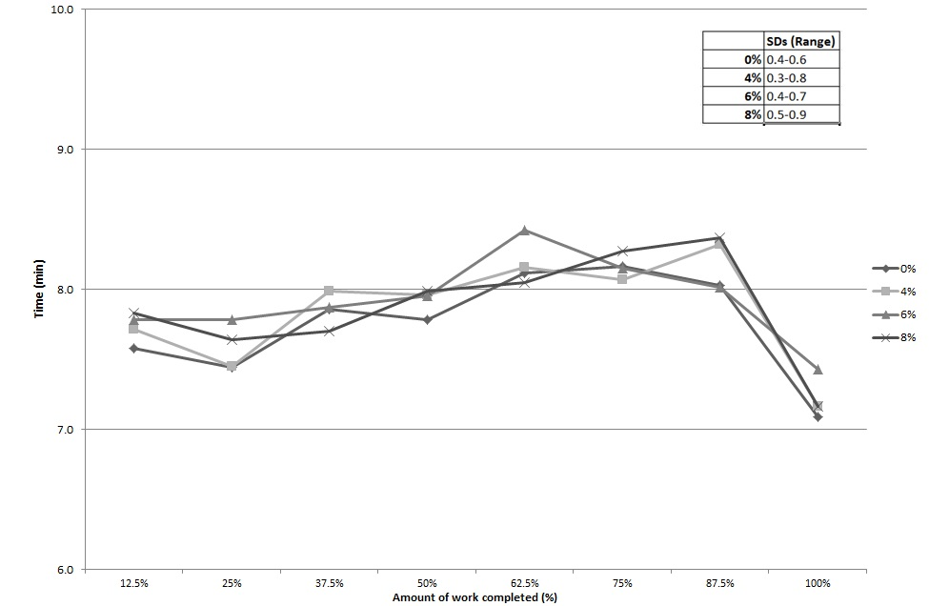
Figure 1: Time (min) required to complete each 12.5% stage of the time-trial (n=7)
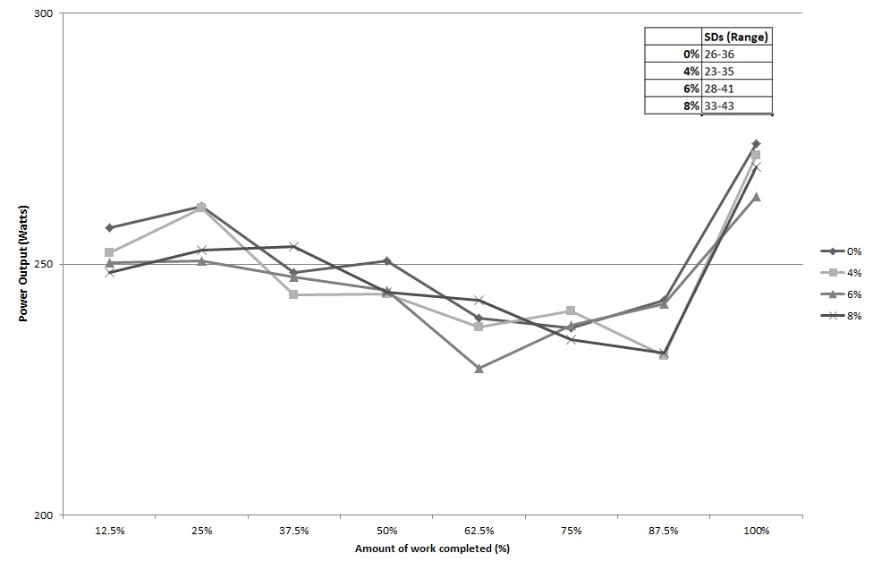
Figure 2: Power output (Watts) at different stages of the time trial (n=7)
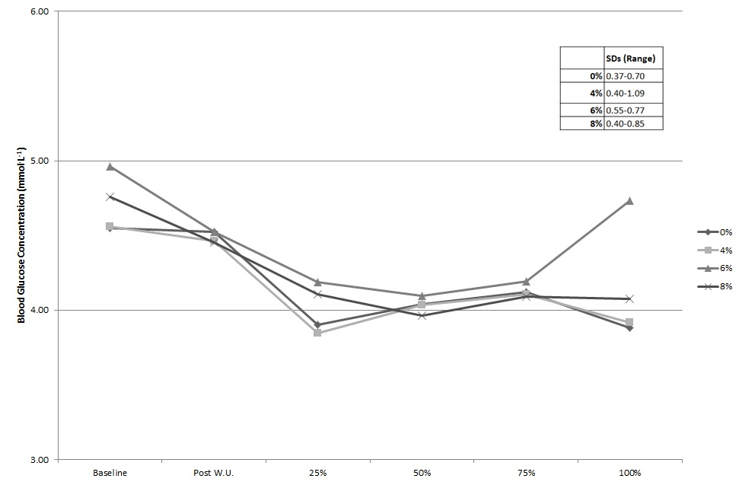
Figure 3: Mean blood glucose at baseline and during the time trials
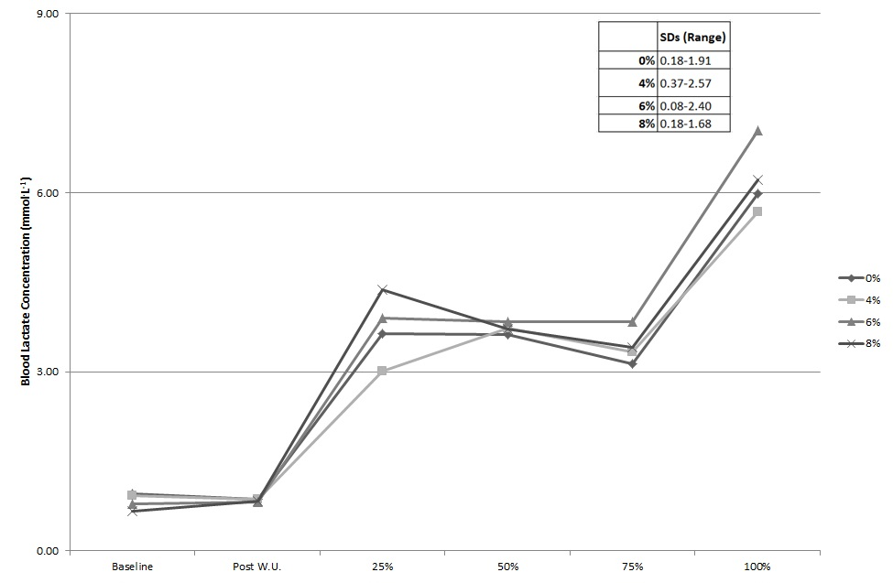

Figure 4: Mean blood lactate concentration at baseline and during the time trials
Table 1: Dietary intake 24 h before each trial (n=6, Mean ± SD).
Condition | Energy | CHO | Protein | Fat | Fluid
 | MJ | g∙kg⁻¹∙bw⁻¹ | g∙kg⁻¹∙bw⁻¹ | g∙kg⁻¹∙bw⁻¹ | ml∙kg⁻¹∙bw⁻¹
0% | 12.3 ± 0.7 | 4.8 ± 0.4* | 1.4 ± 0.5 | 1.3 ± 0.3 | 40 ± 5
4% | 11.8 ± 1.2 | 4.1 ±0.4 | 1.5 ± 0.5 | 1.4 ± 0.5 | 40 ± 3
6% | 11.8 ± 1.5 | 4.6 ± 0.6* | 1.5 ± 0.5 | 1.2 ± 0.2 | 36 ± 6
8% | 11.7 ± 1.4 | 4.4 ± 0.6* | 1.4 ± 0.4 | 1.1 ± 0.2 | 36 ± 5
F (3, 15) | 0.491 | 4.115 | 0.637 | 1.327 | 1.566
P | 0.694 | 0.026 | 0.603 | 0.303 | 0.239
An asterisk (*) denotes significantly different than the 4% condition (p<0.05)

Table 2: Mean physiological responses during time trial (n=7, Mean ± SD)
 | VO₂ | HR | RER | CHO Oxidation
 | (L·min⁻¹) | (bpm) |  | (g·min⁻¹)
0% | 3.9 ± 0.5 | 157.6 ± 5.7 | 1.0 ± 0.0 | 5.0 ± 0.8
4% | 3.9 ± 0.6 | 157.7 ± 7.5 | 1.0 ± 0.1 | 5.2 ± 1.1
6% | 3.9 ± 0.7 | 156.6. ± 5.7 | 1.0 ± 0.0 | 5.2 ± 1.0
8% | 3.9 ± 0.7 | 157.4 ± 6.8 | 1.0 ± 0.0 | 4.9 ± 0.8
F(3, 18) | 0.408 | 0.104 | 0.092 | 0.182
P | 0.064 | 0.957 | 0.893 | 0.907
*CHO oxidation calculated as described by Frayn (1983).

Table 3: Subjective responses during time trials (n=7, Mean ± SD)
 | RPE | FS | FAS | Thirst
0% | 13.9 ± 1.6 | 2 ± 1.1 | 3.9 ± 0.6 | 9.7 ± 3.0
4% | 14 ± 1.9 | 2.2 ± 0.7 | 4.0 ± 0.5 | 10 ± 2.7
6% | 14 ± 2.4 | 2.4 ± 1.0 | 4.1 ± 0.7 | 10.1 ± 3.3
8% | 13.7 ± 1.5 | 2.3 ± 1.2 | 3.8 ± 0.7 | 9.8 ± 2.5
F (3, 18) | 0.225 | 0.270 | 0.045 | 0.378
P | 0.878 | 0.846 | 0.839 | 0.770

