LILAC Stories

Exploring the long-term impact of the LILAC Conference on the Information Literacy community

Jess Haigh

Eva Garcia Grau

2025

LILAC Stories

Exploring the long-term impact of the LILAC Conference on the Information Literacy community

Jess Haigh

Eva Garcia Grau

2025

LILAC Stories
Principal Investigator (PI), Jess Haigh
Secondary Investigator (SI), Eva Garcia Grau
Copyedited by Karen Fisher, Lindsey McDermott and Maria Simões
All photographs are taken from the LILAC Flickr archive and shared using a CC BY-NC-SA licence.

Introduction to Project
The LILAC Conference was established in 2005 by Debbi Boden-Angell, Jane Secker, and the Information Literacy Sub-group of CSG – CILIP. The first conference was hosted by Imperial College, London in 2005 and quickly LILAC (or the Librarian’s Information Literacy Annual Conference as it was originally conceived) was established as “a major annual event” (Glass, 2007) within the Information Literacy community, both for academics and other researchers within the field, librarians and people working on policies and practice in Information Literacy.
The LILAC Committee, which at the time of writing is made up of 14 volunteers who come from a variety of backgrounds in the field, regularly collects feedback on the conference from delegates, sponsors, and hosts. This feedback gives valuable insight into the experience of the conference by delegates but to date there has been no investigation into the long-term impact of the conference on the Information Literacy community. During times of economic hardship for all sectors that are represented by our delegates, it is important to demonstrate the value of continuing to support the professional development that conference attendance and participation brings to people, and to illustrate the effects of conference participation on individual’s careers and the growth of knowledge and scholarship around Information Literacy. As Dumbell says in their 2019 thesis, to support future applications for conference attendance “there is a need for detailed knowledge about how conference attendance impacts on delegates and their institutions, and how influencing factors interact with that impact” (Dumbell, 2019, p. 11).
We know anecdotally that participation in LILAC genuinely changes lives, careers, working practices, and institutional policies. We hear stories every year from returning delegates of things that they have learned or experienced at LILAC, leading to impactful change both within themselves and their workplaces. Indeed, we have experienced this impact ourselves. Work presented at LILAC, and at other conferences, is often cited as inspiration within other sharing events and networks; whilst writing this report the PI attended an excellent TeachMeet in which two presenters shared that the original inspiration for the activities demonstrated came from either conversations that occurred or presentations they saw at LILAC. However, this knowledge is not codified or rationalised and there is a lack of research, not just on LILAC but on conference attendance within LIS more generally and the impact that has on the wider sector (Dumbell, 2019; Stefansdottir, 2020). The aim of this research was to capture the stories of LILAC; to truly understand the impact that this conference, the work presented at it, and the committees that support it, has had.

Our LILAC Stories

Jess Haigh
As Principal Investigator I was aware that my own bias towards the positive impact of LILAC on the sector is because of my own LILAC story. I first became aware of LILAC in 2014, whilst completing my Masters in Information Studies and Library Management at Northumbria University. I was a committed new professional, working within FE as a librarian and wanting to soak up every opportunity to develop within the sector. At the time I was quite young, full of vocational awe (Ettarh, 2018) and had the privilege of time, as well as my other privileges including my abled body, ethnicity, and gender (I am a white cis woman).
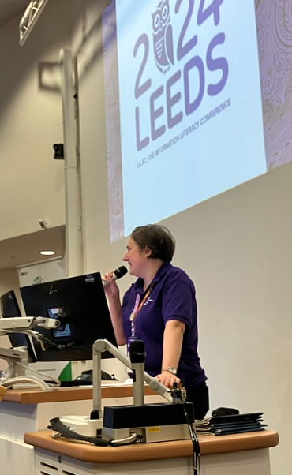
I applied to present a paper on some work we had been doing within my college, with the support of my manager but knowing that I would probably struggle to get permission to attend. To my delight my short paper, “Information Literacy on a shoestring: using a whole team approach to developing in-house resources” was accepted to the 2014 conference at Sheffield Hallam. My manager somehow managed to get funds for me to attend for the day (though I had to pay for my own travel). This was my first conference, my first large professional event. I had been working in libraries as a library assistant and (unqualified) assistant librarian for five years at that point and I’d made some professional links through Twitter and smaller CPD events, but LILAC was just another level.
To be honest, I can’t remember much of that first conference outside of being hyper-aware that I knew very little about Information Literacy compared to others in the space, but that I really really wanted to. This motivated me to work harder and become a more active member of a community of practice that I respected and could see the value in.
I was able to go to my first full LILAC Conference in 2016, after I started working in HE, and my workplace had the resources to be able to send me to a full conference. I learned so much from my time at LILAC in Dublin, and made some important professional contacts, as well as having the opportunity to present in different formats. In the autumn of 2016, the committee put out a call for new members and, with the support of my manager, I put myself forward for a role. I started on the committee as Sponsorship Officer in 2017. The 2017 conference in Swansea came at an important part of my career; I was in the middle of completing my PGCHE and Alan Carbery’s keynote on critical information literacies (Carbery, 2017) gave me the vocabulary to explore both the issues I was coming up against, and the frustrations I felt with the ways I was teaching at the time. That same year I reviewed Critical Library Pedagogy Handbook (Pagowsky and McElroy, 2016) for Information Update, and this combined with more critical approaches being discussed at the conference led me to taking a deep dive into this area of practice. This was transformative for me; it allowed me to fully explore and develop my personal pedagogy. Seeing others who were much higher up and more respected than me taking about this in a serious academic way gave me “permission” do so to. In 2018 I met Elizabeth Brookbank at LILAC, encouraged her to put a panel together on critical librarianship for LILAC 2019 and that relationship led to our co-edited book, published in 2021. None of that would have happened were it not for me attending LILAC in 2014 for one day, after much work on the part of my FE college library manager to get me the funding to go.
I have been on the committee now for eight years and I cannot begin to describe how important LILAC is to me. This research is conducted partly as a thank you to LILAC for all it has given me, but mostly because I find it very frustrating to see how the opportunities afforded to me are not available more widely, partly because of a lack of evidence of exactly how much this conference has done, but also can do, for the sector. I have learned so much from the delegates, keynotes, presenters, and fellow committee members about how to act in a professional manner whilst maintaining a sense of who you are, working in a way that truly reflects your values, and the importance of using my privilege to platform others. I am a more organised, pragmatic, and reflective practitioner because of what I have taken from LILAC. I have also made some very supportive and useful professional relationships and friendships and been given the opportunity and encouragement to pursue career opportunities from the wider Information Literacy community. Conference participation experience should be available to all Information Literacy practitioners and this research aims to show why.

Eva Garcia Grau
My LILAC story had a challenging start. My background is a bit different from that of my colleagues at my institution and also from many subject librarians which I met through LILAC and other CPD events.
Librarianship is my second career, having been a translator for over 20 years. To balance my job as a freelance translator, I applied to be a library assistant at my local public library, and I fell in love with librarianship. After ten years, I had the opportunity to move to an academic library, as an inter-library loans assistant and, later, a supervisor.
At the same time, I was lucky enough for my institution to part-fund my MA in Library and Information Studies by Aberystwyth University.
A secondment to a subject librarian post through a maternity cover gave me my first taste of what information literacy was and, when a permanent post became available, I was lucky enough to be appointed.
I have always been aware that other librarians in my position have had years of experience, both in librarianship and in the academic libraries. Probably this is one of the reasons why I found that my first experience of LILAC replicated some of the feelings of discomfort and exhaustion mentioned by some of the participants in this research.
My first LILAC was supposed to be LILAC 2020, which was cancelled because of Covid. I was finally able to attend in 2022, which I now realise might not have been a typical LILAC. There was still lots of concern about Covid, a bit of tension between wearing masks and networking.
I was fortunate to attend with two of my work colleagues, who were also new to LILAC. We found it a bit challenging to connect with other participants initially, and being our first LILAC, some of the sessions felt very theoretical, with lots of academic jargon that we were not necessarily familiar with. Despite these initial hurdles, the experience was invaluable.
We also tried to attend back-to-back sessions for the three days, and therefore felt quite overwhelmed and exhausted by the end of the conference. However, this intense immersion helped us understand the depth and breadth of Information Literacy and the importance of pacing ourselves.
I was lucky enough to attend again in 2023 and 2024. I was a presenter in both of these LILACs, and the experience was totally different. Because of my presentations, people approached me to talk about the topics (STEM librarianship and accessibility), and I did not feel so much as an outsider. In 2024, I was also a member of the ILG New Professionals Committee, which meant that I had more people that I already knew in advance.
By then I had also learnt to pace myself, and what to expect from the different types of presentation (theoretical, practical, etc.).
I have learnt a lot from my attendance to LILAC, and my teaching reflects that in a variety of ways. From applying Universal Design for learning (CAST, 2024) to making my teaching more interactive, many of the improvements I have made in my teaching in the last few years have been influenced by LILAC presentations.
I have always found the keynotes excellent and, as others have mentioned, Maha Bali’s presentation in 2024 on Critical AI Literacy (Bali, 2024) was seminal for me, and informed the work that I have done on AI literacy in my institution.
I suffer from imposter syndrome and writing about the role of librarians as teachers in my first LILAC (Garcia Grau, 2022) helped me realise that I wasn’t alone in my struggle to identify as a teacher.
As I mentioned to one of the organisers after LILAC 2024, for me LILAC gets better and better every year.
This years’ experience is again going to be different for me, as I will attend as an ILG New Professional representative within the committee. My time as a guest committee member has been incredibly positive. The LILAC committee has been incredibly generous, giving me plenty of opportunities of participating in all aspects of the organisation. I always knew that LILAC was a big endeavour, but I don’t think I really appreciated the huge amount of work that the committee undertake all through the year to make sure that the conference is a success.
I hope many more new professionals have the opportunity to attend LILAC, to learn about information literacy theory and practice, and start to build their network of practitioners, an essential part of our role as librarians.

Aims and Objectives
The aim of this research is to demonstrate the value of the LILAC Conference to employers in all sectors to support future applications for attendance and participation.
“Other barriers that make it challenging to justify the costs of conference attendance are related to the measurable impact of conference attendees’ learning. It can be difficult to assess learning from conference attendance. And it can be difficult to measure the impact of conference attendance on the employee and potential beneficiaries, such as patrons, students, and researchers” (McGowan et al., 2021, p. 551).
This has indeed proved difficult; gathering data in a formal way that is ethically sourced, with participant understanding of use of this data, as opposed to anecdotal evidence, has proved extremely challenging and may demonstrate that whilst this conference (and presumably other professional events and organisations) are esteemed and valued by their communities, there is little to no motivation to engage with research surrounding them outside of individual goodwill towards the event from those members who are already heavily involved within it.
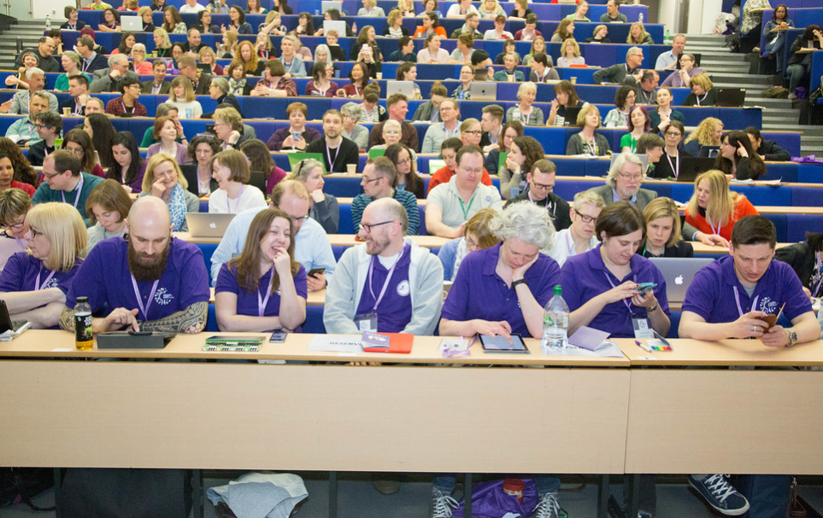

Literature Review on Conference Impact More Widely
Although there is a wealth of scholarship surrounding the motivations and experiences of conference attendance (Mair et al., 2018; Cassar et al., 2020; Pavluković et al., 2022; Ram et al., 2023; Yamashita and Oshimi, 2023; Cavusoglu et al., 2023), and critical studies on the ways in which conferences continue to perpetuate hierarchies within professional discourse and continue the problematic norms of sectors built on racist, sexist and neoliberal values (Ramirez et al., 2013; Walters et al., 2020; Dreeszen Bowman and Dudak, 2025), there is little research conducted on the impact of conference attendance on delegates themselves and the wider professional communities they belong to (Dumbell, 2019; Stefansdottir, 2020).
There are unique benefits to conference attendance and participation that cannot be replicated by other CPD outlets (e.g. engaging with professional discourse over listservs) which are explored in more detail by Rachel Harrison in her 2010 literature review. These include “an opportunity to keep current with trends in the field, interact with colleagues and rejuvenate one self’s professionally” (Harrison, 2010, p. 269).
However, through advertising the conference as the dominant event or space in which to share and grow professional discourse, we are excluding those that cannot or would not attend, as well as giving the subliminal message that any debates or discussion exterior to the conference are less valid (Craggs and Mahony, 2014). Conferences are representative of problematic and discriminatory power dynamics within academia generally (Joo et al., 2022; Dreeszen Bowman and Dudak, 2025), and the cost of the conference and associated costs of travel etc., reviewal and curation of papers, use of English language as standard and the use of keynote speakers all contribute to an imbalance of power (Kitchin, 2005). Although there are actions conferences can do that aim to change the imbalance of power, such as providing bursaries, having accessibility audits, creating safe, private spaces within the conference for those that need them, or rotating conference venues to try to be more accessible to more of the population (Joo et al., 2022), through valorising “certain ways of knowing and doing at the expense of others” (Kitchin, 2005, p. 12) the idea of a conference in and of itself could be argued to be problematic and part of the oppressive practices of the academic hegemony.

Defining Impact
Within this research the authors have used Dumbell’s definition of impact, which most closely matches the original feelings of the PI surrounding wanting to know more about what happens after conference participation because of something that occurred during the conference itself.
“Impact is understood to represent any outcome, change, benefit or disadvantage that librarians attribute to their conference attendance and that affects either library staff or their libraries” (Dumbell, 2019, p. 21).

Participation and Permission to Participate
LILAC Conferences are hosted, for the most part, by HE institutions with large spaces suitable for 200-300 delegates. The conference committee plans and executes the running of the conference, and two members of staff from the hosting institution join the committee for the planning year. Conferences are generally classified as association, corporate or government conferences (Mair, 2017). Stefansdottir defines the type of conference most similar to LILAC as an “association” conference, as opposed to corporate conferences (Stefansdottir, 2020, p. 6), as the conference’s aim is for any profits made from ticket sales being fed back into the work of the parent association (in LILAC’s case the Information Literacy Group (ILG)).
Craggs and Mahony theorise this model of conferencing casts the hosts as powerful and generous and the delegates as guests who must be grateful and behave in certain manners as dictated by the social norms of the host (Craggs and Mahony, 2014). Whilst this dynamic could make conferences less welcoming for delegates unaware of the social norms within the host institution, it also means that all delegates are, or at least should be, welcomed and treated as guests, with politeness and accommodations, by the conference that is hosting them. LILAC is a touring conference that is at a different venue every year, with host venues applying sometimes years in advance to host. This means that at each LILAC the tone of the conference will be somewhat set by the different campus cultures and the accessibility for international delegates; as well as delegates coming from around the UK owing to the variances in transport infrastructure around the conference institution. The differences in the locations, from large cities to more regional, coastal, or rural locations may also affect how delegates perceive their own participation in the conference, and their feelings of welcome and belonging taken from that participation.
“Conferences are multiple sites of action, speech, and relationality, requiring academics to perform various identities: presenter, listener, organiser, supervisor, or networker. The conference demands a professional performance, but also the ability for delegates to ‘relax’ into a casual identity at different moments” (Oliver and Morris, 2020).
Delegates to LILAC come from various parts of the Information Literacy community, both as practitioners working within libraries, learning development or academic skills departments in tertiary education, healthcare and public and private services, and from within the research communities both in universities and private and public research bodies. For many years LILAC has seen a rise in the number of delegates coming to the conference for the first time; in 2024 over a third of delegates had never been to LILAC before. As the data found within this research shows, LILAC is often a delegate’s induction into the Information Literacy community, first timers to the conference may be participating marginally, with increased participation leading to gradual changes in culture and practice within the community as a whole as the newer delegates become more influential “old-timers” (Medaille, 2024). Perceptions of power dynamics within the conference may differ depending on the time delegates have had within the community, and the previous involvement of delegates within the discipline’s outputs, leading to perceived expertise of other delegates or indeed themselves. Conferences give permission for members of a community to access power, through demonstration of their own expertise, visibly performing their own authority through direct exposure to other community members. Craggs and Mahony describe this as “construction and performance of disciplinary identities” (Craggs and Mahony, 2014, p. 415). As the data for this research explores the experiences of both new professionals and first timers to the conference (mostly through the conference reports, which in themselves may be performative, or biased towards the supposed needs of the reporting outlet) and through interviewing established members of the community, whether or not this power imbalance is perceived by LILAC delegates could be seen through the experiences of delegates over time, and through the first exposure to that community.
The “hidden curriculum” of academia that excludes individuals and groups who may not be part of creating the inherent professional norms that conference attendance imbibes may also affect the power dynamics of conference attendance, and inhibit the positive career experience of these delegates (Caro-Diaz et al., 2024). The inaccessibility of conferences owing to this hidden curriculum can be mitigated by the work of conference organisers to not use jargon (including within conference calls for papers), to provide training and support for potential delegates in putting forward their work for presentation, to make the programme itself less intense with more breaks for rest and reflection, enforce a safer spaces policy or code of conduct, and to actively welcome and include all members of the academic community, including newer professionals or first-timers to conferences (Irish, 2020; Hall et al., 2024). There is much to learn about designing conferences in order that every delegate can benefit from their attendance, as Dreeszen Bowman and Duduk say in their autoethnographic piece on conference attendance:
“When a space is clearly not created for you, it takes more energy, advocacy, and creativity to navigate” (Dreeszen Bowman and Dudak, 2025).
Although LILAC does recognise the importance of prioritising inclusive practices in its conference planning, there is more that could and should be done, especially around the inaccessibility of the conference for international delegates without the ability to obtain a visa to travel to the UK, and in better supporting delegates with disabilities, caring responsibilities, and other lived experiences that may limit them being able to fully participate in or gain benefit from all aspects of the conference as it is currently designed.

Motivations for Conference Attendance for Delegates
It is important to remember that it is delegates themselves that make a conference; without the continued motivation of delegates to attend, conferences cannot attract sponsors, keynotes, or be financially sustainable (Ramirez et al., 2013). When the financial proceeds of a conference sustain the activities of a professional network - as LILAC does for the ILG, paying for all the research bursaries, training events and expenses of the group - continuing to be a welcoming attractive and worthy event for delegates is essential if the professional network is to continue and fulfil its own aims.
The location of the conference may also impact delegate’s motivation to attend; they may wish to travel to a new location, or re-visit a place they feel welcome and comfortable in. Delegates may also feel personally safer in different contexts; LILAC is mostly attended by women whom studies have shown consider their personal safety as a key factor in deciding whether to go to a location or not (Ramirez et al., 2013).
Stefansdottir identifies in their literature review the two major motivations for conference attendance as networking and learning, with the expectation that this will enhance the delegate’s life in some way either through learning something new or developing professional relationships (Stefansdottir, 2020). This indicates that conferences that promote the networking and learning opportunities attendance will bring will have more delegates motived to attend; however there is very little research, as Stefansdottir notes, that examines what the long-term impacts of conference attendance are or whether these aims for conference attendees were met, and if they were, what factors contribute to a successful conference experience for delegates.
Motivations for conference attendance may alter in the future owing to the different expectations and norms of prospective delegates. Yamashita and Oshimi see the barriers to conference attendance changing over time owing to a shift in societal expectations, for example more people are requiring assurances of personal safety before committing to conference attendance (Yamashita and Oshimi, 2023). Pavluković et al. in their foundational small study of so called “Generation Z”’s motivations for conference attendance, found that the cohort was most motivated to attend by the destination of the conference and what professional opportunities are available to them, with social events being less important (Pavluković et al., 2022).

Themes Related to the Impact of Conference Attendance for Delegates
This research takes the definition of impact “to represent any outcome, change, benefit or disadvantage that librarians attribute to their conference attendance and that affects either the library staff or their libraries” (Dumbell, 2019, p. 21).
Stefansdottir’s doctoral research analysed the holistic journey of conference attendees over time, including the outcomes for regular conference attendance, with factors influencing the development of these outcomes then considered (Stefansdottir, 2020). McGowan et al. (2021) include the affordability and accessibility of a conference on its impact, as the more affordable and accessible the conference, the more wide-reaching the impact had the potential to be.
Within her theses, Dumbell’s themes related to the impact of a conference were condensed into:
“• informational impact, which relates to information and ideas returned with and any action taken with that content;
• social impact, which encompasses all notions of meeting delegates, networking, gathering contacts and making use of them once back at work; and
• affective impact, which refers to feelings related to attendance”(Dumbell, 2019, p. 109).
Dumbell’s findings also indicate a connection between the information and affective impacts of individuals, giving examples of how knowledge gained in conferences leads to changes within careers; all these themes are linked and stories from conferences are multi-faceted and the differing kinds of impact weave in with each other.

Social Impact of Conference Attendance and Participation
The social impact of conference attendance includes friendships formed through networking, participating in social activities such as parties, gatherings for food and drinks, spending time with colleagues in a more informal setting and generally feeling like you can relax and have fun with others. How social people feel is very personal, and can change from day to day, however, research has found that reaching beyond their “comfort zone” can lead to a more positive conference experience and greater impact of the conference on individuals (Caro-Diaz et al., 2024).
“Some relationships with professional association colleagues may turn into friendships which can make attending conferences and other association events more enjoyable and satisfying” (Sassen, 2023, p. 2).
Friendships take time and work to be established, and rely on values, interests or experiences being able to be shared (Wrzus et al., 2016). LILAC gives people the space to establish these friendships, with social events and time made within the conference programme to meet one another, however, conferences themselves can only do so much; it is the continued interactions and engagement with the wider community which results in the most rewarding experiences socially for delegates.
“When people attend conferences throughout their career and are actively engaged with their attendance during the conference journey, this positively influences their career” (Stefansdottir, 2020, p. 227).
Stefansdottir also found that the conference experience varied depending on the delegate’s career stage, with newer professionals focussed on more learning whilst more established professionals focussed on the networking aspects of conferences, establishing opportunities for collaborations within the sector (Stefansdottir, 2020). Stefansdottir also found that “those who gained the most from the conference journey exhibited not only active and positive engagement with the single conference journeys but also constant reflection on them” (Stefansdottir, 2020, p. 210).
The involvement of delegates in the conference may depend on their status as newcomers or old-timers within the conference community. This longer quote from Medaille explores this concept in detail.
“When newcomers join a community of practice, they participate only marginally at first. Novices begin by performing simple activities but gradually take on more complex ones through their participation in the community. As they observe the activities of others and practice those skills, they become more adept and are able to participate more fully. Thus, participation becomes a way of learning. Eventually, the newcomers become “old-timers” and the community of practice sustains itself through the incorporation of new members over time. Through their increased participation in their communities of practice, learners in turn influence and shape the activities of the community. Learners join other members in co-creating activities, and all members bring about changes in their environment. Through learners’ contributions to their communities, they may potentially change communal knowledge and practices. Not only do individuals learn, but all members learn together. Knowledge itself is located within the community, rather than in an individual. In fact, “communities of practice can be thought of as shared histories of learning”” (Medaille, 2024, p. 13).

Affective Impact: the Feelings Generated by Conference Participation
It is commonly argued within the literature that attending conferences improves professional well-being and rejuvenates delegates (Alaimo, 2004; Harrison, 2010). However, it is also noted that, as sites of shifting and visible power imbalances, conference attendance can generate feelings of inferiority, shame, anxiety, fear and powerlessness (Hall et al., 2024). It can be an overwhelming or intense experience and delegates may feel tired or numb afterwards, which can lessen the positive social and informational impacts of the conference more generally. Disabled delegates may have other requirements such as the need for more time to physically move around the venue or take part in conference activities and the setup of conferences does not accommodate the needs of disabled delegates (Dreeszen Bowman and Dudak, 2025). Conferences should work towards mitigating these anxieties or accessibility issues more generally, and the success of the conference could be measured into how all delegates with all accessibility requirements can enjoy the conference and feel professionally rejuvenated with support from the conference organisers.
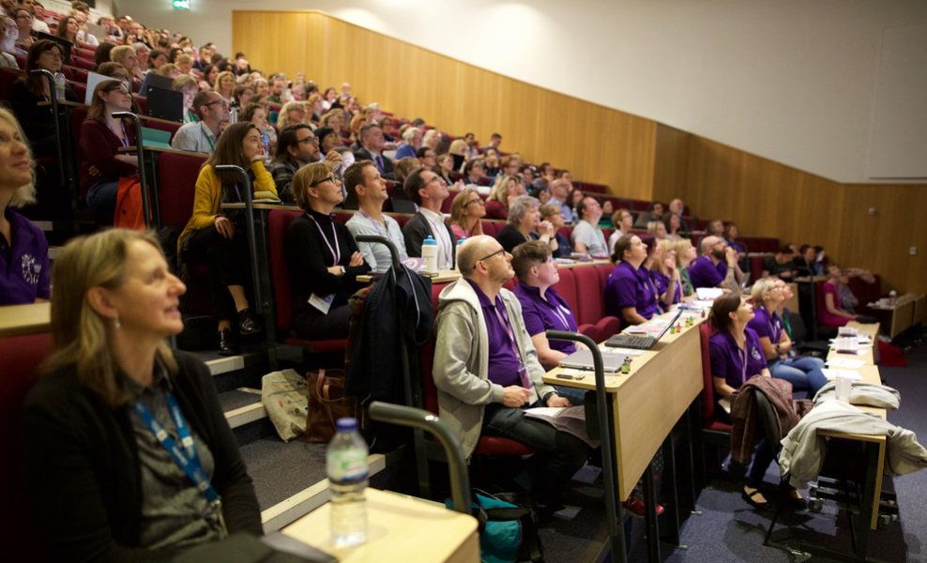

Informational Impact of Conference Attendance and Participation
Conferences are spaces to share professional practice through presenting or disseminating in various formats; either papers submitted through a formal peer review process or through being invited to speak by the conference’s organisers. For delegates, the informational impact could include benchmarking your own organisation’s practices with others or discovering new practices or theories.
“A conference puts you in touch with your profession and keeps you up to date on the latest trends” (Alaimo, 2004, p. 34).
Conferences also give delegates opportunities to reflect on and think critically about the information they are being presented with. If the conference is away from the regular workplace, and space is made by the delegate they could undergo significant personal change in opinions or understanding of direct practices and theories. This learning or change is something valued by delegates and the wider community.
“In the words of one manager, the main value of a conference is its ability to change people's views and perspectives” (Dumbell, 2019, p. 112).
The impact of the conference depends on what happens next; what delegates do after the conference with the information they have gleaned. Within the LILAC community, dissemination of information taken from the conference is often done within the workplace; data gathered in this research showed that several workplaces encourage sharing information through presentations or reports after attending any conference or training event. This furthers the direct impact on the individual to the wider communities that individual is part of, and therefore the impact of the conference attendance itself is heightened when information is reflected on and shared.
“The informational impact of conferences is greatly increased when workplaces engage with disseminating the experiences of attending delegates to their whole team; the practice of supporting in sharing their conference experience with colleagues also increases reflections on those experiences” (Stefansdottir, 2020, p. 227).

Methodology
Qualitative data on attendee’s experiences of LILAC and the impact of the conference was gathered in various ways between April 2023 – June 2024.
A call for submissions for reflections was launched during the 2023 LILAC Conference at the University of Cambridge. These reflections could be submitted anonymously through an online form (created using Microsoft Forms) hosted on the LILAC website, along with participant information about the project and the Research Data Plan for the project. The form also allowed participants to volunteer as interviewees. This form was promoted over the next two years, including during the 2024 LILAC Conference at Leeds Beckett University, through various social media posts and listserv emails. The call for submissions closed at the end of June 2024 to allow for time for the analysis of the submitted data.
Despite the promotion of the research to the wider LILAC community, there was not a large amount of uptake in the research by delegates of the conference who were not either members of either the ILG or LILAC committee, keynotes, or sponsors for the conference. Twenty-five entries to the form either submitting stories or volunteering for interview were submitted, twelve of these came from delegates who had never otherwise been involved with the conference with thirteen from either committee members, former keynotes, or sponsors. This could demonstrate a disconnect between the people already heavily involved in the conference preparation and the delegates that attend, but also show the ways in which involvement in the conference through committee membership or through being an invited keynote leads to feeling that the conference holds more value to them personally.
Delegates personal characteristics including ethnicity were not asked for during the research process, which is a limitation of the methodology as it does not acknowledge or problematise the Whiteness of the conference, or the LILAC community. More work should have been done by the PI to make space for the voices of delegates from marginalised communities and to target these delegates as a key demographic for research participation. The investigator acknowledges that conference attendance requires, as Oliver and Morris put it, “a considerable amount of hidden labour to navigate spaces that continue to be shaped by and for the institution of white men” (Oliver and Morris, 2020) (although in a mostly female industry, this conference continues to be shaped by and for White women). As PI and a member of the LILAC Committee, I acknowledge that this conference is not diverse or equitable, and the results of this research do not adequately demonstrate the ways in which the conference has been complicit in the current oppressive systems that marginalise groups, owing to the lack of representation from these groups within the data. I am guided by the work of Sabnis and Proctor in this acknowledgement.
“Critical theory requires that researchers constantly question the ways in which their group interests, ideological affinities, and social positions influence the topics they study and the conclusions they derive from available data. The point here is not to rid one’s research of these influences. Rather, it is to “enter into an investigation” about the ways in which one may have been complicit in a current or past system of oppression” (Sabnis and Proctor, 2022, p. 664).
More research is needed into the experience of Global Majority delegates at LILAC, and the investigator would be happy to be guided by the work or knowledge of Scholars of Colour in completing this research in the future.

Qualitative Data Gathered Through Online Form
In total, fourteen written stories were submitted, with twelve others using the form to volunteer to be interviewed without submitting a story. The stories were then read by the PI and the SI and coded for themes using NVIVO software. Coding was done by looking for commonalities of expression or instance, with the following quote from Ryan and Bernard in mind.
“You know you have found a theme when you can answer the question, What is this expression an example of?” (Ryan, G. and Bernard, 2003, p. 87).
The coding process was based on that of previous research on conference impact (McGowan et al., 2021), with findings from the literature being firstly used to identify core themes and then other themes being found through the research data.
Themes from the literature include those used in Dumbell’s thesis, which was the largest scale comparable research project identified through the literature review, of various classifications of impact, being Informational impact; Social impact; Affective impact (Dumbell, 2019). Dumbell’s work, completed in 2019 in Australia, was extremely influential in the completion of this research project, also looking at the impact of conference attendance within LIS and where in the conference journey that impact stems from. Dumbell’s research, however, was looking at academic librarians’ experience only, and generated a great deal more primary data. Their research however does provide “robust evidence for practitioners and managers to make a case to funding bodies for conference attendance” (Dumbell, 2019, p. 4) and it is recommended by the PI that a comparable piece of research is completed in the UK.
Other comparable research came from McGown, who categorised their themes into
“1) Knowledge Exchange; 2) Peer-to-Peer Communication; 3) Networking; 4) Technology Updates; 5) Conference Organization; and 6) Skills Training and Workshops” (McGowan et al., 2021, p. 553).
McGowan et al. reinforced their manual coding with statistical analysis, using Principal Component Analysis, to create the following overarching themes;
“1) networking; 2) workshops; 3) content; 4) peers; 5) resources; and 6) conference organization” (McGowan et al., 2021, p. 563).
McGowan et al.’s research was longitudinal, taking place over five years, comparing quantitative and qualitative data gathered over that period and was assessing the impact of an event (The Great Lakes Science Book Camp for Librarians and Library School Students) which used learning objectives whose attainment could be measured. It was decided by the PI that the long-term data to support the use of PCA was not available, and that analysis using the same methods as McGowan et al. was not appropriate to the research aims of LILAC Stories.
In line with the results of this project, the methodology could have been changed by something learned at LILAC – during LILAC 2024 at Leeds Beckett University, Rebecca Scott presented her excellent work on the use of narrative inquiry, including the incredibly useful bibliography (Scott, 2024). The PI was present during this paper and became quite excited about the methodology which they had never come across before (it was also pointed out to the PI at the time that this is why the first year of a PhD is all about research methods and resulted in the reflection perhaps the PI should have learned a bit more about research methods before embarking on this research). However, after reading around the process and meaning of narrative inquiry, the PI concluded that the LILAC Stories research, which was large in scope and included evidence from grey literature and published conference reports, was unsuitable for the narrative inquiry methods. Research on the experience of individuals at specific conferences could be undertaken in the future using this methodology, which would give a rich insight into the experience as a storied phenomenon and could be presented in a more creative or inspiring way.

Interviews
Fourteen interviews were carried out between May 2023 – June 2024. These interviews were all conducted remotely by the PI, over Microsoft Teams. Transcriptions of the recordings were taken, with the original recording then being deleted. These transcriptions were edited by the PI to preserve anonymity before being shared with the SI.
All interviewees came from people volunteering to be interviewed through the online form or from contacting the PI directly. Interviewees had a range of roles within the conference.
Role at time of interview | Number of interviewees
Previous keynote | 2
Previous conference committee member | 2
Current conference committee member | 3
Current sponsor | 1
Previous delegate (no other role) | 6

The interviews consisted of ten questions that were asked in a semi-structured way, depending on the nature of the participant’s experience of LILAC, with some further questions asking participants to expand on points raised or exploring their personal experience of the conference added as needed. At the request of one of the early participants, the main questions were sent to participants in advance in order for them to consider their answers and give them time to reflect on their experiences, look up their own notes etc. for their times at the conference. The main questions asked participants
- When they first heard about the LILAC conference
- What LILAC conferences they had attended, how they paid for these conferences or were given permission to attend the conference and what their role in each conference they attended was
- If they had ever presented at LILAC and further questions on the nature and impact of these presentations as appropriate
- How attending LILAC made the participants feel at the time
- What participants remember seeing at LILAC, who they spoke to and what they did
- How participants share their LILAC experiences after the conference
- If participants have ever cited their LILAC experiences as part of an application for professional body recognition (e.g. MCLIP, FHEA, NTF) or other professional situations such as academic progression or interviews
- How the participants would describe LILAC to someone who had never been (either within the information literacy community or external to that)
- What their hopes are for future LILACS and if they would attend the conference again
- If they had any comments or suggestions for future conferences
The PI and the SI then compared their coding, finding that they both had coded the same parts of the transcripts into similar themes but used slightly different language to describe them. A consensus was found and the final themes that are presented within these findings were selected.

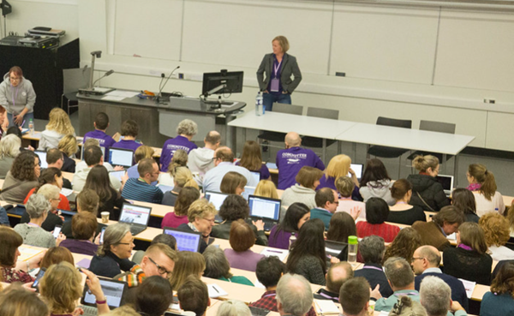

Review of Submitted Stories
A form to submit individual LILAC stories was made available through the LILAC website along with participant information. This link was disseminated at both the 2023 and 2024 conferences, through social media and through community email lists. The form allowed for anonymous answers asking for people’s LILAC Stories and to volunteer themselves to be interviewed. In total, 14 stories were recorded in the form with 11 further people offering to be interviewed without submitting anything to the form itself. These stories have been coded using the same thematic analysis performed across all the data gathered. Each story has been anonymised here using the code S.1, S.2 etc. to differentiate between the submissions.

New Professionals, First Timers and Bursaries
Three of the submissions (S.1, S.4, S.5) mentioned LILAC being their first conference or that they were new to the profession when then attended LILAC, with S.5, who places high value on their participation in LILAC over several years, stating that they “still think it’s the best [conference]”. This shows how exposure to the LILAC conference as a new professional, and active involvement in the conference increases the personal value of the conference.

Bursary Impact
Two submitted stories mentioned that initial attendance at LILAC would not have been possible without bursary funding.
“Attending LILAC would not have been possible without the student award and has been formative in developing my career in Information Literacy.” S.3
“on my third attempt, I was successful in my application for the LILAC Student Award and I was going to LILAC 2016 in DUBLIN!!! Good things come to those who wait (or persevere!) - it had to be one of the best experiences in my career ever, what a year to go to LILAC! The Student Award was the perfect opportunity to begin building my IL network.” S.7
S.7’s story demonstrates the high value this delegate places on their bursary, citing it and their continued experience of attending LILAC as instrumental in their career progression, including opportunities to disseminate their work globally.
“I submitted a paper with [redacted] to deliver a masterclass session at LILAC 2018 - Liverpool called 'Through the My Learning Essentials looking glass' where we got to showcase our approach to workshop delivery. Again, I furthered developed my IL networks and on the back of this we delivered an adapted version of the masterclass at other events; including a bespoke online workshop to librarians in Singapore. For me, my main reflections on what LILAC has done for me, centre around the connections I've made and the opportunities that have arisen from attending a three day conference.” S.7
This again demonstrates that having the opportunity to build a professional network is one of the largest impacts that conference attendance has for individuals.

Social Impact – Community Building, Networking and Collaborations
Several of the submitted stories cite connections made at LILAC leading to further professional and scholarly activities, including academic publications (S.1, S.2), setting up podcasts (S.6), or being able to use the wider community as a sounding board for academic ideas (S.3). S.2 explicitly mentions LILAC as being instrumental in making these connections possible.

“I’ve made some wonderful friends during LILAC conferences, whether chatting at tea breaks, doing karaoke or sit in a hotel bar at silly o’clock in the morning. But these friends in the profession, doing similar things to me (that I probably wouldn’t have met at all otherwise). Most of the exciting, interesting projects I’ve been involved in…. have been born of informal discussion with people I only know because of LILAC” S.2

This involvement in the social side of the conference and a willingness to develop initial contacts into collaborative friendships has led to S.2 gaining more value from the conference.
Other’s spoke of how being with other librarians with an interest in Information Literacy specifically made them feel connected to the profession and part of a committed and worthwhile community of practice.
“It was so good to be surrounded by other librarians who loved what they do, and it really helped reignite my passion for the role” S.6

Affective Impact – How the Conference Makes You Feel
Several of the submitted stories were positive in how LILAC has made them feel and how important attending the conference was to their career and how they feel towards their own profession more widely.
“Participation at LILAC is one of the highlights of my career as a librarian.” S.5

“By going to LILAC, it really reinforced that this was where I wanted to be and what I wanted to be doing.” S.6

Informational Impact

Benchmarking
Many delegates benchmark the work of their own institutions with others presenting research or practice at LILAC. This leads to positive feelings towards their own professional work, as in S.12’s reflection.
“From the outset I was enthused and reassured that the work we are doing in my own institution is in line with what the rest of the sector are also grappling with” S.12
S.12 also was able to look wider than their immediate experience through exposure to practices from other countries, most notably the United States. The International nature of the conference, especially the high number of delegates who travel from the U.S. and Europe, means that U.K. counterparts can learn from and be inspired by the global Information Literacy community.
“As a professional I am always interested to see the emerging themes and trends from our professional colleagues elsewhere to see what might be coming our way. The US are way ahead of us in terms of maker spaces and podcasting booths, such exciting opportunities if we can convince our own institutions to invest in these areas.” S.12

Inspiration
Several of the submitted stories mentioned being inspired to learn more about something or to engage in further scholarship in an area after the conference.
“one of the sessions I attended formed the basis of my dissertation. It was a topic I hadn’t considered before attending the conference”. S.3
“In 2003 [redacted] and I presented in student emotions and research of 1st years. Someone pointed out that the data set was nicely just pre-covid and it would be interesting to see post data….We have an article prepub due to Alison Hicks seeing our proposal and asking us to publish within her journal” S.9
“As an immediate practical result of attending the conference, I am now working in partnership with a colleague from another organisation hoping to share our work and possibly publish” S.12
Other inspirational presentations led to changes in working practices or trialling new activities in the workplace.
“Attending LILAC in 2009 I learnt about the Cephalonian Method (Morgan and Davies, 2004) of conducting library inductions and piloted it in my own organisation” S.13
“I also found Maria King’s presentation about how teaching practices can be made more inclusive for neurodivergent learners very inspiring. The conference inspired me to take inclusion action back in my day job…we have adapted many of the tips that Maria King suggested to make our teaching practice more inclusive…these ideas were already percolating before LILAC – the conference gave the ideas substance and impetus and definitely helped to progress them” S.14

Change in Perspective or Attitude
One submitted story focused on the change in their perspective of a particular practice as being more aligned to their own values
“LILAC has changed my view of playful learning and how it can overlap and link to creativity. I had taken a somewhat cynical view of this before LILAC24 – it’s not critical enough or aligned enough to social justice – my views have changed significantly. This is thanks to Andy Walsh” S.8
Through this delegate being exposed in a platformed keynote to theories and practices they had previously dismissed, they have undergone a significant change. S.12 also mentioned Andy Walsh’s 2024 keynote as leading to developing their perspective surrounding Information Literacy.
“He made me think more deeply around our many approaches to Information Literacy and to recognise that there isn’t one correct way” S.12
The stated changes in attitude within even established professionals, such as S.12, who says they have worked in HE for many years, shows the influence of keynote speakers, and therefore the conference team that invites them, on the profession.

Review of Interviews
Fourteen interviews were conducted by the PI over Microsoft Teams, transcribed using Teams’ inbuilt transcription with minor edits by the PI when needed to correct obvious errors, and then separately coded by the PI and SI, who met to consolidate these themes into the ones discussed below. Quotes from these interviews are taken verbatim from the transcripts, with redactions made when specific institutions or individuals that were not being quoted as impactful (e.g. crediting a particular speaker) were named. Each interview has been anonymised here using the code P.1, P.2 etc. to differentiate between the participants.

Social Impact

Community Building/Community Sustaining
Several of the interviewees spoke of their feelings of their being a community that forms within the conference but then develops from connections made at the conference, and that this community has grown over the years
“There's a real community of practise around LILAC.” P. 3
“most of my professional connections are probably through LILAC.” P. 3
“it's definitely not the same community that it was. It's a, it's a much more mature community” P. 4
“it often not the content that I go for now and it's not often not the content that excites me. It's the opportunity for conversations and discussions and that contact with the people that I've seen say lots of times over the years, whether it's at LILAC or another setting” P. 2
This feeling of community was one that was established in both interviewees that had been to several LILACs, and those who were newer to the conference, for example P. 12 had attended one LILAC before being interviewed but found that they were able to network effectively during that one conference leading to collaboration with other community members
“I felt very privileged and it was such an opportunity for me to be in that same space with all of those other nerdy librarians” P. 12
“You know if you want to extend your networking you know then this is the place to do it and full of opportunity.” P. 12
“I've kind of hooked up with since it was a lady from [REDACTED], as we had a common interest” P. 12
Interviewees described attending LILAC being instrumental to them feeling part of a larger community of librarians that teach information literacy outside of their own day job, (P. 8, P. 10, P. 11), and for some interviewees this community feeling is sustaining and uplifting: P. 4 described going to LILAC as “not feeling alone”, P. 5 spoke of finding value in meeting people in the same situation as them, whilst P. 14 stated;
“Every year when I come back to LILAC, I feel like I've gone home and I forget that I've got all these friends in the community who care about me, so it's lovely.” P. 14
P. 2 especially found the networking and community building vital to their conference experience, and reflected on how, having been to LILAC as a delegate for several years, they were able to see new generations of delegates develop within the conference
“I spent I think I spent more time at the last LILAC talking to various youngsters on the inclusion and EDI and you know diverse type area and less time talking to the people that are a similar age to me that I've known for however long 18, 19 years.” P. 2
There is a concern then, that if New Professionals or less established professionals cannot have the support to attend, these communities will cease to form, or develop, as LILAC has allowed them to over the past 20 years.
“My current frustration with the workplace is that there's a strong driver towards thinking that conferences are where you get given ideas that you then pass on directly rather than about building your communities, chance for you to reflect on things. That content is not just about information that you see. It is a lovely chance to build those networks up.” P. 2

Social Events
Many of those interviewed explicitly mentioned the social events as an important part of LILAC’s programme (P. 5, P. 6, P. 8, P. 13). The social events usually make up a networking evening and a more formal conference dinner/party. Not all the interviewees attended these events, as they are not obligatory, and many delegates choose not to go.
The importance of social events to the LILAC programme was integrated in the design of the conference from the start, P. 4, who was part of the original conference planning team, remembers
“she's like I'm talking three-day conference. I'm talking conference dinner. I'm talking about a disco. I'm talking about you know networking event in a swanky location
I want to go to something that's kind of academically rigorous, but hugely fun and a bit ridiculous and silly
But it was about this idea of getting people to sort of let their hair down so that they would get to know people.” P. 4
This deliberate care invested in the social activity was noted by interviewees as something that makes LILAC different to other conferences.
“annual social highlight calendar of the year for a lot of people in libraries as well, because lots of other conferences seem very sort of conferencey.” P. 13
Conclusion: attendance at LILAC can lead to feeling part of an already established but evolving community. This is achieved through delegate’s personal motivations for being part of a community, and the conference being specifically designed and delivered by an enthusiastic committee to include social events and opportunities to network.

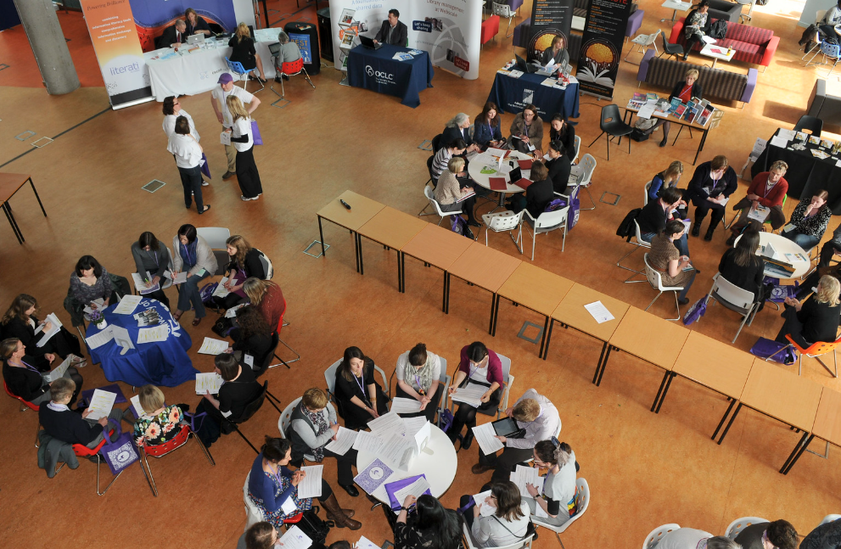

The Role of the Committee
Several of the interviewees were current or former conference committee members. Of these, several spoke of how much positive impact this had had on them professionally, but also socially through forming friendships and networks. P. 14 spoke at length about how being part of the committee had given them skills needed to progress within their career.
“The other thing that I really found at the time is that there was some really exciting leaders who were part of LILAC. They were really inspiring and and I was quite ambitious in my career. And I I felt like they felt like mentors to me
I realised I couldn't get those skills in my job. You know, you're liaising at every different level, with conference and events people which is, you know, can be really difficult, you've got to be a bit kind of ruthless sometimes. you learn a lot….”
“And that to me, actually was that was a big learning curve because that was around networking with what felt like to me senior colleagues”
“I think that's quite difficult for librarians, is the moving into management is really difficult and you are expected when you go to a management role or a leadership role to have had experience of budgets.
Well, the only people I've ever seen do it is with people who are doing like external committee roles It's hard to get that experience because it was cross institutional leadership. I mean it's leading people who are really easy to lead because everyone's very compliant and very enthusiastic.” P. 14
This shows how being on the conference committee leads to developing skills in financial management, liaison, communicating across institutions and at a variety of levels, and decision making; these are all skills that are listed on job descriptions for leadership roles within the sector and yet within day to day working in non-management roles are very hard to come by; this can lead to motivated professionals leaving librarianship or feeling frustrated as there is no scope for progression without having the privilege of institutional support for CPD (Donkor et al., 2024; Rehman et al., 2024). By being part of a conference committee, which is a volunteer role and requires the support of your institution to have the time to fulfil the duties required, LILAC has developed the careers of several of the leaders within HE librarianship and Information Literacy research.
The interviewees who were or had been committee members were all positive about their experience, mostly due to the competence and skill set of their fellow committee members
“I don't feel that LILAC Is a lot of work. I feel it is. That sounds bad. I feel it is a lot of work.
But I feel that it's really well sorted out.” P. 8
Other interviewees who had never been part of the committee were also complementary of their work
“Just keep doing the great work that you're doing is what I would say and can I also just actually say that the organisers and committees throughout the years. Oh my God, I look at you and I just think you're all rock stars.
But you're all fantastic. Ohh brilliant people. So nice. It's just so lovely, so human. And then so polished and slick at the same time. It's a rare breed,” P. 3
Conclusion: Being on the LILAC Committee is demonstrably positive for the individual both in being part of a tightknit community and professionally in gaining skills and contacts.

Affective Impact – How the Conference Makes you Fell

Fear, Anxiety and Feeling Overwhelmed
Interviewees spoke of the conference as being a tiring experience, and used negative words like “skive” (P. 1) or explained that their sleep was affected by worrying about their presentation leading to them missing mornings of the conference (P. 11). Knowing that it is professionally appropriate within a three day event to take breaks and reflect on what you have experienced is something delegates learned over time, with delegates who attended multiple conferences more confident in missing sessions in order to re-charge or take time for reflection.
“you do need to take the break. You do need to have that space and that's really important to learn as well.” P. 5
“I've now since learned to actually take breaks in the sessions to actually try and digest” P. 8
The conference was described by interviewees as “overwhelming” (P. 1, P. 4), with P. 2 and P. 14 describing their first LILAC conference experience as a scary one.
“Didn't know anyone there.
Struggle with crowds, struggle with social interaction.
It was scary as hell.
So I absolutely hated the social stuff. Being in big rooms for tea breaks and what not, with lots of people and thinking Oh my God, what they would do, how they will behave.
What's expected?” P. 2
“I was the most incredibly shy librarian when I first started. Networking and all of that scared the hell out of me.” P. 14
P. 9, when describing their feelings towards keynoting the conference, also spoke of a kind of anxiety
“even though I do big groups, massive lecture theatres, massive groups of student nurses. You don't necessarily always sit in front of a massive room of your peers” P. 9

Professional Validation and Confidence Building
Several of the interviewees had presented at LILAC, and felt professionally validated by this experience, seeing this as recognition of their work as valuable and important.
“I was really chuffed that it's the work I had done, got recognised and seen as valuable enough to have a workshop on the programme” P. 1
“it makes me feel like I'm recognised and and valued and and that's you know. You can't really ask them more than that” P. 6
“it then shows you that there's value in what you're speaking about and that this is important and not just at a professional level, but also at a personal level for attendees” P. 9
Some interviewees mentioned the phrase “imposter syndrome” (P. 4, P. 8, P. 13), and that attending LILAC helped alleviate this. It is beyond the scope of this research to define and diagnose imposter syndrome, which is considered by some to be a problematic phrase that shifts blame to individuals experiencing mental distress because of feelings of inadequacy that stem from structural inequalities. In this instance, where the interviewees claiming that their positive experiences of LILAC alleviated their “imposter syndrome”, it could be that being around a community that understands your job role and is non-hierarchical in that all delegates are entitled to the same secure and welcoming conference experience regardless of job title, makes one feel more confident in one’s own competence.
Some interviewees went further, exploring how presenting at LILAC, having their work assessed and held accountable by their peers within their own community of practice, made them more aware of the professional nature of the job. This increased their confidence in thinking deeply and critically about Information Literacy
“it gave me the confidence to actually have a point of view. A professional point of view” P. 3
“it had a massive impact on me, had a massive impact also on my confidence to think.” P.4
This impacts their work more generally, with P. 9 for example feeling more confident in challenging the academics they work with
“I've been able to feel a bit more confident in addressing or challenging things that sort of academics are sort of saying or doing” P. 9
Even interviewees who had not presented at the conference found attending the conference increased their self-confidence
“I mean aside from the content, the sessions and stuff actually just my being there and interacting and making me feel kind of like I could cope with that environment and also be somewhere I guess you sort of feel validated that you're going to something meant I came away from it personally just feeling a little bit more confident and with like a kind of aim towards OK, this is what I should be doing.” P. 13
Within Higher Education librarianship there is an oft reported disconnect between librarians and academics (Delaney and Bates, 2015). P. 10, who went on to write up their LILAC presentation for academic publication, found that attending LILAC and having their presentation published decreased this disconnect.
“it shows that you're doing work of a similar value to academics, because you're writing up something that's being put in journal article.” P. 10
This feeling of adding value to the conference itself was also echoed by P.1, who also highly valued the opportunity to present.
“I was really chuffed that I got to present cause I felt like I was adding something to the narrative.” P. 1
The interviewee’s feelings of self-doubt and inadequacy before going to LILAC compared to feelings of professional value and self-worth after the conference show the positive affective impact of the conference on individuals. P. 13 was especially passionate in their advocacy for conferences to improve professional validation, and spoke at length about their worries if librarians were unable to continue to attend conferences
“you need to have professional opportunities of people at all grades and all levels, whatever, to be able to come together to talk about the work that you do. And if you don't make those opportunities, you're not really validating the fact that those people have roles and that there is work they're doing.”
“if you don't have these professional opportunities for people, then you're down playing your own sector and you're kind of suggesting that it's not worthwhile.
if we're not prepared to stand up and say people are still doing this stuff and here's a conference and we're going to do it, then how do you expect other people to take you seriously?” P. 13
Through the confidence gained by the professional validation given by a community of their peers, attendees feel empowered to speak up for their own profession or promote their work more. This could have an impact on the role of the delegate and their team within their home institution.
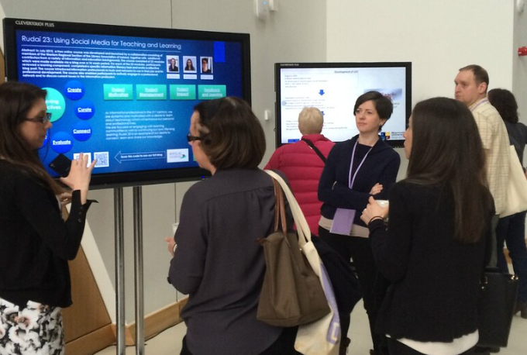

Informational Impact

The Impact of Keynotes
When asked about what they remembered from conferences they attended, inspirational and informative keynote speakers came up several times. Although being informed of theories, concepts and practices was a common finding of conference attendance, it was within keynote sessions where this impact was felt most keenly by some interviewees.
“Well, I definitely not heard the term threshold concepts before then I don't think or I might have read it, but not really paid attention to it. But when you in a keynote, it's in your face, isn't it?” P. 1
“I think the the one that really sticks out to me actually is, was it Ola Pilarot. I don't know if I'm saying that right, but he keynoted yeah. And he talked a lot about the theoretical base of the work that we do in LIS and he was talking about lots of the stuff that I remember to my Masters and all these kind of key theories and frameworks and how you can kind of relate that to like the actual work you do.
And that was a real light bulb moment for me. And that was a real, like, yeah, this stuff, this wasn't just stuff I did in my Masters that I could kind of put in a box and leave to one side. Now I've finished that, like, this is stuff that does and should inform the work that we all do. And it could be something I could contribute to.” P. 7
“Char Booth at a keynote, the imposter syndrome thing. I'd never come across before and that really did change the way I think about myself and stuff” P. 8
For some it was not necessarily the content of the keynote being relevant to their own work, but the style and passion of the speaker invigorating them to think differently about their own practice.
“I really enjoyed Melissa Highton, that was Cardiff. I think I really enjoyed her keynote, but it was more like for the, rather than the content, but more like the style with which she delivered her keynote.” P. 6
“The great example is Alan Carberry's legendary keynote. I don't use the techniques that he talked about in his teaching because I don't teach it the same kind of way that he does, and I I don't. I'm not as fortunate to have incredible sounding Kind of groups and tutorials that that he was describing having. But the ways he was talking about things like, you know, the the filter bubble and and media bias and that kind of thing, I've brought so much of that into my teaching and I talk about so much of that in the context of the teaching that I do, which is very different to his context. But just that that way of thinking around things really informed the way I approach. How I talk about these concepts with my extremely practically focused engineering students.” P. 7
“I think this year a good example [of something that inspired me] was the Maha Bali keynote.
And I know [she’s] not strictly speaking working necessarily in like librarianship in the same way, but it was just really interesting to hear somebody who is just massively engaged across all these different aspects of education and teaching and learning and things and kind of finding it inspiring.” P. 13

Critical Incidents
Several interviewees described how ideas they were developing themselves were made concrete or expanded on following exposure to others’ presenting on the same or similar topics at LILAC. I believe these could be categorized as ‘Critical Incidents’, defined by Landreman et al. as “significant events, interactions, and experiences that served as catalysts for self­reflection and subsequent meaning­making” (Landreman et al., 2007, p. 283). Such moments could take place in a learning environment or through other aspects of the conference, such as speaking to someone at a networking event, how one is treated by fellow delegates and the experiences of being in a new place or away from the normal working environment. These moments are very personal for delegates but have led to profound changes within the wider Information Literacy community; these reflections lead to more scholarship, sharing of practice, and ultimately exposing future delegates and community members to these ideas.
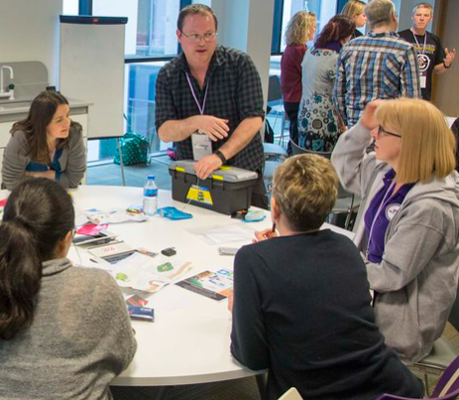
“I can remember seeing the keynote by Ray Land.
Newcastle cause I think that might have been on the first day.
And so that was like the first big keynote. I'd I'd been to.
And the threshold concepts thing sticks with me throughout because it gave a name to something that I’d already, you know, thought about.
And so it kind of legitimised what I was thinking” P. 1

Future Work Being Inspired by Something Taken From LILAC
There were multiple examples within the interviews of delegates’ future work being inspired by something they heard about or saw demonstrated at LILAC.
P. 4 credits LILAC, specifically naming a presenter, with their academic interest in game-based learning which they have gone on to publish about.
“There was a whole thing where Andy Walsh started doing stuff really early on about games. And you know, I'd because I put the programme together and I'd seen some of his staff about games and all of that kind of thing. I had this, like, awareness about games more than 10 years ago.
Ohh yeah, that's like a thing, games based learning. But. It was because of LILAC and it was because of, you know what Andy was doing at LILAC. That's where that all come from.” P. 4
For P. 2, attending LILAC in 2006 fundamentally changed their practice, shaping their entire career and, through them then developing ideas taken from that one session at LILAC, the careers of many other people via their own publications and presentations.
“One of the early ones there was 3 librarians from I think they were all at MMU at the time or from Manchester anyway. They had Some activities going on about active learning.
Ohh, that led to all the sort of teaching and learning stuff that I've I've done since there.
it shaped how I've approached teaching and learning within the team.” P. 2
“I've taken stuff from LILAC and from other places and reflected on it, and then I put that for the community in all sorts of ways. So I've written books, journal articles, peer reviewed and informal, blogs, workshops, all sorts of different things.” P. 2
P. 7 would also would not have the same career pathway were it not for attending LILAC
“I 100% think I would not be doing a PhD now if not for the experience of going to LILAC each year and kind of seeing sort of researching process and seeing people talk about that kind of thing and getting an idea of what is possible in that space.” P. 7
It is not just high-level academic research and publication that is influenced by LILAC, but the day-to-day working within the libraries that are represented by delegates.
“I've just remembered somebody did a presentation.
I think again two years ago about.
The lack of usefulness of feedback forms at the very end of a session and how it's more useful to get longitudinal feedback and get some sort of value of how they've put things into practice a little bit down the line. So I implemented that in my own practice, and we have rolled it out as a full team from September 2023.” P. 9
“So I mentioned already mentioned about the Cardiff people that I saw, I kind of because I really took away those practical elements into my work and was able to actually use that. And I do still think about my approach is always still kind of based around that.” P. 13
Inspiration from LILAC is also carried forward to interviewee’s wider institutions, often leading to immediate changes in practice or new ways of thinking in terms of the development of Information Literacy support.
“And there's still lots of things that I can think back from LILAC and I go, oh, look at this goblin tools is the one that I've been showing to everybody. My boss was really impressed, goblins tools. She loved it.” P. 8
“I saw Cardiff - work that they were doing with their students to use the student voice in the quality of their materials and to, you know, to co produce them. And I thought, my God, we've got a pot of student workers here that we're not using in that way, so that that's the kind of sharing that I want to do with the colleagues back here.” P. 12
Conclusion: delegates come away from LILAC informed of theories, concepts and practices related to Information Literacy that are both immediately relevant to their work and inspire changes in praxis or personal growth in critical thinking and teaching. Some keynotes especially are inspirational in both their content and in their manner of delivery. The LILAC’s programme continues to shape the direction of Information Literacy theory and praxis both in the UK and Internationally through showcasing new ideas resulting in delegates’ active learning of the vocabulary that allows them to further their research and development. Several major developments in Information Literacy praxis would not have taken place without delegates attending LILAC. Delegates also implement in their work specific techniques or tools they have learnt about at the conference, leading to changes in procedure and practice within their institutions.

Benchmarking
One interviewee, P. 12, spoke of benchmarking the work of their own institutions with others presenting research or practice at LILAC. For P. 12, this formed part of their feedback to colleagues on what they had learnt at the conference.
“It's allowing me to evidence for myself what's happening in the sector and benchmark it, because I can now go back and say, well, Newcastle are doing this. If you want to look at the presentation here are the materials, you know, Cardiff University are doing this with their student workers for, you know, their learning materials. So why don't, why aren't we looking at this?” P. 12
Through this benchmarking, this delegate is able to affect change within their own institution, sharing good practice from other institutions.

Review of Conference Reports
LILAC generates many conference reports, either in official publications in journals such as the Journal of Information Literacy or New Library World, or through blogs including those belonging to institutions such as Sheffield iSchool’s Information School News or CityLIS News from Library & Information Science at City, University of London. There are also blogs written by bursary winners from CILIP Special Interest Groups (SIGs) such as the Academic and Research Libraries Group (ARLG), as well as personal blogs written and published by individual delegates. Conference reports are collated by the LILAC Committee after the conference and shared on the LILAC website.
During this research, 70 conference reports were read by the PI, dating from 2007 to 2024. A full list of references can be found within the appendices of this report. Reports were found after searching LISA, the Journal of Information Literacy’s Archive, a general search using the search engine DuckDuckGo, and through the LILAC website archive, which collates reports after each conference.
There were no conference reports found by this author from before 2007; the range and number of conference reports varied over the years, as can be seen from the table below. The author did not include any blogs or videos created during the conference in this listing. There were also several citations for reports from 2017 which are no longer available as they were created on a platform that no longer exists, Storify, that could explain the drop in reports from this year.

Year | Number of conference reports included in this review
2007 | 1
2008 | 1
2009 | 2
2010 | 1
2011 | 2
2012 | 2
2013 | 3
2014 | 4
2015 | 6
2016 | 9
2017 | 2
2018 | 5
2019 | 3
2022 | 13
2023 | 4
2024 | 13

As well as the various conference reports written after the conference, several authors contribute reflections during the different events, most notably Pam McKinney and Sheila Webber, who keep the Information Literacy Weblog and have live-blogged from the conference since 2009 (McKinney and Webber, 2024). This excellent long-term blog is also a record of how the conference has changed over the years.’
Owing to the reporting nature of the pieces, a lot of their content is descriptive, with lists of what had been seen and said being a frequent feature. Early conference reports (Glass, 2007; Glass, 2008; Glass, 2009; Glass, 2010; Harvey, 2011) all focussed on the keynotes, with readers of the report urged to access the conference’s archive. Individual paper authors who are not keynotes are introduced within these reports by Eleini Zazani in 2011 (Zazani, 2011).
As this research is looking specifically at the impact of the conference, rather than the content, the thematic review of the conference reports below focusses on the more reflective elements of the reports, or where the reports speak to the personal, informational, affective, or social impact of the conference on the delegates reporting.

Following Delegates Over Time
Many of the conference reports were written by the same author attending and reporting on several LILAC conferences over time, which gives a useful insight into the progression of that delegate’s thoughts and feelings and how they developed over the various LILAC conferences.
The early conference reports by Bob Glass established that LILAC’s reputation for friendliness and openness, whilst maintaining high standards in presentations was present from at least 2007.
“LILAC is a very well planned and executed event. The extensive behind the scenes co-operation between the members of the group really pays dividends and produces a friendly, efficient and very relevant event which is quickly becoming a must for those involved in, or with some interest in, Information Literacy” (Glass, 2007).
Glass, who contributed several conference reports to New Library World, continued to be complimentary of LILAC’s contribution over the years.
“The LILAC Conference has been developing in its importance and its contribution to the IL research and practitioner community since its inception in 2005. This year’s conference was probably the most successful so far. The range of papers, workshops and posters was diverse and of high quality, the mix of delegates synergetic and the venue excellent” (Glass, 2010).
Other delegates reporting on the conference over an extended period of time include Laura Woods, who writes reflective and accessible blog posts of her LILAC experience on both her own blog and that of the Information Literacy Group, which she now co-chairs (Woods, 2016; Woods, 2022a; Woods, 2022b; Woods, 2023). These posts show a growing emphasis on critical librarianship and the foregrounding of social justice within Information Literacy, with 2016’s blog talking about the importance of critical thinking, and more critical reflections in 2023.
“This all underlined for me how vital it is that we as librarians encourage critical thinking, rather than just teaching basic database searching skills as we are often expected to do” (Woods, 2016).
“To me, [the 2023 New Professionals panel keynote] highlighted the need for this work to continue at all levels – too often, the work of social justice falls on people who are newer in their careers, and have the least structural power” (Woods, 2023)
“Several sessions made me reconsider prior assumptions, either my own or those that are commonly found in media and in the literature” (Woods, 2023).
This critical awakening reflects the growth of critical thinking, critical pedagogy, and social justice within the sector more widely, and shows how attendance at LILAC over time, and engagement with the wider conference community, impacts people’s approaches to Information Literacy.
Diane Bell also published three conference reports on the City, University of London’s Library blog between 2015 – 2017 (Bell, 2015; Bell, 2016; Bell, 2017). These blogs show Bell’s journey within academia, in 2015 they report on applying what they have taken from LILAC in their own academic work.
“I learned about having liminal, breakthrough moments when learning and keep having these now when writing my Academic Practice coursework” (Bell, 2015).
Bell then goes on to present the findings from the MA in Academic Practice at LILAC 2017 (Bell, 2017), showing that information and learning from the conference feeds forward into future academic work and conference papers being presented.

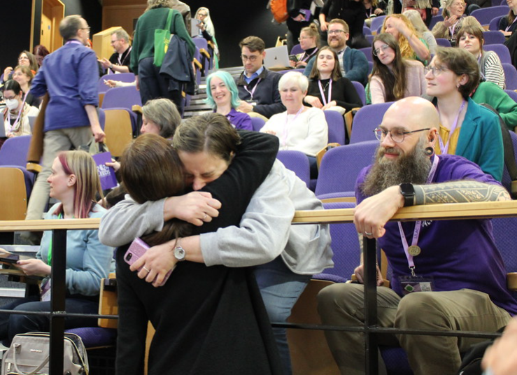

The Social Impact; Networking and Community Building
“I met with many people from different parts of the world. Listening to their library and IL journeys was so inspiring. The LILAC conference had a feeling of unity, apparent as soon as I walked up to the registration desk on the first day” (Elliott, 2012).
Feeling welcomed and accepted is an important part of community building, and of widening the diversity and experience of that community; a sense of ‘belonging’ increases trust in and perceived value of a community and the spaces that community occupies (Vogl, 2016), according to the conference reports at least, LILAC manages to give an impression of being a welcoming space. The conference reports of delegates for whom this was the first time at LILAC were positive about the welcome they received (Haire, 2024; Moosun, 2024), the openness of the fellow delegates (Reeve, 2024), and the provisions from the conference organisers to support their conference experience (Nagle, 2015). The friendliness of the conference was frequently mentioned, both by first-time delegates and others (Tattersall, 2015; pennylibrarian, 2018; Jones, 2023), and for some delegates formed part of their previous knowledge of the conference (Czerkaszyn, 2019).
Delegates also took the opportunity to explore the cities in which the conference was hosted (Rippon, 2016), with this often forming an important part of the overall conference experience.
“I joined the local library (housed in a beautiful Grade II listed building), took a late-night stroll around town, and visited the grand mosque, where I happily stumbled across adorable bunnies in the Leeds University Eco Garden! The city is filled with culture and numerous higher education institutions, making it an excellent choice for a conference focused on information literacy” (Moosun, 2024).
What was particular striking within the conference reports was appreciation for the passion felt by the wider delegates for Information Literacy (Secker, 2016; Bell, 2017; pennylibrarian, 2018; Ryan, B., 2024), with this “wanting to make a difference” attitude contributing to “a renewed sense of enthusiasm for what professional librarians do” (Palmer, 2018). This was particularly important for new professionals, who felt transformed, and inspired, by the conference community (Graviet, 2023; Moosun, 2024).
“The open, friendly nature of organisers, speakers, volunteers and delegates alike provided a fertile environment for new ideas and knowledge sharing – it was so inspiring to be around people who take pride in and care deeply about their work…I feel confident that this experience has transformed my view of the profession and will be invaluable to my studies and future career” (Nagle, 2015).

The Affective Impact – How The Conference Makes You Feel
“What I’ve taken away from the experience is a newfound confidence in both my job role and in IL, faith in my profession, and a sense of belonging to a committed community. I have fresh eyes and innovative ideas, and I feel equipped to develop as a professional” (Elliott, 2012).
Several conference reports spoke to feeling accepted and validated by the other delegates sharing their experiences, reporting feeling reassured and having their own experiences verified (Gandour, 2016; Garcia Grau, 2022). There was also a feeling of encouragement in seeing the career progression of others within the sector (Graviet, 2023), and seeing other librarians career choices as inspirational or relatable (Moosun, 2024), the conference being an opportunity to consider their own careers within “the broader context of the role of librarians, libraries and Information Literacy in society” (camiln, 2019). Meeting others that held the same values was reported as being positive to the conference experience (Løkse, 2013) as was being around people with similar cultural touchstones (Kirschbaum, 2022). Increasing the representation of all groups, sectors, and lived experiences is therefore vital, so that all members of the Information Literacy community can see themselves reflected within the conference and have equally positive experiences.

The Informational Impact
The conference reports, as descriptors of session content, demonstrate a wealth of knowledge and information learned from presenters, posters and keynotes. The information taken from the conference was often reflected on within these reports as highly relevant to their work, as well as creating critical incidents of learning.
“A number of well-planned and beautifully executed talks and workshops at this conference provided me with that motivation and with “Eureka moments”. I was also constantly exchanging email addresses and phone numbers along with thoughts, ideas and queries” (Fernandes, 2024).
The relevance of the contents of the LILAC conference to delegate’s jobs, academic studies and continued professional development is apparent within the conference reports, with a 2024 delegate describing the conference as “by far the most enlightening and thought-provoking conference I have ever attended” (Moosun, 2024). LILAC is reported as being notable for how interactive the sessions were and how much the conference programme pushed people to reflect on and think critically about what was being discussed (Elliott, 2012; Woods, 2016; camiln, 2019; Kirschbaum, 2022; Ryan, B. and Feeney, 2024). This reflection is not static; interactions at LILAC are reported as leading to contributing to changes within the professional practice of the delegates, and their institutions.
“This may actually be one of my main highlights of the conference so far. The PACE Programme is forward-thinking and incredibly inspiring for me, as I’m constantly looking at how we may make the library a more accessible space, but also a space that students understand the purpose of” (Semple, 2022).
Several reports mentioned benchmarking the work of their own institutions with what they saw at LILAC (Brennan, 2014; camiln, 2019; thelibrarianerrant, 2019; Napthine-Hodgkinson, 2022; Woods, 2023; Reeve, 2024; Silva, 2024) and taking specific activities mentioned into their own teaching or professional practice (Hare, R., 2014; Bedford, 2016; Burnett, 2016; Jenkins, 2022; Moosun, 2024; Purcell and Mandall, 2024).
There were examples within the reports of work presented at LILAC influencing future conference papers, with Semple talking about how a teaching tool presented by librarians from Swansea in 2018 led to their own LILAC workshop in 2022 (Semple, 2022). Jones in 2024 wrote of plans to develop ideas taken from the conference to submit as future papers (Jones, 2024) and Ryan and Feeney hope to submit “public library focussed sessions” after starting a collaborative project through connections made at the conference (Ryan, B. and Feeney, 2024). This shows that the papers presented at LILAC are relevant to the delegates, contribute to the widening of good practice across UK institutions and globally, and lead to the advancement of the theories and pedagogies of Information Literacy more generally.

Influence of LILAC on Other Conferences
The influence of LILAC on other conferences is also shown within the conference reporting, Jenkins reports on taking ideas from LILAC’s organisation and procedures, as well as the structure of the conference for the University Health and Medical Librarian’s Group’s (UHMLG) summer conference (Jenkins, 2022).
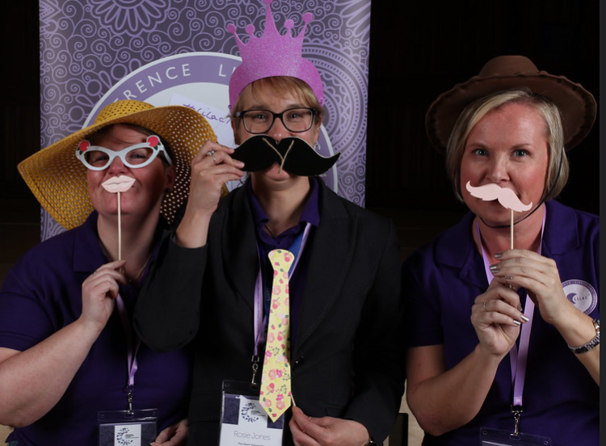

Discussion of Results
The following statements come through the analysis of the data gathered from interviews, submitted stories and conference reports. They have been thematically organised as per the themes found in previous scholarship on the impact of conference attendance (Dumbell, 2019) which match the findings of this research.

Social Impact, Networking and Collaborations
- Connections established at LILAC have led to and continue to lead to collaborative work between researchers from different institutions, areas of practice, and sectors including published academic works, policies, and guidance in the areas of Information Literacy.
- Sustained involvement in LILAC, either through attending multiple conferences over time or being part of the LILAC committee or ILG, has a significant impact on the careers of delegates and committee members, with delegates being offered opportunities for career advancement through connections made at the conference, applying learning taken from the conference into job applications, or professional accreditation applications, and through exploiting the positive reputation of the conference as proof of their own influence within the Information Literacy and wider Higher Education or research landscapes.
- Sustained involvement in LILAC also leads to more collaborative work, and more engagement with the professional community more generally. It can also create friendships between the regular delegates that are seen as positives to those involved.
- For many individuals, attendance at LILAC initially was dependent on bursary funding, either through awards from LILAC and the ILG or external partners. Several of the delegates contributing to this research quote this initial bursary as instrumental in career development, future involvement in Information Literacy research collaborations or being further involved in the conference through joining the committee. It is therefore essential for the bursary schemes to continue, and to grow in number to allow more areas of the Information Literacy community to attend the conference. Publicity of the bursary schemes outside of HE should increase, and the benefits of attending LILAC through a bursary should be more widely publicised and understood by the Information Literacy community.

Affective Impact, Feelings Surrounding Conference Attendance
- Attending LILAC can lead to professional validation; through seeing Information Literacy as centred in a professional context: through feeling part of an evolving dialogue or seeing their work as valued, and through seeing a community empowered to speak up for their own profession and promoting their own work.
- Delegates report feelings of self-doubt and inadequacy before going to LILAC compared to feelings of professional value and self-worth post conference attendance.
- First time attendees of the conference often feel anxiety or overwhelmed. This is lessened by more frequent conference attendance. Being reassured by conference funders (either bursary providers or institutions) that self-care, space and taking time away from the conference to reflect on your experience is professionally appropriate may help to lessen this anxiety.
- The internationalisation of the conference can lead to feelings of negativity towards delegate’s own institutions owing to limitations in budget or power varying between the professional norms within countries.
- There is a substantive LILAC “fan” community, which has developed over the twenty years of the conference and includes frequent returner delegates, current and former conference committee members, and keynotes. These people frequently talk about the conference, plan their work around the conference and going to the conference forms a large part of their professional and occasionally personal identity. These people have often personally benefitted from the close association with the conference and the wider network and community it is part of. The visibility of the connectiveness of this fan community members throughout the conference and its associated communities and networks may have led to LILAC having a reputation for being “cliquey”. More research is needed to be conducted by researchers external to the conference community on this “fan” base, and the impact that membership or non-membership has within the Information Literacy community.

Information, Scholarship and Learning
- Papers presented at LILAC are relevant to the delegates, contribute to the widening of good practice across UK institutions and globally and lead to the advancement of the theories and pedagogies of Information Literacy more generally.
- The conference presentations are used by delegates to benchmark the work of their own institutions with others both locally and internationally.
- Information and learning from the conference feeds forward into future academic work and conference papers being presented, both within LILAC and the Journal of Information Literacy, and elsewhere.
- Several of the delegates, either through interviews or submitted stories, mention specific keynotes as instrumental to a change in their practice, their thinking, or their career. Keynotes, and the selection of whose voices are platformed by the conference, make a large impact on the profession’s practices and what theories or mindsets carry forward to the wider Information Literacy communities. The LILAC and ILG committees who suggest and invite keynotes have therefore a great deal of power over what voices will be the more influential to the community in the future.
- LILAC delegates frequently report a consolidation of a critical awakening through attending the conference, which has contributed to a trend within the wider Information Literacy community towards a more critical praxis.
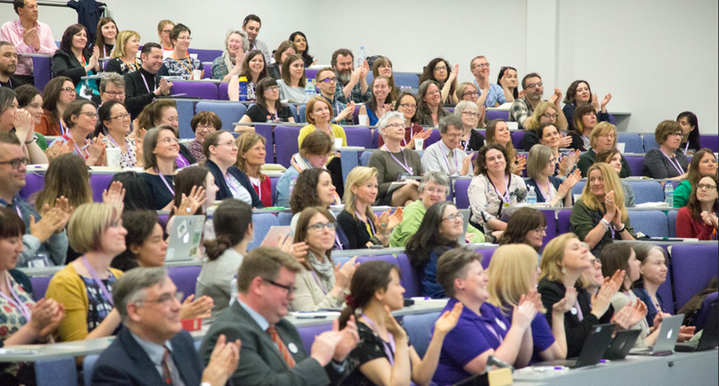

Recommendations

Making the Conference Less HE More IL
It is often noted in the conference reports and interviews that LILAC is too focussed on the work of tertiary education (Ryan, B., 2024; Silva, 2024); the majority of attendees, presentations and keynotes come from a HE background. This is problematic as Information Literacy crosses the lifespan, is not limited to those that attend HE and it could be argued is a larger issue for society more generally, including those in schools, in healthcare and within the public sector.
LILAC offers bursaries to underrepresented groups (Schools, FE, Public Libraries and Health), however the number of applications for these bursaries is relatively low, despite the clear benefits that attending LILAC on a bursary has for individuals in terms of career progression and networking. It is recommended that the wider conference community does more to promote these bursaries and the value of conference attendance to all sectors.
LILAC Committee membership is also open to all sectors, however there are few applications from outside of HE librarianship to join the committee, despite evidence that this is personally a very valuable activity to engage in (Haigh, 2023). It is recommended that recruitment to the LILAC Committee in the future targets all sectors currently not represented to offer the opportunities that come with Committee membership outside of those working in HE.
As the culture of the conference is influence by its physical setting, one of the recommendations is that the conference is hosted by organisations external to HE, such as a local authority’s public library service or an NHS trust. Although there are many practical issues to this, such as these organisations generally not having access to the same sorts of accessible venues with appropriate lecture theatres, break-out spaces or infrastructure for catering, there are several purpose built conference centres that could be utilised, as is the current practice within the NHS for hosting their own conferences (NHS ConfedExpo, 2024). This could encourage other sectors to feel a sense of inclusion within the conference community and to participate more within the conference.

Making Professional Opportunities of Conference Attendance and Participation More Explicit
The LILAC Committee has since 2023 included a representative from the New Professionals group within the Information Literacy Group. This representative is part of the programme team, reviewing papers as suitable for inclusion. The value of this was instantly felt by the programme team, as giving an important new perspective to the needs of New Professionals and should continue to enhance the LILAC conference programme. The role of New Professionals within the conference planning should be made more explicit to delegates for them to recognise the value the inclusion of these voices has to the programme. As the next generation of delegates comes in to the workforce it is important to recognise that the professional value of conference attendance, rather than being as a social event, may be more important to the next group of New Professionals who value their time in terms of what it will give them to increase their employability and enhance their future career.
The majority of those that were interviewed were involved deeply in the conference, either as organisers or keynotes, and the impact this has had on their careers was very clear for them, through the connections made and opportunities to engage in research or publishing, as well as mentoring and support with applying for jobs. This reflects the findings of previous research into conference attendees, as Stefansdottir shows for example,
“When people attend conferences throughout their career and are actively engaged with their attendance during the conference journey, this positively influences their career” (Stefansdottir, 2020, p. 227).
LILAC can do more to showcase the impact that participating in a conference as an organiser or speaker can have on careers and help others learn from these experiences by incorporating more mentoring opportunities within the wider organisation with a specific focus on employability and/or career-building training/masterclass sessions through ILG that may be of greater value to the wider community.

Encouraging Reflection on the Conference
Within the interview data it was noted that many delegates valued the time and space the three days of the conference gave them to reflect both on what they were learning and experiencing and their own professional development. Reflection is an important part of developing a critical consciousness and learning from other’s and personal experiences, and having the time to do this is important, but not everyone either allocates this time or has the privilege of time to do this. However, in order to get the most out of attending a conference, this time is needed, as Stefansdottir noted in their own research:
“Those who gained the most from the conference journey exhibited not only active and positive engagement with the single conference journeys but also constant reflection on them” (Stefansdottir, 2020, p. 210).
Conference reports that give highlights of presentations and link back to the conference’s abstracts and archives enable members of the community unable to attend the conference to have a good idea of what was presented; however, for the impact of the conference to be better understood, more reflective reporting is encouraged that shows how the information taken from the conference has been understood and thought about in differing contexts or lenses. It is recommended that reflective writing and thinking are incorporated into the ILG’s training offer to further enhance delegate’s conference experiences and to improve the reflective quality of conference reports.

References
Alaimo, R. (2004) Top Six Reasons to Attend a Conference. Knowledge Quest, 33 (1) October, pp. 34–35.
Bali (2024) Teaching Critical AI Literacies - Maha Bali [Online]. SlideShare. Available from: <https://www.slideshare.net/slideshow/teaching-critical-ai-literacies-maha-bali/267125300> [Accessed 19 March 2025].
Bedford, D. (2016) Reflecting on LILAC #lilac16. Libraries, Learning and Teaching, 26 March [Online blog]. Available from: <https://liblearnteach.wordpress.com/2016/03/26/reflecting-on-lilac-lilac16/> [Accessed 11 May 2023].
Bell, D. (2015) LILAC Conference 2015 – Developing@City [Online]. Available from: <https://blogs.city.ac.uk/developingatcity/2015/04/22/lilac-conference-2015/> [Accessed 11 May 2023].
Bell, D. (2016) LILAC 2016: Leabharlannan, Learning & Leprechauns – Developing@City [Online]. Available from: <https://blogs.city.ac.uk/developingatcity/2016/03/31/lilac-2016-leabharlannan-learning-leprechauns/> [Accessed 11 May 2023].
Bell, D. (2017) Reflections on LILAC 2017. citylibresearchers, 19 April [Online blog]. Available from: <https://citylibresearchers.wordpress.com/2017/04/19/reflections-on-lilac-2017/> [Accessed 11 May 2023].
Brennan, A. (2014) LILAC 2014 Conference Report: A Student’s Perspective. Journal of Information Literacy, 8 (1).
Burnett, E. (2016) The Librarian Identity: Lilac Linings Playbook. The Librarian Identity, 11 April [Online blog]. Available from: <https://thelibrarianidentity.blogspot.com/2016/04/lilac-linings-playbook.html> [Accessed 11 May 2023].
camiln (2019) Snippets from Our LILAC Diaries. Cambridge Information Literacy Network, 3 May [Online blog]. Available from: <https://camiln.wordpress.com/2019/05/03/snippets-from-our-lilac-diaries/> [Accessed 11 May 2023].
Carbery, A. (2017) Authentic Information Literacy in an Era of Post Truth - Alan Carbery (LILAC 2017 Keynote Speaker) | PPT [Online]. Available from: <https://www.slideshare.net/slideshow/authentic-information-literacy-in-an-era-of-post-truth-alan-carbery-lilac-2017-keynote-speaker/75119661> [Accessed 16 June 2025].
Caro-Diaz, E. J., Balunas, M. J., Giddings, L.-A., Loesgen, S., Murphy, B. T., Naman, C. B., Salomon, C. E., Tidgewell, K. J. and Winter, J. M. (2024) Outlining the Hidden Curriculum: Perspectives on Successfully Navigating Scientific Conferences. Journal of Natural Products, 87 (5) May, pp. 1487–1492.
Cassar, J., Whitfield, J. and Chapman, A. (2020) Contemporary Factors Influencing Association Conference Attendance. Journal of Convention & Event Tourism, 21 (1) January, pp. 57–90.
CAST (2024) UDL Tips for Accessible Educational Materials [Online]. CAST. Available from: <https://www.cast.org/resources/tips-articles/udl-tips-accessible-educational-materials-aem/> [Accessed 19 March 2025].
Cavusoglu, M., Dogan, S., Kirant Yozcu, O., Hsu, M.-J. and Cobanoglu, C. (2023) A Conjoint Analysis of Attributes Influencing Attendance of Academic Conferences. International Journal of Contemporary Hospitality Management, 35 (9) January, pp. 3263–3284.
Craggs, R. and Mahony, M. (2014) The Geographies of the Conference: Knowledge, Performance and Protest. Geography Compass, 8 (6), pp. 414–430.
Czerkaszyn, D. (2019) #LILAC19 a Student Perspective on the LILAC Conference 2019. Information School News [Online blog]. Available from: <https://information-studies.blogspot.com/2019/05/lilac19-student-perspective-on-lilac.html>.
Delaney, G. and Bates, J. (2015) Envisioning the Academic Library: A Reflection on Roles, Relevancy and Relationships. New Review of Academic Librarianship, 21 (1) January, pp. 30–51.
Donkor, A. B., Asimah, A. P. A. and Nwagwu, W. E. (2024) Torn Between Two Worlds: Perceptions of the Role, Status, and Career Progression of Librarians Working in University Libraries. The Journal of Academic Librarianship, 50 (2) March, p. 102861.
Dreeszen Bowman, R. and Dudak, L. T. (2025) Cripping Conferences: An Autoethnographic Exploration of Disability in Academia – In the Library with the Lead Pipe. [Online blog]. Available from: <https://www.inthelibrarywiththeleadpipe.org/2025/cripping-conferences/> [Accessed 16 January 2025].
Dumbell, P. (2019) The Impact of Conference Attendance on Australian Academic Librarians and Libraries [Online]. Bentley, Perth, Western Australia: Curtin University. Available from: <https://espace.curtin.edu.au/bitstream/handle/20.500.11937/77366/Dumbell%20P%202019.pdf?sequence=1>.
Elliott, T. (2012) Student to LILAC Superhero. Journal of Information Literacy, 6 (1) May, pp. 96–98.
Ettarh, F. M. (2018) Vocational Awe and Librarianship: The Lies We Tell Ourselves – In the Library with the Lead Pipe. 10 January [Online blog]. Available from: <https://www.inthelibrarywiththeleadpipe.org/2018/vocational-awe/> [Accessed 11 June 2024].
Gandour, A. (2016) And Books Will Fly...: Sketchnoting My Way through #lilac16. And books will fly..., 1 April [Online blog]. Available from: <https://andbookswillfly.blogspot.com/2016/04/sketchnoting-lilac16.html> [Accessed 11 May 2023].
Garcia Grau, E. (2022) LILAC 2022: A Reflection on Librarians as Teachers. Journal of Information Literacy, 16 (1) June, pp. 138–140.
Glass, B. (2007) LILAC Conference 2007. New Library World, 108 (11–12), pp. 565–566.
Glass, B. (2008) LILAC 2008 in Liverpool, European Capital of Culture. New Library World, 109 (11/12), pp. 587–588.
Glass, B. (2009) The LILAC Conference 2009. New Library World, 110 (11–12), pp. 564–567.
Glass, B. (2010) The LILAC Conference 2010. New Library World, 111 (11/12) January, pp. 530–532.
Graviet, Y. (2023) Reflections on LILAC 2023. Information School News [Online blog]. Available from: <https://information-studies.blogspot.com/2023/05/reflections-on-lilac-2023.html>.
Haigh, J. (2023) What Being on the LILAC Committee Has Done for Me… – Information Literacy Website. [Online blog]. Available from: <https://infolit.org.uk/what-being-on-the-lilac-committee-has-done-for-me/> [Accessed 11 June 2024].
Haire, A. (2024) LILAC 2024: Hidden Knowledge, Empathy and Understanding. Journal of Information Literacy, 18 (1) June, pp. 220–223.
Hall, S. M., Kochin, D., Carne, C., Herterich, P., Lewers, K. L., Abdelhack, M., Ramasubramanian, A., Alphonse, J. F. M., Ung, V., El-Gebali, S., Currin, C. B., Plomp, E., Thompson, R. and Sharan, M. (2024) Ten Simple Rules for Pushing Boundaries of Inclusion at Academic Events. PLOS Computational Biology, 20 (3) March, p. e1011797.
Hare, R. (2014) ARLG North East and Yorkshire: Report from LILAC 2014 by Rosie Hare. ARLG North East and Yorkshire, 12 May [Online blog]. Available from: <https://arlgnortheast.blogspot.com/2014/05/report-from-lilac-2014-by-rosie-hare.html> [Accessed 11 May 2023].
Harrison, R. (2010) Unique Benefits of Conference Attendance as a Method of Professional Development for LIS Professionals. The Serials Librarian, 59 (3–4) September, pp. 263–270.
Harvey, M. N. (2011) LILAC Goes to London. Journal of Information Literacy, 5 (1) May, pp. 89–90.
Hines, S. S. (2014) What Do Library Workers Want From Professional Conferences? [Online]. In: Revolutionizing the Development of Library and Information Professionals: Planning for the Future. IGI Global, pp. 1–16. Available from: <https://www-igi-global-com.leedsbeckett.idm.oclc.org/chapter/what-do-library-workers-want-from-professional-conferences/92406> [Accessed 5 May 2023].
Irish, J. E. N. (2020) Increasing Participation: Using the Principles of Universal Design to Create Accessible Conferences. Journal of Convention & Event Tourism, 21 (4) August, pp. 308–330.
Jenkins, R. (2022) And We’re Back (in Person!) – The LILAC Conference. Kangarooth, 19 April [Online blog]. Available from: <https://kangarooth.wordpress.com/2022/04/19/and-were-back-lilac22-conference-in-person/> [Accessed 11 May 2023].
Jones, M. (2023) Thoughts from the LILAC Conference 2023 in Cambridge [Online]. Available from: <https://www.linkedin.com/pulse/thoughts-from-lilac-conference-2023-cambridge-mike-jones> [Accessed 9 May 2024].
Jones, M. (2024) Thoughts from the LILAC Conference 2024 in Leeds [Online]. Available from: <https://www.linkedin.com/pulse/thoughts-from-lilac-conference-2024-leeds-mike-jones-bdode> [Accessed 17 April 2024].
Joo, R., Sánchez-Tapia, A., Mortara, S., Saibene, Y. B., Turner, H., Peter, D. H., Morandeira, N. S., Bannert, M., Almazrouq, B., Hare, E., Ación, L., Narváez-Gómez, J. P., Córdoba, M. A., Marini, F., Giordano, R., Canelón, S., Ebou, A., Upadhya, A. R., Chávez, J. and Ravi, J. (2022) Ten Simple Rules to Host an Inclusive Conference. PLOS Computational Biology, 18 (7) July, p. e1010164.
Kirschbaum, A. (2022) LILAC 2022: Amongst One’s Own. Information School News [Online blog]. Available from: <https://information-studies.blogspot.com/2022/05/lilac-2022-amongst-ones-own.html>.
Kitchin, R. (2005) Commentary: Disrupting and Destabilizing Anglo-American and English-Language Hegemony in Geography1. Social & Cultural Geography, 6 (1) February, pp. 1–15.
Landreman, L. M., Rasmussen, C. J., King, P. M. and Jiang, C. X. (2007) A Phenomenological Study of the Development of University Educators’ Critical Consciousness. Journal of College Student Development, 48 (3), pp. 275–296.
Løkse, M. (2013) Fagreferenten Forteller: LILAC 2013. Fagreferenten forteller, 17 April [Online blog]. Available from: <https://fagreferenten.blogspot.com/2013/04/lilac-2013.html> [Accessed 11 May 2023].
Mair, J. (2017) Conferences and Conventions: A Research Perspective. Routledge advances in event research series. London: Routledge, Taylor & Francis Group.
Mair, J., Lockstone-Binney, L. and Whitelaw, P. A. (2018) The Motives and Barriers of Association Conference Attendance: Evidence from an Australasian Tourism and Hospitality Academic Conference. Journal of Hospitality and Tourism Management, 34 March, pp. 58–65.
McGowan, B., Hart, J. and Hum, K. eds. (2021) College & Research Libraries.
McKinney, P. and Webber, S. (2024) Information Literacy Weblog. Information Literacy Weblog [Online blog]. Available from: <https://information-literacy.blogspot.com/>.
Medaille, A. (2024) The Librarian’s Guide to Learning Theory: Practical Applications in Library Settings. Chicago: ALA Editions.
Moosun, W. (2024) LILAC 2024 - There’s Always a Hidden Owl in knOWLedge. Information School News [Online blog]. Available from: <https://information-studies.blogspot.com/2024/08/lilac-2024-theres-always-hidden-owl-in.html> [Accessed 1 August 2024].
Nagle, M. (2015) Where the Buses Don’t Run: A LILAC 2015 Conference Report. Journal of Information Literacy, 9 (1), p. 108.
Napthine-Hodgkinson, J. (2022) LILAC 2022: Conference Report. Journal of Information Literacy, 16 (1), p. 135.
NHS ConfedExpo (2024) NHS ConfedExpo 2024 [Online]. NHS ConfedExpo 2024. Available from: <https://www.nhsconfedexpo.org/> [Accessed 3 June 2024].
Oliver, C. and Morris, A. (2020) (Dis-)Belonging Bodies: Negotiating Outsider-Ness at Academic Conferences. Gender, Place & Culture, 27 (6) June, pp. 765–787.
Pagowsky, N. and McElroy, K. (2016) Critical Library Pedagogy Handbook. Association of College and Research Libraries, a division of the American Library Association.
Palmer, L. (2018) LILAC 2018 Student Blog Laura Palmer. Information School News [Online blog]. Available from: <https://information-studies.blogspot.com/2018/04/lilac-2018-student-blog-laura-palmer.html>.
Pavluković, V., Davidson, R., Chaperon, S. and Vujičić, M. (2022) China’s Generation Z: Students’ Motivations for Conference Attendance and Preferred Conference Design [Online]. Available from: <https://leedsmu.library.ingentaconnect.com/content/cog/em/2022/00000026/00000004/art00011#> [Accessed 3 June 2024].
pennylibrarian (2018) LILAC – a First-Timer’s Perspective. pennylibrarian cpd, 8 April [Online blog]. Available from: <https://pennylibrariancpd.blog/2018/04/08/lilac-a-first-timers-perspective/> [Accessed 11 May 2023].
Purcell, S. and Mandall, T. (2024) LILAC 2024: Compassion, Authenticity and Positive Pragmatism. Journal of Information Literacy, 18 (1) June, pp. 233–236.
Ram, S. S., Stricker, D., Pannetier, C., Tabin, N., Costello, R. W., Stolz, D., Eva, K. W. and Huwendiek, S. (2023) Cliques within the Crowd: Identifying Medical Conference Attendee Subgroups by Their Motivations for Participation. Advances in Health Sciences Education, 28 (5) December, pp. 1485–1508.
Ramirez, D., Laing, J. and Mair, J. (2013) Exploring Intentions to Attend a Convention: A Gender Perspective [Online]. Available from: <https://leedsmu.library.ingentaconnect.com/content/cog/em/2013/00000017/00000002/art00007#> [Accessed 3 June 2024].
Reeve, J. (2024) Will AI Replace Librarians? LILAC 2024 Student Blog. Information School News [Online blog]. Available from: <https://information-studies.blogspot.com/2024/05/will-ai-replace-librarians-lilac-2024.html>.
Rehman, I. ur, Majeed, U. and Ganaie, S. A. (2024) Continuous Professional Development of LIS Professionals in Academic Libraries: Channels, Challenges and Motivation. Global Knowledge, Memory and Communication [Online], ahead-of-print (ahead-of-print) January. Available from: <https://www.emerald.com/insight/content/doi/10.1108/gkmc-08-2023-0298/full/html> [Accessed 6 March 2025].
Rippon, A. (2016) #citylis Student Perspectives: Amy Rippon at LILAC | CityLIS News – Library & Information Science at City, University of London [Online]. Available from: <https://blogs.city.ac.uk/citylis/2016/04/11/citylis-student-perspectives-amy-rippon-at-lilac/#.Vw0YSHqjtFt> [Accessed 11 May 2023].
Ryan, B. (2024) LILAC 2024: A Newbie’s Report. Journal of Information Literacy, 18 (1) June, pp. 224–227.
Ryan, B. and Feeney, D. (2024) LILAC Conference, 25 to 27 March 2024. Social Informatics research, 26 April [Online blog]. Available from: <http://blogs.napier.ac.uk/social-informatics/2024/04/lilac-conference-25-to-27-march-2024/> [Accessed 10 May 2024].
Ryan, G. and Bernard, H. R. (2003) Techniques to Identify Themes - Gery W. Ryan, H. Russell Bernard, 2003 [Online]. Available from: <https://journals.sagepub.com/doi/abs/10.1177/1525822x02239569> [Accessed 3 July 2023].
Sabnis, S. V. and Proctor, S. L. (2022) Use of Critical Theory to Develop a Conceptual Framework for Critical School Psychology. School Psychology Review, 51 (6) November, pp. 661–675.
Sassen, C. (2023) A Beginner’s Guide to Library Association Service. College & Undergraduate Libraries, 0 (0) April, pp. 1–9.
Scott, R. J. (2024) Narrative Inquiry: An Annotated Bibliography for Library and Information Professionals. [Online]. Available from: <http://uhra.herts.ac.uk/handle/2299/27494> [Accessed 10 April 2024].
Secker, J. (2016) Lessons from LILAC 16. Libraries, Information Literacy and E-learning, 4 April [Online blog]. Available from: <https://janesecker.wordpress.com/2016/04/04/lessons-from-lilac-16/> [Accessed 11 May 2023].
Semple, N. (2022) Live Highlights: LILAC Conference Day 1. Nicola Semple, 11 April [Online blog]. Available from: <https://nicolasemple.co.uk/2022/04/11/lilac-conference-2022-day-one/> [Accessed 11 May 2023].
Silva, A. (2024) LILAC 2024: A View from Public Libraries – Information Literacy Website [Online]. Information Literacy Weblog. Available from: <https://infolit.org.uk/lilac-2024-a-view-from-public-libraries/> [Accessed 14 May 2024].
Stefansdottir, K. S. (2020) The Holistic Conference Experience: Understanding the Individual Attendee’s Conference Journey [Online] [doctoral]. Sheffield Hallam University. Available from: <https://shura.shu.ac.uk/27555/> [Accessed 12 May 2023].
Tattersall, A. (2015) ScHARR Information Resources Blog: Research Hacks at LILAC 2015. ScHARR Information Resources Blog, 20 April [Online blog]. Available from: <https://scharrlibrary.blogspot.com/2015/04/research-hacks-at-lilac-2015.html> [Accessed 11 May 2023].
thelibrarianerrant (2019) Speaking and Listening: 2019 LILAC Conference. thelibrarianerrant, 30 April [Online blog]. Available from: <https://thelibrarianerrant.wordpress.com/2019/04/30/speaking-and-listening-2019-lilac-conference/> [Accessed 11 May 2023].
Vega, R. D. and Connell, R. S. (2007) Librarians’ Attitudes Toward Conferences: A Study | Vega | College & Research Libraries. [Online]. Available from: <https://crl.acrl.org/index.php/crl/article/view/15900> [Accessed 23 May 2023].
Vogl, C. H. (2016) The Art of Community : Seven Principles for Belonging [Online]. Oakland, CA: Berrett-Koehler Publishers, a BK Currents Book. Available from: <https://search.ebscohost.com/login.aspx?direct=true&scope=site&db=nlebk&db=nlabk&AN=1219895>.
Walters, T., Hassanli, N. and Finkler, W. (2020) Who Is Seen to Be Doing Business Research, and Does It Really Matter? Gender Representation at Academic Conferences. Equality, Diversity and Inclusion: An International Journal, 40 (3) January, pp. 338–354.
Woods, L. (2016) Reflections from LILAC 2016. Organising Chaos, 1 April [Online blog]. Available from: <https://woodsiegirl.wordpress.com/2016/04/01/reflections-from-lilac-2016/> [Accessed 11 May 2023].
Woods, L. (2022a) LILAC 2022: Reflections. Organising Chaos, 18 April [Online blog]. Available from: <https://woodsiegirl.wordpress.com/2022/04/18/lilac-2022-reflections/> [Accessed 11 May 2023].
Woods, L. (2022b) Social Justice: The LILAC Keynotes. Organising Chaos, 19 April [Online blog]. Available from: <https://woodsiegirl.wordpress.com/2022/04/19/social-justice-the-lilac-keynotes/> [Accessed 11 May 2023].
Woods, L. (2023) LILAC Reflections – Information Literacy Website. [Online blog]. Available from: <https://infolit.org.uk/lilac-reflections/> [Accessed 11 May 2023].
Wrzus, C., Zimmermann, J., Mund, M. and Neyer, F. (2016) Friendships in Young and Middle Adulthood: Normative Patterns and Personality Differences. p. nn.
Yamashita, R. and Oshimi, D. (2023) The Motivations for and Barriers to Academic Conference Attendance: Insights from an International Sport Management Conference. Journal of Convention & Event Tourism, 24 (3) May, pp. 294–312.
Zazani, E. (2011) Trends on Information Literacy Discussed at LILAC 2011. Journal of Information Literacy, 5 (1) May, pp. 91–94.

Bibliography of Conference Reports
Bedford, D. (2016) Reflecting on LILAC #LILAC16. Libraries, Learning and Teaching, 26 March [Online blog]. Available from: <https://liblearnteach.wordpress.com/2016/03/26/reflecting-on-LILAC-LILAC16/> [Accessed 11 May 2023].
Bell, D. (2015) LILAC Conference 2015 – Developing@City [Online]. Available from: <https://blogs.city.ac.uk/developingatcity/2015/04/22/LILAC-conference-2015/> [Accessed 11 May 2023].
Bell, D. (2016) LILAC 2016: Leabharlannan, Learning & Leprechauns – Developing@City [Online]. Available from: <https://blogs.city.ac.uk/developingatcity/2016/03/31/LILAC-2016-leabharlannan-learning-leprechauns/> [Accessed 11 May 2023].
Bell, D. (2017) Reflections on LILAC 2017. citylibresearchers, 19 April [Online blog]. Available from: <https://citylibresearchers.wordpress.com/2017/04/19/reflections-on-LILAC-2017/> [Accessed 11 May 2023].
Brennan, A. (2014) LILAC 2014 Conference Report: A Student’s Perspective. Journal of Information Literacy, 8 (1).
Burnett, E. (2016) The Librarian Identity: LILAC Linings Playbook. The Librarian Identity, 11 April [Online blog]. Available from: <https://thelibrarianidentity.blogspot.com/2016/04/LILAC-linings-playbook.html> [Accessed 11 May 2023].
camiln (2019) Snippets from Our LILAC Diaries. Cambridge Information Literacy Network, 3 May [Online blog]. Available from: <https://camiln.wordpress.com/2019/05/03/snippets-from-our-LILAC-diaries/> [Accessed 11 May 2023].
Chamley, J. (2015) ARLG North East and Yorkshire: LILAC Sponsored Place: Event Write Up. ARLG North East and Yorkshire, 5 May [Online blog]. Available from: <http://arlgnortheast.blogspot.com/2015/05/arlg-north-east-sponsor-place-each-year.html> [Accessed 11 May 2023].
Clay, J. (2016) Building Digital Capability in the Library. Jisc Building Digital Capability Blog, 31 March [Online blog]. Available from: <https://digitalcapability.jiscinvolve.org/wp/2016/03/31/building-digital-capability-in-the-library/> [Accessed 11 May 2023].
Czerkaszyn, D. (2019) #LILAC19 a Student Perspective on the LILAC Conference 2019. Information School News [Online blog]. Available from: <https://information-studies.blogspot.com/2019/05/LILAC19-student-perspective-on-LILAC.html>.
Developing@City Staff Development blog for City, University of London Library staff (2015) LILAC 2015 – Conference Report – Developing@City [Online]. Developing@City Staff Development blog for City, University of London Library staff. Available from: <https://blogs.city.ac.uk/developingatcity/2015/05/05/LILAC-2015-conference-report/> [Accessed 11 May 2023].
Elliot, J. and Manecke, U. B. (2022) LILAC 2022: A Reflection on Inclusivity. Journal of Information Literacy, 16 (1) June, pp. 141–143.
Elliott, T. (2012) Student to LILAC Superhero. Journal of Information Literacy, 6 (1) May, pp. 96–98.
Fernandes, J. (2024) LILAC 2024: Conference Report. Journal of Information Literacy, 18 (1) June, pp. 228–232.
Fister, B. F., Barbara (2015) “A Bit of a Tall Order” [Online]. Available from: <https://www.insidehighered.com/blogs/library-babel-fish/%E2%80%9C-bit-tall-order%E2%80%9D> [Accessed 11 May 2023].
Gandour, A. (2016) And Books Will Fly...: Sketchnoting My Way through #LILAC16. And books will fly..., 1 April [Online blog]. Available from: <https://andbookswillfly.blogspot.com/2016/04/sketchnoting-LILAC16.html> [Accessed 11 May 2023].
Garcia Grau, E. (2022) LILAC 2022: A Reflection on Librarians as Teachers. Journal of Information Literacy, 16 (1) June, pp. 138–140.
Glass, B. (2007) LILAC Conference 2007. New Library World, 108 (11–12), pp. 565–566.
Glass, B. (2008) LILAC 2008 in Liverpool, European Capital of Culture. New Library World, 109 (11/12), pp. 587–588.
Glass, B. (2009) The LILAC Conference 2009. New Library World, 110 (11–12), pp. 564–567.
Glass, B. (2010) The LILAC Conference 2010. New Library World, 111 (11/12) January, pp. 530–532.
Graviet, Y. (2023) Reflections on LILAC 2023. Information School News [Online blog]. Available from: <https://information-studies.blogspot.com/2023/05/reflections-on-LILAC-2023.html>.
Haigh, J. (2016) LILAC, Thoughts and Reflections. Jess Haigh, 30 March [Online blog]. Available from: <https://jesshaigh.wordpress.com/2016/03/30/LILAC-thoughts-and-reflections/> [Accessed 11 May 2023].
Haigh, J. (2018) LILAC Reflections. Jess Does Teaching, 13 April [Online blog]. Available from: <https://jessdoesteaching.wordpress.com/2018/04/13/LILAC-reflections-part-1/> [Accessed 11 May 2023].
Haire, A. (2024) LILAC 2024: Hidden Knowledge, Empathy and Understanding. Journal of Information Literacy, 18 (1) June, pp. 220–223.
Hare, R. (2014) ARLG North East and Yorkshire: Report from LILAC 2014 by Rosie Hare. ARLG North East and Yorkshire, 12 May [Online blog]. Available from: <https://arlgnortheast.blogspot.com/2014/05/report-from-LILAC-2014-by-rosie-hare.html> [Accessed 11 May 2023].
Harvey, M. N. (2011) LILAC Goes to London. Journal of Information Literacy, 5 (1) May, pp. 89–90.
Ingle, E. (2022) LILAC 2022: Origami Bees and Sunflower Seeds. Information School News [Online blog]. Available from: <https://information-studies.blogspot.com/2022/05/LILAC-2022-origami-bees-and-sunflower.html>.
Jenkins, R. (2022) And We’re Back (in Person!) – The LILAC Conference. Kangarooth, 19 April [Online blog]. Available from: <https://kangarooth.wordpress.com/2022/04/19/and-were-back-LILAC22-conference-in-person/> [Accessed 11 May 2023].
Johnson, B. and Reed, E. (2023) The Impact of Cultural Capital on Searching as Strategic Exploration in Incoming First-Year Students. The Journal of Academic Librarianship, 49 (6) November, p. 102807.
Johnson, Z. (2024) LILAC 2024 Report – Information Literacy Website. Information Literacy Weblog [Online blog]. Available from: <https://infolit.org.uk/LILAC-2024-report/> [Accessed 14 May 2024].
Jones, M. (2023) Thoughts from the LILAC Conference 2023 in Cambridge [Online]. Available from: <https://www.linkedin.com/pulse/thoughts-from-LILAC-conference-2023-cambridge-mike-jones> [Accessed 9 May 2024].
Jones, M. (2024) Thoughts from the LILAC Conference 2024 in Leeds [Online]. Available from: <https://www.linkedin.com/pulse/thoughts-from-LILAC-conference-2024-leeds-mike-jones-bdode> [Accessed 17 April 2024].
Kelly, B. (2014) Capturing the Conference Buzz: #LILAC14 as an Example. UK Web Focus (Brian Kelly), 28 April [Online blog]. Available from: <https://ukwebfocus.wordpress.com/2014/04/28/capturing-the-conference-buzz-LILAC14-as-an-example/> [Accessed 11 May 2023].
Kirschbaum, A. (2022) LILAC 2022: Amongst One’s Own. Information School News [Online blog]. Available from: <https://information-studies.blogspot.com/2022/05/LILAC-2022-amongst-ones-own.html>.
Løkse, M. (2013) Fagreferenten Forteller: LILAC 2013. Fagreferenten forteller, 17 April [Online blog]. Available from: <https://fagreferenten.blogspot.com/2013/04/LILAC-2013.html> [Accessed 11 May 2023].
McKinney, P. and Webber, S. (2024) Information Literacy Weblog. Information Literacy Weblog [Online blog]. Available from: <https://information-literacy.blogspot.com/>.
Moosun, W. (2024) LILAC 2024 - There’s Always a Hidden Owl in knOWLedge. Information School News [Online blog]. Available from: <https://information-studies.blogspot.com/2024/08/LILAC-2024-theres-always-hidden-owl-in.html> [Accessed 1 August 2024].
Nagle, M. (2015) Where the Buses Don’t Run: A LILAC 2015 Conference Report. Journal of Information Literacy, 9 (1), p. 108.
Napthine-Hodgkinson, J. (2022) LILAC 2022: Conference Report. Journal of Information Literacy, 16 (1), p. 135.
Palmer, L. (2018) LILAC 2018 Student Blog Laura Palmer. Information School News [Online blog]. Available from: <https://information-studies.blogspot.com/2018/04/LILAC-2018-student-blog-laura-palmer.html>.
pennylibrarian (2018) LILAC – a First-Timer’s Perspective. pennylibrarian cpd, 8 April [Online blog]. Available from: <https://pennylibrariancpd.blog/2018/04/08/LILAC-a-first-timers-perspective/> [Accessed 11 May 2023].
Purcell, S. and Mandall, T. (2024) LILAC 2024: Compassion, Authenticity and Positive Pragmatism. Journal of Information Literacy, 18 (1) June, pp. 233–236.
Reeve, J. (2024) Will AI Replace Librarians? LILAC 2024 Student Blog. Information School News [Online blog]. Available from: <https://information-studies.blogspot.com/2024/05/will-ai-replace-librarians-LILAC-2024.html>.
Rippon, A. (2016) #citylis Student Perspectives: Amy Rippon at LILAC | CityLIS News – Library & Information Science at City, University of London [Online]. Available from: <https://blogs.city.ac.uk/citylis/2016/04/11/citylis-student-perspectives-amy-rippon-at-LILAC/#.Vw0YSHqjtFt> [Accessed 11 May 2023].
Ryan, B. (2024a) Everything’s Coming up LILACs. Bruce’s IT-ish world, 15 April [Online blog]. Available from: <https://bruceryan.info/2024/04/15/everythings-coming-up-LILACs/> [Accessed 10 May 2024].
Ryan, B. (2024b) LILAC 2024: A Newbie’s Report. Journal of Information Literacy, 18 (1) June, pp. 224–227.
Ryan, B. and Feeney, D. (2024) LILAC Conference, 25 to 27 March 2024. Social Informatics research, 26 April [Online blog]. Available from: <http://blogs.napier.ac.uk/social-informatics/2024/04/LILAC-conference-25-to-27-march-2024/> [Accessed 10 May 2024].
Schulte, J., Tiffen, B., Edwards, J., Abbott, S. and Luca, E. (2018) Shaping the Future of Academic Libraries: Authentic Learning for the Next Generation: College & Research Libraries. College & Research Libraries, 79 (5) July, pp. 685–696.
Secker, J. (2014) LILAC 2014: Reflections and Thoughts. Libraries, Information Literacy and E-learning, 20 May [Online blog]. Available from: <https://janesecker.wordpress.com/2014/05/20/LILAC-2014-reflections-and-thoughts/> [Accessed 11 May 2023].
Secker, J. (2016) Lessons from LILAC 16. Libraries, Information Literacy and E-learning, 4 April [Online blog]. Available from: <https://janesecker.wordpress.com/2016/04/04/lessons-from-LILAC-16/> [Accessed 11 May 2023].
Secker, J. (2022) LILAC Coloured Joy and Focus. Libraries, Information Literacy and E-learning, 19 April [Online blog]. Available from: <https://janesecker.wordpress.com/2022/04/19/LILAC-coloured-joy-and-focus/> [Accessed 11 May 2023].
Semple, N. (2022a) Live Highlights: LILAC Conference Day 1. Nicola Semple, 11 April [Online blog]. Available from: <https://nicolasemple.co.uk/2022/04/11/LILAC-conference-2022-day-one/> [Accessed 11 May 2023].
Semple, N. (2022b) Live Highlights: LILAC Conference Day 2. Nicola Semple, 12 April [Online blog]. Available from: <https://nicolasemple.co.uk/2022/04/12/LILAC-conference-2022-day-two/> [Accessed 11 May 2023].
Semple, N. (2022c) Live Highlights: LILAC Conference Day 3. Nicola Semple, 13 April [Online blog]. Available from: <https://nicolasemple.co.uk/2022/04/13/LILAC-conference-2022-day-three/> [Accessed 11 May 2023].
Silva, A. (2024) LILAC 2024: A View from Public Libraries – Information Literacy Website [Online]. Information Literacy Weblog. Available from: <https://infolit.org.uk/LILAC-2024-a-view-from-public-libraries/> [Accessed 14 May 2024].
Street, P. and Hawksworth, L. (2012) LILAC Conference 2012. New Library World, 113 (9–10), pp. 495–498.
Tattersall, A. (2015) ScHARR Information Resources Blog: Research Hacks at LILAC 2015. ScHARR Information Resources Blog, 20 April [Online blog]. Available from: <https://scharrlibrary.blogspot.com/2015/04/research-hacks-at-LILAC-2015.html> [Accessed 11 May 2023].
thelibrarianerrant (2019) Speaking and Listening: 2019 LILAC Conference. thelibrarianerrant, 30 April [Online blog]. Available from: <https://thelibrarianerrant.wordpress.com/2019/04/30/speaking-and-listening-2019-LILAC-conference/> [Accessed 11 May 2023].
Walsh, A. (2017) Making Games for Libraries: Lagadothon and LILAC17. Making games for Libraries, 16 April [Online blog]. Available from: <https://gamesforlibraries.blogspot.com/2017/04/lagadothon-and-LILAC17.html> [Accessed 6 June 2024].
Webber, S. (2013a) Information Literacy Weblog: Final Reports from #LILAC13 - Health Literacy and Teachmeet Sessions. Information Literacy Weblog, 17 April [Online blog]. Available from: <https://information-literacy.blogspot.com/2013/04/final-reports-from-LILAC13-health.html> [Accessed 11 May 2023].
Webber, S. (2013b) Information Literacy Weblog: Mainstreaming Information Literacy #LILAC13. Information Literacy Weblog, 10 April [Online blog]. Available from: <https://information-literacy.blogspot.com/2013/04/mainstreaming-information-literacy.html> [Accessed 11 May 2023].
Woods, L. (2016) Reflections from LILAC 2016. Organising Chaos, 1 April [Online blog]. Available from: <https://woodsiegirl.wordpress.com/2016/04/01/reflections-from-LILAC-2016/> [Accessed 11 May 2023].
Woods, L. (2022a) LILAC 2022: Reflections. Organising Chaos, 18 April [Online blog]. Available from: <https://woodsiegirl.wordpress.com/2022/04/18/LILAC-2022-reflections/> [Accessed 11 May 2023].
Woods, L. (2022b) Social Justice: The LILAC Keynotes. Organising Chaos, 19 April [Online blog]. Available from: <https://woodsiegirl.wordpress.com/2022/04/19/social-justice-the-LILAC-keynotes/> [Accessed 11 May 2023].
Woods, L. (2022c) Understanding Library Users to Support Change. Organising Chaos, 20 April [Online blog]. Available from: <https://woodsiegirl.wordpress.com/2022/04/20/understanding-library-users-to-support-change/> [Accessed 11 May 2023].
Woods, L. (2023) LILAC Reflections – Information Literacy Website. [Online blog]. Available from: <https://infolit.org.uk/LILAC-reflections/> [Accessed 11 May 2023].
Zarach, V. (2009) LILAC Conference: Day 1: Melissa Highton Keynote. Cabinet of Curiosities, 20 May [Online blog]. Available from: <https://thecabinetofcuriosities.wordpress.com/2009/05/20/LILAC-conference-day-1-melissa-highton-keynote/> [Accessed 25 August 2023].
Zazani, E. (2011) Trends on Information Literacy Discussed at LILAC 2011. Journal of Information Literacy, 5 (1) May, pp. 91–94.

Anonymised versions of all interview transcripts and other research data is openly available through Leeds Beckett University.

