Response to ‘Area-level deprivation and adiposity in children: is the relationship linear?

Conflicts of interest: the authors declare no conflicts of interest.

Corresponding author | Dr Claire Griffiths  PhD  C.Griffiths@leedsmet.ac.uk | Senior Lecturer in Physical Activity, Exercise and Health  Leeds Metropolitan University  Fairfax Hall  Headingley Campus  Leeds  LS6 3QS
Additional authors | Professor Paul Gately  PhD  P.Gately@leedsmet.ac.uk | Professor of Exercise and Obesity  Leeds Metropolitan University  Churchwood  Headingley Campus  Leeds  LS6 3QS
 | Dr Paul R Marchant  PhD  P.Marchant@leedsmet.ac.uk | Chartered Statistician  Leeds Metropolitan University  Caedmon Hall  Headingley Campus  Leeds  LS6 3QS
 | Professor Carlton B Cooke  PhD  C.Cooke@leedsmet.ac.uk | Carnegie Professor of Sport and Exercise Science  Leeds Metropolitan University  Fairfax Hall  Headingley Campus  Leeds  LS6 3QS

We are grateful to Rutter and colleagues (1) who raise some interesting discussion points in relation to our article investigating the relationship between adiposity and area level deprivation in children (2).
When describing the peaks of obesity prevalence in the letter (1) (second paragraph) they are reported the wrong way around for boys and girls. Girls’ obesity prevalence peaks at an Income Deprivation Affecting Children Index (IDACI) score of 0.45 and boys peak at an IDACI score of 0.31.
Our findings (2) are contrary to those reported by the National Child Measurement Programme (NCMP) and suggest that the relationship between obesity and deprivation is not linear. In light of these conflicting conclusions it is important to highlight three key points for consideration when comparing the results:
- Different measures of deprivation were used. NCMP use the Index of Multiple Deprivation (IMD), we used IDACI.

It is possible that alternative deprivation measures would result in different findings. The only NCMP report to include IDACI and IMD (3) does however, report a linear relationship for both.

Furthermore, as stated in the paper ‘a positive linear trend was observed for all measures of adiposity in the logistic modelling of the RADS data (only significant in girls) when the relationship was assumed to be only linear (agreeing with the NCMP report). However, the inclusion of the IDACI² term modified this linear relationship and provided a better fit’ (2).

- In all NCMP reports the child population is divided into deciles. In our analysis deprivation is treated as a continuous variable.

Rutter et al highlight that IDACI scores are not evenly distributed across the population and so children are placed into deciles. Although using this measure may account for the uneven distribution of IDACI scores in the population, it will result in loss of information through grouping. Furthermore, including IDACI as a continuous rather than categorical variable has the advantage of being an absolute measure.

Figure 1 shows the probability of being obese against IDACI score with standard errors. These confidence intervals increase with increasing IDACI score. It also shows a non-linear relationship for both boys and girls. Obesity prevalence decreases above an IDACI score of 0.45 for girls and 0.31 for boys which are considerably lower than 0.8 reported by Rutter et al. (The relationship seems to be approximately linear in a much lower IDACI range). It is also noteworthy that 25% of our sample had an IDACI score greater than 0.4.

- In the most recent NCMP report (4) children are placed into a deprivation decile based on the IMD score of the school postcode rather than the home postcode, whereas the latter was used in our analysis.

Data is presented this way in NCMP reports to be comparable with previous years. However, using aggregated measures of deprivation (e.g. school) will result in a loss of information at the individual level.

SUMMARY
We agree that our findings were, in some respects misrepresented in the press coverage and the associated editorial (5). We also agree that the peaks in obesity prevalence occur in areas of above average deprivation not in ‘middle affluent areas’ as we described it in the paper (although it is the midpoint of the IDACI scale). However, the findings in our paper (2) and the evidence presented here remain consistent in that the relationship between obesity (measured by sBMI) and deprivation (measured by IDACI) for our data is not linear. These differences may be due to different measures of deprivation and the statistical techniques applied to the two data sets. We are also keen to see more detailed analyses of this and other data sets to investigate this important public health issue further, and it would be interesting to see the NCMP data analysed using IDACI scores based on child postcodes incorporating more complex models.

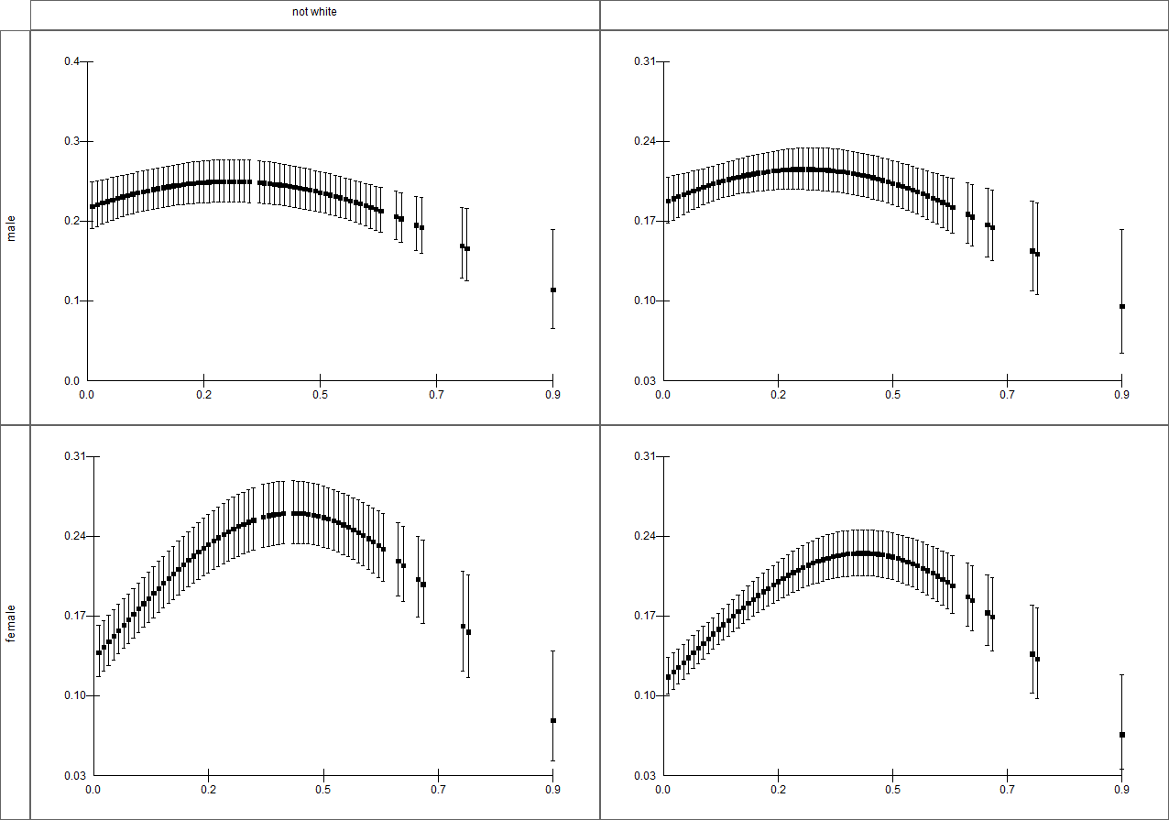
Not white-British
White-British
Male
Female
Probability of being obese (BMIsd)
IDACI score (0 = least deprived)
Figure 1 – Probability (converted from logit) of being obese, dependent upon IDACI score with associated 1 standard error confidence intervals

References

1. Rutter H, Hancock C, Ells L. Reply to Griffiths C et al. Area-level deprivation and adiposity in children: is the relationship linear? International Journal of obesity,. 2013.
2. Griffiths C, Gately P, Marchant PR, Cooke CB. Area-level deprivation and adiposity in children: is the relationship linear? International Journal of Obesity,. 2013 Feb 12.
3. The NHS information centre. National Child Measurement Programme: Detailed Analysis of the 2007/08 National Dataset. Stationary Office, London; 2009.
4. The NHS information centre. National Child Measurement Programme: England, 2011/12 school year. 2012.
5. Kelly SJ. Deprivation indices and childhood BMI: a re-evaluation. International Journal of Obesity,. 2013 Apr;37(4):475-6.

