Seims, Amanda L.; O'Hara, John P.; King, Roderick FGJ; Thomas, Aaron; Cooke, Carlton B. (2006). Core Temperature Responses of Fire-fighter Instructors During Work in a Hot and Normal Environment. Medicine and Science in Sports and Exercise, 38 (5), S58

It is important to employ training practices that ensure that fire-fighter instructors work in an environment which does not provoke unacceptable rises in core temperature (>38°C).
PURPOSE: To assess the effects of a two-day fire-behaviour training (FBT) course on the core temperature (T_{c}) of fire-fighter instructors in order to establish whether current training practices ensure a safe working environment.
METHODS: Eleven males (mean±sd age 38.3±4.3 yr, body mass 88.5±12.7 kg and stature 177.8±5.3 cm) from two regional training centres completed three days of standard FBT, wearing full protective clothing and breathing apparatus. Two consecutive days (HOT1 and HOT2, mean ambient temperature of 12.7°C) each consisted of a morning and an afternoon heat exposure (approximately 30 minutes in duration). The third day was a control (NORM), without heat exposure (mean T_{c} of 19.3 °C). T_{c} was measured at baseline (BASE) and at the start and end of the two exposures (PRE-AM, POST-AM and PRE-PM, POST-PM respectively) for each subject using a telemetry pill (HQ Inc, USA).
RESULTS: There was a different pattern of T_{c} response over the two HOT days compared with the NORM day due to the significant increase in T_{c} associated with each of the heat exposures (p<0.01, PRE to POST, Table 1). Mean T_{c} did not reach 38°C, but in 10 out of 44 individual exposures subjects had a T above 38°C post heat exposure. In contrast, baseline T for the three days was not significantly different and showed a consistent significant increase to PRE-AM values (p<0.01, BASE to PRE-AM, Table 1) associated with the wearing of protective clothing and morning activities. The mean (±sd) unit temperatures of the HOT and NORM days were 160.2 (±89.3) and 27.6 (±8.4) °C respectively.
Table 1
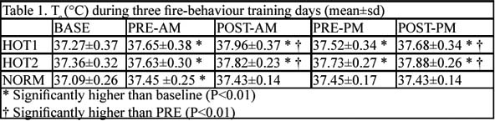
Table 1. T (°C) during three fire-behaviour training days (mean±sd)

