Selling the Smokeless City: Advertising Images and Smoke Abatement in Urban-industrial Britain, circa 1840-1960.
Introduction
Urban air pollution has attracted a good deal of scholarly attention in recent years, but few historians have focused on the strong visual culture that helped to shape understandings of smoke emissions. Images, from cartoons to photographs, can reveal more vividly the values of past cultures than texts and other historical evidence. The coal smoke that issued from industrial and domestic chimneys had contested meanings for contemporary urbanites; for most it signified the creation of wealth, jobs and well-being, while for a minority of critics this form of air pollution symbolised waste, inefficiency and ill-health. These competing visions were communicated in powerful images that circulated in British society at the time, and they played an active role in shaping and reshaping ideas about smoke and the city. However, the ‘testimony of images’, as Peter Burke has noted, is generally underappreciated and underused by historians who still prefer to work with traditional textual sources. Although the ‘Images, Technology and History’ feature of the journal is itself evidence that this situation is now beginning to change.
In this short study of urban-industrial Britain circa 1840-1960, I aim to show how images – mainly commercial advertisements – offer an important lens through which contemporary attitudes to air pollution can be examined. Putting visual evidence at the heart of the story allows us to see the ‘bigger picture’; opening up new perspectives on ‘carboniferous capitalism’ and smoke production in the industrial city. For example, by drawing attention to advertising campaigns to recover and recycle potentially valuable byproducts of coal that were lost during inefficient combustion. In addition, the paper shows how visual culture can help to create social, technological and environmental change by influencing consumer behaviour. It is divided into three sections: the first provides context for my discussion; the second section engages with the advertisements and the messages they contain; and, by way of a conclusion, I briefly reflect on the role of advertising images in supporting smoke abatement.
The Dark Age
In 1889 an editorial in The Spectator magazine spoke of a ‘reign of darkness’ in Britain’s capital, London, adding that its citizens lived ‘in something not far from perpetual twilight.’ High levels of atmospheric pollution, from both homes and businesses, had also enveloped other great cities such as Glasgow, Leeds, Manchester and Sheffield in a permanent smoke haze. Industrialisation and urbanisation in Britain had been based on the use of inexpensive bituminous coal for heat and power. And as its consumption increased, from around 65 million tons in 1853 to over 200 million tons in 1950, the harmful impacts of smoke emissions were difficult to for contemporaries to ignore: loss of sunlight; destruction of vegetation; blackened buildings; and not least of all damage to people’s health. Rickets was endemic in British cities, and respiratory diseases were the nation’s biggest killer by the turn of the twentieth century.
The tall smokestacks that dominated cityscapes, some over 100 metres in height, were designed to reduce local air pollution and the problems it caused by discharging smoke far up into the atmosphere to be dispersed by the prevailing winds. It was erroneously thought that the earth’s atmosphere was an inexhaustible sink, a ‘vast sea of air’, that could dilute and neutralise the pollutants that industrial chimneys emitted. However, topographical and meteorological conditions often prevented the dispersal of coal smoke away from industrial cities. Manchester, for example, bounded by the Pennine chain of hills, found that its factory smoke became trapped for days at a time during spells of cold, calm weather. And when industrial chimneys did function effectively, they simply displaced smoke pollution to plague other communities situated downwind. Domestic smoke emissions, released into the air at street-level, were more difficult to disperse and caused most damage to health and the urban environment.
However, smoke emissions were not generally viewed in a negative light by businessmen and the public. The production of smoke was commonly understood as an unmistakable sign that Britain’s industrial towns and cities were flourishing. It was, in the words of Rueben Spencer, chairman of Rylands and Sons, Manchester’s leading cotton textile company, ‘the incense of industry.’ Smoke meant bright trading conditions, jobs and wealth creation to most city dwellers. It was a ‘normal’ part of daily life, as this tongue-in-cheek postcard from the early twentieth century helps to show (Figure 1). The postcard portrays the power and dynamism of the modern industrial city, and its belching factory smokestacks signified work and commercial activity in a way that could easily be understood by contemporaries.

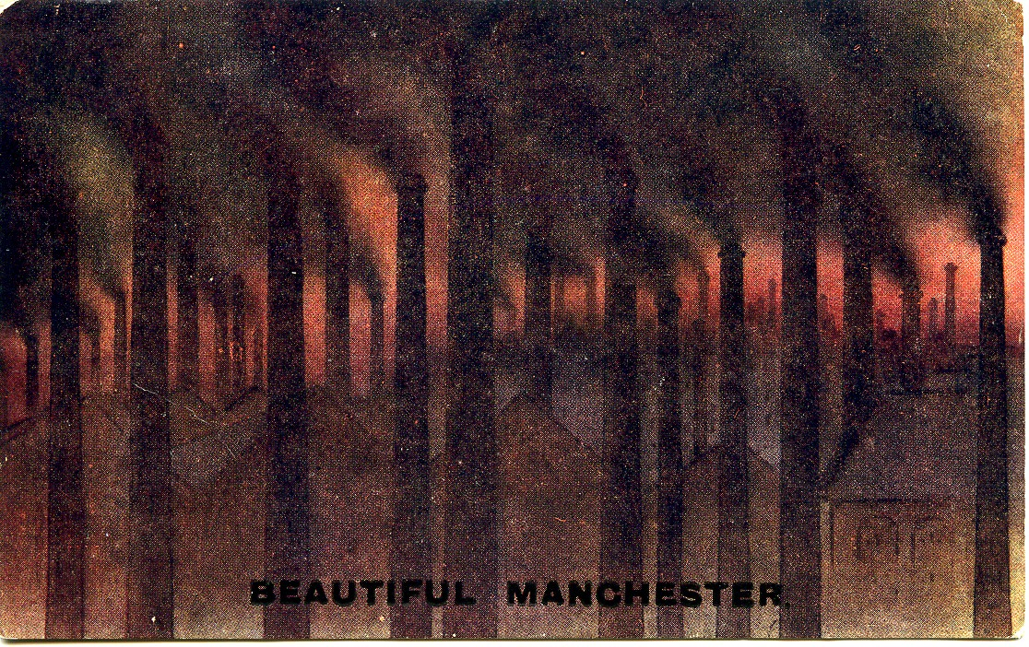
Figure 1. Beautiful Manchester
Source: Postcard in the author’s possession

Postcards transmitted cultural values and, despite its darkly humorous tone, ‘Beautiful Manchester’ celebrated industrial smoke as a symbol of progress and prosperity. What is more, some contemporaries really did find beauty in the way that coal smoke helped to create dramatic sunsets in Britain’s industrial cities; an atmospheric effect seen here in the colourful red hue of the Manchester skyline. While most artists struggled to see the ‘aesthetic potential’ of steam, smoke and fog, remarkable painters such as J.M.W. Turner, James McNeill Whistler and Claude Monet all drew inspiration from the ‘unusual light effects’ that polluted air produced. Writers too often praised the urban smoke cloud for its aesthetic appeal. In 1913, for example, the author of Blacks Guide to Manchester commended the view from Queen’s Park back towards the city thus: ‘there is a wide prospect of roofs, spires, and chimneys that sometimes loom through the sunlit smoke with quite Turneresque effect’.

While the density of belching smokestacks is undoubtedly exaggerated in Figure 1, in 1898 ‘Cottonopolis’, as the city was often known, contained around 1,200 industrial chimneys (with neighbouring Salford adding a further 760 of its own). According to the renowned travel writer Henry V. Morton, Manchester’s smoke-blackened environment made it ‘a man among the cities of the earth’, adding that it inspired loyalty and respect in its inhabitants. In addition, household emissions from the traditional open coal fire were widely associated with ‘pleasant ideas of comfort’. The ‘homely hearth’ was the hub around which family life revolved, and it signified warmth in every sense of the word. Despite the tangible nature of this form of air pollution, its positive connotations – especially reliable wages and home comforts – meant that there was little support for clean air campaigns among working class urbanites until the second half of the twentieth century. As Arnold Marsh, publications editor for the National Smoke Abatement Society pointed out in 1947, for ‘millions of our town-dwellers … The idea that smoke is a “problem”, something to be prevented, simply does not exist.’

Anti-smoke pressure groups had been active in many of Britain’s major cities since the 1840s. Architects, doctors, engineers, lawyers and others from the professional ranks joined together to establish organisations such as the Manchester Association for the Prevention of Smoke in 1842, the Leeds Smoke Abatement Committee in 1890, and the London-based Coal Smoke Abatement Society in 1899. National organisations were formed in the early years of the twentieth century, most notably the National Smoke Abatement Society in 1929. Rather than viewing coal smoke as a symbol of wealth-creation and wellbeing, the members of these societies saw it as signifying waste, inefficiency and ill-health. One of their main aims was to educate industrialists and householders to see smoke differently; to discredit the popular and durable belief that muck equated with money.

From the outset, anti-smoke activists drew attention to the loss that air pollution represented in valuable resources. While the damage that it caused to both human health and the urban environment featured prominently in campaigning articles, pamphlets and other initiatives that challenged popular perceptions of smoke, activists never tired of pointing out that billowing chimneys meant the failure to make profitable use of coal. As early as 1855 The Times depicted London’s smoke-filled air as a vast, unused ‘aërial coalfield’, while in 1927 the smoke inspector Herbert Clinch wrote:

It has long been said that where there is muck there is also money to be made, but this should be brought up to date by remembering that muck at the top of the chimney means money wasted, whereas steam raising from muck means money made.

Investment in cleaner and more efficient technologies for cooking, heating and power generation, it was argued, would result in clearer skies and wealthier cities.

‘A fortune up the chimney’: Advertising waste and inefficiency

Transforming coal into gas, electricity and clean-burning fuels such as coke held out the promise of making Britain’s cities smokeless. After the First World War the gas and electricity industries cooperated closely with clean air campaigners, and both marketed their products as clean, efficient and modern – the solution to the smoke problem. Businessmen and householders, however, were usually reluctant to replace tried and tested coal-burning furnaces and ‘homely’ fireplaces with costly new technologies, so they needed to be persuaded that it was in their interest to do so. As well as promoting their technologies at smoke abatement exhibitions, where the public could see a wide variety of gas and electrical appliances working effectively and economically, ‘propaganda’ materials also included films, posters and advertising. A good deal of effort and expertise went into publicity campaigns, with the gas industry creating the popular cartoon character of ‘Mr Therm’ in 1931 – a ‘prime mover in smoke abatement’ – to represent the older utility (Figure 2). The distinguished artist and illustrator Eric Fraser designed the memorable figure for the Gas Light and Coke Company, a forerunner of British Gas, to keep the industry in the public eye and sell cookers, fires and water heaters. With his flame-like body Mr Therm was ‘instantly recognisable’, personifying the gas industry, and he added to the appeal of its press advertising for over 30 years (he survived nationalisation in 1948). Fraser’s Mr Therm was ‘one of the most successful and long-lived cartoon images in the history of advertising’ (only the Michelin Man, created in 1898, was more successful). As well as featuring regularly in national press campaigns, Mr Therm also appeared on books, films, leaflets, posters and even gas company vehicles. In a hard-fought battle for customers, the ‘under-advertised’ electrical industry never came up with a convincing rival.

Mr Therm, named after the energy unit that appeared on the utility bill, was used to promote gas to consumers as a clean, efficient and increasingly competitive alternative to coal for heating and cooking. By the 1950s, it had long been known that the domestic coal fire was a hugely inefficient technology, with as much as 80 per cent of the heat it produced being lost up the chimney along with smoke emissions. However in Figure 2 Mr Therm not only highlighted this heat loss, but also the valuable by-products that could be recovered from coal if only it was ‘carbonised’ in retorts to produce gas and coke (a smokeless solid fuel). To date, the recycling of ‘residuals’ is a topic that has been largely overlooked by environmental historians working on urban air pollution.

Turning old ideas about ‘wealth and well-being’ on their head, in Figure 2 a disapproving Mr Therm informed householders that coal smoke meant the loss of a ‘fortune up the chimney.’ As well as the cost to their own pockets in wasted heat, this 1954 advertisement makes clear that reducing domestic smoke production would also improve urban health: ‘By carbonizing coal, Mr Therm saves heat, saves natural resources, and saves health.’ The same year, the Beaver report on air pollution had revealed a huge disparity between death rates from bronchitis in urban and rural areas of Britain, and it also linked excessive coal smoke in towns and cities to lung cancer. Not only that, ‘wise’ Mr Therm encouraged people to think about what their choice of fuel meant for the wider economy. Coal was still in short supply as Britain emerged from post-war austerity, and its rationing did not end until June 1958.

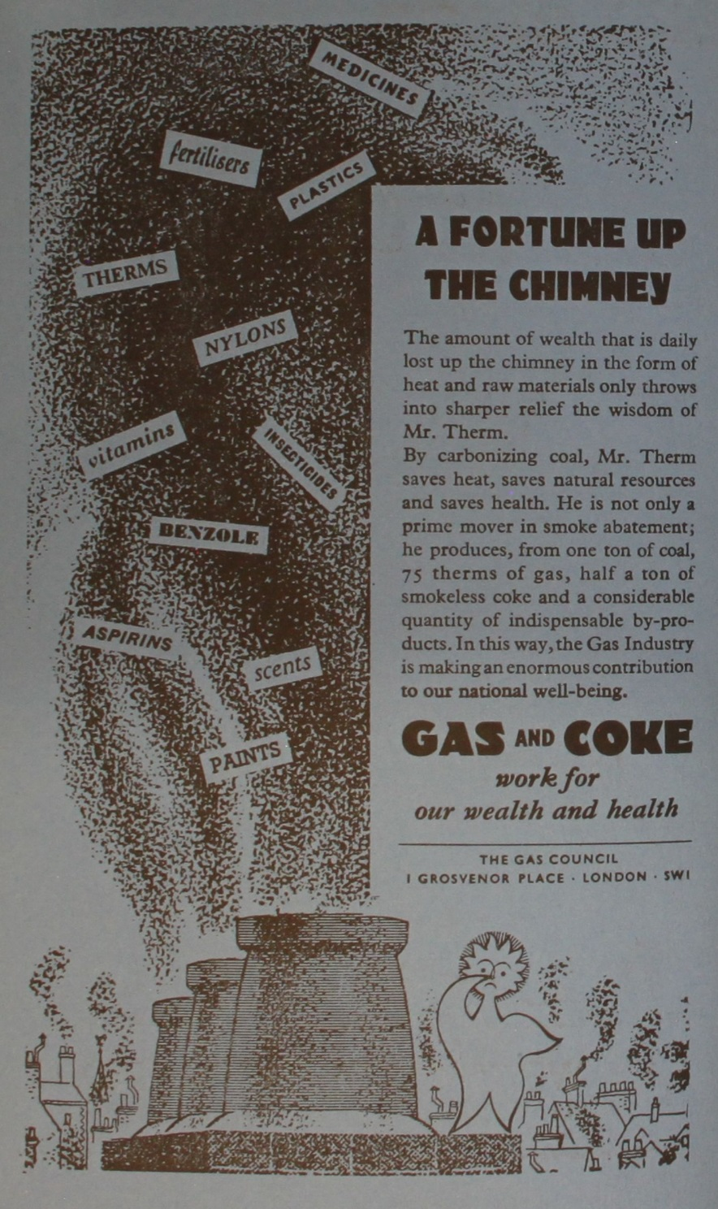
Figure 2. A fortune up the chimney
Source: National Smoke Abatement Society, Year Book 1954.
Reproduced with permission of the National Grid Archive, Warrington.

The information compressed into the embedded text was clear and simple to understand; by using gas and coke for home heating more ‘indispensable by-products’ could be collected and utilised profitably in agriculture, industry and medicine for ‘our wealth and health.’ The carbonisation of coal yielded coal tar and ammoniacal liquor, which could be further distilled into ammonium sulphate, anthracene, benzene, naphthalene, toluene and other chemicals used in the manufacture of dyes, drugs, fertilisers, perfumes, plastics and even explosives. Surrounded by polluting chimneypots, Mr Therm lamented a range of products with a direct connection to ‘our national well-being’, from insecticides to medicines, visibly going up in smoke. Householders still familiar with wartime campaigns to prevent waste and to recycle valuable resources should have been highly receptive to such ideas.

In Britain, however, the very idea of home had long been associated with the ‘cosy coal fire.’ A traditional open coal fire was represented as a living thing that on its own created a ‘homely’ atmosphere, and without which domestic life would be dull and miserable. For example, in 1945 George Orwell defended the open fireplace from ‘the noisy minority’ who wanted to replace it with gas or electric fires. He argued that:

For a room that is to be lived in, only a coal fire will do … This evening, while I write, the same pattern is being reproduced in hundreds of thousands of British homes. To one side of the fireplace sits Dad, reading the evening paper. To the other sits Mum, doing her knitting. On the hearthrug sit the children, playing snakes and ladders. Up against the fender, roasting himself, lies the dog. It is a comely pattern, a good background to one’s memories, and the survival of the family as an institution may be more dependent on it than we realise … It is quite true that it is wasteful, messy and the cause of avoidable work … The point is that household appliances should be judged not simply by their efficiency but by the pleasure and comfort that one gets out of them.

And social survey data from the period highlighted the public’s continuing attachment to the open coal fire. During the summer of 1939 Mass Observation, as part of an enquiry into people’s homes, asked the question: ‘What type of heating would you like if you could choose?’ Some 73 per cent of respondents opted for an open coal fire or range, with the remaining 27 per cent split between gas, electric and other forms of domestic heating. An extensive wartime housing survey by the National Union of Townswomen’s Guilds found 88 per cent of English respondents in favour of coal fires, with the figure rising to 91 per cent in Scotland, while a 1943 report on the design of dwellings by the Society of Women Housing Managers concluded: ‘Evidence from all parts of the country showed an overwhelming demand for an open coal fire in the living room.’ Despite advertising campaigns that promised to ‘work for our wealth and our health’, in the early 1950s most city dwellers were still unenthusiastic about swapping a ‘cheerful’ tried and tested domestic technology for something new and unfamiliar.

Unlike Britain’s householders, who were reluctant to give up their ‘homely’ coal fires, by the interwar years many businessmen had switched to cleaner and more efficient gas, oil and electrical technologies, particularly where power was needed intermittently in production processes, such as the food, ceramic, steel and engineering industries. While the construction and design of steam engines had improved considerably since they were first employed to provide power for industry, the latest smokeless technologies promised savings on fuel consumption as well as clearer skies.

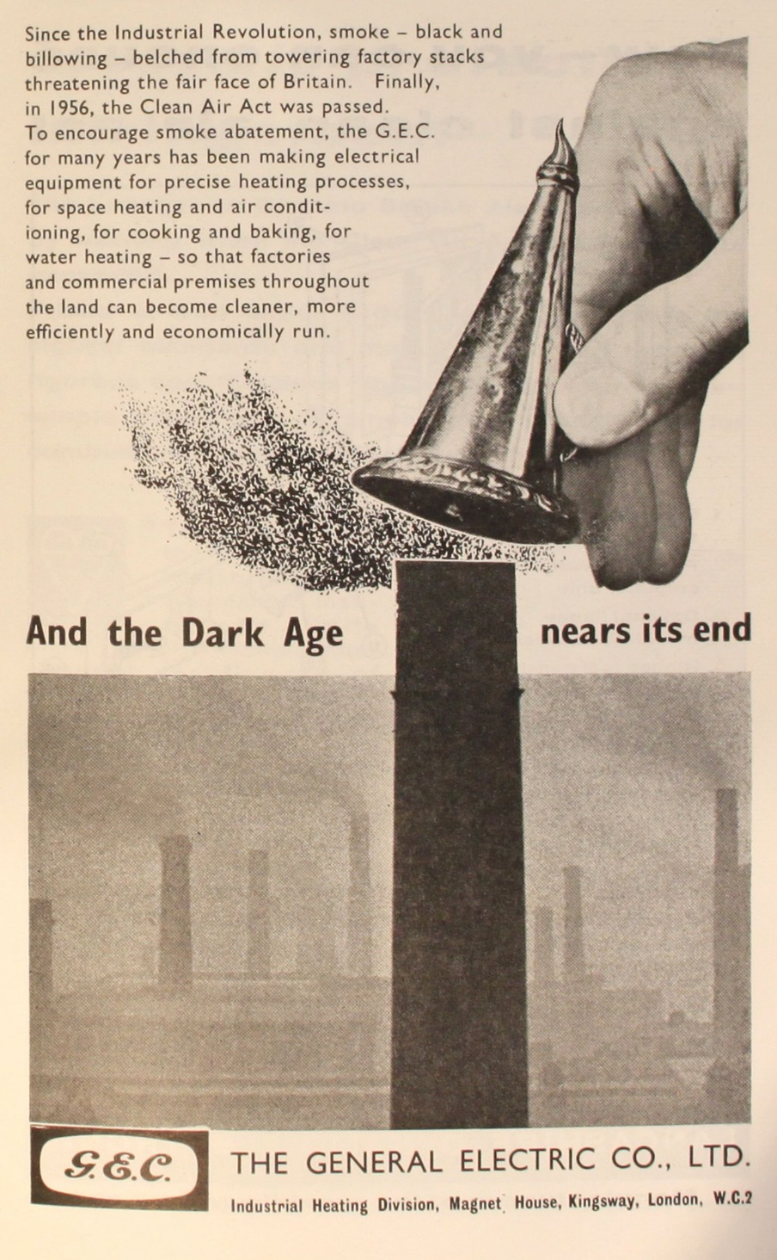
Figure 3. And the Dark Age nears its end
Source: National Smoke Abatement Society, Year Book 1961

Figure 3, for example, produced in 1961 by the Industrial Heating Division of the General Electric Company, one of the country’s leading suppliers of electrical goods, extolled the virtues of harnessing this form of smokeless energy as it sought to create demand for its products. The embedded text explicitly linked advances in smoke abatement with the use of modern electrical equipment that was clean, precise, efficient and economical in providing energy to factories and other commercial enterprises. The photographic montage, in which an antiquated candle snuffer is about to extinguish the polluting ‘factory stack’, left the reader in no doubt that steam power was now a thing of the past. This triumphalist advertisement announced that the ‘Dark Age’ – also a pejorative reference to the technological limitations of the pre-electric period – was almost over, and that the ‘black and billowing’ smokestacks which had dominated manufacturing centres since the Industrial Revolution would soon be made redundant. Rather than celebrating smoking chimneys as a sign of progress and economic vitality, they were condemned as dirty, wasteful and a threat to ‘the fair face of Britain.’

This threat to the nation’s ‘fair face’ echoed the long-standing concerns of anti-smoke campaigners about the damage air pollution caused to its architectural heritage and green spaces, such as town halls and municipal parks. The advertisement also corresponded with the government’s drive for fuel efficiency, and its emphasis on planning for fresh air and sunlight in rebuilding a ‘better Britain’ after the Second World War. The Clean Air Act mentioned in Figure 3 was passed after the 1952 Great Smog disaster had resulted in the deaths, according to official figures, of around 4,000 Londoners (mainly from respiratory problems and heart failure). More recent research suggests that there were perhaps as many as 12,000 victims. An important milestone in environmental protection, the 1956 Clean Air Act ‘finally’ outlawed the burning of raw coal in towns and cities across the country and established closely regulated ‘smokeless zones’ (the advertisement suggests that it was long overdue). In these zones smokeless fuels had to be burnt, which meant that the gas and electricity industries had a crucial role to play in their success. However, energy transitions take time. Manchester’s smoke control programme, for example, was not completed until 1985.

Conclusion

Commercial advertising by the gas and electricity industries did more than simply sell their products. It also sold the idea of the smokeless city; of how clean, efficient and modern fuel technologies could help to protect the environment and improve the ‘health and wealth’ of householders and manufacturers alike. Advertising images played an important part in changing the dominant narrative about smoke emissions, particularly by challenging the age-old axiom that ‘muck was money’. This shift in emphasis encouraged a move away from traditional coal-fired technologies even before the passage of the 1956 Clean Air Act (especially in businesses and middle class homes), and saw an intensifying sales battle for new customers between the gas and electricity industries afterwards. The embedded text also encouraged readers to see smoke differently, and the key messages to businessmen and the wider public were that smoke was preventable, uneconomic, and a waste of natural resources; and that environmental degradation, ill health and loss of life was unnecessary. Images were an integral part of the smoke abatement story in urban-industrial Britain, and their careful interpretation helps to bring it to life more fully and vividly – adding another dimension to our understanding of social, technological and environmental change.

Acknowledgements I would like to thank the editor, Jennifer Tucker, and an anonymous reviewer for their helpful comments on the first draft of this paper. Notes See, for example, Mosley, Chimney of the World; Stradling, Smokestacks and Progressives; Thorsheim, Inventing Pollution; Uekoetter, Age of Smoke; and Whitehead, State, Science and Skies.
Burke, Eyewitnessing; Rose, Visual Methodologies; and Mirzoeff, How to See the World.
Burke, Eyewitnessing, 9-16.
A ‘Gallery’ feature has also appeared in the journal Environmental History since April 2003.
The phrase was coined by Lewis Mumford in Technics and Civilization, 156.
‘Reign of Darkness’, 85.
Mosley, Chimney of the World, part 1; Thorsheim, Inventing Pollution, chapters 4 and 5; and Department of Energy and Climate Change, ‘Historical Coal Data.’
Lowe, ‘Tall Chimneys,’ 11-19; Mosley, Chimney of the World, 25-35; Mosley, ‘Fresh Air and Foul,’ 1-21.
Spencer, Manufactures of Lancashire, 48.
Corton, London Fog, 178-89; Mirzoeff, How to See the World, chapter 6; Danahay, ‘The Aesthetics of Coal’, 3-18.
Black’s Guide to Manchester, 70.
Mosley, Chimney of the World, 18; Morton, Call of England, 144.
Mosley, ‘Fresh Air and Foul,’ 1-21; Mosley, ‘Home Fires,’ 196-223; Smith, ‘Noxious Vapours and Smoke,’ 513.
Marsh, Smoke, 264.
Mosley, Chimney of the World, 89-113; Thorsheim, Inventing Pollution, chapter 7.
‘London Smoke,’ 5; Clinch, ‘Smoke Abatement,’ 2.
For example, see: Simon and Fitzgerald, The Smokeless City.
Mosley, ‘Home Fires,’ 206-210; Whitehead, State, Science and Skies, chapter 4; ‘Mr Therm,’ 1010; Boon, ‘The Smoke Menace,’ 57-88; Goodall, Burning to Serve, 207.
Hodgson, Eric Fraser, 19 and 30; Luckin, Questions of Power, 26.
Although a start has been made. See Clapp, Environmental History of Britain, chapter 10.
Committee on Air Pollution. Report, 8-10.
Clapp, Environmental History of Britain, 220-24; Bone, ‘Coal and Health,’ 3-6; Mackenzie, The Vital Flame, 65-70.
Although Britons soon slipped back into a ‘throwaway culture.’ See: Cooper, ‘Challenging the “Refuse Revolution.”’
Mosley, ‘The Home Fires,’ 210-16.
Orwell, ‘The Case for the Open Fire,’ 190-91.
Mass Observation, An Enquiry into People’s Homes, 136; PEP, Household Appliances, 125; Association for Planning and Regional Reconstruction, Housing Digest, 51.
PEP, British Fuel and Power, part 2.
Mosley, Chimney of the World, part 1.
Meller, Towns, Plans and Society, 68; Worpole, Here Comes the Sun, chapters 1 and 4; Labour Party, ‘Your Home,’ 4-9 and 14; Davis, Smoke Ran like Water, chapter 2.
But we should not overlook the fact that smokeless fuels, still derived from coal, did not wholly solve pollution problems, but shifted them to new sites of centralised production (gasworks and power stations). See Thorsheim, ‘Smokeless Fuels,’ 381-401; and Sheail, Power in Trust, chapter 19.
Mosley, ‘Home Fires,’ 206-10; Goodall, Burning to Serve, 238-48. Bibliography Primary Sources Association for Planning and Regional Reconstruction, Housing Digest: An Analysis of Housing Reports 1941-45. London & Glasgow: Art & Educational Publishers, 1946. Black’s Guide to Manchester. London: A & C Black, 1913. Bone, William A. Coal and Health. London, 1919. Clinch, Herbert G. ‘Smoke Abatement: A Business Proposition.’ West Riding of Yorkshire Regional Smoke Abatement Committee (1927-28). West Yorkshire Archive Service, Wakefield: WMT/WH/6/1/11. Committee on Air Pollution. Report. Cmd.9322. London: HMSO, 1954. Labour Party, Your Home Planned by Labour. London: Victoria House Printing Company, 1943. ‘London Smoke.’ The Times, January 2 (1855): 5. Mackenzie, Compton. The Vital Flame. London: Frederick Muller, 1947. Marsh, Arnold. Smoke: The Problem of Coal and the Atmosphere. London: Faber and Faber, 1947. Mass Observation. An Enquiry into People’s Homes. London: John Murray, 1943. Morton, Henry V. The Call of England. London: Methuen, 1929. ‘Mr. Therm Goes Into the Cinema Business.’ The Gas World 140, no.3662 (1954): 1010. Mumford, Lewis. Technics and Civilization. London: George Routledge & Sons, 1934. Orwell, George. ‘The Case for the Open Fire.’ In Facing Unpleasant Facts: Narrative Essays George Orwell, compiled by George Packer, 189-92. Boston: Mariner Books, 2009. First published 8 December 1945. PEP (Political and Economic Planning). Report on the Market for Household Appliances. London: The Stanhope Press, 1945. PEP (Political and Economic Planning). The British Fuel and Power Industries: A Report by PEP. London: The Stanhope Press, 1947. ‘The Reign of Darkness.’ The Spectator 62, January 19 (1889): 85-86. Simon, E.D. and Fitzgerald, Marion. The Smokeless City. London: Longmans, Green & Co., 1922. Smith, Robert A. ‘What Amendments are Required in the Legislation Necessary to Prevent the Evils Arising from Noxious Vapours and Smoke?’ Transactions of the National Association for the Promotion of Social Science, (1876): 495-42. Spencer, Rueben. A Survey of the History, Commerce and Manufactures of Lancashire. London: The Biographical Publishing Company, 1897. Secondary Sources Boon, Timothy. ‘“The Smoke Menace”: Cinema, Sponsorship and the Social Relations of Science in 1937.’ In Science and Nature: Essays in the History of the Environmental Sciences, edited by Michael Shortland, 57-88. Oxford: The Alden Press, 1993. Burke, Peter. Eyewitnessing: The Uses of Images as Historical Evidence. London: Reaktion Books, 2001. Clapp, B.W. An Environmental History of Britain since the Industrial Revolution. Harlow: Longman, 1994. Cooper, Tim. ‘Challenging the “Refuse Revolution”: War, Waste and the Rediscovery of Recycling, 1900-50.’ Historical Research 81, issue 214, (2008): 710-31. Corton, Christine L. London Fog: The Biography. Cambridge, MA: The Belknap Press, 2015. Danahay, Martin A. ‘The Aesthetics of Coal: Representing Soot, Dust, and Smoke in Nineteenth-Century Britain.’ In Caverns of Night: Coal Mines in Art, Literature, and Film, edited by William B. Thesing, 3-18. Columbia: University of South Carolina Press, 2000. Davis, Devra. When Smoke Ran Like Water: Tales of Environmental Deception and the Battle Against Pollution. Oxford: Perseus Press, 2002. Department of Energy and Climate Change, ‘Historical Coal Data: Coal Production, Availability and Consumption 1853 – 2014.’ https://www.gov.uk/government/statistical-data-sets/historical-coal-data-coal-production-availability-and-consumption-1853-to-2011, accessed on 24 May 2015. Goodall, Francis. Burning to Serve: Selling Gas in Competitive Markets. Ashbourne: Landmark Publishing, 1999. Hodgson, Pat. Eric Fraser: An Illustrator of Our Time. British Gas, 1991. Lowe, J. ‘In Praise of Tall Chimneys.’ Industrial Heritage 8, (1989): 11-19. Luckin, Bill. Questions of Power: Electricity and Environment in Inter-war Britain. Manchester: Manchester University Press, 1990. Meller, Helen. Towns, Plans and Society in Modern Britain. Cambridge: Cambridge University Press, 1997. Mirzoeff, Nicholas. How to See the World. London: Pelican, 2015. Mosley, Stephen. The Chimney of the World: A History of Smoke Pollution in Victorian and Edwardian Manchester. Abingdon: Routledge, 2008. Mosley, Stephen. ‘The Home Fires: Heat, Health, and Atmospheric Pollution in Britain, 1900-45.’ In Health and the Modern Home, edited by Mark Jackson, 196-223. New York: Routledge, 2007. Mosley, Stephen. ‘Fresh Air and Foul: The Role of the Open Fireplace in Ventilating the British Home, 1837-1910.’ Planning Perspectives 18, no.1 (2003): 1-21. Rose, Gillian. Visual Methodologies: An Introduction to Researching with Visual Materials. London: Sage, 2012. Sheail, John. Power in Trust: The Environmental History of the Central Electricity Generating Board. Oxford: Clarendon Press, 1991. Stradling, David. Smokestacks and Progressives: Environmentalists, Engineers, and Air Quality in America, 1881-1951. Baltimore: Johns Hopkins University Press, 1999. Thorsheim, Peter. Inventing Pollution: Coal, Smoke, and Culture in Britain since 1800. Athens: Ohio University Press, 2006. Thorsheim, Peter. ‘The Paradox of Smokeless Fuels: Gas; Coke and the Environment in Britain, 1813-1949,’ Environment and History 8, no.4 (2002): 381-401 Uekotter, Frank. The Age of Smoke: Environmental Policy in Germany and the United States, 1880-1970. Pittsburgh: University of Pittsburgh Press, 2009. Whitehead, Mark. State, Science and the Skies: Governmentalities of the British Atmosphere. Chichester: Wiley-Blackwell, 2009. Worpole, Ken. Here Comes the Sun: Architecture and Public Space in Twentieth-Century European Culture. London: Reaktion Books, 2000.

