

**Yorkshire Innovation Fund Small Innovation Project – Eco Home Prototype Report**

Professor David Johnston, Centre for the Built Environment (CeBE) Group, Leeds Beckett University

Dr Jim Parker, Centre for the Built Environment (CeBE) Group, Leeds Beckett University

Matthew Brooke-Peat, Centre for the Built Environment (CeBE) Group, Leeds Beckett University

June 2015

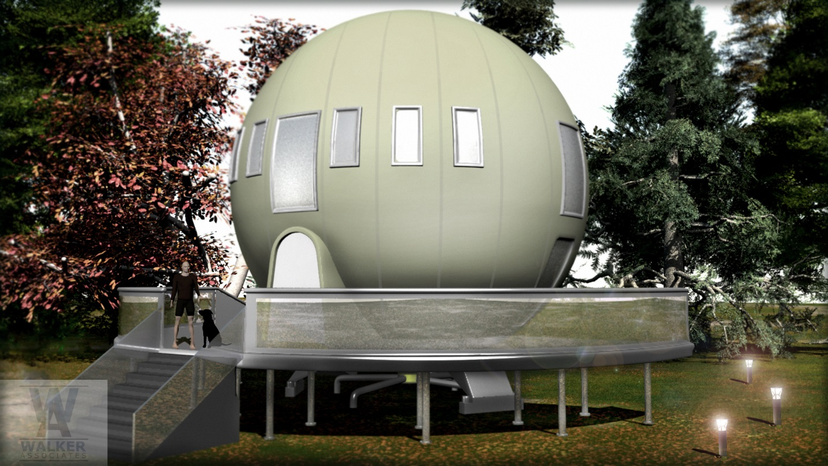

**TABLE OF CONTENTS**

Introduction 3

Test method 6

Limitations 7

Results 7

Dynamic thermal simulations 8

Test method 9

Limitations 12

Results 13

Conclusions and recommendations 29

References 31

# Introduction

1. This report presents the results of the thermal bridging calculations and dynamic thermal simulations that were undertaken to assess the thermal performance of a prototype Code for Sustainable Homes (CSH) Level 6 Eco home that has been designed to have very high levels of building fabric thermal performance and very low energy demand. The calculations were undertaken by the Centre for the Built Environment (CeBE) Group within the Leeds Sustainability Institute at Leeds Beckett University as part of a collaborative project with the dwellings designer Walker Associates. The project was supported by a Yorkshire Innovation Fund (YIF) Small Innovation Project (SIP) grant.
2. This project builds on some initial thermal bridging calculations and dynamic thermal simulation modelling work that was previously undertaken as part of an Innovate UK Innovation Voucher (see Johnston, Brooke-Peat and Parker, 2015). The aim of the YIF Small Innovation Project was to extend the thermal bridging work by enabling a small number of alternative construction details to be investigated, namely:
   1. General jamb detail.
   2. Lobby door threshold.
   3. Lobby floor/external wall detail.
   4. Services penetration
3. In addition, the dynamic thermal simulation work was also extended to enable a number of different scenarios to be assessed. These include an alternative space heating system (heat pump) and a range of measures that could be adopted to help mitigate against potential overheating. In addition, the dwelling has also been evaluated in various different geographical locations throughout the UK to provide greater understanding of how the prototype dwelling will perform in different climatic conditions.

***The Eco home***

1. The study dwelling is a 118.5m2 3 storey two/ three bedroom detached property which has a novel spherical architectural form and is elevated above the surrounding ground level (see Figure 1). Consequently access to the dwelling is gained via an elevated decking area that surrounds half of the floor plan of the dwelling. A spherical form was chosen for the dwelling by the designer as a sphere has a smaller surface area-to-volume ratio than any other shape for a given volume. The smaller the surface area-to-volume ratio, then the more thermally efficient the building is for a given level of building fabric performance. As part of the original concept design, the spherical form was elevated above the ground level to enable the dwelling to rotate horizontally in order to track the sun and maximise the collection of solar radiation.

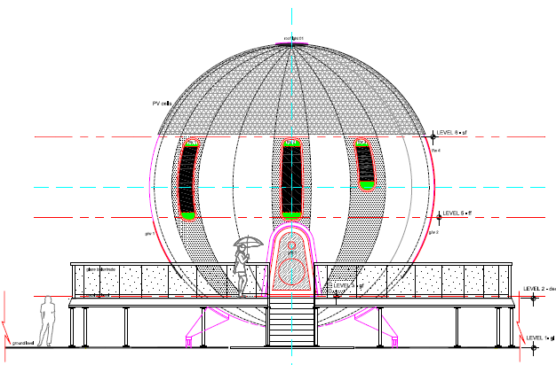

**Figure 1 South elevation of the prototype dwelling (Source: Walker Associates, 2015).**

1. Internally, the prototype dwelling comprises an entrance lobby, storage cupboards, a bedroom, shower room, WC, landing and stairs on the entrance level (level 3). On the first floor, (level 5) there is a hallway, an open plan living, kitchen and dining area, a study/bedroom 3 and the stairs to the second floor. Finally, on the second floor (level 6), there is a landing, master bedroom and an en-suite. The internal layout the prototype dwelling is illustrated in Figure 2.

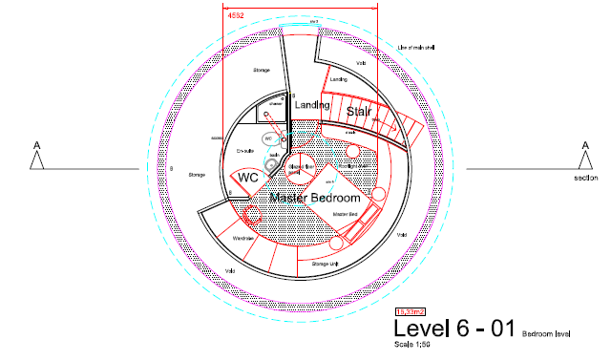

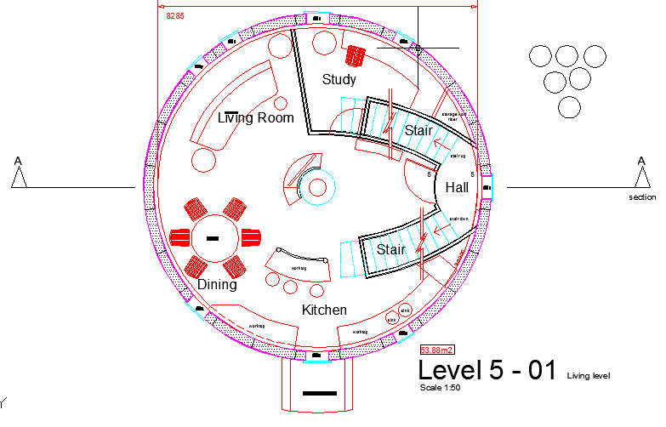

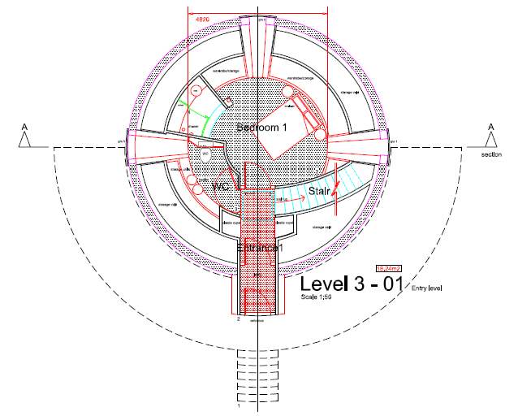

**Figure 2 Prototype dwelling layout (Source: Walker Associates, 2015).**

1. The external walls, roof and floor of the prototype dwelling are to be constructed from Structurally Insulated Panels (SIP’s) comprising a 300mm Expanded Polystrene (EPS) insulated core. The windows and roof light are to be double glazed units which are set back within the SIP panel system. To enable a flush external finish to be achieved, all of the windows and the roof lights are to be secondary glazed with a curved glass panel.
2. A summary of the U-values for the various elements of the building fabric are contained within Table 1.These figures have been obtained from the as-built SAP worksheet dated 11th August 2011.

|  |  |
| --- | --- |
| **Element** | **U-value (W/m2K)** |
| External walls | 0.12 |
| Floor | 0.12 |
| Roof | 0.12 |
| Windows, roof light and door | 1.00 |

**Table 1 U-values of the main elements of the prototype dwelling.**

1. In terms of airtightness, the design air permeability target for the test dwelling is 3.0 m3.h-1.m-2 @ 50Pa. This target is commensurate with the use of an MEV or MVHR system.

**Thermal bridging calculations**

1. As part of the Innovate UK Innovation Voucher, all of the junctions contained within the prototype dwelling were modelled in order to assess and quantify the thermal bridging and determine whether there were any potential condensation risks associated with the prototype design. In total, 16 No. junctions were modelled. The modelling revealed that the linear thermal transmittance (Ψ-values) calculated for two of the junctions, the door threshold junction to the lobby and the lobby wall/floor junction, were considered to be high at 0.348 W/m·K and 0.411 W/m·K, respectively. The reason for the high Ψ-value for the door threshold junction to the lobby was a consequence of the brush seal that penetrates through the floor insulation, resulting in a discontinuity in the insulation layer at this junction. The reason for the high Ψ-value for the lobby/wall floor junction (0.411 W/m·K) could be attributed to the position of the brush seal coupled with the fact that the structural steelwork fully penetrates the thermal envelope.
2. In addition to excessive thermal bridging being identified in two of the junctions, the modelling also identified an additional two junctions that presented a risk of condensation, as the temperature factor (ƒRsi) for these junctions was either less than or equal to the critical temperature factor of (ƒCRsi) 0.750 required for Building Regulation compliance (Ward, 2006). For the jamb junction, an internal surface temperature of (Tsi) of 15° was calculated under the modelled conditions resulting in a ƒRsi of 0.750. Although the ƒRsi of this junction does comply with Part L of the Building Regulations (≥ 0.750), there is no margin for error associated with this junction. For the services penetration through the floor junction, a Tsi of 13.43° was calculated under the modelled conditions resulting in a ƒRsi of 0.672 to the stainless steel part of the spigot. This figure is clearly below the ƒCRsi the compliance figure of ≥0.750 (Ward, 2006) and presents a risk of surface condensation.
3. As part of the YIF Small Innovation Project, it was decided that the four junctions identified as being problematic within the Innovate UK Innovation Voucher project would be amended and then remodelled to ascertain the improvement in their Ψ-value and ƒRsi. The junctions that were remodelled were as follows: the lobby threshold at the door (see Figure 3), the jamb with the edge of the glazing unit squared off, the lobby floor/external wall junction (see Figure 4), and the service penetration with the stainless steel of the spigot changed to a high density plastic.

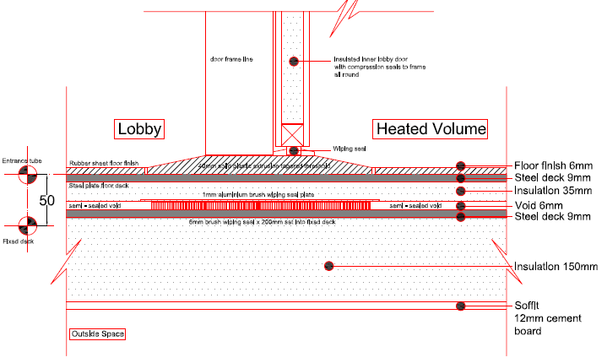

Figure 3 Amended lobby threshold at the door junction (Source: Walker Associates, 2015).

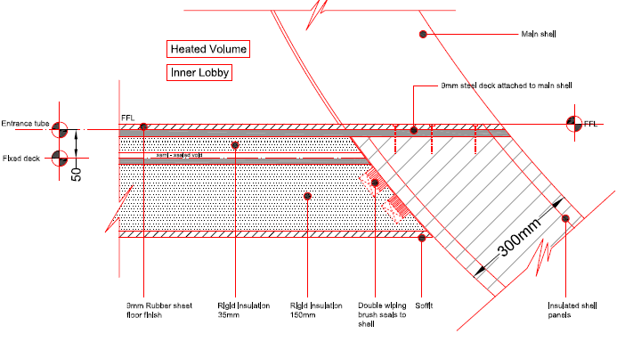

Figure 4 Amended lobby floor/external wall junction (Walker Associates, 2015).

## Test method

1. In order to undertake the thermal bridging calculations, a numerical modelling technique known as thermal modelling was employed. All of the individual thermal bridges associated with each junction type within the prototype dwelling were explicitly thermally modelled using the Physibel TRISCO version 12.0w software program (Physibel, 2010). When undertaking the modelling, the conventions given in BR 497 (Ward & Sanders, 2007) were followed throughout. The equivalent thermal conductivities for all air spaces and voids were calculated in accordance with BS EN ISO 6946 (British Standards Institution (BSI), 2007). Material conductivities were sourced from manufacturers’ literature where possible based on the project specification. In instances where these could not be obtained, suitable values were sourced from BS EN 12524 (BSI, 2000) or from BR 443 (Anderson, 2006). The geometry of the thermally modelled junctions was based on the content of the design drawings provided to the CeBE Group by Walker Associates.

## Limitations

1. The complex geometry of the spherical envelope had to be simplified to enable thermal modelling of the junctions. The rectilinear nature of the thermal modelling software meant that the number of nodes that would be created in the model when attempting to represent the curved nature of the building envelope would exceed the software’s processing capability. Consequently, the simplified envelope was formed in the thermal models with each of the flanking elements to the junction represented in a single plane (flattened). In order to calculate results that are representative of the thermal bridging inherent to the design, the angle of intersection between the plane elements to the simplified envelope matched the average intersection angles with the curved envelope. This approach is considered to have minimal impact on the accuracy of the results because the additional length of flanking elements that would be generated by the curved envelope would be very small at the junctions.
2. The proposed design shows secondary glazing to the window and roof window openings. In order to model this arrangement, two adiabatic boundaries were incorporated into the thermal models to represent the two glazing units.

## Results

1. The results of the thermal bridging calculations are presented for each of the four amended junction details in Appendix A. A summary of the results are also presented in Table 2 for ease of reference. The results obtained for the original prototype junctions are also contained within Table 2 for comparative purposes. The columns headed Ψ and ƒRsi are the values calculated for the amended designs. The values in the column headed ADD Ψ represent the Approved Design Detail (Approved) values identified in Appendix K of SAP 2012 (Department of Energy and Climate Change (DECC), 2013). The values in the column headed Default Ψ represent the Building Regulations Default values identified in Appendix K of SAP 2012 (*ibid*).

|  |  |  |  |  |  |
| --- | --- | --- | --- | --- | --- |
| **Junction:** | **Ref:** | **Ψ:** | **ƒRsi:** | **ADD Ψ:** | **Default Ψ:** |
| Lobby Threshold at Door (Improved) | TB/21 | 0.310 | 0.834 | NA | NA |
| Lobby Threshold at Door (Original) | TB/13 | 0.348 | 0.809 | NA | NA |
| Jamb (Improved) | TB/22 | 0.032 | 0.858 | 0.050 | 0.100 |
| Jamb (Original) | TB/02 | 0.038 | 0.750 | 0.050 | 0.100 |
| Lobby Floor/External Wall (Improved) | TB/23 | 0.265 | 0.908 | 0.070 | 0.140 |
| Lobby Floor/External Wall (Original) | TB/16 | 0.411 | 0.842 | NA | NA |
| Services Penetration (Improved) | TB/24 | 0.007 | 0.960 | NA | NA |
| Services Penetration (Original) | TB/08 | 0.091 | 0.672 | NA | NA |

Table 2 Summary of thermal bridging calculations.

1. The modelling results indicate that although the Ψ-value of the Lobby Threshold at Door (Improved) has reduced marginally from the original design value of 0.348 W/m·K, it is still considered to be high at 0.310 W/m·K. This is result of the steel plate structural decking to both the lobby floor and the landing deck. Despite the steel plates being surrounded by insulation, the steel plates can be seen in the temperature distribution of thermal bridging calculation TB/21 to be conducting heat along their length. This indicates that heat is being lost to both the unheated lobby and the external environment. There are two options identified for further reducing the extent of thermal bridging at the Lobby Threshold at Door (Improved) junction. Firstly, the steel plates could be thermally broken at the threshold line, but this would be difficult to achieve because of the structural requirements of the steel plate and the limited construction depth of the lobby floor/landing deck. Alternatively, the structural concept could be changed to remove the need for the steel plates in the junction design. The calculated ƒRsi of 0.834 for this junction has increased slightly from the original design (0.809) and exceeds the critical temperature factor (ƒCRsi) of 0.750 (Ward, 2006). Therefore, the Lobby Threshold at Door (Improved) junction does not present a risk of surface condensation or mould growth.
2. For the Jamb (Improved) junction, the modelling results indicate that the Ψ-value of this junction has improved slightly from the original design of 0.038 W/m·K to 0.032 W/m·K It also improves on the Approved Ψ-value by 0.018 W/mK (36%) and the Default Ψ-value by 0.068 W/m·K (68%). The junction design created an internal surface temperature (Tsi) of 17.15°C under the modelled conditions. This resulted in a ƒRsi of 0.858 that greatly exceeds the ƒCRsi and the ƒRsi calculated for the original jamb junction. The results indicate that the junction design does not present a risk of surface condensation or mould growth.
3. It can also be seen from Table 2 that the Ψ-value of the LobbyFloor/External Wall (Improved) junction has improved slightly from the original design value of 0.411 W/m·K to 0.265 W/m·K. However, the figure of 0.265 W/m·K is still considered to be high and is some 0.195 W/m·K (278.6%) higher than the Approved Ψ-value and 0.125 W/m·K (89.3%) higher than the Default Ψ-value. This is considered to be a result of the steel plate decking to the landing deck. It can be seen in the temperature distribution of the thermal bridging calculation TB/23 that the steel plate is conducting heat along its length. The density and orientation of the heat flow lines shown in the temperature distribution indicate that the steel plate is acting as a substantial constructional thermal bridge. The options for reducing the extent of thermal bridging at this junction are similar to those identified for the Lobby Threshold at Door (Improved) junction. Firstly, the steel plate to the landing deck could be thermally broken at the junction. However, this would be difficult to achieve. Alternatively, the structural concept could be revised to eliminate the steel plate. The calculated ƒRsi of 0.908 for this junction has increased slightly from the original design (0.842) and exceeds the critical temperature factor (ƒCRsi) of 0.750 (Ward, 2006). Therefore, the Lobby Floor/External Wall (Improved) junction does not present a risk of surface condensation or mould growth.
4. Finally, changing the stainless steel parts of the spigot to the services penetration junction can be seen to greatly improve the Ψ-value and eliminate the risk of surface condensation. It can be seen in Table 2 that the revised design reduces the Ψ-value by 0.084 W/m·K (92.3%). The calculated ƒRsi of 0.960 for the improved junction has increased substantially from the ƒRsi of 0.672 calculated for the original junction design.

# Dynamic thermal simulations

1. As part of the Innovate UK Innovation Voucher, two baseline dynamic thermal simulations (DTS) were undertaken on the prototype dwelling (Scenarios 1.1 and 1.2). Both of these simulations assumed that all of the space and domestic hot water heating for dwelling was provided by a gas-fired condensing combination boiler and that the dwelling was mechanically ventilated using an MVHR system. In one of the simulations, a ‘normal’ 9am to 5pm working week day occupancy regime has been assumed (Scenario 1.1) whilst on the other simulation a home working week day occupancy regime has been assumed (Scenario 1.2). In addition, in both simulations, the building was rotated by 30° increments to establish if there are any energy benefits or penalties associated with rotating the building. The findings for the Innovate UK Innovation Voucher suggested that negligible energy benefit was to be gained by rotating the building. The findings also suggested that the dwelling was likely to experience overheating, particularly in those spaces with the longest periods of occupancy (lounge, study and kitchen).This finding has influenced the investigation of scenarios where additional cooling has been introduced.
2. For the YIF Small Innovation project, a number of additional scenarios have been modelled. These scenarios were designed to investigate the implications of installing an alternative heating system within the prototype dwelling (a heat pump) and to investigate the implications of introducing a number of different measures into the prototype dwelling in order to mitigate against overheating. All of these additional simulations use the CIBSE Test Reference Year (TRY) simulation weather files and have been undertaken at 30° increments to help validate the findings from the complementary Innovate UK Innovation Voucher report (see Johnston, Brooke-Peat and Parker, 2015). The scenarios modelled as part of this project were as follows:
   1. Scenario 2.1 – As Scenario 1.1, but with an electric heat pump installed (as per the original SAP assessment provided by the client) instead of a gas-fired condensing combination boiler. This is referred to in the results and conclusion sections as 2.1 SAP HP TRY (SAP inputs with Heat Pump and TRY weather file).
   2. Scenario 2.2 – As Scenario 1.2, but with an electric heat pump instead of a gas-fired condensing combination boiler. This is referred to as 2.2 SAP HP HW TRY (SAP inputs with Heat Pump, a Home Working schedule and TRY weather file).
   3. Scenario 3.1 – As Scenario 1.1, but with additional mechanical ventilation to combat potential overheating. This is referred to as 3.1 SAP HP + MV TRY (SAP inputs with Heat Pump additional Mechanical Ventilation and TRY weather file).
   4. Scenario 3.2 – As Scenario 1.1, but with the addition of air conditioning. This is referred to as 3.2 SAP HP + MV TRY (SAP inputs with Heat Pump, additional Mechanical Ventilation and TRY weather file).
   5. Scenario 3.3 – As Scenario 1.1, but with the use of natural ventilation in addition to the MVHR system. This is referred to as 3.3 SAP HP + NV TRY (SAP inputs with Heat Pump, Natural Ventilation and TRY weather file).
   6. Scenario 4.1 – As Scenario 1.1, but locating the dwelling in different geographical locations throughout the UK. This is referred to as 4.1 SAP geo 180 TRY (SAP inputs in different geographical locations, orientated to 180° using a TRY weather file).
   7. Scenario 4.2 – As Scenario 3.1, but in different geographical locations throughout the UK. This is referred to as 4.2 SAP NV geo 180 TRY (SAP inputs in different geographical locations, orientated to 180°, with Natural Ventilation using a TRY weather file).
3. In addition to the above scenarios, Scenario 2.1 and the naturally ventilated version of this scenario (Scenario 3.3) have been modelled for the 14 different CIBSE weather file locations that are available in the UK for both heating demand and overheating. The 14 CIBSE locations are: Plymouth, Southampton, London, Swindon, Cardiff, Norwich, Birmingham, Nottingham, Manchester, Leeds, Newcastle, Belfast, Glasgow and Edinburgh.
4. Overheating analysis has also been undertaken for all scenarios using the CIBSE Design Summer Year (DSY) simulation weather files. These were as follows:
   1. Scenario 2.11 – As Scenario 2.1, but using a DSY simulation weather file. This is referred to in the results and conclusion sections as 2.11 SAP HP DSY (SAP inputs with Heat Pump and DSY weather file).
   2. Scenario 2.21 – As Scenario 2.2, but using a DSY simulation weather file. This is referred to as 2.21 SAP HP HW DSY (SAP inputs with Heat Pump, a Home Working schedule and DSY weather file).
   3. Scenario 3.11 – As Scenario 3.1, but using a DSY simulation weather file. This is referred to as 3.11 SAP HP + MV DSY (SAP inputs with Heat Pump additional Mechanical Ventilation and DSY weather file).
   4. Scenario 3.21 – As Scenario 3.2, but using a DSY simulation weather file. This is referred to as 3.21 SAP HP + MV DSY (SAP inputs with Heat Pump, additional Mechanical Ventilation and DSY weather file).
   5. Scenario 3.31 – As Scenario 3.3, but using a DSY simulation weather file. This is referred to as 3.31 SAP HP + NV DSY (SAP inputs with Heat Pump, Natural Ventilation and DSY weather file).
   6. Scenario 4.11 – As Scenario 4.1, but using a DSY simulation weather file. This is referred to as 4.11 SAP geo 180 DSY (SAP inputs in different geographical locations, orientated to 180° using a DSY weather file).
   7. Scenario 4.21 – As Scenario 4.2, but using a DSY simulation weather file. This is referred to as 4.2 SAP NV geo 180 DSY (SAP inputs in different geographical locations, orientated to 180°, with Natural Ventilation using a DSY weather file).
5. The energy consumption required under Scenario 2.1 has also been analysed to determine the amount of PV’s and the size of wind turbine that would be required to be installed in m2 to enable the dwelling to have net zero energy use.

## Test method

1. The dynamic thermal simulations (DTS) have been undertaken using Integrated Environmental Solutions (IES) Virtual Environment (VE) software version 2014.2.1.0 (IES, 2014). This software is approved for regulatory compliance energy calculations for non-domestic buildings. Simulations can be produced at hourly time-steps covering 8,760 hours of operation (all 365 days of the year). The IES software is validated for use against various global standards, the most prominent of these being the Chartered Institute of Building Services Engineers (CIBSE) “TM33: Tests for Software Accreditation & Verification” in the UK and the American Society of Heating, Refrigeration and Air Conditioning Engineers (ASHRAE) “Standard 140-2007: Standard method of test for the evaluation of building energy analysis computer programs” (CIBSE, 2006a; ASHRAE, 2007).
2. The model geometry is based upon the drawings provided by the client shown in Figure 1 and Figure 2. Unfortunately, it is not possible to produce a fully curved sphere using the IES VE software. Consequently, a fully faceted sphere has been used to represent the geometry of the prototype dwelling. The resultant geometry used in the IES VE software is visualised in Figure 5.

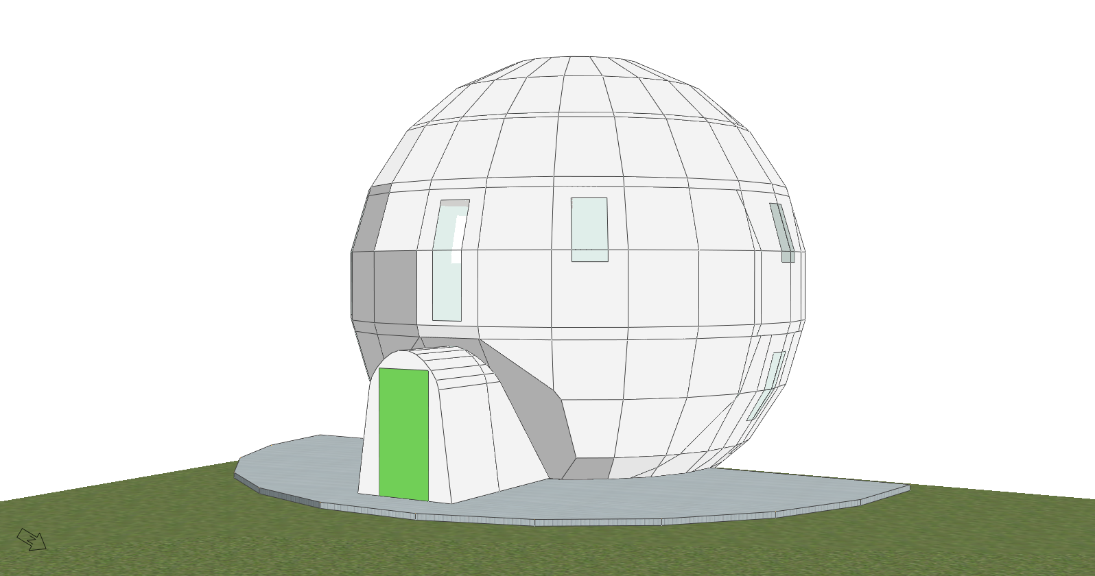

Figure 5 Example image of geometry used in the DTS models.

1. A simulation weather file for the Leeds area was used for the first stage of analysis. The CIBSE Test Reference Year (TRY) and Design Summer Year (DSY) files were used; these are the files approved for use in non-domestic building Part L regulatory compliance calculations (CIBSE, 2006b). The TRY files are used to estimate annual energy and thermal performance, whilst the DSY files are used to evaluate summer overheating. The TRY files are created using actual weather data from a twenty year period, with the most average month for each month being incorporated within the simulation file. A similar method is used for the DSY files, but these are based upon the hottest months from the data set covering the period April – September inclusive. The DSY file is used to simulate heat wave conditions
2. There are five main zone types used in the model which use shared thermal templates. The contents of these templates are described in the following paragraphs. The five zone types are: bathrooms, bedrooms, circulation space, kitchen and lounge (also used for the study).
3. Internal heat gains and the associated operating schedules are based upon those specified in the National Calculation Methodology (NCM) database for domestic occupancy. The NCM underpins the calculation method used in both SAP and the non-domestic alternative. The occupancy schedules for scenario 1 are illustrated in Figure 4. The heating schedules have also been assumed to follow these occupancy patterns. As the NCM input data is meant for use in much larger non-domestic buildings, an occupant density of 4m2/person is normally used. However, this would be unrealistic in this instance. It has therefore been assumed that one person would be in each space for a fraction of the occupied hours as per the schedule shown in Figure 6. It should be noted that when using a ‘fraction’ of a person this merely relates to them being in the space for some of the hour and not for example half a person in the room for a full hour. In the model, people are represented as a heat gain. It is assumed that all occupants are adults and account for 70 W/m2 of sensible and 70 W/m2 of latent heat gain.

Figure 6 Occupancy schedules used in the thermal analysis.

1. Other internal heat gains come from equipment and lighting. These also operate on the same schedules as the occupancy shown in Figure 6. There are however different standard lighting levels and different types of equipment installed within each space, resulting in different levels of internal heat gains. A summary of the heat gains associated with each zone type is contained within Table 3. The lighting heat gains are based upon default NCM values for low-energy lighting. The model used for scenario 1.2 uses identical heat gain inputs but has occupancy, equipment and lighting operations beginning at 10:00am in both the lounge and study areas.

|  |  |  |  |
| --- | --- | --- | --- |
|  | Equipment W/m2 | Lighting W/m2/(100lux) | Lux level |
| Bathrooms | 1.67 | 5.20 | 150 |
| Bedrooms | 3.58 | 5.20 | 100 |
| Circulation | 1.57 | 5.20 | 100 |
| Kitchen | 30.28 | 5.20 | 300 |
| Lounge/Study | 3.90 | 5.20 | 150 |

Table 3 Summary of equipment and lighting internal heat gain inputs.

1. All of the models have the same fabric and HVAC inputs. The U-values for the building fabric have been obtained from the as-built SAP worksheet dated 11th August 2011 (shown in Table 1), with an adjustment made for thermal bridging based upon a calculated y-value of 0.023. The y-value is based upon the findings of the thermal bridging calculations undertaken as part of the earlier Innovate UK Innovation Voucher (see Johnston, Brooke-Peat and Parker, 2015).
2. A ground source heat pump with a coefficient of performance (CoP) of 3.2 has been used in the models as the sole heat source for both space heating and hot water as per the SAP worksheets (Golinski, 2011). A heating set point of 21°C (internal temperature) and a cooling set point (the point at which free cooling is provided through bypass of the heat recovery system) of 25°C (internal temperature) has been assumed in the models. The heat recovery system is assumed to have a thermal efficiency of 90%. The balanced MVHR system is assumed to operate continuously delivering 0.5 air changes per hour in all spaces with extracts in the kitchen and bathroom areas. A specific fan power of 0.46 Watts per litre per second (W/l/s) has been used in accordance with the original SAP worksheets provided by the client (Golinski, 2011). Air exchanges that are a result of infiltration are also referenced from the SAP worksheet and are assumed to provide 0.17 air changes per hour throughout the dwelling.
3. Results analysis is based upon total annual energy consumption for space heating, domestic hot water, ventilation system energy (referred to as ‘ventilation’ in the results), chillers (for scenario 3.2 only), lighting and equipment. Overheating has been evaluated using two different metrics. Under traditional measures of overheating used for non-domestic buildings, a room is considered to provide uncomfortable conditions when the internal temperature exceeds 25°C for more than 5% of the occupied hours and exceeds 28°C for more than 1% of the occupied hours (CIBSE, 2006c). This is a more rigorous test of potential overheating than is currently used for domestic buildings in SAP. It has been assumed that external shutters will be closed during all daylight hours in the overheating analysis. This is again in accordance with specifications set within the SAP calculations provided by the client (Golinski, 2011).
4. The absolute metrics used to assess overheating mentioned above were superseded in 2013 in favour of adaptable comfort metrics. The finite metrics were defined in the CIBSE Guide A document (CIBSE, 2006c) but have been updated to align with other European and American metrics. The justification for this and the calculation methods are defined in the document “TM52: The limits of thermal comfort: avoiding overheating in European buildings” (CIBSE, 2013). This sets out three criteria to evaluate overheating based upon the theory of adaptive comfort, which acknowledges that people are more tolerant of higher internal temperatures when external temperatures are higher themselves. Both assessment methods have been used here to provide a comparison. The absolute metrics help to illustrate the actual temperatures that will be experienced in the dwelling, whereas the adaptive comfort metrics provide a more holistic illustration of personal thermal comfort.
5. The adaptable comfort metrics measure: hours of exceedence; the daily weighted exceedence; and the upper limit temperature. These are defined below:
   1. **Hours of exceedance –** Sets a limit for the number of hours that the operative temperature can exceed the threshold comfort temperature (upper limit of the range of comfort temperature) by one degree or more during the occupied hours of a typical non-heating season (1st May to the 30th September). The number of hours during which the difference between internal and external temperatures (ΔT – Delta T) is greater than or equal to one degree (K) during the period May to September inclusive, shall not be more than 3% of occupied hours.
   2. **Daily weighted exceedance –** Deals with the severity of overheating, which can be as important as its frequency, the level of which is a function of both temperature rise and its duration. This criterion sets a daily limit for acceptability. To allow for the severity of overheating, the weighted exceedence shall be less than or equal to six in any one day.
   3. **Upper limit temperature –** Sets an absolute maximum daily temperature for a room, beyond which the level of overheating is unacceptable. It sets an absolute maximum value for the indoor operative temperature; the value of ΔT shall not exceed 4K.

## Limitations

1. It is important to note that the DTS models used here are not approved for regulatory compliance calculations for dwellings; they are only approved for regulatory compliance use in non-domestic buildings. This also applies to the weather files used in the simulation. This type of modelling does enable a much more detailed energy and thermal performance analysis to be undertaken than would otherwise be the case if a SAP calculation was used. This is particularly relevant to the overheating analysis included in this report.
2. As mentioned previously, there are limitations associated with replicating the geometry of the prototype dwelling within the modelling software. As such, a faceted, rather than perfect sphere, has been constructed within the model. However, this does not result in any additional thermal bridging, as this value is defined independently of the geometry in this type of model.
3. The simulations designed to help quantify any potential advantage that may be gained by rotating the dwelling are not exhaustive. Although the dwelling has been modelled in annual scenarios at 30° increments, it has not been modelled to gradually follow the path of the sun during each day. The estimates of energy consumption at different incremental orientations are therefore only indicative of the potential differences in performance that may be achieved if the dwelling was rotated to that particular increment.
4. In models that simulate natural ventilation, it is assumed that the occupants will open windows when internal temperatures reach a particular set point. In reality, the behaviour of individuals is very difficult to predict and this behaviour is unlikely to occur. Despite this, it would be possible to install automated opening window devices into the dwelling, if opening of windows at set temperatures was deemed to be vital to the dwelling’s effective operation.
5. The software used as part of this analysis has limited scope for the assessment of renewable energy generation. In this instance the potential for photovoltaic (PV) panels and wind turbines has been evaluated. The way in which these technologies are modelled in the DTS software is relatively simple. There is no specific function for mounting these technologies on the building in the model space. Inputs are limited to the size of the respective systems, their orientation, inclination (in the case of PV) and height (in the case of wind turbines).

## Results

1. In order to more clearly illustrate the relationship between heating and cooling requirements in each of the scenarios, estimates of annual energy consumption, space heating requirements and potential overheating have been presented together for each scenario. There is also a summary and comparison of results from each scenario at the end of this section. The energy performance results presented for all of the scenarios use the TRY simulation weather files. Charts include total consumption, space heating, domestic hot water (DHW), ventilation, chiller energy (Scenario 3.2 only), lighting and equipment. The space heating energy consumption for the alternative location scenarios is also presented. The difference between consumption at different orientations can be seen more clearly in these charts. To help visualise and be able to compare differences in energy consumption at different orientations, the lowest value on the y-axis has been limited to 400 kWh and the highest to 900 kWh.
2. The potential risk for overheating has been evaluated using both metrics described previously in paragraphs 34 and 35 using the DSY simulation weather files. Although overheating could have been assessed in all of the rooms within the prototype dwelling, this analysis focuses only on those rooms with the highest levels of occupancy, namely: L3 Bedroom, L6 Bedroom, L5 Study, L5 Lounge and L5 Kitchen. During this analysis, it has been assumed that the external shutters are closed during daylight hours, as per the information provided in the SAP worksheet dated 11th August 2011 (Golinski, 2011). In the tables that have been produced to illustrate the risk of overheating, any cell shaded in red indicates a failed case for that particular metric. In case of the adaptive comfort metrics, a room is considered to experience unacceptable overheating if two out of the three criteria have failed. In terms of the individual criteria, for criteria 1 a score of 3 or over indicates a failed result, for criteria 2 a score of 6 or over indicates a failed result, whilst for criteria 3 a score of 4 or over indicates a field result.

***Scenario 2.1 – SAP inputs with Heat Pump***

1. In this scenario, the overall energy consumption is significantly lower than examined in Scenarios 1.1 and 1.2 in the Innovate UK Innovation Voucher report (see Johnston, Brooke-Peat and Parker, 2015). This is attributable to the increased efficiency of the heat pump system, as opposed to the gas boiler system (320% as opposed to 89%). It is not however appropriate to compare the electricity and the gas-fired system using the total energy consumption metric only, due to the much lower carbon emission factor and cost of gas; this is explained further at the end of this section. When rotating the dwelling, there would be a maximum total energy saving of 21 kWh per annum in this scenario. This is much smaller than the savings modelled in Scenarios 1.1 and 1.2, due to the large differences in efficiency associated with the differing space and water heating systems. Consequently, even less energy will have been saved by rotating the dwelling in this scenario to offset against the amount of energy required to physically revolve the structure.

Figure 7 Scenario 2.1 end-use energy consumption.

Figure 8 Scenario 2.1 space heating energy consumption.

1. The minimum consumption is 59.13 kWh/m2/year (at 0°), the maximum consumption is 59.29 kWh/m2/year (at 210°) and the mean consumption for scenario 2.1 is 59.22 kWh/m2/year. Overall, the space heating consumption is very low in this scenario with a minimum of 5.22 kWh/m2/year (at 0°), a maximum of 5.39 kWh/m2/year (at 210°) and a mean of 5.31 kWh/m2/year There is however significant risk of overheating in this scenario as can be seen in Table 4 and Table 5.



Table 4 Scenario 2.11 Percentage of occupied hours above 25°C and 28°C.



Table 5 Scenario 2.11 adaptive comfort criteria results.

1. Further analysis of the data contained within Table 4 and Table 5 reveals that it is only the two bedrooms that are not considered to significantly overheat, and this is only when using the adaptive comfort criteria. As mentioned previously, the extent of the overheating that was predicted in the Innovate UK Innovation Voucher work directly influenced the development of a number of additional scenarios used to examine possible overheating mitigation strategies. It should be noted that the overheating results presented here are the same as those for Scenario 1.1. The only difference between Scenarios 1.1 and 2.1 is that they use a different heating fuel which has no direct influence on overheating.

***Scenario 2.2 – SAP inputs, home working with Heat Pump***

This version of the model is essentially the same as Scenario 1.2 reported in the Innovate UK Innovation Voucher report, but with the gas-fired condensing combination boiler replaced by a an electrically driven ground source heat pump (as is the case in Scenario 2.1). As expected, overall energy consumption is higher in this scenario than in Scenario 2.1 due to the extended occupancy schedule and the extended use of equipment and lighting during these periods. Despite this increased occupancy, the space heating consumption in this scenario is actually fractionally lower than that in Scenario 2.1. This can be attributed to the increased internal gains associated with the use of lights and equipment due to daytime occupancy.

Figure 9 Scenario 2.2 end-use energy consumption.

Figure 10 Scenario 2.2 space heating energy consumption.

1. As with Scenario 2.1, there is very little difference in overall energy consumption between the different orientations. The difference is slightly greater that that observed in Scenario 2.2, but does only account for 22.6 kWh/year. The minimum consumption is 62.13 kWh/m2/year (at 0°), the maximum consumption is 62.3 kWh/m2/year (at 210°) and the mean consumption for this scenario is 62.23 kWh/m2/year. As with Scenario 2.1, the space heating consumption is particularly low in this scenario with a minimum consumption of 5.1 kWh/m2/year (at 0°), a maximum consumption of 5.28 kWh/m2/year (at 210°) and a mean consumption of 5.2 kWh/m2/year.
2. In terms of overheating, there is a significant risk of overheating which is increased in this scenario due to the additional internal heat gains resulting from daytime occupancy. The results of the overheating analysis are illustrated in Table 6 and Table 7. In this scenario, all of the rooms significantly exceed the absolute metrics. The L6 bedroom also fails the adaptive comfort assessment when the rear of the dwelling is orientated between 180° and 210°. This is due to the amount of glazing at the rear of the dwelling combined with the increased internal heat gains. As with Scenario 2.1, the results for this scenario are identical to those produced for scenario 1.2.



Table 6 Scenario 2.21 Percentage of occupied hours above 25°C and 28°C.



Table 7 Scenario 2.21 adaptive comfort criteria results.

***Scenario 3.1 – SAP inputs with Heat Pump and Mechanical Ventilation***

1. This is the first of three models that incorporate additional means of cooling to help minimise summertime overheating. However, this will have some impact on overall energy consumption of the prototype dwelling. Therefore, these scenarios have been simulated using both the TRY and DSY weather files; the first to estimate energy consumption and the second to predict overheating.
2. Scenario 3.1 is the same as Scenario 1.1 but includes additional mechanical ventilation that operates when the internal temperatures reach 25°C. In reality, this may not prove a practical or cost effective solution, as the flow rates required to achieve cooling are much higher than those specified for the existing MVHR system for ventilation purposes (20 litres/second/ person when the set point is reached). This would mean installing additional mechanical ventilation plant which would not be practical or financially viable. It has however been included for academic purposes to demonstrate the additional energy consumption required to deliver more fresh air to the dwellings without having to resort to natural ventilation. Inevitably, overall energy consumption will increase in this scenario due to the electricity required to run the additional mechanical ventilation system for cooling purposes. The results for energy consumption by end use and space heating only are shown in Figure 11 and Figure 12.

Figure 11 Scenario 3.1 end-use energy consumption.

Figure 12 Scenario 3.1 space heating energy consumption.

1. As can be seen from Figure 11 and Figure 12, the potential savings from rotating the building remain relatively low in this scenario accounting for 22.7 kWh/year. The minimum consumption is 67.67 kWh/m2/year (at 0°), the maximum consumption is 67.85 kWh/m2/year (at 210°) and the mean consumption for scenario 3.1 is 67.77 kWh/m2/year. The minimum space heating consumption for Scenario 3.1 is 5.46 kWh/m2/year (at 0°), the maximum consumption is 5.64 kWh/m2/year (at 210°) and the mean consumption is 5.56 kWh/m2/year.
2. Space heating consumption is increased in this scenario by approximately 40 kWh/year of energy consumption when compared with Scenario 2.1. The increase in energy consumption can be attributed to the conflicts that exist between the space heating system and the additional mechanical ventilation system that has been inserted to help cool the dwelling. In the model, the controls for each of these systems (the temperature set points) operate against one another throughout the year. In reality, it would be possible to address this by optimising the space heating controls to turn off between the months of May to September, for example, but this has not been done in other versions of the model, so would not result in a reasonable comparison. Despite the increased energy consumption, the additional mechanical ventilation does mitigate overheating to a certain extent, as can be seen in Table 8 and Table 9.



Table 8 Scenario 3.11 Percentage of occupied hours above 25°C and 28°C.



Table 9 Scenario 3.11 adaptive comfort criteria results.

1. In terms of overheating, the introduction of additional mechanical ventilation reduces the percentage of hours that exceed the higher absolute metric threshold in the two bedrooms. However, it does not mitigate against overheating enough in the two bedrooms to reduce it below the lower absolute metric, or more importantly, reduce overheating in any of the other rooms within the dwelling. When assessed against the adaptive comfort criteria, the two bedrooms pass under all orientations and the L5 study passes when orientated away from the south (between the 150° to 240° orientations, inclusive). All of the other rooms fail under the adaptive comfort criteria.

***Scenario 3.2 – SAP inputs with Heat Pump and Air Conditioning***

1. In this scenario, an air conditioning system has been installed to ascertain the impact that such a device may have on the overall energy use and the degree of overheating modelled within the prototype dwelling. However, it is recognised that the introduction of an air conditioning system may be just as practically and financially problematic as the additional mechanical ventilation described in Scenario 3.1. This model has been included to demonstrate the impact that this solution would have on energy consumption and the internal thermal environment. The modelled air conditioning chiller has a nominal CoP of 3.125 and a seasonal CoP of 2.5. As would be expected, the overall energy consumption has increased when compared with Scenario 2.1, due to the additional energy required to operate the air conditioning system. The results for Scenario 3.2 end-use and space heating consumption are shown in Figure 13 and Figure 14.

Figure 13 Scenario 3.2 end-use energy consumption.

Figure 14 Scenario 3.2 space heating energy consumption.

1. Total savings from rotating the building are particularly low in this scenario, accounting for only 9.6 kWh/year. This is due to the conflicting effects associated with rotating the dwelling. When the glazing at the rear of the building (largest glazed area) is facing towards the south, space heating is reduced slightly and air conditioning is increased. The reverse occurs when the glazing is facing towards the north. The minimum consumption for Scenario 3.2 is 67.28 kWh/m2/year (at 0°), the maximum consumption is 67.36 kWh/m2/year (at 210°) and the mean consumption is 67.35 kWh/m2/year. The minimum space heating consumption for scenario 3.2 is 6.44 kWh/m2/year (at 0°), the maximum consumption is 6.54 kWh/m2/year (at 210°) and the mean consumption is 6.5 kWh/m2/year.
2. Space heating consumption is increased in this scenario by approximately 145 kWh/year of energy consumption when compared with Scenario 2.1. The majority of this additional space heating is consumed primarily during the summer months (May to September) when the air conditioning is active. This occurs due to the space heating and air conditioning controls not being optimised within the simulation model, resulting in the dwelling being cooled during the day and then requiring heating again in the evening to reach the specified temperature set point. This could be avoided in reality by adjusting heating controls so that no space heating was provided in the summer months. However, this type of control is not included in any of the other models so has not been included here.
3. The most important result relating to this scenario is clearly illustrated in Table 10 and Table 11. In no circumstances does the air conditioned iteration of the building (Scenario 3.21) exceed either the absolute or the adaptive comfort overheating thresholds. This is to be expected as the cooling set point is set at 25°C and the air conditioning will ensure that enough cooled air is provided to maintain this set point temperature.



Table 10 Scenario 3.21 Percentage of occupied hours above 25°C and 28°C.



Table 11 Scenario 3.21 adaptive comfort criteria results.

***Scenario 3.3 – SAP inputs with Heat Pump and Natural Ventilation***

1. There is additional complexity associated with modelling natural ventilation within the modelling software, as it introduces air exchanges through openings within the building fabric that are driven by wind direction, speed and buoyancy. Infiltration is also calculated using the perimeter values of openings, which will result in a different infiltration value to that specified in the SAP worksheet and used in previous scenarios. Natural ventilation has been included within this scenario to mitigate against overheating only and it is assumed that the MVHR system provides minimum fresh air during heating periods. Introducing natural ventilation does however illustrate the extent that overheating can be avoided without having a significant impact on overall energy consumption. Energy consumption for end-use and space heating is illustrated in Figure 15 and Figure 16.

Figure 15 Scenario 3.3 end-use energy consumption.

Figure 16 Scenario 3.3 space heating energy consumption.

1. The potential savings associated with rotating the building increase in this scenario and equate to 39.80 kWh/year. These savings are greater than those achieved in Scenario 2.1. The minimum consumption for Scenario 3.3 is 59.27 kWh/m2/year (at 0°), the maximum consumption is 59.58 kWh/m2/year (at 210°) and the mean consumption is 59.41 kWh/m2/year. The minimum space heating consumption in this scenario is 5.37 kWh/m2/year (at 0°), the maximum consumption is 5.68 kWh/m2/year (at 210°) and the mean space heating consumption in this scenario is 5.51 kWh/m2/year.
2. As with Scenario 3.2, space heating consumption is also increased in this scenario due to non-optimised control of the natural ventilation which results in increase space heating. This accounts for approximately 37 kWh/year of energy consumption when compared with Scenario 2.1. Despite the increased energy consumption, the additional natural ventilation does mitigate overheating to a certain extent, as can be seen in Table 12 and Table 13.



Table 12 Scenario 3.31 Percentage of occupied hours above 25°C and 28°C.



Table 13 Scenario 3.31 adaptive comfort criteria results.

1. Table 12 and Table 13 illustrate that the addition of natural ventilation reduces the percentage of hours that exceed the absolute metrics, to the extent that the L3 bedroom and the kitchen are not considered to excessively overheat. The kitchen in particular overheats less in this scenario than in Scenario 3.11, as there are two large windows and one small window providing ventilation in this space. When assessed using the adaptive comfort criteria, all of the rooms are predicted to remain within the acceptable thresholds when using natural ventilation, although both the study and lounge do fail criteria 2 in all orientations.

***Comparison of performance for alternative scenarios***

1. It is useful to compare the mean performance from all of the scenarios evaluated within this report and the report produced for the Innovate UK Innovation Voucher (see Johnston, Brooke-Peat and Parker, 2015). As mentioned previously, although a comparison can be made between the total energy consumed in each scenario, this does not provide a meaningful comparison between scenarios that have used gas as opposed to electric space and domestic hot water heating. This is due to the higher cost and carbon intensity of grid supplied electricity. The effect of comparing the scenarios in such a way is emphasised in Figure 17 and Figure 18.

Figure 17 Comparison of mean energy consumption for Leeds based scenarios.

Figure 18 Comparison of mean CO2 emissions for Leeds based scenarios.

1. Based upon a comparison of mean energy consumption alone, Scenarios 2.1 to 3.3 are considerably more efficient than the scenarios that incorporate a gas-fired space and domestic hot water heating system. Total energy consumption in Scenario 1.1 is almost double that estimated in Scenario 2.1. However, when total CO2 emissions are considered, performance between all of the scenarios tested is less varied. It is only the high CoP of the heat pump system that results in lower emissions in Scenarios 2.1 to 3.3 when compared with 1.1 and 1.2. A similar situation may be apparent if annual energy costs for all of the alternative scenarios were compared, although this is outside the scope of this report.

***Performance in alternative geographic locations within the UK***

1. As part of this work, simulations were produced to estimate the performance of the prototype dwelling in the fourteen different CIBSE weather locations. The TRY files were used to estimate annual energy consumption and the DSY files were used to evaluate overheating. All versions of the model are assumed to be south facing (orientated to 180°). Locations are listed in order of Latitude, from the furthest south to the furthest north.

***Scenario 4.1 – SAP inputs in different geographical locations.***

1. Results for end-use energy consumption and space heating consumption are shown in Figure 19 and Figure 20. There is a wide range of predicted performance across these locations. The lowest consumption would be 57.65 kWh/m2/year in Plymouth, whilst the maximum energy consumption would be experienced in Glasgow, with a total consumption of 60.56 kWh/m2/year. The mean across all sites was 59.27 kWh/m2/year.

Figure 19 Scenario 4.1 end-use energy consumption in different CIBSE locations.

Figure 20 Scenario 4.1 space heating energy consumption.

1. The range of performance across the locations in terms of overheating is similar to that for overall energy consumption. Results for Scenario 4.11 are presented in Table 14 and Table 15. Many of the more northern and costal sites overheat less frequently, as would be expected. However, at all sites, the lounge, study and kitchen all exceed the 25°C absolute threshold. It is of particular note that the locations experiencing the greatest overheating are within large cities, specifically London, Birmingham, Manchester and Leeds. It is likely that part of the reason for the greater degree of overheating may be attributable to the urban heat island effect.
2. When he results are analysed in terms of the adaptive comfort criteria, although all of the large city locations mentioned above are more tolerable, the lounge, study and kitchen tends to fail against at least two of the criteria. The only exception to this is Manchester, where the study falls within an acceptable range. The site that is predicted to overheat the most excessively is London, where the L6 bedroom fails against all three adaptive comfort criteria along with the lounge, study and kitchen.



Table 14 Scenario 4.11 Percentage of occupied hours above 25°C and 28°C.



Table 15 Scenario 4.11 adaptive comfort criteria results.

***Scenario 4.2 – SAP inputs with natural ventilation in different geographical locations.***

1. The end-use energy consumption and space heating consumption results for Scenario 4.2 are shown in Figure 21 and Figure 22. The lowest consumption would be 58.28 kWh/m2/year in Plymouth, whilst the maximum energy consumption would again be experienced in Glasgow, with a total consumption of 60.59 kWh/m2/year. The mean consumption across all sites was 59.35 kWh/m2/year. The space heating energy consumption ranges from 4.38 kWh/m2/year in Plymouth to 6.69 kWh/m2/year in Glasgow.

Figure 21 Scenario 4.2 end-use energy consumption in different CIBSE locations.

Figure 22 Scenario 4.1 space heating energy consumption.

1. With respect to overheating, aside from the London site, all other locations experience relatively low levels of summer overheating when natural ventilation is introduced (see Table 16 and Table 17). Using the absolute metrics, only the L3 bedroom falls within acceptable tolerances for the London site, whilst in Birmingham, Manchester and Leeds, some overheating is experienced in the study and/or the lounge. When assessed using the adaptive comfort criteria, it is only the London site that includes any rooms that fail two criteria or more. In all other locations, the natural ventilation strategy is predicted to mitigate overheating in all rooms examined.



Table 16 Scenario 4.21 Percentage of occupied hours above 25°C and 28°C.



Table 17 Scenario 4.21 adaptive comfort criteria results.

***Renewable energy generation***

1. The potential for renewable energy sources to provide enough electricity to power the prototype dwelling for one year has been assessed as part of this work. However, the limitations described earlier restrict the scope of this analysis and this should be considered when interpreting the results. It should also be noted that energy generated through the renewable systems would only mean that the building used zero net energy, as electricity generated on-site could not necessarily be used at the time of production. It is likely that the majority of it would need to be exported to the national grid at the time of generation. Without some form of energy storage system, it would not be possible for the building to operate autonomously in terms of electricity. The maximum electricity required by the baseline SAP model (Scenario 2.1) has been used as the target generation value in this instance; this is equal to 7,568 kWh per annum. The amount of electricity generated has not been optimised to meet this exact amount; the simulated arrays were simply adjusted at 5m2 increments to most closely match the 7,568 kWh baseline.
2. In terms of PV generation systems, there are four different types of PV system that can be modelled using the DTS software. These include amorphous silicon, monocrystaline silicon, ‘other thin films’ and polycrystalline systems. Results for each system type are contained within Table 18. They have been ranked from the smallest to the largest array required. All systems are assumed to be south facing (at an orientation of 180°) and to be at an inclination of 30°, so that they are optimised for summer time collection. It is also assumed that there is no over-shading. As L6 of the dwelling (the top floor) has a surface area of approximately 49m2, it is very unlikely that a building mounted PV system could produce enough electricity to offset the total electricity consumed in one year.

|  |  |  |
| --- | --- | --- |
| System: | Size (m2) | Energy generated (kWh): |
| Monocrystaline silicon | 80 | 7,747 |
| Polycrystaline silicon | 95 | 7,785 |
| Other thin films | 150 | 7,805 |
| Amorphous silicon | 205 | 7,603 |

Table 18 Estimated electricity generated by alternative PV systems.

1. The size and type of wind turbine that could accompany the building will be highly dependent on planning restriction in specific areas, so the following results should be seen as being indicative only. The potential to generate power will also be highly dependent on the local topography, the exposure of the site and the form and layout of the built environment that surrounds the site. It is assumed in this exercise that the dwelling is in an unsheltered position.
2. Three hub heights have been simulated; these were set at 10m, 15m and 20m from the ground level. The power rating (kW) required at each height to generate sufficient electricity and the totals generated in one year are shown in Table 19. As with the PV systems, these have not been optimised to match the electricity demand and have been increased in capacity at increments of 5 kW until enough electricity is generated to serve the dwelling for one year. A 15kW system with a hub height of 20m would generate 7,473 kWh/year which is only 95 kWh from meeting the total required to operate the building. In reality, it is unlikely that the additional capital costs for the larger turbine would be justified when the smaller meets virtually all of the specified load.

|  |  |  |
| --- | --- | --- |
| Hub height (m) | Power rating (kW) | Energy generated (kWh): |
| 10 | 25 | 7,947 |
| 15 | 20 | 8,321 |
| 20 | 20 | 9,964 |

Table 19 Estimated electricity generated by alternative PV systems.

# Conclusions and recommendations

1. The following conclusions can be drawn from the findings of the thermal bridging calculations:
   1. The thermal bridging calculation for the Lobby Threshold at Door (Improved) indicates that the steel plates to the lobby floor and landing deck represent substantial constructional thermal bridges. The steel plates will need to be thermally broken or the structural concept will need to be revised if the extent of thermal bridging is to be reduced. Despite the extent of thermal bridging, the Lobby Threshold at Door (Improved) junction does not present a risk of surface condensation or mould growth.
   2. The Jamb (Improved) junction performs well when compared to the Approved and Default values. The Jamb (Improved) junction does not present a risk of surface condensation and mould growth.
   3. The steel plate decking to the landing deck in the Lobby Floor/External Wall (Improved) junction represents a substantial thermal bridge. The steel will need to be isolated or removed from the structural concept if the extent of the thermal bridging is to be reduced. Despite the extent of thermal bridging, the Lobby Floor/External Wall (Improved) junction does not present a risk of surface condensation or mould growth.
   4. Changing the material of the spigot substantially improves the Ψ-value of the services penetration and eliminates the risk of surface condensation present in the original design.
2. The following conclusions can be drawn from the findings of the dynamic thermal simulations:
   1. Overall energy consumption in the baseline Scenario 2.1 is estimated to be relatively low. This is due to the thermal efficiency of the building fabric and the high CoP of the specified heat pump.
   2. The baseline Scenario 2.1 included in this report is the most efficient version of the dwelling that has been modelled in either this or the Innovate UK Innovation Voucher report. The CO2 emissions from versions of the dwelling with either the gas-fired or electricity fuelled heating systems are however in a similar range.
   3. The baseline Scenario 2.1 is however predicted to experience excessive overheating when assessed using either absolute or adaptive comfort criteria; this is contrary to the SAP calculations provided by the client which indicates that external shutters and the fresh air delivered by the MVHR system would be sufficient to avoid summer overheating.
   4. The rotation has limited impact on the overall energy consumption in any of the scenarios examined in this report; the largest saving is approximately 40 kWh per annum.
   5. It is only when additional cooling is provided that the dwelling will avoid excessive overheating.
   6. The naturally ventilated version of the building (Scenario 3.3) offers the most efficient means of cooling the building from the models tested in this work for the Leeds location.
   7. There is a wide range of performance across the alternative CIBSE weather location sites and in most locations the baseline Scenario 2.1 avoids excessive overheating when assessed using the adaptive comfort criteria. The range of these results also helps to emphasise the limitations of SAP in providing detailed design assessment, particularly with respect to overheating risk.
   8. As with Scenario 1.1, the electricity demand associated with Scenario 2.1 could be met by the installation of either a PV system or a wind turbine installed on site. However, due to the size of the installation required, such systems are not capable of being integrated into the building fabric or structure, so would need to be mounted remotely from the prototype dwelling. It should also be reiterated that the software used for this analysis has limited scope for evaluating these systems in detail.
3. The following recommendations are made based on the conclusions of the thermal bridging calculations:
   1. Designs should be explored to thermally isolate or remove the steel plates in the Lobby Threshold at Door (Improved) junction.
   2. The Lobby Floor/External Wall (Improved) junctions should be revised to isolate or remove the steel plate decking to the landing deck.
4. The following recommendations are made based on the conclusions of the dynamic thermal simulations:
   1. It will be useful to establish how much energy is required to rotate the building. Potential energy savings associated with rotating the dwelling in all of the models simulated in this report are very low. During development of the overall design, it should be noted that the more efficient the space heating system, the less absolute saving that is made to offset the energy required for rotation.
   2. The use of natural ventilation should be considered as it provides an efficient means of mitigating overheating and warrants further investigation once the design has been developed further.
   3. The possibility of adding extra opening windows should be considered for sites that are predicted to experience high levels of overheating.
   4. In accordance with the details provided in the SAP calculations, all models simulated in this work assumed that external shutters were closed during daylight hours. The practicality of this in reality should be considered, and if alternative solutions are proposed, these should be modelled to test their impact on summertime internal temperatures.
   5. In the models that include opening windows, triple glazed units are specified based upon the design drawings. This is effectively a vertical double glazed unit with a third layer of glazing following the external curve of the building fabric. Again, the practicality of this should be considered as this would require two opening mechanisms. One potential option would be to remove the outer layer of glazing. However, this will require the dwelling to be simulated again to understand the impact on overall performance.
   6. It is worth noting that the rooms that experience the most overheating (lounge, study and kitchen) are all located on L5 where there are no storage voids. It would be expected that these spaces overheat more frequently due their occupancy patterns, but the impact of unconditioned buffer spaces like the storage voids may be worthy of further investigation.
   7. The ability of specific MVHR systems to deliver additional cooling could also be explored. A particular system may be able to provide sufficient fresh air to avoid overheating in summer months. It would again be advised that this be evaluated using simulation models.
   8. It will be beneficial to model any proposed buildings using location specific simulation weather files as this could help to optimise design for local conditions. This can also include topographical and localised site shading and exposure.
   9. It is advised that any proposed renewable energy generation systems are evaluated in a site specific context using more specialised software.

# References

Anderson, B. (2006) Conventions for U-value Calculations. BR 443. Watford: Building Research Establishment.

ASHRAE (2007) Standard 140-2007: Standard method of test for the evaluation of building energy analysis computer programs. Atlanta: ASHRAE.

British Standards Institution (2000) BS EN 12524: Building Materials and Products – Hygrothermal Properties – Tabulated Design Values. Milton Keynes: British Standards Institution.

British Standards Institution. (2007) BS EN ISO 6946: Building Components and Building Elements – Thermal Resistance and Thermal Transmittance – Calculation Methods. Milton Keynes: British Standards Institution.

CIBSE (2006a) TM33: Tests for Software Accreditation & Verification. London: CIBSE.

CIBSE (2006b) Guide A: Environmental Design. CIBSE: London.

CIBSE (2006c) Current CIBSE TRY and DSY Hourly Weather Data (2005 files). London: CIBSE.

CIBSE (2013) TM52: The limits of thermal comfort: avoiding overheating in European buildings. CIBSE: London.

Department of Energy and Climate Change (2013) SAP 2012: The Government’s Standard Assessment Procedure for Energy Rating of Dwellings. Watford: Building Research Establishment.

Golinksi, J. (2011) Regulations compliance report for Eco Dwelling Prototype. Printed 11th August 2011 at 13:21:08.

HM Government (2013) Approved Document L1A: Conservation of Fuel and Power in New Dwellings. The Building Regulations 2010. London: NBS.

Integrated Environmental Solutions. (2014) Virtual Environment, version 2014.2.1.0.

Johnston, D. Brooke-Peat, M. and Parker, J. (2015) Innovate UK Innovation Voucher Project – Development of a Low Energy 3 Bedroom Prototype Dwelling. Leeds, Leeds Sustainability Institute, Leeds Beckett University.

Physibel (2010) TRISCO. version 12.0w [Software]. Maldegem: Physibel.

Walker Associates (2015) Personal Communication, June 2015.

Ward, T. (2006) Assessing the Effects of Thermal Bridging at Junctions and Around Openings. IP 1/06. Watford: Building Research Establishment.

Ward, T. and Sanders, C. (2007) Conventions for Calculating Linear Thermal Transmittance and Temperature Factors. BR 497. Watford: Building Research Establishment.

**Appendix A**







