USING COLLABORATIVE SOCIAL MEDIA FOR GROUP WORK WITH DISTANCE LEARNING STUDENTS AND WITH FACE TO FACE STUDENTS
Leeds Beckett University UK

Abstract
Group Work is usually unpopular with students. High achieving students worry that their marks may be adversely affected by poor performance from other members. Conversely, they may feel that under-performing members of the group may get “a free ride” from the work of others.
Employers, however, welcome “team players” who can work in groups. Group work, therefore, is often a component of assessment I order to promote work place skills in students.
There are various strategies for peer assessment whereby members of the group report on each other’s contributions. This form of peer assessment, however, is far removed from workplace practice, thus removing one of the reasons for group work. It also places stress on students who may be reluctant to mark down colleagues or friends. Students may also be intimidated by group members and not confident that their remarks will be treated as confidential.
Distance Learning students often report that they feel a sense of isolation in their course. Group projects can foster a sense of inclusiveness, and overcome the feeling of isolation. However, the group work has to be well-designed to avoid the problems identified above.
Social media, in the form of a student wiki, has been very successfully used for group work on distance learning courses, for several years. Students collaborate in producing the wiki, yet each student is assessed on their individual contribution to the wiki. Introducing the same technique to students on a traditional face-to-face course, however, met with very limited success.
This paper will firstly identify the techniques for successful use of social media in group work on distance learning courses, and secondly address reasons why the same techniques were not successful in a face-to-face course.
Keywords: Distance Learning, Group work, Heutagogy

BACKGROUND
Leeds Beckett University, School of The Built Environment and Engineering has a suite of web-based distance learning MSc courses delivered via the Blackboard Vista VLE.
There are two intakes to the programmes each year; and some modules are common between programmes. A module, therefore, may have students from different cohorts and different programmes studying together.

Group work on Masters Level Distance Learning Programmes
To help with fostering student cohesion on distance learning courses, group work was introduced several years ago. The group work has always been successfully received by the student and has introduced into further modules.

Group Work on the Module "Managing the Property Asset"
Students are allocated into groups of four by the tutor. As far as possible the tutor tries to create students from different countries. They are given a scenario in that they are property managers for a large financial services organisation. The same scenario is used on another module. The organisation intends to open an office in another country and the property managers have to research and compare two cities.
Cities used include:
- Nairobi or Dar es Salaam.
- Saint Petersburg or Moscow.
- Mumbai or Delhi
- Beijing or Shanghai.
- São Paulo or Rio de Janeiro
- The tutor allocates one pair of cities to each group. The cities should be in a country different to the home country of the students. A group of students from, UK, Canada, Hong Kong and Ireland might be comparing São Paulo and Rio de Janeiro.

For each city, the group has to research and report on:
- Office Rents and the Office Market.
- Residential Rents and the Residential Property Market
- Services and Transport.
- Quality of Life
Students have to decide amongst themselves who will undertake each task. They collaboratively produce a wiki with a common introduction and conclusion. Each task is a discrete page on the wiki. The students mark is largely based on their individual wiki page.
Additionally, individually, each student has to reflect on the experience.
Fig1. Group Wiki, Opening Page
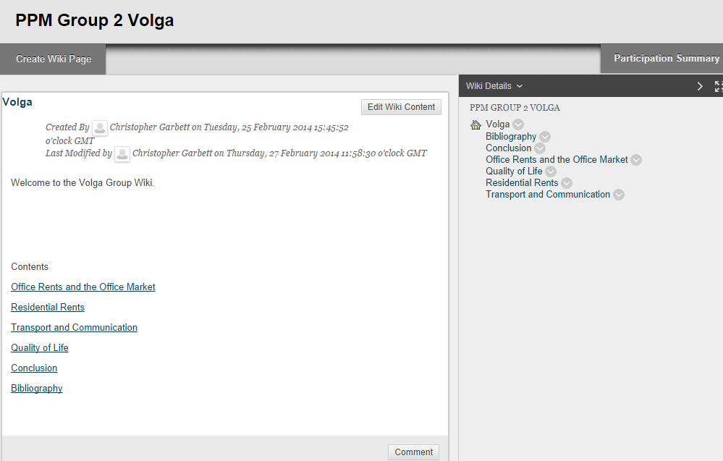
Screenshot from a group wiki.

Fig 2. Sample of an extract from individual wiki page

Office Rents and the Office Market
Section 1: Office Rents and the Office Market
Author:

The selection of Class A offices within the most desirable business locations would be a major factor in relocation which have costly financial implications. A selection of three office properties per city have been selected to provide focus regarding rents, availability and classification specifications. Other key factors are considered.
Comparison of Office Rents
A comparison of the office rental rates for the properties selected shown below reveal that Moscow’s rental is almost double than that of Saint Petersburg. Furthermore, operating costs in Saint Petersburg are included.
Table 1.1
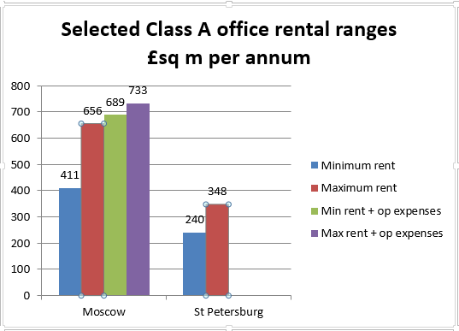

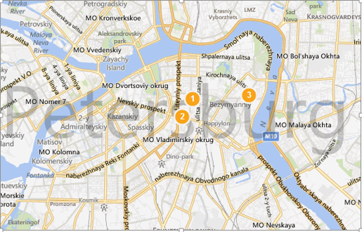

Illustration 1.1:

This is an extract from a students’ submission on an individual page. The student compared office accommodation in Moscow and St Petersburg. The students can upload images, files, video’s etc.
Feedback to the students is given by:
- Audio feedback – an MP3 file of comments from the tutor.
- A detailed rubric sheet, below.

Fig 3. Rubric Sheet
STUDENT NAME: |  |  | DATE:

MODULE LEARNING OUTCOMES

This module is intended to enable students to synthesis theoretical, financial, and legal knowledge in order to formulate and evaluate strategies for corporate real estate management. The module encompasses property as an operational and a strategic asset. Students will be empowered to direct the property life-cycle, from feasibility study to commissioning and evaluating designs, to occupation, to post-occupation evaluation, through to disposal strategies.

On satisfactory completion of the module students will be able to:

Identify and critically evaluate appropriate strategies to undertake the effective management of the organisation’s built assets.

Undertake or commission financial, technical and human appraisals of corporate property.

Make informed decisions regarding design and design solutions.
ASSIGNMENT ONE | - Undertake or commission financial, technical and human appraisals of corporate property.
A good answer will clearly demonstrate the student’s ability to think strategically about and research into property values and property acquisition. Students will demonstrate the ability to manipulate practical knowledge in order to contribute to a viable strategy.
Note to tutors: May award half marks. Award half marks if only one city considered.
Individual Part of Group Task:
Depth and appropriateness of research. |  | Marks Available | Marks Awarded | Comments
Evidence of research - correct referencing |  | 1 | 1
Use of authoritative sites |  | 1 | 1
Depth of research, not too detailed, yet sufficient for purpose |  | 1 | 1
Appropriate presentation of facts. Clear and readable |  | 1 | 1
Conclusion (shared) |  | 2 | 2
Maps, illustrations |  | 1 | 1
Tables |  | 1 | 6
Other |  | 2 | 2
TOTAL |  | 10 | 10
General Comments:

Rubric sheet for marking the assignment. Tutors can comment on individual components of the assessment. Students can clearly see where marks have been gained or lost.

Masters’ Students’ Response to Collaborative Group Work
Students overwhelmingly like the collaborative group work. They appreciate that although working collaboratively, they are marked on their own efforts. There are no “free riders” or marks dragged down by other students’ efforts.
As distance learners, they appreciate being compelled to work in small groups with other students.
Marks for the group work are consistently high. The rare failures only arise through non-submission by the student.

Group work on face to face undergraduate Level 5 Programme

Students on the module “Planning & Property Development” Level 5 BSc (Hons) Building Surveying have been assessed on a group project for many years. Due to dissatisfaction with group work, it was decided to try the same approach to group work on the Level 5 Undergraduate module as on the Masters’ Distance Learning module; i.e. a collaborative project with each student creating, and being assessed on, one part of the project, again using a wiki. The students were given the following brief. The site is an actual site in the city. They are given site plans, and taken to examine the site, and the surrounding areas.

Group Project (60 Marks)
Scenario
You are a team of developers seeking investment funding to develop a site in Leeds.
You have identified a site. If you buy the site, you will be able to raise secured funding to undertake the development. For the purposes of this exercise, assume that the property(ies) is/are all vacant or let on very short-term licence. There will be no cost in buying up the existing businesses.
You need to convince a group of investors to purchase the site, on your behalf.
In order to do this you will have to make two presentations to the investors explaining why this is a good investment. You will also submit a detailed report.

Deliverables
Presentations
There will be two formative presentations on your project. These will not be marked, but you will receive feedback to help you with your project.
Report
You will deliver one composite report with all of your groups’ contributions.
Topic Areas.
You will work in Groups of 6. Each Group will be allocated 6 topic areas. Amongst yourselves, decide who is going to tackle which topic area.
The individual student will receive marks for that topic and you will all receive some marks for the group presentation.
There can be no “Free-riders” in the group. If an individual does not contribute, they will get no marks.
Although there are individual topics, you must help each other out.
Topic Areas
Site considerations.
Why this site in Leeds? What makes Leeds a good investment and what are the external factors affecting this site?
Market research.
What is the best type of development for the site? Why is this the best, how can you justify this decision?
Market appraisal.
How much is the site going to cost to buy? This is what you are asking from the investors.
Planning.
What are the Planning issues concerning this site? Are there any known development proposals, or restrictions?
Design.
What will your building look like? Present elevations, iso- or axio-matric representations. You MAY use drawing packages such as Sketch-up to present your proposals but this is not essential. What has influenced your design?
Environmental Considerations.
Are there any environmental factors affecting the site? Are there any environmental considerations in your design?

NB These are not mutually exclusive. For example, location factors and nearby buildings will affect your choice of design, the market appraisal, and Planning considerations. The same research may be interpreted in many different ways.
FINAL REPORT
The end illustrated report should be set out as a wiki. Use a separate page of the wiki for each topic area. This will be a recap of the information presented in the presentations, as amended in the light of the feedback you received in the presentations. These should be clearly marked with the author’s name.
Use separate pages for the (joint) introduction and the (joint) conclusion.
Tutorial guidance will be given throughout the module/Semester to support your group. It is vital that you turn up for these sessions, at either the scheduled times or those mutually agreed between you and the lecturers.

Student Support
As stated in the brief, students were given face to face lectures on each of the topic areas. Lectures were supported by on-line material with copies of slides, and links to supporting material. Students also had two lectures about how to format and use the wiki tool, again, there was supporting material on the website. Students were also encouraged to meet with the tutors; either as a group or individually, to discuss their progress. Additionally, groups were required to make two presentations on their work in progress and their initial findings and proposals; for formative feedback.

Results from the Group Project.
The results of the group project were very disappointing. 9 out of 38 (24%) of students failed the group work. This was a far higher failure than in previous years.
At the mid-module review, students overwhelmingly liked the collaborative format as it avoided the free-rider or dragging down effect of group work. However, when the results became known students were far more dissatisfied with the module than in previous years.

Why was the technique successful with distance learners; but unsuccessful with face-to-face learners?
An investigation was undertaken into what went wrong. Student views were sought and the following issues were identified:

Fig 4. Issues identified by face-to-face students
Issue identified by face-to-face students | Comparison with DL students
Technology.  The wiki was an unfamiliar tool, despite having two lectures on how to use the wiki. | The wiki is also an unfamiliar tool to the Masters’ students.
Learner Autonomy  Groups did not “click” despite being able to meet face-to-face. Difficult to decide who was doing what | The Masters’ groups are unknown to each other, and never meet face to face.
The lectures were not always relevant to the wiki. - This was noted, all of the topics were covered in lectures. (However, the lecture programme was not solely directed to the assessment, the module programme is broader than the assessment). | The Group project is only a small component of the overall assessment for the Masters’ students. It is the major component for the face-to-face students.
Difficulty in contacting one of the tutors. – This was noted, and a valid comment. Due to circumstances, one tutor was unavailable for some of the time. | One would assume that full-time face to face students would have greater opportunity to contact tutors than distance learning students.
Profile and Commitment. The face-to-face students suspected that the Masters’ students had more commitment to their project. | Masters students are:  - working at a higher level  - Older, more mature and already holding down responsible jobs.
These issues were identified by the face-to-face students.

Commitment (p.a.h. continuum)
The issue of commitment seemed to be the main issue with the face-to-face students. For distance learning students a high degree of commitment is necessary anyway. This way of collaborative working was seen as supportive to them in distance learning study. For face-to-face students the independence of being able to select their own topics and work at their own pace was a distraction.
This concurs directly with the concepts of Pedagogy, Andragogy and Heutagogy. Pedagogy is defined by “It was always the teacher who decided what the learner needed to know, and indeed, how the knowledge and skills should be taught.” (Kenyon, 2001). Andragogy was defined as “the art and science of helping adults learn” (Knowles, 1970). Heutagogy “… applies a holistic approach to developing learner capabilities, with learning as an active and proactive process…. Heutagogy applies a holistic approach to developing learner capabilities, with learning as an active and proactive process” (Blashcke, 2012)

Blashcke (op cit.) further identifies 3 characteristics of Heutagogy “Specific characteristics of distance education that align themselves with heutagogy include:
- Technology: …
- Profile of the distance education learner: …
- Learner autonomy: “Significantly, these characteristics coincide very neatly with what the face-to-face students identified as major problems with approach adopted in the module.
Furthermore, (Narayan, & Baglow 2010) that “a student-centred approach for some students could be overwhelming, especially for students who have been through a teacher-centred learning for almost all their lives. This could be made worse by the introduction of etools in the process”.

Conclusion
Students on both the Distance Learning and the Face to Face Courses overwhelmingly approved of the concept of collaborative group work. Particularly they approved of being marked on their own effort in a group project. Where the group work project failed was in the educational approach.
Despite being in daily face to face contact; Level 5 students were unable to work in a Heutagogic environment. They require more “hands-on” direction from the tutor whereby they still have some autonomy in their learning; but the project is more directly supervised by the tutor; i.e. an Andragogic approach to learning. The operation of the group work project with the two different types and levels of learners firmly supports the triple level theory of Pedagogy, Andragogy and Heutagogy.

Recommendations
The project is going to be delivered again next year to face to face students. It was suggested by the students, and agreed by the tutors that there should be:
- More use of milestones. The groups will be given deadlines as to when:
  - The allocation of tasks to individuals is completed,
  - Initial draft findings are shown to the tutors, by individual students,
  - Initial draft combined reports are shown to the tutors.
- Further instruction in the use of the technology.
- Greater emphasis on expectations and responsibilities of individual students.

references
- Blashcke, 2012. Heutagogy and Lifelong Learning: A Review of Heutagogical Practice and Self-Determined Learning. International Review or Research in Open and Distance Learning, 3(1).
- Kenyon, H., 2001. University of Glasgow/ Psychology. [Online]
Available at: http://www.psy.gla.ac.uk/~steve/pr/Heutagogy.html
[Accessed 25 September 2014].
- Knowles, 1970. The Modern Practice of Education. Andragogy versus Pedagogy. New York: Association Press.
- Narayan, B., 2010. New beginnings: Facilitating effective learning. Sydney, Proceedings ascilite.

